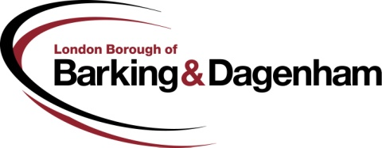 |  |  |  |  |  |  |  |  |  |  |  |  |  |  |  |  |  |  |  | Instruction to your  bank or building society  to pay by Direct Debit
Please fill in the whole form and send it to: Rent Accounts, London Borough of Barking & Dagenham, Roycraft House, 15 Linton Road, Barking, IG11 8HE  Name and full postal address of your bank or building society |  |  |  |  |  |  |  |  |  |  |  |  |  |  |  |  |  |  |  | Service user number
To: The Manager |  |  |  |  |  |  |  |  | Bank/building society |  |  |  |  |  |  |  |  |  |  | 7 | 2 | 4 | 2 | 5 | 2
Address
 |  |  |  |  |  |  |  |  |  |  | Postcode
Name(s) of account holder(s) |  |  |  |  |  |  |  |  |  |  |  |  |  |  |  |  |  |  |  | Instruction to your bank or building society  Please pay London Borough of Barking & Dagenham Direct Debits from the account detailed in this Instruction subject to the safeguards assured by the Direct Debit Guarantee. I understand that this Instruction may remain with London Borough of Barking & Dagenham and, if so, details will be passed electronically to my bank/building society.
Bank/building society account number
 |  |  |  |  |  |  |  |  |  |  |  |  |  |  |  |  |  |  |  | Signature(s)
Branch sort code
Rent Reference Number
 |  |  |  |  |  |  |  |  |  |  |  |  |  |  |  |  |  |  |  | Date
Banks and building societies may not accept Direct Debit Instructions for some types of account
This is not part of the Instruction to your bank or building society and must be detached by London Borough of Barking & Dagenham before submission to the paying bank.

Please choose when you want to pay by ticking one shaded box ONLY

1st of each month | 8th of each month | 15th of each month | 22nd of each month | Weekly
Please give us your name, address and telephone number:

This guarantee should be detached and retained by the payer.

The Direct Debit Guarantee

This Guarantee is offered by all banks and building societies that accept instructions to pay Direct Debits
If there are any changes to the amount, date or frequency of your Direct Debit London Borough of Barking & Dagenham will notify you 10 working days in advance of your account being debited or as otherwise agreed. If you request London Borough of Barking & Dagenham to collect a payment, confirmation of the amount and date will be given to you at the time of the request
If an error is made in the payment of your Direct Debit, by London Borough of Barking & Dagenham or your bank or building society you are entitled to a full and immediate refund of the amount paid from your bank or building society
  - If you receive a refund you are not entitled to, you must pay it back when London Borough of Barking & Dagenham asks you to
- You can cancel a Direct Debit at any time by simply contacting your bank or building society. Written confirmation may be required.
Please also notify us.

