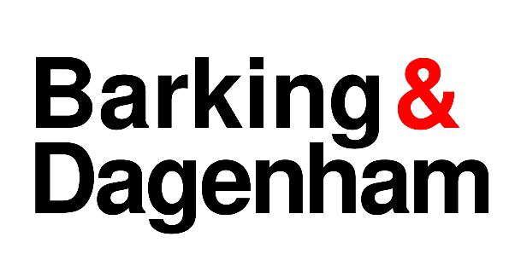
LICENSING ACT 2003 NOTICE OF APPLICATION TO GRANT A PREMISES LICENCE / CLUB PREMISES CERTIFICATE

Notice is given that (1) Name or Company name……............................ has applied to the London Borough of Barking & Dagenham on (2) Date .................to Grant a Premises Licence or Club Premises Certificate under Section 17 of the Licensing Act 2003 for:

Premises | (3) Name and Full postal address

The Licensable activities are:

Anyone who wishes to make representations regarding this application must give notice in writing to the: Barking Town Hall, Town Hall Square, Barking IG11 7LU or by email to licensing@lbbd.gov.uk.

Representations must be received by:

(5)Date:…….………………………………………

(Not to be less than 28 days, starting on the day after the application was given to the Licensing Authority)

The Application Record and Register may be viewed during normal office hours at the above address or at www.lbbd.gov.uk.

The Licensing Authority must receive representations by the date given above. The Licensing Authority will have regard to any such representation in considering the application. It is an offence, under section 158 of the Licensing Act 2003, to knowingly or recklessly make a false statement in or in connection with an application for premises licence. To do so could result in prosecution and a fine of any amount.
Insert the full name of the applicant.
- Insert the date of application to the Licensing Authority i.e. the date the complete application is given to the Licensing Authority.
- Insert the name and full postal address of the premises
- Days & times of proposed licensable activity
- Insert the date the by which all relevant representations must be received by the Licensing Authority (28 consecutive days after the application is give to the Licensing Authority).

The Display Notice must be on A4 paper, in Font 16 and be light blue in colour

