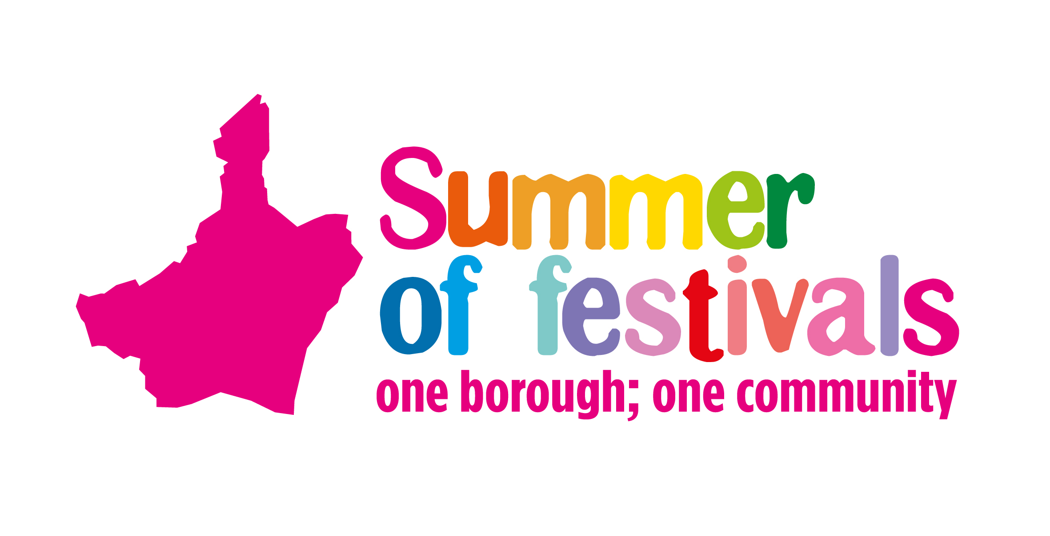
Catering Application Form
Event Information and Guidelines

One Borough Festival

Saturday 27 July 2024
12pm to 7pm
Valence Park, Dagenham RM8 3AX
Expected numbers: 6,000 - 8,000 per day
Details: The One Borough Festival is back and bringing summer feel good vibes to our community and Summer of festivals’ family. The festival will include live music, dance performances, family shows, classic cars, and more. You will still see flavours of our popular past Summer of festivals’ events such as the Roundhouse Music Festival and the Steam & Cider Fair. This family fun festival looks to bring around 7,000 festival goers, so it is a great way for you to reach out to a wider audience and showcase your food.
www.lbbd.gov.uk/summeroffestivals

Paperwork required with form:
- We will only consider food vendors, who have achieved a Food Hygiene Rating of 3 or above at their last inspection and have a Food Safety Management System based on HACCP Principles (SFBB or equivalent).
- Risk assessment document for the operation of all catering units
- Public liability insurance (£5 million)
- Proof of local authority registration of all units and current hygiene rating
- Hazard Analysis Critical Control Points
- Food Hygiene Certificates for all staff handling food
- Completed Food Hygiene and Event Catering Checklist (attached)
- Gas and electrical certificates
- Accurate price list for all items you intend to sell at the event including any meal deals or offers e.g. for volunteers/crew
- A photo of your units should be included with your application

Our Food Safety Team may require additional information after your space has been confirmed

Important Information

- The Council are striving towards a ‘greener borough’ and pledge to zero tolerance on single use plastics at our events, so we want all caterers to work with us on bringing alternatives to plastic when you cater at our event, if possible. This includes no single use plastic packaging for example polystyrene containers and cups, plastics cutlery, and stirrers etc and plastic bottled drinks, only cans/cartons can be sold. Any caterer not adhering to these regulations will not be able to trade until the issue has been resolved.

- Please read the paperwork carefully and include tenders for the event/s you wish to be considered for. Please submit all requested documentation at the time of applying. If paperwork is missing tenders will not be reviewed.

- Deadline for applications is Friday 14 June.

- Caterers will be emailed by mid-June to confirm if they have been successful to cater at the event. This correspondence will include site rules, which will be re-sent before the event, please note the latter may be revised to include more event details.

- Once you have been confirmed to cater at the event, your confirmation and the site rules will be issued to confirm set up times, access information and other important information that should be read and followed.

- Site rules will be issued prior to the event and must be adhered to. Any caterer not rectifying any raised issues pointed out by the Events Team, will be asked to cease trading if they do not comply.

- Payment needed in June. This year we cannot accept cash at the event.

- Please arrive on site at the times stated in your confirmation letter unless by prior arrangement.

- Caterers are responsible for supplying their own power requirements. Only diesel generators are allowed on site. If generators are to be used it must have a valid safety certificate which may be inspected at the event and a fully qualified competent, experienced person must carry out the installation. The Events Team can provide power at a hire charge.

- Catering units/stalls may have their own firefighting equipment which will inspected on the day.

- Caterers are responsible for bringing in their own barrier/fencing for the generator and the back of unit to ensure all equipment/gas are segregated from the public.

- Prices submitted at the time of application will be reviewed and when confirmed a Council branded price list will be given to you on arrival at the event. Therefore, please carefully consider the price list you submit as this must be displayed at all times during the event.

- If you are happy to offer a meal deal and accept vouchers for volunteers/crew for a pre-agreed price, please include this on your price list.

- All rubbish must be taken away from you on site; however, bins will be located near the catering areas.

- Every effort will be made to site your catering units together if requested but this cannot always be fulfilled. We usually site caterers in 2-3 areas on the event site.

- Please note if you are chosen to cater at our events you will only be allowed to serve what you have tendered for e.g. ice cream tender can only serve ice cream and slush tender can only serve slush. If you are deemed to be serving something you have not tendered for then you will be asked to stop serving that item and may not be allowed to attend future events.

- Please be aware when tendering, that the Council do not only consider the tender quote but also the price you sell your item at as well as other factors including complete Health & Safety and Hygiene paperwork.

- All cancellations need to be submitted four weeks prior to the event. If we are notified after this then you will not receive a refund.

- If you have any questions, please contact Gurvinder Bhaker from the Events Team on 07977 018 821 or email summeroffestivals@lbbd.gov.uk

Catering Application Form
Trading Name
(organisation/business)
Contact Name
(lead person)
Address
Contact number
(daytime)
Email
No. of staff on site
No. of vehicles on site
Type of Food | No. of Units | Frontage per Unit (meters) | Depth of Unit (meters) | Tender Offer (£) (not including VAT)
Saturday 27 July
Power required? (hire charge) please state usage amount
Notes to Events Team:

The Council reserve the right to select applicants that suit the event and audience, therefore not every request may be successful, but all will be considered.

Deadline for submission: Friday 14 June

Please return by email to: summeroffestivals@lbbd.gov.uk



