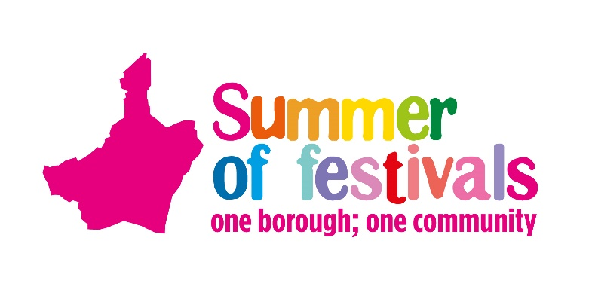
Stallholders Application Form
We can offer free pitches for charities and those in the voluntary sector and there is a small charge for businesses and traders.
Before completing, please read the guidance pack to assist you in your application.

Name
(organisation/business)
Name of lead
(if different from above)
Address
(For invoicing if required)
Contact number.
(daytime)
Email
Cost Code
(Council ONLY)
No. of vehicles on site
(Passes will be sent for all vehicles)
Description of stand including activities and goods on sale

Outdoor Space - Voluntary Sector and Council Teams
Please tick which stall you require. If you are applying for multiple events and wish to have different size stands, please in the ‘Notes to Organiser’ box.
Size | Total m2 | Price | Tick
3m x 3m | 9 | Free
6m x 6m | 36 | Free
9m x 9m | 81 | Free
Larger space (Please specify in metres)

Outdoor Space – Traders and Businesses
Please tick which stall you require. If you are applying for multiple events and wish to have different size stands, please in the ‘Notes to Organiser’ box.
Size | Total m2 | Price | Tick
3m x 3m | 9 | £50
6m x 6m | 36 | £75
9m x 9m | 81 | £100
Larger space (Please specify in metres)
 |  | POA

Please tick if you have any of the following:
Guy ropes q Marquee/gazebo/structure q
Tow Bar q Generators (MUST BE DISEAL) q
Pressurised containers q Hazardous substances q

The One Borough Festival Saturday 27July | 12pm to 5pm

Optional Extras (per event)
If you are applying for multiple events and wish to order different equipment (optional extras) for each of these events, please specify in the ‘Notes to Organiser’ box. Please note all gazebos/ marquees must be sufficiently pegged/weighted into the ground
Item | Cost per Item | Number Required
Trestle table | £12
Chair | £5
Weights (for a 3m x 3m marquee) | £85
Weights (for a 6m x 3m marquee) | £125
Marquee (3m x 3m)  Marquee (3m x 6m) | £175  £275
Access to power (single socket) | £75
Total per event | £
Total for all events | £
Notes to organiser (Please state what days you would like to attend, Saturday, Sunday or both)

Health and Safety (to be included with this application)
Risk Assessment
Method Statement
Public Liability Insurance (£5 million)
Price list if selling items or charging for activities
The Council and event organisers reserve the right to select applicants that suit the event and audience, therefore not every request may be successful.

Deadline for submission: 1 July 2024
Please return asap to: summeroffestivals@lbbd.gov.uk

