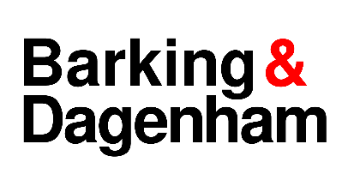
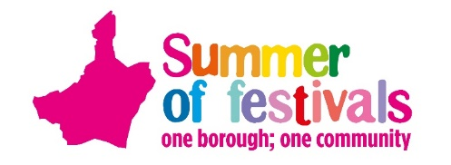

Stallholders Guidance Pack

.
The One Borough Festival
Saturday 27 July 2024
12pm to 5pm Valence Park, Dagenham, RM8 3AX
Expected numbers: 6,000 – 8,000
Details: www.lbbd.gov.uk/summeroffestivals

Paperwork required with form:
- Risk assessment (see template if you wish to use)
- Public liability insurance (£5 million)
- Accurate price list (if selling items or running paid activities)

Important Information

- Please read the paperwork carefully and ensure you note which events/s you wish to attend. Please submit all requested documentation at the time of applying.

- Deadline for applications is Monday 1 July 2024.

- The Council reserve the right to reject application if not in keeping with the event or based on too many similar stalls applying to each event.

- Stalls operating in an unsafe manner, fail to adhere to the Council’s instructions especially around operating times or selling/giving away dangerous or counterfeit goods will be closed down by the Council unless actions are rectified, or the goods withdrawn from sale. No weapons or replica weapons may be sold or given away as prizes including all types of knives, guns, swords, or lasers.

- This year the festivals will be zero tolerance on single use plastics so please do not give away/sell single use plastic items/bottles. There will be water points on the site so please bring along your water bottles or enviro cups will be valuable at the bar to purchase/hire. Please do not give away plastic bags and where possible limit plastic products on sale.

- Please note face painting this year will be free to the public, if anyone wishes to be added to our list of face painters to be booked the Council please get in touch. Insurance and health and safety paperwork will be reviewed for anyone wishing to offer free face painting.

- Please state if you require power or furniture. If you are supplying your own power, ONLY diesel generators are allowed on site. If generators are to be used it must have a valid safety certificate which may be inspected at the event and a fully qualified competent, experienced person must carry out the installation.

- ALL GAZEBOS/MARQUEES MUST BE sufficiently pegged/weighted into the ground, any marquee not secured safely will be asked to be dismantled.

- Stallholders will be emailed from June onwards to confirm their attendance. This correspondence will include site rules and guidelines. Nearer to the event you will be emailed your vehicle passes if required.

- For traders, full payment must be received before the event. An official invoice will be sent out. This year we cannot accept cash at the event.

- Council applications MUST supply their cost code if hiring furniture otherwise your application will not be accepted.

- Please arrive on site at the times stated in your confirmation letter.

- Please note the close time for exhibiting areas at each event, we strongly discourage stalls to close before this time unless in exceptional circumstances. No vehicle movement will be allowed before the time stated in our site rules.

- Rubbish must be taken away; bins are located in the catering areas. Waste will be recycled.

- All cancellations need to be submitted by 8 July. If we are notified after this, then you will not receive a refund.

- If you do not comply with the site rules, then you will not be asked to come to any future events and may lose any money you have already paid.

- If you have any questions, please contact the Events Team email summeroffestivals@lbbd.gov.uk

