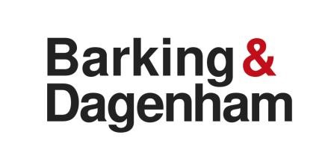
E Supplier
Accounts for Payment
London Borough of Barking and Dagenham
ESupplier@lbbd.gov.uk

Dear Supplier

As part of LBBD’s e5 Finance System upgrade program, we are inviting existing suppliers that fulfil eSupplier criteria to join our eSupplier solution, which replaces our previous system iSupplier.

We have a strict “No valid Purchase Order no Pay” policy, therefore please do not provide goods or services without receiving a valid Purchase Order Number, but once you receive this by using eSupplier you will be able to view approved PO’s, check their statuses, as well as create invoices/credit notes that will workflow straight into our accounting system e5, and view payment details.

Before we can register your access to eSupplier please provide the below information and return it to us via email at eSupplier@lbbd.gov.uk

Whilst we may already have some of the details being requested on file, please ensure that all the questions are answered fully so that we can cross-check the information that is already held and update and amend details were necessary.

Company Details

Company Name:

Address:

Postcode:

Name of Main Contact (Full name of those that will need access to raise invoices)

Email of that Main Contact : (please note email addresses cannot be generic an example email must be name/initial.name@business.com)

**Note for audit reasons we cannot have multiple people using the same email address to access eSupplier

Additional Company Information

VAT Number (if applicable)
Company Registration Number (if applicable)
Are you a Construction Industry Scheme (CIS) supplier - YES/NO

If Yes please state Deduction rate(ie Gross or Standard Rate )

(for further information on the HMRC Construction Industry Scheme please use this link to the HMRC website http://www.hmrc.gov.uk/cis/intro/con-or-sub.htm)

Are you a Small or Medium Size Company (SME) – YES/NO

(for further information please use this link
http://ec.europa.eu/growth/smes/business-friendly-environment/sme-definition/index_en.htm)

Existing Payment Details

Bank/Branch Name:

Account Name:

Sort Code:

 |  | - |  |  | -

Account Number:

Once we have received and cross referenced the above information. We will make sure that you fulfil the criteria to ensure that using the eSupplier Portal is the best solution for you. We will notify you as to when you will receive your password, and this will be accompanied by any further documentation and training manuals that you might need.

Thank you for your assistance with this matter.

Yours sincerely,

Accounts Payable Manager
eSupplier
London Borough of Barking and Dagenham

