Proposed Main Modifications to the Barking and Dagenham Submission Local Plan (submission documents C1: ‘Regulation 19(2) Draft Local Plan 2021’, and C2: ‘Draft Local Plan Appendix 2: Proposed Site Allocations 2021’)

May 2024

Main Modifications
The modifications below are expressed either in the conventional form of strikethrough for deletions and underlining for additions of text, or by specifying the modification in words in italics.

The page numbers and paragraph numbering below refer to the submission local plan, and do not take account of the deletion or addition of text.

Ref | Policy/  Paragraph | Main Modification
MM1 | Vision and Objectives | CHAPTER 1 A vision for Barking and Dagenham 2037  Chapter 1: Our vision and objectives  By 2037, we want to realise our vision for inclusive growth, to harness the growth opportunity that arises from our people, our land and our location, while ensuring it is sustainable and improves prosperity, wellbeing and participation for all. This will mean achieving our objective to deliver:  - Over 40,000 44,051 High-quality new homes that meet the needs of our residents and working Londoners – in the pPlan period – in safe and ‘liveable’ neighbourhoods, which are well supported by optimum health, education and community facilities. (Latest Housing Trajectory)  - Around 20,000 Jobs in diverse enterprises, from media to biotech to food-based industries; re-asserting our role as a key part of London’s industrial engine and an important economic centre in our own right.  - Around 85 463 Additional Hhectares of beautiful parks and natural open spaces in combination with development of energy-efficient homes and a decarbonised energy system to make our borough the ‘Green Capital of the Capital’.  - 7 Areas characterised by distinctive neighbourhoods that are well-connected to each other and where residents and businesses are connected to the opportunity development and growth brings.  - 0 People left behind  Objective Related Strategic Policies  Over 40,000 High Quality new homes that meet the needs of our residents and working Londoners – in the Plan period – in safe and ‘liveable’ neighbourhoods, which are well supported by optimum health, education and community facilities. (Latest Housing Trajectory) SPDG 1 SP2 SP4 SP3 SP9 SPP1-SPP7  Around 20,000 jobs in diverse enterprises SPDG 1 SP5 SP9 SPP1-SPP7  Delivery of around 85 additional hectares of beautiful parks and natural open spaces in combination with development of energy-efficient homes SP6 SP9 SPP1-SPP7  7 Areas characterised by distinctive neighbourhoods SPDG 1 SP2-SP9 SPP1-SPP7  0 People left behind SPDG1 SP3 SP4 SP5 SP8 SP9 SPP1-SPP7
MM2 | Chapter 2 | Chapter 2: Introduction  2.1. This Local Plan sets out our strategy for delivering our vision and objectives by 2037. It is made up of this document, which contains planning policies, and Appendix 2: Site Allocation Proformas (which contains more detailed requirements for the allocated sites). As such, Appendix 2: Proposed Site Allocations should be read in conjunction with this document. It sets out a framework for new development in the borough, shaped by engaging with our delivery partners and communities. The Local Plan distils development-related aspects of our emerging Inclusive Growth Strategy¹ and covers a range of issues, from our commitment to building new homes, creating new jobs and taking climate change actions, to our desire to embed healthy new town principles across the borough².  2.2. The Local Plan has the status of a Development Plan Document (DPD) under planning legislation. This means that, together with the London Plan³, it will be used to assess and decide on whether planning applications for development in the borough should be granted permission. It should be the starting point for, and set the brief for, developers who wish to submit planning applications in the borough.  2.3. The policies in this pPlan set priorities for different types of development in different parts of our borough. The pPlan is accompanied by a Policies Map, which shows the areas where specific policy requirements apply, and also identifies those development sites that have ‘site allocations’ to define the way they should be used.  2.4. Our Local Development Scheme (LDS), published on our website and regularly updated, can help you identify any other DPDs and related policies set out in Supplementary Planning Documents (SPDs) that are relevant to development in the borough and that should be taken into account when developing planning applications. The LDS identifies all DPDs that have already been adopted or are currently being prepared. It also identifies any adopted and forthcoming SPDs.  2.5. We consulted on a draft Local Plan (Regulation 19 stage) from October 2020 to November 2020. Notwithstanding the positive response to the Plan, we have made amendments to reflect the recently adopted London Plan 2021 and have provided more details on site allocations (Chapter 3 and Appendix 2), and an updated industrial land strategy reflected in Chapter 7 (Economy).  2.6. The other key section is Transport (Chapter 10). This is supported by our new borough-wide Transport Strategy, new Cycling and Walking plans and the A13 Transport Study prepared jointly with TfL and the City of London. The work presents a greater emphasis on how we connect and strengthen links between new and existing communities with an emphasis on active travel, and improved public transport. Wwhile recognising car use is still a vital part of Barking and Dagenham’s heritage, economy and day-to-day life. the car still forms an essential part of Barking and Dagenham’s economy and day-to-day life, a shift to sustainable modes is needed to support the objectives of this plan.  2.7. This revised version of the Local Plan is now being published for comment before it is submitted to the Planning Inspectorate, along with any comments received, for an independent examination. This independent examination will consider whether the plan is ‘sound’ when considered against the criteria in national planning policy before it can be formally adopted by the Council as planning policy⁴.  2.8. Details of how to make comments on this document, including when and where these should be sent, and more details about the examination process are set out in the Statement of Representations Document, which has been published and circulated alongside this document.  2.79. The structure of the Local Plan is illustrated in Figure 1. Our long-term and strategic approach to growth is contained within the Strategic Area Policies in Chapter 3 and the strategic policies that open each subsequent chapters.  2.810. Our policy approach in each case is: (a) justified by local evidence; and (b) will still deliver the outcomes sought by regional and national policies. Once adopted, this Local Plan will supersede our current adopted planning policies as set out in Appendix 1.  2.911. The remainder of this Local Plan sets the framework for the kind of development we want to see. It also aligns with relevant government policy, and the Mayor of London’s planning policies⁴⁵. It articulates how these national and regional policies should apply locally, taking account of our specific environmental and socio-economic context.  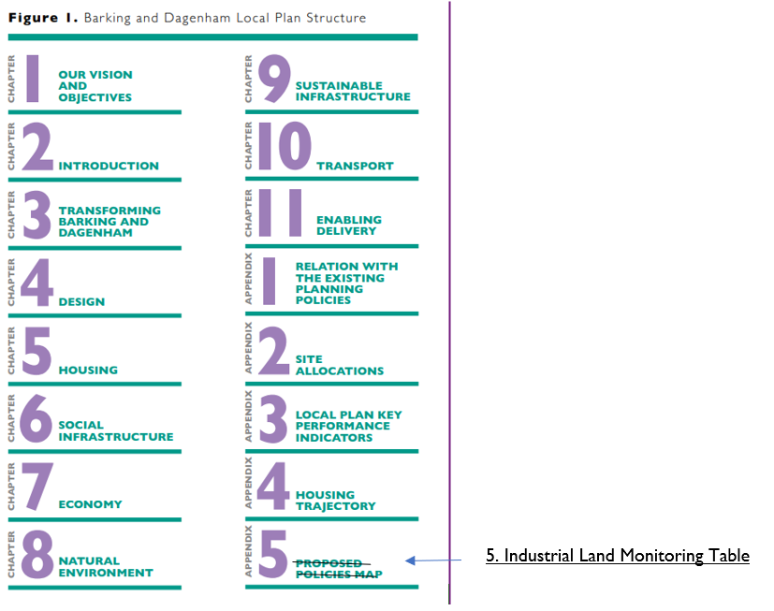  The opportunity  2.1012. Barking and Dagenham is located between the City of London, the UK’s financial centre, and the M25 motorway which circles the capital (see Figure 2, page 12). It is London’s single biggest growth opportunity with some of the best-value land for development, including many of the capital’s largest stretches of undeveloped riverside frontage, and the most affordable premises for large and small businesses in London.  2.1113. Central London is just 20 minutes by rail. London City Airport, offering international connections, is within 30 minutes by train and the borough is well-connected to the Eurostar at London St Pancras and Ebbsfleet International. The Elizabeth Line (Crossrail1) railwaylink is nearing completion and will, once operational, serve Chadwell Heath. This The now completed Elizabeth Line (Crossrail 1) railway link serving Chadwell Heath will slash current journey times to Heathrow International Airport by 20 minutes. Important regional economic centres at Stratford, Canary Wharf and Tilbury Docks can all be reached in 30 minutes.  2.1214. Our natural landscapes and heritage assets add value to the future development of the borough – providing a rich and interesting setting for high-quality new developments. The River Thames forms the southern boundary of the borough and the River Roding and Beam River are to the west and east. A massive third of the borough, some 463 hectares, is green open space and Epping Forest and the Essex countryside are just a few miles away. Furthermore, through the borough's planned regeneration programmes, approximately 85.46 hectares of public space will be added over the next twenty years (as identified in the 2017 Parks and Open Spaces Strategy⁵).  2.1315. The borough grew from an ancient settlement; evidence of habitation has been found dating back to the Neolithic or early Bronze age, and Barking is mentioned in the Domesday Book of 1066. By the 14th century, sSaltwater fishing was Barking’s main trade and a thriving fishing port supplied London Market’s by the 17th Century, reaching its peak in the mid-19th century before railway enabled delivery from East Coast Ports⁶⁵.  2.1416. There are 45 statutory listed buildings, 123 locally listed buildings, 1 scheduled ancient monument and four conservation areas – these buildings and areas of architectural and historic importance give provide a sense of place and distinctiveness. There are a myriad of features of the historic built and natural environment and the character and ‘feel’ of our neighbourhoods, of which our 211,998 residents are rightly proud⁷⁶.  2.1517. Our population is diverse; nearly over 40% of our residents were born abroad, and as many as 72 different non-English languages are spoken in households across the borough. We celebrate this through a range of programmes that build and reinforce a strong community spirit⁸⁷. Coventry University in London and the award-winning Barking and Dagenham College, along with other educational institutions, are raising skill levels in our population, which is younger than most other parts of London⁹⁸. These institutions are already acting to connect their learning, research and innovation activities with the local economy and we will continue to capitalise and expand on this over the period that this Local Plan covers.  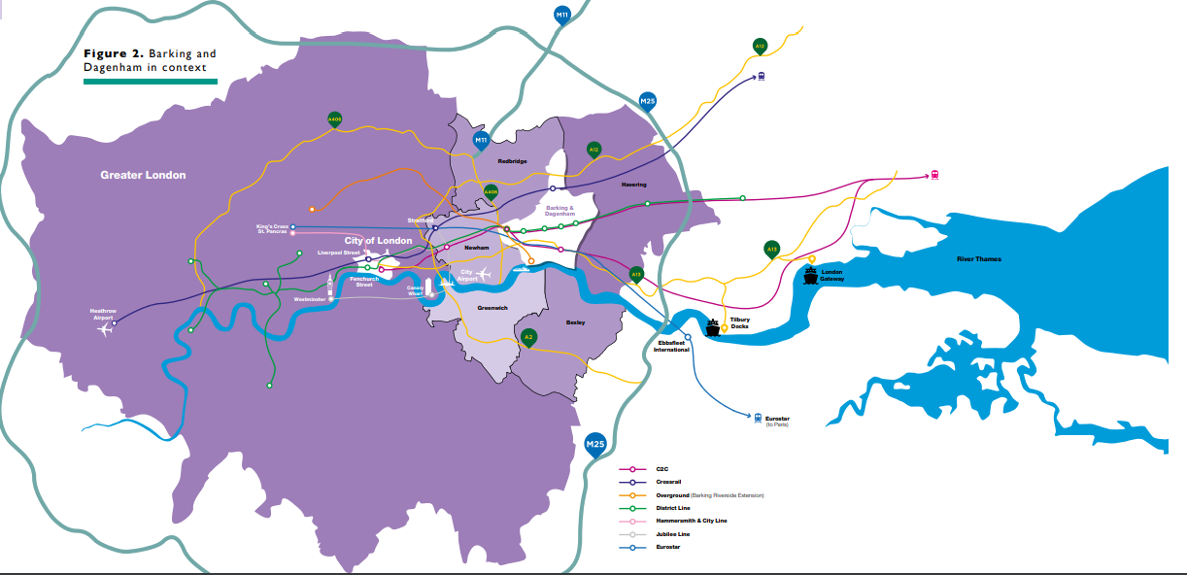  2.1618. We are driving a range of interventions to diversify and strengthen the local economy with the GLA and other partners. The planned consolidation and relocation of London’s three historic wholesale markets in our borough – Billingsgate, Smithfield and New Spitalfields – will also bring thousands of new jobs and create opportunities in food-based employment. Development of the Made in Dagenham film studios at Dagenham East is envisaged as part of a wider digital, science and tech cluster in the borough. The beginnings of an expanded creative sector and cultural offering are also in evidence. Icehouse Quarter Studios on the Roding River are the first steps in a set of longer-term ambitions for Barking Ttown Ccentre to become a location and destination for creative businesses and entrepreneurs.  2.1719. We also recognise the unique opportunities for developing modern freight and logistics hubs in the south of the borough at the Eurohub, Dagenham Dock and Ford sites. LBBD has the only operational intermodal rail terminal in London (other than ports); the only location in the UK with freight access to HS1 and a fast connection to the continent. The area has unique access to the River Thames, the M25 and road access to Central London. We want to work collaboratively with key stakeholders such as Network Rail, DB Cargo, Ford, Tesco, Unilever and the City of London to create an innovative, 21st century logistics hub. The opportunity for creating a new freeport in Dagenham as a special economic zone could create up to 25,000 new jobs, alongside the Ports of London Gateway and Tilbury in Thurrock.  The challenge  2.1820. The opportunity is huge, but we are also being realistic about the challenges we face. There is an urgent need to tackle climate change through reducing the amount of carbon emitted from homes, businesses, construction and the way we travel. We also need to strengthen the borough’s resilience to the impacts of climate change, such as increased flood and heat risk. The urgency of this challenge led us to declare a climate emergency in January 2020. While carbon emissions in LBBD are lower than other parts of London¹⁰⁹, taking bold action to reduce them further is the only way we will meet our ambitious plans for the borough to become carbon neutral.  2.1921. The CovidCOVID-19 pandemic is another global challenge that has had a profound impact on the way that we live and work. This challenge is likely to continue to affect the way our neighbourhoods are planned, with more emphasis on sustainability, active travel, and place-making and access to open space. The economic implications of CovidCOVID-19 are still unfolding, but it is almost certain this will cause economic uncertainty in addition to that already anticipated from Brexit.  2.2022. These immediate problems all take place in the context of other longer-term changes arising from a decline in UK manufacturing, and a shift to a service and knowledge-based economy. Industry is already being transformed by technological change, including increased labour automation and the consequent reduced workforce demand. Online retail shopping grew from less than 5 per cent of total sales in 2008 to around 20 per cent by 2019¹¹¹⁰ and has exploded under COVID-19 lock down. These challenges for the high street retail sector mean that town and district centres across the country are already in decline. LBBD is not immune from this. Our centres need to develop a new identity as commercial and community centres beyond just shopping if they are to attract new investment and remain viable and vibrant.  2.2123. These wider economic shifts have meant that many of the major industrial employers in the area have declined from their peak and some have disappeared entirely. A question mark hangs over the future of for the Former Ford Stamping Plant, which manufactures diesel engines, the sale of which will be halted by 2035 at the latest under the government’s carbon neutral plans.  2.2224. There are other local challenges to overcome, too. Longstanding issues of deprivation linked to lower local economic opportunity that have resulted from these local economic shifts, cannot and must not be ignored. The health of our residents is worse than in other parts of London, with lower life expectancy and higher levels of child obesity. Educational attainment continues to be an area of underperformance and this results in a skills deficit – and workforce supply challenges.  2.2325. Our borough-wide vision for harnessing these opportunities is illustrated in Figure 3. on the right.  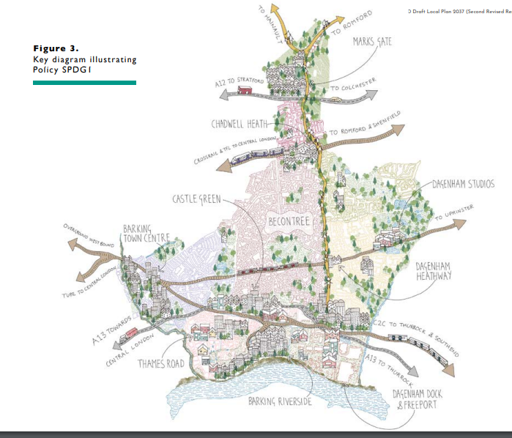  The key drivers for Local Plan policies  2.2426. Even in the face of these challenges, we are aiming to seize the present opportunities to generate social and financial value in LBBD and we have established and invested our own funds in Be First – our own regeneration company. Be First is tasked with capitalising on the emergence of LBBD as London’s growth opportunity, through accelerating the pace and scale of transformation of the borough, and ensuring development is sustainable, high quality and benefits local people. It has responsibility for delivering our planning services, and for directing development, including the delivery of thousands of new, high-quality, sustainable homes, many of which will be affordable, and the creation of new high-quality jobs and great places to live, work and play that build on the borough’s amazing history and traditions. The pProfit that we make will be channelled into funding Council services, including for the most vulnerable in our communities. Existing residents will benefit from the opportunities that come from new investment and regeneration.  Industrial areas fit for future growth industries  2.2527. We want to support our local economy, and that of Greater London, by stepping up investment in our ageing industrial stock. LBBD has around 446.3 hectares of strategic industrial land accommodating slightly more than 1.5 million square metres of commercial floorspace, with 70% of this floorspace being located within the Strategic Industrial Locations and 22% within the Locally Significant Industrial Sites¹²¹¹. We want to transform these floorspaces into modern commercial stock capable of attracting modern businesses, and creating diverse new jobs at all levels, along with supply opportunities for our residents and businesses.  2.2628. While there is much uncertainty, we know the future is not in the heavier, and often more polluting, industries. Growth prospects lie within the rising care, creative, logistics, city markets, education, and construction sectors. Within these sectors there are opportunities to provide training and career progression in the borough. We also have ambitions to attract investment in the decarbonisation sector, bringing both economic and environmental benefits by creating space and opportunities for new industries as part of our Industrial Land Strategy and supporting Masterplans (See Chapter 3, Chapter 7, Chapter 9 and Appendix 2).  Stepping-up housing delivery  2.2729. Our housing target since December 2019 is 1,944 The borough has a stepped-housing requirement new homes each year until 2029, as set established out in the London Plan 2021 and through our evidence base. In common with the rest of London, the need for affordable housing is high. In the past, the speed of housing delivery has been slow, however we are taking action to pick up the pace and increase the number of affordable homes for local residents. We are making every effort to work with developers and infrastructure providers to improve our rates of delivery, and to align growth with critical and necessary infrastructure. Our own development activity, driven by Be First, the Council’s rRegeneration cCompany, will increase housing supply significantly (See Chapter 5).  2.2830. Delivery is, of course, impacted by a range of other factors from site specific matters, such as infrastructure requirements, to global trends such as economic impacts arising from CovidCOVID-19¹³¹².  Unlocking growth through infrastructure investment  2.2931. Ensuring there is necessary social infrastructure – such as schools and health services – to meet the needs of new and existing communities is fundamental. While strategic transport access is good, connectivity and capacity issues at stations in Barking and Dagenham, on the Tube, C2C line and the A13 and other parts of the road network must be addressed to avoid ‘holding the borough back’ from attracting investment¹⁴¹³. In the wake of COVID-19, improving walking and cycling infrastructure is essential to Pandemic Recovery in London¹⁵¹⁴. There are other local environmental infrastructure needs, too. Areas of land within the south of the borough are at significant risk of tidal and coastal flooding¹⁶¹⁵, and flood defences and flow control structures must be maintained (see Chapter 8 and 9).  Becoming the green capital of the capital  2.3032. We are committed to creating a clean, green and sustainable borough, reinforced by our climate change emergency declaration, and our targets to becoming a carbon neutral council by 2030 and a carbon neutral borough by 2050. To help achieve these targets, we are promoting the development of sustainable infrastructure and the protection and enhancement of our natural environment. In particular, there is a strong emphasis on high standards of: energy efficiency,; sustainable design and construction;, utilising innovative renewable energy technologies;, vastly improving air quality;, conserving our water and natural resources, reducing our waste, promoting the ‘Circular Economy’, and enhancing biodiversity and green infrastructure.  Promoting sustainable transport  2.3133. We recognise our ambitions for the scale of new housing and development will require a new emphasis, promoting a shift to sustainable modes of transport (walking, cycling and public transport) with less dependency on car use. We also need to address the borough’s poor position in health and activity levels. To achieve this, we are promoting ambitious targets (see Policy SP8, Chapter 10) in line with the London Plan 2021. This will be achieved by a combination of behavioural change and education initiatives, prioritising new infrastructure all underpinned by policies surrounding new developments in this Pplan.  Unlocking the London Riverside Opportunity Area and beyond  2.3234. The Council is focused on working with our neighbouring boroughs, TfL, GLA, Barking Riverside, Network Rail, C2C, City of London, Ford, London Freeport, and many other developers, and local people to unlock the huge economic and social opportunities which exist through development and investment in new infrastructure in the London Riverside area.  2.3335. These are already happening with the City Markets, and the Thames Freeports and the massive redevelopment of Barking Riverside and the new rail extension. The potential for the borough and surrounds is enormous with the likelihood of creating a new town with over 40,000 homes in this area alone by 2050.  2.3436. Figure 4The illustration to the right, shows the scale of this ambition and the next sections describe the policy framework which will enable this transformation.  Amend Figure 4 as per the below, removing reference to a district centre at Merrielands.  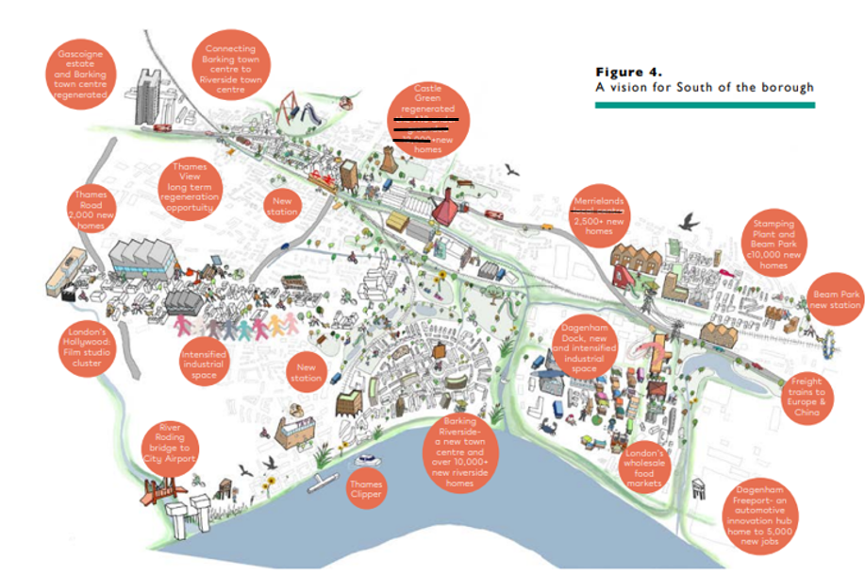  1For details, please visit the Council’s website at: https://www.lbbd.gov.uk/inclusive-growth  2Healthy New Town Principles in a LBBD doc: https://www.england.nhs.uk/ourwork/innovation/healthy-new-towns/  3The New London Plan 2021 has been adopted and is available at: https://www.london.gov.uk/what-we-do/planning/london-plan/new-london-plan/london-plan-2021  4This is in line with Regulation 19 of the Town and Country Planning (Local Planning) (England) Regulations 2012).  45This Local Plan conforms with the National Planning Policy Framework (2019) and is largely in general conformity with the emerging London Plan.  56LBBD Townscape and Socioeconomic Characterisation Study, 2017  67 2018 Mid-Year Population Estimates  78 A cohesion and integration strategy for Barking and Dagenham, 2019 Accessed: https://www.lbbd.gov.uk/sites/default/files/attachments/LBBD8687_Cohesion%26Integration2019_A4_32pp_AUG19_digital.pdf  89Barking and Dagenham (2020) Infrastructure Delivery Plan.  910Department for Business, Energy & Industrial Strategy (2019) 2005 to 2017 UK local and regional CO2 emissions – data tables. Available at: https://www.gov.uk/government/statistics/uk-local-authority-and-regional-carbon-dioxide-emissions-national-statistics-2005-to-2017  1011Source: ONS Internet sales as a percentage of total retail sales.  1112LBBD Borough Industrial Strategy (2021)  1213Greater London Authority’s post crisis housing delivery recovery plan: https://www.london. gov.uk/sites/default/files/2020-07-21_housing_delivery_taskforce_recovery_plan_rev1_1.pdf  1314Metro Dynamics (2019) Growth Commission Stocktake Towards Inclusive Growth for Barking and Dagenham. Available at: https://modgov.lbbd.gov.uk/internet/documents/s128726/Growth%20Commission%20Stocktake%20Report%20-%20App.%20A.pdf  1415Fraser Macdonald of Transport for London issued a letter to Londoners in September 2020 and pointed out the importance of giving people an alternative way to travel in order to reduce road congestions and ensure the efficient operation of emergency services, businesses and buses and taxis: https://consultations.tfl.gov.uk/general/f2826d1b/user_uploads/cs7-notable-issues-28-september.pdf  1516WSP Parsons Brinckerhoff (2017) London Borough of Barking and Dagenham Local Flood Risk Management Strategy. Available at: https://www.lbbd.gov.uk/sites/default/files/attachments/Local-Flood-Risk-Management-Strategy.pdf
MM3 | Chapter 3 | CHAPTER 3 Transforming Barking and Dagenham  LBBD Strategic Development Strategy  3.1. This chapter sets out our growth and development strategy, which reflects the borough’s significant potential to deliver new homes, jobs and supporting ancillary uses alongside key infrastructure interventions.  3.2. This chapter contains the following policies:  STRATEGIC POLICY SPDG1: Delivering growth in Barking and Dagenham  STRATEGIC AREA POLICY SPP1: Barking and the River Roding  STRATEGIC AREA POLICY SPP2: Thames Riverside  STRATEGIC AREA POLICY SPP3: Dagenham Dock and Freeport  STRATEGIC AREA POLICY SPP4: Chadwell Heath and Marks Gate  STRATEGIC AREA POLICY SPP5: Dagenham East  STRATEGIC AREA POLICY SPP6: Dagenham Heathway and Becontree  STRATEGIC AREA POLICY SPP7: Becontree Heath and Rush Green  3.3. The key evidence documents that this section relies on include:  Key evidence documents Date produced  LBBD Local Plan Sustainability Appraisal 2021  Be First Industrial Land Strategy 2021  LBBD Local Plan Viability Assessment 2020  LBBD Infrastructure Delivery Plan 2020  LBBD Green Grid Infrastructure & Biodiversity Strategy 2019  LBBD Townscape and Socioeconomic Characterisation Study 2017  Characterisation Study Barking Riverside Gateways Housing Zone 2015  Delete Figure 5 and replace with new Figure 5 below, correcting some SPP Area Policy names and correcting boundary illustration between Dagenham East, and Becontree and Heathway.  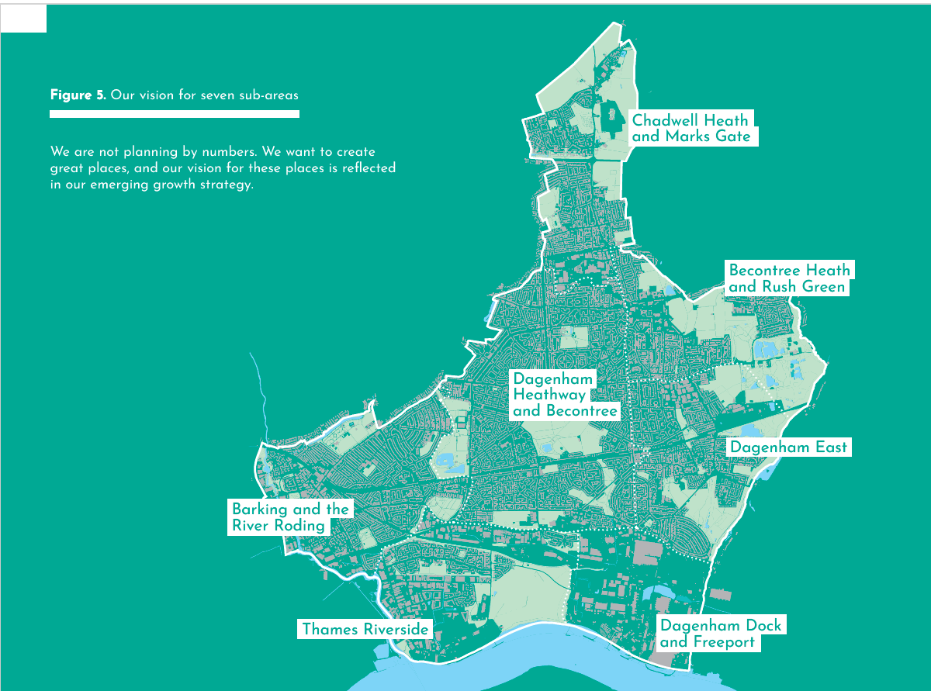  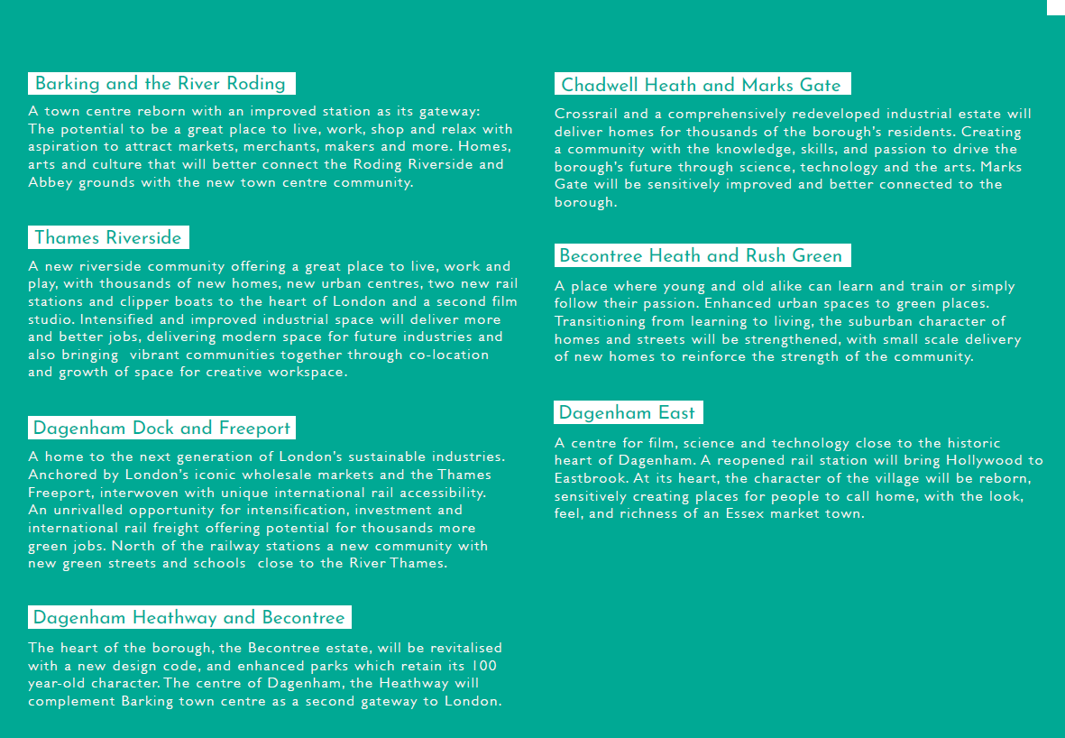
MM4 | SPDG 1 | Justification  Sustainable growth that is deliverable  3.4. The development approach outlined in this chapter has been informed by a sustainability assessment of the impacts of several growth options¹⁷¹⁶. It focuses more extensive development within those areas of the borough where there is existing or planned sustainable transport provision to meet demand, and in locations where social infrastructure is already accessible or can be delivered to serve the community.  3.5. By adopting this planned distribution of growth, we hope to minimise carbon emissions arising from vehicular transport, which in turn will help to address local air quality impacts. It also limits encroachment on the natural environment, which plays an important role in addressing the impact of climate change.  3.6. While sustainability has driven our approach, we have also considered the viability implications of the development strategy set out in this chapter and the specified policy ‘asks’ of development set out in the remainder of the Local Plan. We have tested the individual and cumulative effects of our policies on development viability¹⁸¹⁷, and our assessment demonstrates that our approach is deliverable.  Intelligent use of industrial land to deliver more homes and more business space  3.7. Central to our development strategy is the adoption of a more intelligent use of our extensive industrial land in accordance with Policy E4 and E7 of the London Plan 2021. We recognise that industrial occupiers and activities require a wide range of operational needs, including yard space, and that we need to facilitate this provision, having regard to which parts of the borough are most suitable for specific industrial activities and/or other land uses including residential.  3.8. Adopting a comprehensive approach to our industrial land has enabled us to identify which parts of the borough are most suitable for encouraging continued industrial activity, which are suitable for the intensification of industrial floorspace and greater job densities on less land, and which parts can be released to enable the co-location of industrial activities with other uses, such as residential, and/or new residential-led neighbourhoods.  3.9. Our proposed approach will therefore ensure that the borough continues to meet current and future demands for industrial and related functions through the intensification and modernisation of industrial stock within Strategic Industrial Locations (SIL) and Locally Significant Industrial Sites (LSIS). This will provide a significant opportunity for the provision of additional residential dwellings and mixed-use developments with supporting social infrastructure alongside new intensified industrial uses or on former industrial land.  3.10. This approach is backed by a robust evidence base which demonstrates that we will continue to provide a significant amount of additional industrial space to meet future demand whilst also delivering an ambitious housing target. There is also sufficient capacity across the borough to manage any short-term displacement of industrial uses through the loss or intensification of existing industrial space.  3.11. It is anticipated that the Plan’s approach to industrial land could deliver between 9,160 and 20,000 new jobs over the Plan period. This figure uses the additional 10,777 jobs in Barking and Dagenham (in 2040 in comparison to 2020) modelled in the Industrial Land Strategy (ILS) as a starting point, with 3,730 of these expected to come forward in the industrial sector. At an average of 538 jobs per year, this estimates an additional 9,160 jobs over the Plan period. Recent planning applications suggest this figure is already being met through the planning pipeline and so the ambition of 20,000 jobs remains an important target for the borough.  3.12. The ILS also calculated that ~200,000 sqm of floorspace and ~50ha of employment land is required to deliver the projected 3,730 industrial sector jobs.  3.13. Further detail on how the borough's employment land and job growth requirements have been calculated is set out in Chapter 9.  3.14. However, it is our view that through the significant industrial intensification proposed in areas such as Dagenham Dock and Freeport, and at recently delivered sites such as Industria, alongside other key employment generating opportunities such as Eastbrook Film Studios and the relocation and colocation of the London Wholesale Markets, our ambition for the creation of 20,000 jobs is deliverable. There are already proposals for 1,800 jobs at Dagenham Film Studios and 11,308 identified through planning applications, showing we are already expected to exceed our 2020-2040 job creation figures through the current planning application pipeline.  3.15. Designated industrial areas are shown in Policy SP5 (see illustrative Figure 16), and shown in detail on the Site Allocations (Appendix 2) and on the Policies Map. The borough’s key industrial locations containing SIL and LSIS are also set out in Table 2 in Policy DME 1.  Strategic Area policies and Transformation Areas  3.1611. Policy SPDG 1 explains our overall strategy for delivering growth. The seven ‘area policies’ that follow explain how this overall growth strategy will be implemented across the borough.  3.1712. Transformation Areas are locations that are likely to be subject to more extensive growth and development. Thesey areas are shown on the Policies Map and include our most significant allocated development sites and build on existing and planned public transport hubs. Allocations are included on the basis that they:  - have a total site area or remaining developable area (where applicable), of greater than 0.25 hectares; and  - deliver 150 homes or more or 500 sqm or more of commercial floor space over the Local Plan plan period (excluding sites with implemented planning consents); or  - can deliver a critical and essential piece of identified infrastructure for the area over the Local Plan plan period; or  - where existing site-specific characteristics mean establishing the acceptability of uses and quantum of development on the site is especially necessary to enable delivery.  3.1813. The level of detail across these area policies are not standardised. This is intentional. More detailed policies reflect the scale of development and complexities involved in unlocking growth in that area. All policies set high-level development principles and highlight some key infrastructure needs in these locations. This is to ensure that the impact of new development is mitigated, and existing communities also benefit from opportunities in the identified Transformation Areas.  3.1914, Where needed, Wwe will produce further Supplementary Planning Documents (SPDs) and guidance for Transformation Areas, for key sites within them, or for existing neighbourhoods and smaller scale householder development, to supplement the policies in this chapter. We have already started preparing Masterplans for Thames Road and River Road Employment Area and Chadwell Heath, as well as design guidance for the Becontree Estate. We also have ambitions for Masterplans at Barking Town Centre (including Town Quay, Barking Station, Harts Lane and East Street), Castle Green, Marks Gate and Dagenham Heathway.  Housing Requirement  3.20. The borough's housing requirement is 38,864 new homes over the Plan period (2020/21 to 2036/37). Our housing requirement calculation is based on Policy H1(a) of the London Plan 2021 which sets a 10-year housing requirement for Barking and Dagenham of 19,440 homes between 2019/20 and 2028/29. This equates to 1,944 dwellings per annum (DPA). The London Plan 2021 is also clear that if a target is needed beyond the 10-year period to 2028/29, boroughs should draw upon the 2017 SHLAA and any local evidence of identified capacity, in consultation with the GLA, and should take into account any additional capacity that could be delivered as a result of any committed transport infrastructure improvements.  3.21. The London Plan 2021 and the GLA SHLAA 2017 set out the following for Barking and Dagenham:  - 19,440 (or 1,944 per annum) for 2019/20-2028/29 - London Plan 2021*  - 13,499 (or 2,699 per annum) for 2029/30-2033/34 - as established for 'phase 4' in the 2017 GLA SHLAA, and  - 13,359 (or 1,908 per annum) 2034/35-2040/41 - as established for 'phase 5' in the 2017 GLA SHLAA  *The 38,864 requirement includes the full 19,440 figure from the London Plan 2021 covering years 2019/20-2028/29. Whilst this falls slightly prior to the Plan period, Barking and Dagenham Council is projected to meet the entirety of the 2021 London Plan 2019-2029 housing target by the end of 2028/29.  Addressing Undersupply  3.22. Our housing completion data since 2021 (London Plan adoption year) shows that the borough underdelivered by 2,483 homes over the 2020/21-2022/23 period. This averages out as 497 per year over the first five-year period, or 177 per year if spread over the remaining Plan period (2023/24-2036/37). The shortfall will be spread over the remainder of the Plan period as the trajectory shows key targets will still be met (i.e., the 2021 London Plan's targets for the borough between 2019/20 and 2028/29) and significant delivery is expected in the medium-long term through the borough's Transformation Areas. This would result in a target of 2,121 per annum for years 1-5 of the Plan period. The borough is expecting significant delivery of our Transformation Areas in the medium-term Plan period and it is expected that yearly delivery will increase in this period.  Stepped Requirements  3.23. The 2017 GLA SHLAA shows capacity for 2029/30-2033/34 as 2,699 per annum, and for 2034/35-2040/41 as 1,908 per annum. The Council's housing supply evidence (as set out in the Strategic Housing Land Assessment 2021 and recently updated trajectory) shows broadly that the London Plan 2021 stepped requirements can be met in the borough over the Plan period and these requirements reasonably reflect the Council's evidence (with higher delivery being expected in the medium-term). Whilst the Council's supply evidence shows the GLA SHLAA capacity figures could be exceeded towards the later years of the Plan period, this relies on large sites in multiple ownership which will require delivery support through masterplans, infrastructure, and in some cases assembly. Delivery plans for several of these sites are currently high level for these reasons. The Stepped Requirement figures provide an appropriate basis for the borough's housing requirements as set out below:  Plan Period London Plan 2021/GLA SHLAA based target New requirement (London Plan 2021/GLA SHLAA target + undersupply spread across Plan period)  2020/21-2028/29 (with first 5year post adoption period starting 23/24) 1,944 2,121  2029/30-2033/34 2,699 2,876  2034/35-2036/37 1,908 2,085  Housing Supply over the Plan Period  3.24. Our Strategic Area policies each set out the development potential for their respective areas. This includes the indicative housing capacity expected to come forward over the Plan period. Combined, these show that the borough has an anticipated housing supply of over 40,000 homes up to 2037. This exceeds our housing requirement of 38,864 new homes. Our projected housing supply of 40,000+ provides flexibility, and our trajectory shows it can realistically be achieved assuming the allocated sites come forward as anticipated.  Small Sites  3.25. The London Plan 2021 sets out a minimum housing target for Barking and Dagenham of 1,990 up to 2028/29. It is anticipated that 472 homes could be delivered in this period on the Plan’s allocated small sites, with 381 homes expected/delivered through windfall (from 2019/20 when the London Plan 2021 target initiated, to 2028/29). This leaves a shortfall of 1,137 homes for the 10-year period (or 114 a year when averaged). Be First intends to try and address some of this shortfall through its Innovative Sites programme (which it intends to early 2024). Sites within this programme will be advertised via the GLA as part of the Small Sites, Small Builders Programme. This programme does contain some of the sites allocated in the Plan, but also contains smaller unallocated sites. Currently there are 29 small sites which we anticipate to be delivered in a number of ways (some through disposal, some through community led-housing, and the remainder through Be First/Council delivery). In addition, policies SPDG 1 and SP3 intend to encourage greater small site delivery.  STRATEGIC POLICY SPDG 1: Delivering growth in Barking and Dagenham  1. The Council will take a positive approach to development and will work with the local community, landowners, developers and other key stakeholders to proactively deliver the borough’s development vision and objectives.  2. Policies from the main body of the Plan should be read in conjunction with the specific policy requirements for each site as set out in the individual proformas in Appendix 2.  Housing Requirement  3. The Plan establishes a housing requirement of 38,864 over the Plan period (2020/21-2036/37). This is intended to be met (and exceeded) through the sites allocated within the Plan which indicate a supply of over 40,000 new homes.  Intelligent use of our industrial land  42. The Council will support the development of a minimum of 38,864 44,051 new homes across the Pplan period, with ambitions to exceed this policy-driven target where possible, together with some 20,000 new jobs across the borough. This will be largely achieved through:  - concentrating the existing industrial floor space capacity and jobs to the south of the borough as employment land and floor space  - focus on intensifying existing sites south of the A13 and Dagenham Dock (including the Thames Freeport in Dagenham) plus other locations such as Dagenham East and Chadwell Heath  - releasing some industrial sites as set out in SP5, balanced by reprovision and intensification of the borough’s industrial floor space capacity elsewhere  - where appropriate, co-location of industrial activities with other uses, including residential and other commercial activities  - Seeking to develop the under-used rail lands for increased industrial and rail freight opportunities and the borough’s unique access to the rest of the UK and Europe.  3. Designated industrial areas are listed in Local Plan policy SP5, (see Figure 26 and Table 1) and in detail shown on the Site Allocations (Appendix 2) and Policies Map (Appendix 5).  5. There is an estimated requirement of ~200,000 sqm of floorspace and ~50ha of land to provide for the projected job growth in the borough's industrial sector, with Policies SP5 and DME 1 setting out greater detail on how this will be achieved.  Transformation areas  64. Extensive and larger scale development will be focused primarily in Transformation Areas. These are:  a) Barking Town Centre and the River Roding  b) Barking Riverside  c) Thames Road  d) Castle Green  e) Chadwell Heath and Marks Gate  f) Marks Gate  gf) Dagenham Dock and Beam Park Freeport  h) Beam Park  ig) Dagenham East  jh) Dagenham Heathway.  75. These Transformation Areas (as shown on the Policies Map) offer the potential for higher density and (with the exception of Dagenham East and Marks Gate) taller development (see Policy DMD 2: Tall Buildings and the relevant SPP Area Policy), particularly near existing and planned transport hubs. Existing residential neighbourhoods, including Becontree Estate and Dagenham Village, will be the focus of smaller-scale development and improvements.  8. Our overarching policy on tall buildings is set out in Policy DMD 2, however, individual tall building zone heights are set out within each SPP Strategic Area Policy. Any development proposals exceeding these heights will require strong justification as part of their design and access statement as to why their proposal will not be detrimental to the area.  9. Alongside increased densification in the Transformation Areas shown on the Policies Map, the Plan also encourages incremental intensification of existing residential areas within PTALs 3-6 or within 800m distance of a station or town centre boundary. This is to help bring forward smaller sites which also make an important contribution to the borough’s housing supply.  610. Masterplan Supplementary Planning Documents (SPDs), Area Action Plans (AAPs) and other guidance may be prepared to support the achievement of cohesive communities across the Transformation Areas and adjoining areas.  Town centres  117. Barking’s major town centre and the district centres of Chadwell Heath, Dagenham Heathway and Green Lane, together with a proposed new district centres at Barking Riverside and Merrielands Crescent, will remain as our focus for retail development and complementary commercial, cultural and community uses. At a neighbourhood level, existing neighbourhood centres will also continue to have an important role in providing for convenience shopping. The Town Centre hierarchy is set out in Policy DME 3.  Key transport improvements  128. Delivery of key transport improvements, which support strategic links into London, regionally and internationally will be promoted through providing greater access to the rail network, new and enhanced local public transport and walking and cycling connections, which address the north-south severance across the borough and the barrier created by the A13.  139. We will plan and seek funding to deliver more sustainable travel programmes including Liveable Neighbourhoods, and continuing our School Streets Programme, which promotes good streetscape, healthy streets, and road safety through more 20mph zones. This will provide benefits in terms of air quality and health, and with new infrastructure it will encourage cycling and walking and reduce reliance on car use.  1410. Our vision, proposals and delivery plans are set out in our borough-wide Transport Strategy and Chapter 10.  Social and sustainable infrastructure  1511. We will seek the delivery of other social and sustainable infrastructure, identified in the Council’s most up-to-date Infrastructure Delivery Plan, which will be prioritised as follows:  a) expanded education provision;  b) primary health care facilities;  c) parks and open spaces;  d) new or improved community and cultural facilities;  e) energy infrastructure including District Heat Nnetworks; and,  f) improved digital infrastructure.  1617Detailed assessment of growth options is set out in the Local Plan Sustainability Appraisal.  1718See the LBBD Local Plan Viability Report (2020) published on the Council’s website.
MM5 | SPP1 | AREA POLICY SPP1: Barking and the River Roding  Justification  1. Within the Barking and the River Roding Policy Area as identified on the Policies Map, wWe are committed to the transformation of Barking Ttown Ccentre into a great place for people. Its historic past will be rediscovered and strengthened as part of its evolution into a 21st century town centre. This will mean new homes and reinvigorated shopping, leisure and workspace facilities, the rediscovery and animation of its historic buildings and the opening of the Roding Riverside to achieve the borough’s new creative and cultural centre.  2. Barking Sstation will be strengthened by delivering new homes, offices and a hotel. The heritage listed concourse will be brought back to its former glory and become a gateway fit for the future. East Street will form a spine connecting life from the station to Abbey Green. A new river sidewalk from Town Quay to the River Thames will animate the Roding with residential and commercial development, cafes and creative workspaces. We will also be bringing forward a comprehensive delivery plan for Gascoigne East and West to provide more and better homes for local people.  3. A Barking Town Centre Strategy¹⁸ has been prepared and developments within Barking Town Centre should have regard to it. The Gascoigne ‘Big Picture Neighbourhood Strategy’ includes design principles to support the implementation policy relating to the Gascoigne Estate (see section on Gascoigne Estate within SPP1 Policy).  4. A Tall Building height for the Tall Building Zone in SPP1 (as shown on the Policies Map) is set out in policy as 95m. This reflects the heights of some newer developments in the area. In some places within the Tall Building Zone shown in SPP1, heights of up to 50m may be more appropriate (for example, where taller builders would be of detriment to the enjoyment of Barking Abbey, or where building density is lower and mainly formed of terraced housing.  5. Figures 6, 7, 8, 9, 10 & 11 provide illustrations of the larger scale development expected to come forward during the Plan period within each of the sub-areas. The site boundaries for the development sites can be seen on the Barking and Dagenham Policies Map, and further detail on the scale and expected use of the development can be found in Appendix 2: Proposed Site Allocations. No illustration has been provided for the Becontree Heath and Rush Green area as the development in that area is proposed at a smaller scale.  Delete Figures 6 and 7 and replace with new Figure 6 as follows:  Figure 6: Illustrative Locations of Larger Scale Development within the ‘Barking and River Roding’ Sub-Area  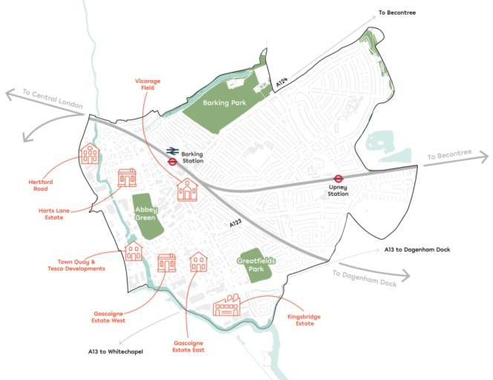  Policy SPP1  Barking Town Centre and the River Roding Transformation Area (as shown on the Policies Map)  Development Potential  63. In this area there is indicative capacity for 15,609 16,175 new homes in the Pplan period. Buildings that are up to 95 metres in height could be appropriate in the Tall Building Location, as shown on the Policies Map. The key site allocations are illustrated in Figure 7. Outside of the Tall Building Location, buildings in this area taller than 18m are not generally appropriate.  7. This policy allocates the following sites as identified on the Policies Map (with further details and requirements for individual sites available in the site proformas in Appendix 2 and in the Housing Trajectory in Appendix 4):  Site Ref Site Name Indicative Net Minimum Capacity  Housing and Housing-Led Mixed Use Allocations  AO Mellish Close Garages 6  AJ Gascoigne Estate East 1,943  AK Vicarage Field 900  AL Gascoigne Estate West 850  AM Crown House and Linton Road Car Park 396  AV Abbey Sports Centre 170  BB Tesco Car Park 1,500  BO Elim Pentecostal Church 194 9  BZ 174-176 Ripple Road 8  CD Former site of White Horse Public House and Omnibus Park, North Street 196  CM Gascoigne Industrial Area 2,296  CP Sebastian Court 30  CY Artist Housing, Linton Road 12  DG Bamford Road 98  DJ Clockhouse Avenue 250  DO Town Quay 138  DP Former Abbey Retail Park 1,089  EA Barking Station 1,193  HA Wickes (Hertford Road) 899  HL Hapag-Lloyd House at 48A Cambridge Road in Barking Town Centre 75  HM Old Granary 6  HN Ripple Road and Methodist Church 252  HO 14-34 London Road 29  HQ Town Quay Wharf 147  HY Street Record Margaret Bondfield Avenue 15  HZ Hertford Road Industrial Estate 957  WD Former Victoria Public House, Axe Street, Barking 26  XC Harts Lane Estate 1,301  XD 38-64 (Even) Southwold Drive 108  XQ Former Volunteer Public House, Alfred’s Way 112  YA IBIS Barking, Highbridge Road, Barking 136  YG Garages at Kier Hardy Way 23  YM Phoenix House, 12-14 Wakering Road, Barking 188  YO Barking Foyer 134  ZO Cambridge House 117  Economic Sites  E022 Kingsbridge Estate 63,071sq.m (floorspace)  84. To deliver our vision, (see figure 6) development proposals should be consistent with the principles listed below.  a) Planning for a comprehensive mixed-use development of retail, cultural and community uses alongside office and residential development. This will be supported by a broad range of social infrastructure, including schools, childcare facilities, heath services, places of worship, libraries, youth facilities, sport and leisure facilities, all of which contribute to the quality of life and well-being of the population.  b) Renewal of the Barking Station by working with the rail industry to upgrade access and capacity in line with Network Rail’s increased passenger projections¹⁹.  c) Any proposed buildings taller than prevailing heights must recognise the historic quality of the existing environment and local character and respond appropriately to realise the potential to increase its capacity and provide a fitting gateway to the town centre and the borough as a whole.  d) Conserving and enhancing heritage and cultural assets, having regard to the Council’s latest guidance on Barking Town Centre and Abbey Conservation Area. Development proposals must conserve or enhance the significance, including any contribution to that significance by its setting, of Barking Abbey, a scheduled monument.  e) Working with existing operators to retain and develop Barking’s street markets role as a commercial and community offer area in their current location.  f) Continued improvements to the public realm between key buildings, the introduction of urban greening and the creation of a lively street culture and safe environment in East Street, reinforcing the role of this area as an important social asset for the borough.  g) Continued improvements to the public realm around Barking Station, addressing anti-social behaviour, including trials to make the Station Parade area safer with pedestrian, taxi and bus only. Improving public transport and cycle access to the town centre, and promoting car-free developments near the station.  h) Reducing the perceived separation between the High Street, Abbey Green and the River Roding, repositioning Town Quay and Abbey Green as a focal point of the Town Centre and strengthening pedestrian and cycle routes and way-finding in the entire area, opening up access to and attracting visitors to the River Roding.  i) Promoting further measures to improve access across the Town Centre, in line with the Barking Town Centre Movement Strategy.  Gascoigne Estate  95. The emerging Gascoigne ‘Big Picture Neighbourhood Strategy’²⁰ is under development and will includes design principles to support implementation of this policy in a co-ordinated and comprehensive fashion. Development proposals should be consistent with the principles listed below.  - Locating community buildings in strategic places to create points of attraction and more active street frontages.  - Restoring the historic grid pattern in Gascoigne Estate through more legible connections and fine grain permeability that allows ease of movement and creates a more walkable environment.  - Establishing a clearly defined hierarchy of public, private and semi-private outdoor spaces, which are tailored to fit well in the context of the fine grain permeability and promotes activity and play.  - Enhancing biodiversity value throughout the area, including tree planting in appropriate locations and retention of the existing London Plane trees that line and characterise Abbey Road.  - Deliver an integrated nature-based blue and green strategy, providing flood mitigation and adaptation measures to comply with the Local Plan policy Policies DMNE4 and DMSI 6.  - Creation of new high-quality places through a clearly defined hierarchy of spaces, homes and articulated architecture to strengthen the identity of the place; the massing and typology should be varied across the site to allow for a different silhouette and scale depending on view.  Harts Lane Estate, Hertford Road Industrial Estate and Wickes  106. Development proposals should be consistent with the principles listed below.  - Planning for a comprehensive mixed-use development of commercial and community uses alongside residential development. This will be supported by a broad range of social infrastructure, including schools, open spaces, community centres, health care facilities, places of worship and a new river crossing.  - Deliver high quality design, amenity space and improvements to the public realm by working collaboratively with other developers and landowners from adjacent sites to form a north-south link along the river path.  - The scale and massing of development should contribute to the creation of a new coherent townscape which responds positively to its existing and emerging context.  - Provide riverside towers and gateway blocks facing the Northern Relief Road (A124).  - Create a green link at the heart of Harts Lane to link the River Roding to Barking Park with new civic space on the river front.  - Create a new legible hierarchy of pedestrian, vehicular and cycle routes into the existing fabric to connect the neighbourhood with an additional access from the Northern Relief Road (A124).  - Create a new pedestrian bridge across the River Roding to link the sites together and improve accessibility.  h) Include a new green pedestrian link over rail to Barking Park towards the east.  hi) Enhancement of existing social infrastructure including an opportunity to expand existing schools.  Vicarage Field Shopping Centre  117. Development proposals should be consistent with the principles listed below.  - Work collaboratively with key stakeholders to improve and transform the site as an important gateway opposite Barking Train Station, enhancing the immediate environment and create creating new housing and employment opportunities.  - Deliver co-ordinated and comprehensive redevelopment of the Shopping Centre as a high-quality and high-density mixed-use development, which responds to the existing built form.  - Contribute to the vitality of the centre and reinstate it as a natural part of the pedestrian network with new routes connecting with existing streets and movement patterns.  8. The preparation of a Masterplan SPD is anticipated for Barking Town Centre (including Barking Station, East Street, Town Quay and Harts Lane). The emerging Gascoigne ‘Big Picture Neighbourhood Strategy’ is also under development and will include design principles to support the implementation of this policy where it relates to the Gascoigne Estate.  129. Development within this area is to come forward in accordance with the relevant approved Masterplan SPDs and Neighbourhood Strategies and p Proposals will be expected to demonstrate how they deliver comprehensive and co-ordinated redevelopment in accordance with Area Policy SPP1 and have regard to any relevant supplementary planning document and Neighbourhood Strategies for the area these documents. Development proposals should include a statement setting out how they align with the strategy for the area.  10. Proposals for piecemeal development which may undermine the delivery or viability of the comprehensive and co-ordinated redevelopment of these areas in accordance with the approved Masterplan SPDs or Neighbourhood Strategies will not be supported  18Barking Town Centre Regeneration Strategy 2020-2030: https://yourcall.befirst.london/13753/widgets/39553/documents/21209  ¹⁹Essex Thameside Study: Railway investment choices (July 2020) https://www.networkrail.co.uk/wp-content/uploads/2021/02/Essex-Thameside-Study.pdf  ²⁰https://yourcall.befirst.london/2351/widgets/7850/documents/8191#:~:text=The%20strategy%20has%20been%20developed,socially%20and%20environmentally%20sustainable%20neighbourhood.
MM6 | SPP2 | AREA POLICY SPP2: Thames Riverside  Justification  1. Within the Thames Riverside Policy Area as identified on the Policies Map, oOur plan is to create one new integrated community, a whole new Thames side district of London with more homes and better industry in improved, intensified space. Masterplan led growth will deliver new integrated sustainable communities. The new rail and river connections will join Thames Riverside to Barking Ttown Ccentre and the rest of London. The A13 will be improved, and upgraded and, subject to funding and Government support, undergrounded to create one contiguous borough community.  2. Thames Road will be re-developed providing new homes alongside businesses and improving connectivity to Barking Riverside and other Transformation Areas and a new street network linking the rest of the borough to Barking Riverside. Castle Green will have its industrial uses reduced, intensified, improved and pushed to the periphery with new homes delivered as part of the overall area’s regeneration following the undergrounding of the A13. A new town centre will be born at the heart of Barking Riverside, anchored by culture, sustainability and life generating uses.  3. A recent study conducted by Homes England²¹ indicated that around 7,000 homes could come forward at Castle Green once the flyover had been replaced. The Council is also looking at the Castle Green area as a broader location for a future Gypsy and Traveller site to meet the borough’s remaining unmet Gypsy and Traveller pitch need for the Plan period. This is expected to come forward in the later part of the Plan period and will be identified in more detail in a subsequent review of the Plan and as part of future Masterplan work. Due to current land ownership, the Council is unable to bring forward a site here immediately, but is committed to doing so in the longer-term.  4. The business case for A13 improvements and the Castle Green Masterplan will be brought forward over the next two years. This is supported by the evidence in the Industrial Land Strategy (ILS) which identifies scope for releasing some industrial floorspace at Castle Green in the longer term. However, the ILS makes clear that such consideration is subject to the delivery of new transport links, a new station, and supporting social and green infrastructure.  5. The Masterplan SPDs for Castle Green and Thames Road Transformation Areas will provide further details and policy guidance on the implementation of an employment use intensification and co-location strategy in these Transformation Areas.  6. This area falls within the London Riverside Opportunity Area where building heights of up to 50 metres may be appropriate.  Delete Figures 8 and 9 and replace with new Figure 7 as follows:  Figure 7. Illustrative Locations of Larger Scale Development within the ‘Thames Riverside’ Sub-Area  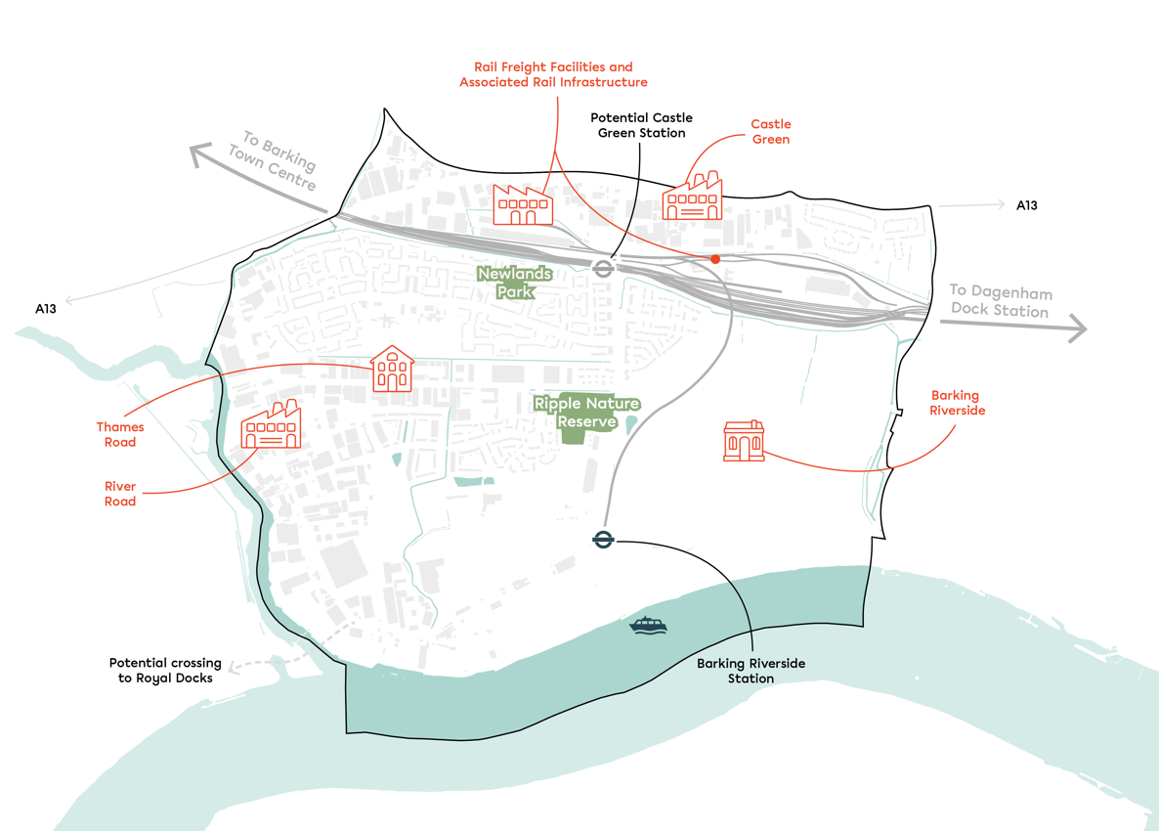  Policy SPP2  Development potential  73. In this area there is indicative capacity for 14,294 15,619 new homes and approximately 119,260 288,866 sqm additional of industrial floorspace in the Pplan period. Buildings up to 50 metres in height could be appropriate in this area. The key site allocations are illustrated in Figure 9.  8. This policy allocates the following sites as identified on the Policies Map (with further details and requirements for individual sites available in the site proformas in Appendix 2 and in the Housing Trajectory in Appendix 4):  Site Ref Site Name Indicative Net Minimum Capacity  Housing and Housing-Led Mixed Use Site Allocations  AA Barking Riverside 11,162  CE Site of Old Thames View Clinic, Bastable Avenue 50  CI Thames Road 2,000  CS Sugden Way 13  CT Former Wivenhoe Garages, Wivenhoe Rd, Barking 7  DI Roxwell Road (53-135) 46  DY Chelmer Estate 28  XK Riverside Gateway 538  Economic Site Allocations  E027 Welbeck House/Welbeck Wharf 15,328 sq.m (floorspace)  E029 Thames Road Economic Use 38,461 sq.m (floorspace)  E058 River Road Not specified, but <51,292 of the 121,477 sq.m wider River Road Area floorspace  E088 Unit A, Creek Road 11,362 sq.m (floorspace)  E089 72-76 Land to the Rear of River Road 433 sq.m (floorspace)  E090 Alfreds Way Industrial Estate 3,213 sq.m (floorspace)  CF Castle Green (include Box Lane site for integrity) * 375,219 sq.m (floorspace)  * Subject to the rights conditions coming forward (see policy SPP2), site CF-Castle Green would be suitable for new major housing development with capacity for around 7,000 homes. We estimate around 450 of these could come forward during the Plan being. Currently, the site is being retained as SIL, maintaining or increasing rail freight capacity across the rail sites within Castle Green..  9. The Castle Green Masterplan will also provide further details on how we intend to bring forward a Gypsy and Traveller site within the Castle Green area, including a more specific location and principles for site design, in line with Policy DMH 6. The monitoring of industrial land and any reprovision required will be key considerations and will require ongoing engagement with the GLA.  Barking Riverside Transformation Area (as shown on the Policies Map)  104. To deliver our vision (see Figure 8) development proposals should be consistent with the principles listed below.  a) A comprehensive and co-ordinated residential-led redevelopment of Barking Riverside, by working collaboratively with Barking Riverside Limited and Transport for London (TfL) to provide significant transport infrastructure including:  - the extension of London Overground services;  - the extension of Thames Clipper sServices;  - significant investment in bus services; and,  - on-site walking and cycling infrastructure; and  - potential river crossing with the London Borough of Bexley  b) Intensifying residential, commercial and leisure development in the new District Centre.  c) On-site social infrastructure projects that create capacity for additional new homes and accelerate delivery, enabling new primary school provision.  d) Sustainable places that create a new local identity and distinctive character within the area, each defined by location, density, form and materiality. Provide a sensitive design response to the riverside and focusing on higher density development and taller building forms within the new District Centre and elsewhere where appropriate.  e) Strengthening the relationship with the adjacent Transformation Areas to ensure a comprehensive and joined-up delivery approach, particularly for infrastructure schemes such as school provision.  f) A central boulevard to create a central spine through the area with a dedicated bus-only route.  g) High-quality, new open space across the entire site, divided between public parks and a more natural landscape.  h) East-west green links connecting existing green infrastructure assets and:  - linking Barking Riverside to River Road;  - removing physical and perceptual barriers between Barking Riverside and Thames View Estate; and,  - prioritising access to the Riverside by opening up 2km of riverfront to walkways and cycle ways.  i) High-quality design that reflects the 10 ‘Healthy New Town Principles’ in development.  Castle Green Transformation Area (as shown on the Policies Map)  115. Castle Green is an industrial area currently allocated as Strategic Industrial Land (SIL) but identified as a key Transformation Area to be developed during and beyond the Pplan period to deliver new local and regional benefits. Castle Green has potential to deliver a major new community with circa 7,000 10,000 new homes, new jobs, supported by community infrastructure and new green space. The eastern section contains the existing Euro-hub site with opportunities for enhanced rail/freight links from Europe and onward nationally across the UK by rail or road. Castle Green contains a substantial area of rail freight sites (Eurohub, Renwick Road Rail Terminal, Ripple Lane West Yard and Ripple Lane Stora sites), all with opportunities for intensification and future development building on their unique position with easy access to Europe and nationally.  126. Development is currently blighted by the existing A13 Lodge Avenue flyover (see below) which severs the borough, dividing communities. The borough is working with key stakeholders (Government, TfL and Homes England) to examine options to replace the flyover, which is no longer fit-for-purpose and a safety hazard. Plans include undergrounding the A13 to remove the physical severance, as part of a comprehensive masterplan solution benefiting Castle Green, the London Riverside Area and beyond with improved connections Studies have considered a variety of options to address the physical severance caused by the A13 and improve transport links to the south of the borough as part of a comprehensive masterplan solution benefiting Castle Green and the wider London Riverside Opportunity area.  137. The A13 undergrounding solution would be part of an overall transport vision for the area, including a new overground station at Castle Green and supported by additional public transport and cycling and walking links to create a new, sustainable community. The emerging conclusion from this work is that the most viable option is to proceed and replace the flyover with a new modern structure as part of new transport vision for the area, including a new improved junction at Lodge Avenue, new north-south green bridges to deal with the severance and the new Overground station at Renwick Road. This would form the centre of a new community built around sustainable housing, mixed industrial and rail freight logistics centres and new green space.  8.The business case for A13 improvements and the Castle Green Masterplan will be brought forward over the next two years. This is supported by the evidence in the Industrial Land Strategy which identifies scope for releasing some industrial floor space at Castle Green in the longer term. However, the ILS makes clear that such consideration is subject to the delivery of schemes to tunnel the A13 and a new station.  Amend title of image:  A13 Castle Green – new rail station and undergrounding green bridge over the A13  149. The Masterplan SPD for Castle Green will also identify key infrastructure requirements and accommodate the delivery and phasing of A13 improvement works necessary to provide suitable environmental conditions for residential use. Any proposals for the release of SIL or change of use within the Transformation Area is only to come forward in accordance with the approved Masterplan SPD and comprehensive delivery strategy as per Policy DME1 and London Plan 2021 Policy E7 and should have regard to the approved Masterplan SPD and comprehensive delivery strategy. Proposals for piecemeal development which may undermine the delivery or viability of the comprehensive and co-ordinated redevelopment in accordance with this approach will not be supported. There should be no loss of rail freight capacity within the Castle Green area. Any change of use or development of the rail lands therefore has to be agreed with Network Rail, relevant land-owners and the rail freight operator.  15. Acknowledging that the Eastbrookend Country Park site cannot fully meet the needs of the LBBD 2020 Gypsy and Traveller Need Assessment, the Council has also identified Castle Green as a broader location for a Gypsy and Traveller site in the future, as directed by the Council’s Cabinet in May 2022. This area has been identified as a broader suitable location as the plans for the delivery of Castle Green are at an early stage and it is considered that this would provide an opportunity to incorporate a future Traveller site into the area through the development of a Masterplan SPD. The scale of the site allows sufficient flexibility to ensure that a future traveller site has residential and acoustic privacy and does not impact on wider residential amenity. This will require further landowner engagement and feasibility work and will also require the release of SIL as part of a future Local Plan review.  16, The Castle Green Masterplan will provide further details on how we intend to bring forward a Gypsy and Traveller site within the Castle Green area, including a more specific location and principles for site design, in line with Policy DMH 6. The monitoring of industrial land and any reprovision required will be key considerations and will require ongoing engagement with the GLA.  Thames Road Transformation Area (as shown on the Policies Map)  17. To bring forward significant regeneration in the area including 2,000 new homes, an improved public realm and new social infrastructure, the Council is de-designating 14ha of land on Thames Road from SIL to Locally Significant Industrial Land (LSIS), and releasing 7.6ha of SIL on Thames Road for residential use. The new designations are reflected on the Policies Map.  1810. To deliver our vision, (see Figure 8) development proposals should be consistent with the following principles:  a) a thriving mixed-use neighbourhood characterised by a rich mix of industrial and commercial space alongside new homes, community uses, schools and open space, in accordance with having regard to the latest Masterplan SPD any relevant supplementary planning document for the area.  b) incorporate innovative typologies that intensify land use and maximise optimise site potential, including multistorey industrial and co-located industrial and residential uses  c) provide high quality, mixed tenure housing for local people and working Londoners with new homes and jobs near to and stitched together jobs, amenities and transport  d) create an improved streetscape and active frontages to industrial and commercial plots  e) deliver additional pocket squares and gardens high quality open spaces and green infrastructure to support new and existing communities, a new mixed-use centre, plant new trees and vertical greening to improve air quality and introduce new sustainable drainage systems  f) create a new legible identity identifty and sense of place for Thames Road whilst retaining its distinctive industrial character  g) promote sustainable modes of transport including car lite and car free principles  h) have full regard to the consented scheme at Barking Riverside and to engage with Barking Riverside Limited in the common interest of securing the benefits and comprehensive regeneration of the London Riverside and Strategic Opportunity Area (e.g., through attending the existing Barking Riverside Steering Group).  i) flood defences investment should focus on improved river frontage along the River Roding, realignment and landscaping along the River Thames  j) improved pedestrian and connectivity within and between the Transformation Areas through:  - establishing north-south green links including pedestrian and cycle links connecting Thames Road with the Ripple Greenway, Thames View, and Barking Riverside Phase 1 development and Barking Centre  - creation of a riverside walk along River Roding, with a pedestrian crossing at Mayesbrook and A13 underpass enhancements  - enhancements to pedestrian and cycle links between Thames Road, River Road and Barking Riverside to River Roding and Barking centre.  - establishing a new green link along the River Roding via Newham into Redbridge and to Wanstead flats  - in addition to the new station at Barking Riverside, which opened in planned for 2022, the area needs the planned second station at Castle Green to provide more public transport links.  k) The use of existing rail, maritime and river transport infrastructure should be maximised within the wider area and the Thames Estuary as a whole.  1911. The ILS identifies scope for areas of SIL Strategic Industrial Land in the Thames Road Transformation Area to become Local Significant Industrial Sites LSIS allowing for some further co-location development. However, any proposals for the release of SIL Strategic Industrial Land or change of use within the Transformation Area is only to come forward in accordance with Policy SPP2 (and having regard to any relevant supplementary planning document for the area), an approved Masterplan SPD and comprehensive delivery strategy, Policy DME1 and London Plan 2021 Policy E7.  12. The Masterplan SPDs for Castle Green and Thames Road Transformation Areas will provide further details and policy guidance on the implementation of an employment use intensification and co-location strategy in these Transformation Areas.  2013. Development proposals within the Masterplan SPD areas will be expected to demonstrate how they deliver comprehensive and co-ordinated redevelopment in accordance with the Masterplan SPD and accord with Area Policy SPP2 (and have regard to any relevant supplementary planning document for the area). Proposals for piecemeal development which may undermine the delivery or viability of the comprehensive and co-ordinated redevelopment of this area will not be supported. Development proposals should include a statement setting out how they align with the strategy for the area.  ²¹A13 Study and South Barking Vision (August 2023): https://yourcall.befirst.london/11324/widgets/38986/documents/46562
MM7 | SPP3 | AREA POLICY SPP3: Dagenham Dock and Freeport  Justification  1. Dagenham Dock is the borough’s economic heart. A home to the next generation of sustainable industries, London’s wholesale markets and the new Thames Freeport. International rail access provides unrivalled opportunity for investment and industrial intensification leading to more and better jobs. Ford’s 20th century car production will be encouraged to evolve into the 21st century sustainable industry, creating jobs and opportunity for the future.  2. New housing at Beam Park and the former Stamping Plant will bring thousands of new homes, supported by an improved public realm, sustainable transport modes and social infrastructure to create a cohesive new community. These new residential districts will be anchored by a motoring heritage attractor of regional significance.  3. A new rail station is planned at Beam Park to serve the new community there. The station is proposed to be sited on the London to Grays line operated by C2C, adjacent to Marsh way and New Road (A1306).  4. Funding for the delivery of the project is in place, with the GLA having committed £42 million to the project. However, the delivery of the station cannot progress until the DfT supports its adoption onto the wider network with a business case fully agreed. Additional demand modelling is currently in progress and a firm decision to commit to the station is due later in 2024.  Alternatives to Beam Park Station  5. The Council strongly supports the new station. However, if Beam Park Station is not secured, the developer will need to apply to lift the Grampian condition which would include discussions about potential alternative public transport provision.  6. If Beam Park Station were not to come forward, alternatives could include improved walking and cycling infrastructure, new pedestrian/cyclist bridges, and the use of bus connections. There are currently two main proposals for bus connections to Beam Park:  • A shuttle bus service between Beam Park and Rainham and Dagenham stations  • Improvements to existing bus routes.  7. The Thames Freeport is an economic zone connecting Ford’s Dagenham engine plant to the global ports at London Gateway and Tilbury, with an emphasis on introducing electric and autonomous vehicle technology. The Freeport will combine a customs zone with tax zone designed to incentivise and encourage new investment.  8. The Ford estate will diversify through reuse, redevelopment and intensification of industrial use with new businesses moving in. River connectivity will be improved and works undertaken to allow larger ships to access the wharves. The site also offers unrivalled international rail connectivity.  9. The Billingsgate & Smithfield markets are to relocate in 2028/29, with New Spitalfields to follow.  10. This area falls within the London Riverside Opportunity Area where building heights of up to 50 metres may be appropriate.  Delete Figures 10 and 11 and replace with new Figure 8 as follows:  Figure 8: Illustrative Locations of Larger Scale Development within the ‘Dagenham Dock and Freeport’ Sub-Area  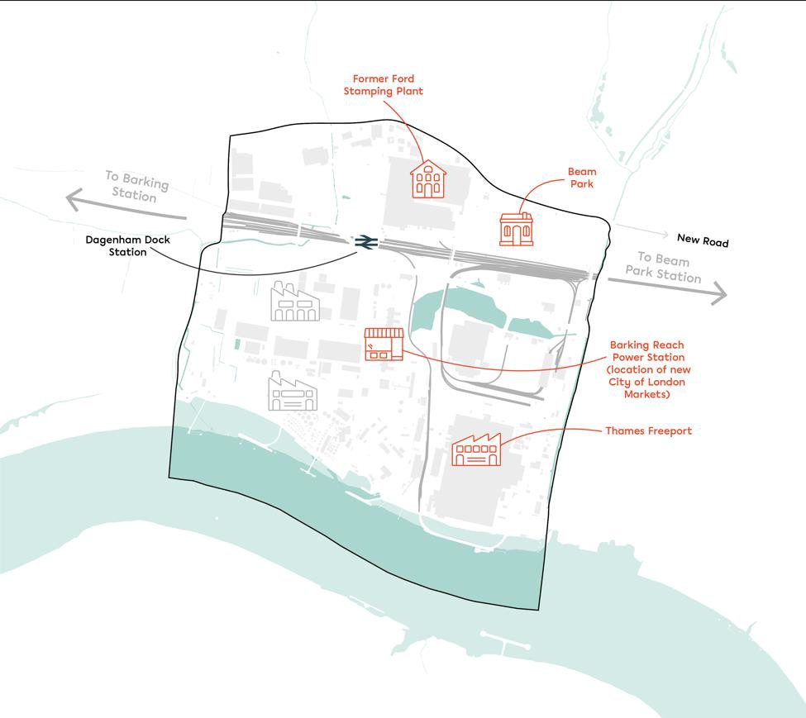  Development Potential  Policy SPP3  113. Within the Dagenham Dock and Freeport Policy Area as identified on the Policies Map, In this area there is indicative capacity for 7,240 6,011 new homes and approximately 647,636 776,852 sqm additional of industrial floorspace in the Pplan period. Buildings up to 50 metres in height could be appropriate in this area. The key site allocations are illustrated in Figure 10  Insert Table of Site Allocations below  12. This policy allocates the following sites as identified on the Policies Map (with further details and requirements for individual sites available in the site proformas in Appendix 2 and in the Housing Trajectory in Appendix 4):  Site Ref Site Name Indicative Net Minimum Capacity  Housing and Housing-Led Allocation  AC Merrielands Crescent Two 324  AE Beam Park (South Dagenham East) 3,119  WA Former Dagenham Job Centre Chequers Lane 90  XJ Former Ford Stamping Plant 3,000  ZZ GSR and Gill Sites, Land on the West side of Chequers Lane, Dagenham 707  Economic Allocation  E014 Barking Reach Power Station 237,946 sq.m 'Sui Generis'  E015 Plot 62 SEGRO Park Contributing to Dagenham Dock SIL 647,636 sq.m  E016 Plot 63 SEGRO Park Contributing to Dagenham Dock SIL 647,636 sq.m  E017 Plot 64 SEGRO Park Contributing to Dagenham Dock SIL 647,636 sq.m  E018 Plot 65 SEGRO Park Contributing to Dagenham Dock SIL 647,636 sq.m  E019 Plot 67 SEGRO Park Contributing to Dagenham Dock SIL 647,636 sq.m  E020 Plot 70 SEGRO Park Contributing to Dagenham Dock SIL 647,636 sq.m  E052 Dagenham Dock 647,636 sqm. (floorspace)  School Allocation  ED1 Polar Ford Special Education Needs School N/A  Dagenham Dock Transformation Area (as shown on the Policies Map)  134. To deliver our vision, (see Figure 10) development proposals should be consistent with the following principles:  a) enable redevelopment of the area, incorporating sustainable and green industries and building on the location’s logistics, food and energy operations  b) capitalise capitalising on the extensive road, rail and river infrastructure connections, which provide national and international connections, including a rail hub as part of the proposed Freeport  c) enable the expansion and intensification of employment floorspace enabling wider regeneration opportunities for the Thames Freeport in Dagenham (also see below)  dc) have having full regard to the consented scheme at Barking Riverside and to engage with Barking Riverside Limited in the common interest of securing the benefits and comprehensive regeneration of London Riverside and Strategic Opportunity Area (e.g., through attending the existing Barking Riverside Steering Group)  ed) align with plans for the successful relocation and co-location consolidation of London’s three wholesale city markets – Billingsgate, Smithfield and New Spitalfields, enabling development that will support its operation within the borough  e) expansion and intensification of employment floorspace enabling wider regeneration opportunity for the Thames Freeport in Dagenham (see also below)  f) enhance the supporting the development of existing rail, maritime and river transport infrastructure to be utilised within the wider area and the Thames Estuary as a whole  g) deliver a new secondary school to the north of the area, at the Ford Stamping Plant site; and a new primary school at the GSR & Gill site  h) strengthening links to Dagenham Dock Station with a clear hierarchy of movement routes through the site up to New Road. There will be a strong focus on improved visual connections, including new bus cycle walking links incorporating enhanced green infrastructure  i) improve improving road and bus links connectivity along Chequers Lane and Kent Avenue to improve access along and between to the Freeport and the City Markets  j) Remove the service bridge across Chequers Lane to improve the visual appearance in this area and public realm  k) the areas along the A13, railway line and the River Thames are particularly appropriate to building significantly taller than prevailing heights, subject to design quality.  5. The Council may also develop a vision plan for the south of the borough in order to set out how the Masterplan SPDs will integrate with each other and how the spaces between them will be managed.  Thames Freeport in Dagenham  6. The Thames Freeport is an economic zone connecting Ford’s Dagenham engine plant to the global ports at London Gateway and Tilbury, with an emphasis on introducing electric and autonomous vehicle technology. The Freeport will combine a customs zone with tax zone designed to incentivise and encourage new investment.  7. The Ford estate will diversify through reuse, redevelopment and intensification of industrial use with new businesses moving in. River connectivity will be improved and works undertaken to allow larger ships to access the wharves. The site also offers unrivalled international rail connectivity.  148. Development of an open access international intermodal rail terminal will be supported and any development proposals on the Ford site will need to demonstrate they do not prejudice the potential for delivery of such a rail terminal.  9. The Council may develop a vision plan for Dagenham Dock in order to set out how the Freeport will be delivered and integrated with the surround area.  Beam Park Transformation Area (as shown on the Policies Map)  1510. The Council will continue to support the comprehensive redevelopment of Beam Park by working collaboratively with the Greater London Authority, London Borough of Havering and other stakeholders to support development that contributes to the delivery of a thriving, mixed-use residential neighbourhood supported by health, education and other community infrastructure in line with the Council’s latest Infrastructure Delivery Plan. The Council will support development that delivers:  a) new affordable family homes with low rise housing terraces  b) two new primary schools and a new medical centre  c) a station square to provide a new retail and commercial focus to the area, integrated with the planned new transport interchange – Beam Park Station  d) new park and community meeting spaces in an open space and parkland setting to form a natural meeting place for the neighbourhood  e) new hierarchy of routes for safe connections within and between neighbourhoods; a street pattern provides wide shared footpaths and cycle routes  f) a landscape identity that creates clear wayfinding links to and from the park; visible verdant environments that can double for amenity and ecological value  g) a green corridor providing a pedestrian connection to the station and enhancements to the pedestrian and cycle network across the area  h) strengthen the relationship a strengthened relationship with adjacent land/areas, including Dagenham Dock and Castle Green Transformation Areas and Merrielands Crescent  i) provide flood mitigation and adaptation measures to comply with Local Plan Policies DME4 and DMSI 6.  Ford Stamping Plant  1611. The Council will support development in this location which:  - provides a comprehensive residential-led mixed-use development including flexible community and commercial floorspace  - provides new supportive social infrastructure including a 10-form intake secondary school, cultural facilities and open space  - creates a coherent townscape which responds positively to its existing and emerging context, including amenity space and improved public realm  - assists the integration of improved public transport links including new accessible bus stops and improved accessibility to Dagenham Dock station  e) creates an improved walking environment to allow access to employment sites, retail hubs and the proposed secondary school.  Merrielands  1712. The Council will support development in this location which:  - strengthens the relationship with adjacent land/areas including Merrielands Crescent One and the Transformation Areas at Beam Park and Dagenham Dock (as shown on the Policies Map)  - contributes to the creation of a new district centre for the wider area  - b) provides flood mitigation and adaptation measures in line with Local Plan policy Policies DMNE4 and DMSI6  d c) promotes sustainable modes of transport and incorporates car free and car lite principles.  GSR and Gill Sites  1813. The Council will support development in this location which:  a) delivers outstanding design and makes a positive contribution to the local character and neighbourhood  b) improves links with the site to the north and Stamping Plant and new public realm and accessibility to the station to the south as well as the roads to the north and west  c) delivers improvements to the overall quality of the greenway  d) through the scale and massing of development should contribute to the creation of a new coherent townscape which responds positively to its existing and emerging context  e) seeks to minimise car parking in the location with the delivery of car lite and car free principles developments in line with Policy DMT 2.  22 See 'Beam Park Station Topic Paper' for further background: https://yourcall.befirst.london/11324/widgets/38986/documents/46560
MM8 | SPP4 | AREA POLICY SPP4: Chadwell Heath and Marks Gate  Justification  1. Chadwell Heath is one of the biggest remaining regeneration opportunities at a Crossrail station. Within the Chadwell Heath and Marks Gate Policy Area as identified on the Policies Map, tThe industrial estate will be comprehensively redeveloped to create new homes as well as improved and intensified industrial space. This will see new homes stitched into the existing residential neighbourhoods, adding new services and social infrastructure, improvements to local transport and the renewal of the whole public realm.  2. North of Chadwell Heath, Marks Gate will be sensitively improved to deliver more and better homes with further work to review the existing flatted parts of the estate and improvements to wider infrastructure necessary for any further expansion, including the impact of the development of the neighbouring de-designated Green Belt land in Redbridge. The Council will work in partnership with the London Borough of Redbridge to ensure proposals complement housing development to the west of Marks Gate in terms of sustainable transport connections and community infrastructure.  3. Marks Gate will be a focus of estate renewal and improvements to community facilities through proactive consultation and engagement with the existing community. Further area specific guidance will be set out in a Masterplan.  43. Masterplan SPDs for the Chadwell Heath and Marks Gate Transformation Areas (as shown on the Policies Map) will provide further details and policy guidance to shape proposals for these Transformation Areas.  54. Development proposals will be expected to demonstrate how they deliver comprehensive and co-ordinated redevelopment in accordance with the relevant Masterplan SPD in accordance with Area Policy SPP4 and having regard to any supplement planning document for the area. Proposals for piecemeal development which may undermine the delivery or viability of the comprehensive and co-ordinated redevelopment of the area in accordance with the relevant Masterplan SPD will not be supported. Development proposals should include a statement setting out how they align with the strategy for the area.  6. In Tall Building Locations (as identified on the Policies Map), heights up to 50 metres may be appropriate. This is in line with other Tall Building Locations in the borough located outside of Barking Town Centre.  Delete Figures 12 and 13 and replace with new Figure 9 below:  Figure 9. Illustrative Locations of Larger Scale Development within the ‘Chadwell Heath and Marks Gate’ Sub-Area  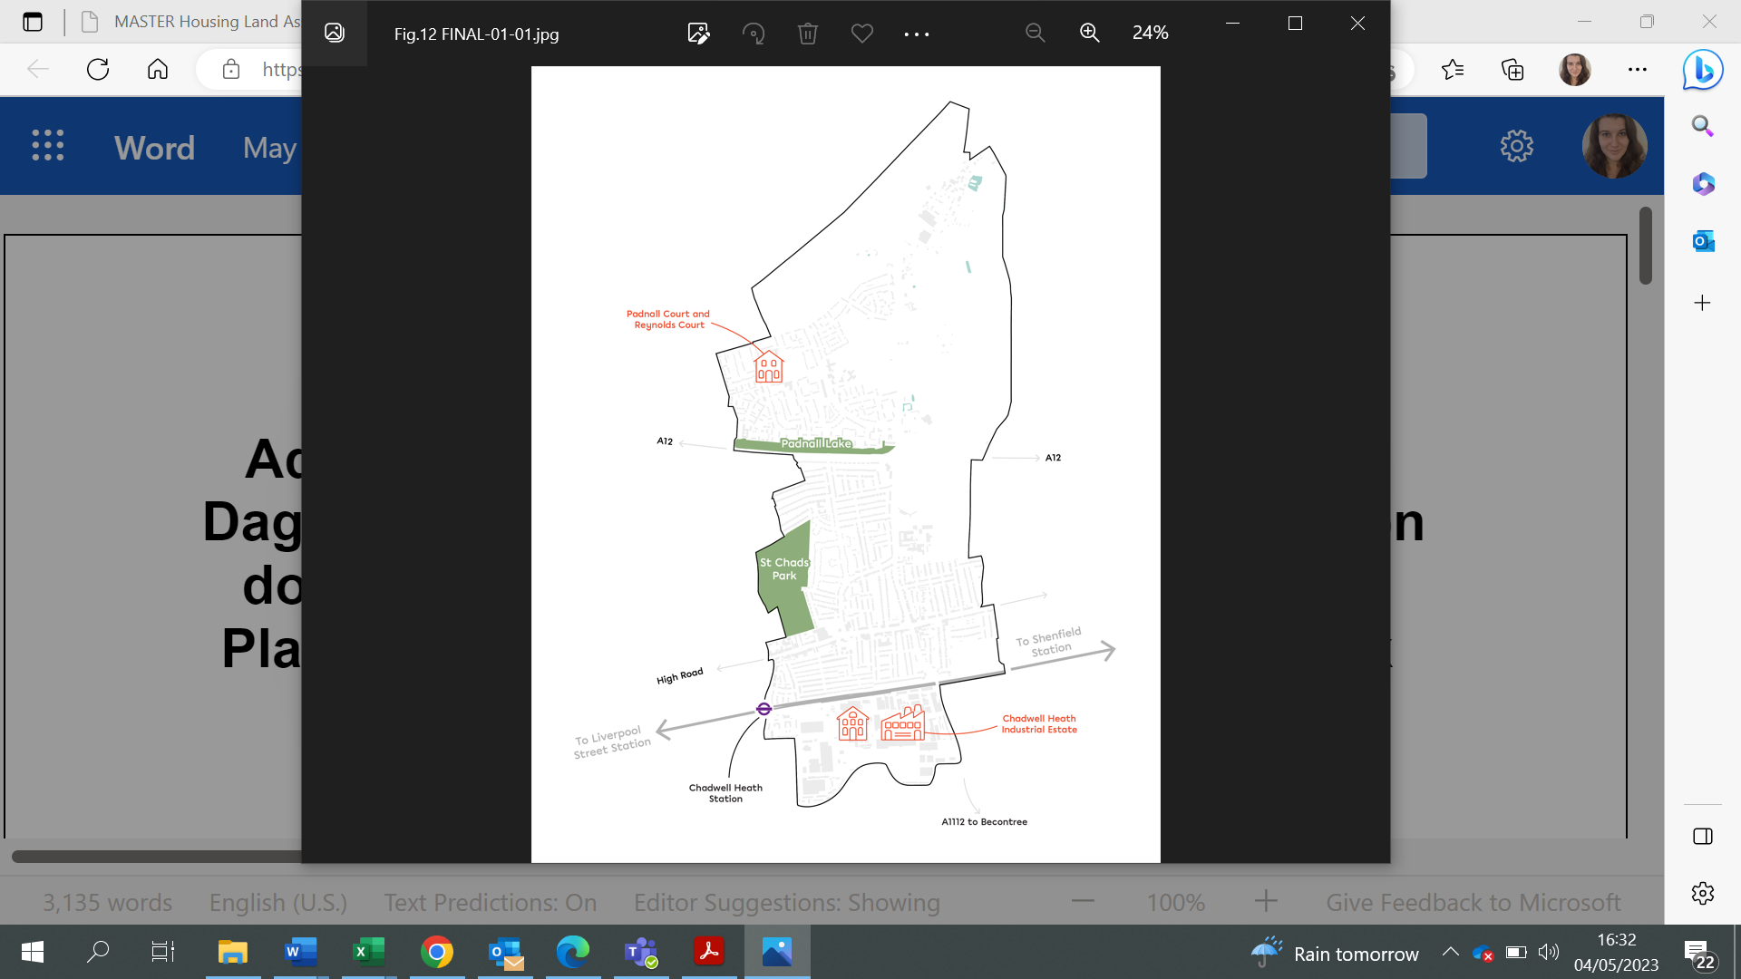  Development potential  Policy SPP4  75. In this area, there is indicative capacity for 4,750 4,839 new homes in the Pplan period. Within the Tall Building Location identified on the Policies Map, heights up to 50 metres may be appropriate. Outside of the Tall Building Location, development taller than 18 metres would not generally be appropriate due to the low density and sensitivity of the area. The key site allocations are illustrated in Figure 12. The redevelopment of the area is also a good opportunity to work collaboratively with the London Borough of Redbridge to discuss the opportunity for a potential public realm strategy.  Insert Table of Site Allocations as per the below  8. This policy allocates the following sites as identified on the Policies Map (with further details and requirements for individual sites available in the site proformas in Appendix 2 and in the Housing Trajectory in Appendix 4):  Site Ref Site Name Indicative Net Minimum Capacity  Housing and Housing-Led Allocations  AS Padnall Court and Reynolds Court 125  BG 26 And 28 Land to the Rear High Road 8  BR 3 Station Road 9  CH Chadwell Heath Industrial Estate 3,685  CO Padnall Lake 289  HS Former White Horse Pub, Chadwell Heath 104  HV 7, Apollo Housing 6  HW 31 -35 Mill Lane 9  WC Selinas Lane 150  WF 97-131 High Road 365  Economic Site Allocations  E051 Coopers Arms 697 sq.m (floorspace)  Chadwell Heath Transformation Area (as shown on the Policies Map)  96. Development proposals should be consistent with the following principles:  a) comprehensive delivery of a new liveable mixed-use neighbourhood is planned – optimising the development potential arising from Crossrail – to deliver new homes and jobs that are integrated with existing neighbourhoods  b) intensification and modernisation of industrial activities and integration of these with, potentially, new media, film and gaming uses as part of a mixed-use neighbourhood including residential. Innovative new typologies that enable the co-location of industrial and residential uses will be encouraged and supported in the appropriate locations  c) new homes supported by expanded social infrastructure, including two primary schools and one secondary school  d) development that is seamlessly woven into the surrounding context with an appropriate massing strategy that responds to the existing context and urban grain through focusing:  - focusing larger-scale development, including buildings significantly taller than prevailing heights scaling upwards to the heart of the area  - focusing smaller, lower-scale buildings on the perimeter to respond to the existing terraced housing  e) establishing a ‘sense of place’ and local identity through the creation of distinctive character areas across the neighbourhood, each defined by location, density, form and materiality  f) improvements to Freshwater Road and Selina’s Lane for vehicular access and public transport  g) improvements to the pedestrian environment and connections throughout the aArea, including markers for intuitive wayfinding and links into the existing surrounding neighbourhoods  h) improvements to the green infrastructure network, including a green spine through the area connected to a variety of public realm spaces including parks and squares which are pedestrian and cycle friendly and integrated with existing street and movement patterns  i) enhancement and refurbishment of buildings with local heritage value.  107. While the ILS identifies scope for the loss of industrial floor space in Chadwell Heath, The the Council is committed to delivering employment space alongside new homes and the expectation is that there will be no net loss of industrial floor space across the Chadwell Heath Transformation Area. Any release of Local Significant Industrial Land within the Transformation Area is only to come forward in accordance with Development proposals will be expected to demonstrate how they deliver a comprehensive and co-ordinated delivery strategy that accords with Area Policy SPP4 (having regard to any supplementary planning document for the area), the approved masterplan SPD, Policy DME1 and London Plan 2021 Policy E4. Development proposals should include a statement setting out how they align with the strategy for the area.  118. Proposals resulting in the net loss of industrial floorspace across the Transformation Area will only be supported in accordance with Policy DME1 of the Local Plan, and will be expected to robustly demonstrate why this is justified through, for example, reprovision elsewhere in the borough, a significant demonstrable uplift in the number and quality of jobs, and/or other significant material benefits that demonstrably meet the Council’s regeneration aspirations as set out in this Local Plan.  Marks Gate and Padnall Lake Transformation Area (as shown on the Policies Map)  9. Marks Gate will be a focus of estate renewal and improvements to community facilities through proactive consultation and engagement with the existing community.  1210. A vision masterplan document will be developed to inform the strategic vision for the area. Major development proposals should seek to contribute to the following objectives: which will seek to enhance the area through:  - delivery of improved sustainable transport connectivity to surrounding neighbourhoods and open spaces, including east west connections throughout Marks Gate, and in particular connections across the A12 and towards Chadwell Heath Sstation.  - enhancements to public realm, streetscape and open spaces, including maximising opportunities for greening to reflect the landscape character of the wider area.  - Improving emproving the vibrancy and facilities offered within the local centre.  11. Further area specific guidance will be set out in a Masterplan SPD if needed.  12. The Council will work in partnership with the London Borough of Redbridge to ensure proposals complement housing development to the west of Marks Gate in terms of sustainable transport connections and community infrastructure.  13. The Padnall and Reynolds Court and Padnall Hall site will be subject to estate renewal, seeking to:  a) enable delivery of new, high-quality homes with an improved public realm  b) improve sustainable transport links throughout the sites  c) provide supporting commercial and community uses.  14. The Padnall Lake site will behave a significant focus on placemaking activity to create a more liveable residential area. that Ddevelopment in this location must contribute to:  a) enabling delivery of more homes set in an improved public realm  b) reconfigured and better located open space that improves quality, access and function  c) providinge small-scale community uses  d) enhancing areas for wildlife and biodiversity around Padnall Lake as part of any future development masterplans.
MM9 | SPP5 | AREA POLICY SPP5: Dagenham East  Justification  1. Within the Dagenham East Policy Area as identified on the Policies Map, Dagenham East is now developing a new life as the centre of London’s ever-growing film sector. Other businesses are also beginning to wrap the film studio site including University College London’s transport research facility (PEARL), a tech business hub and the data industry. We will turn Dagenham East into a centre for modern media and research-based business.  2. We are seeking to reopen the adjoining mainline station to provide faster connections to central London and the Thurrock Freeports. We will develop the area around the station into a gateway to provide new homes and a hotel. In the wider area we will support future intensification of industrial uses and residential areas will be sensitively improved and enhanced, bringing village character to post war suburban development. This will provide more and better homes and a great place for people to live.  3. In Tall Building Locations (as identified on the Polices Map), heights up to 50 metres may be appropriate. This is in line with other Tall Building Locations in the borough located outside of Barking Town Centre.  Delete Figures 14 and 16 and replace with new Figure 10 as follows:  Figure 10. Illustrative Locations of Larger Scale Development within the ‘Dagenham East' Sub-Area  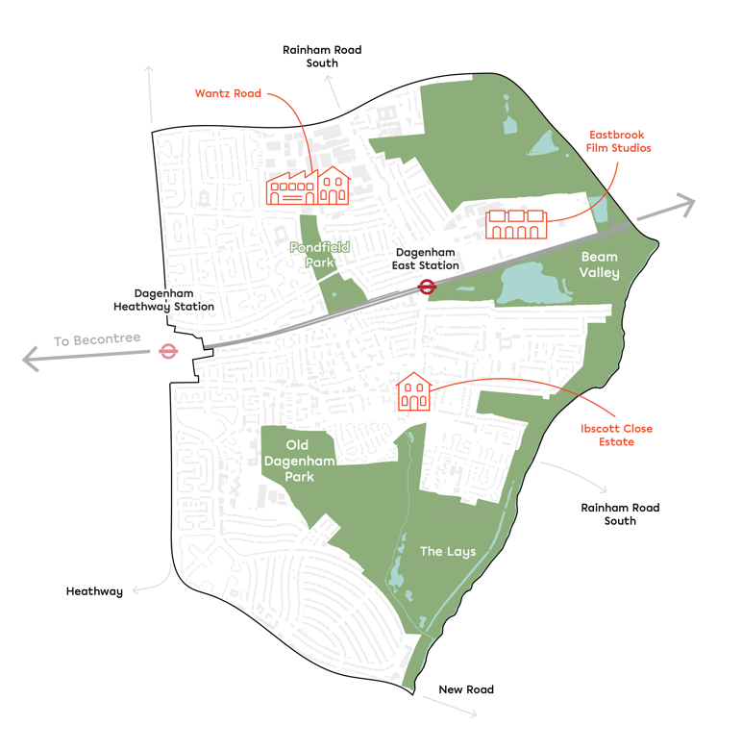  Policy SPP5  Development potential  4.3. In this area there is indicative capacity for 1,123 1,200 new homes and approximately 57,293 sqm additional industrial floorspace in the Pplan period. Within the Tall Building Location identified on the Policies Map, heights up to 50 metres may be appropriate. Outside of the Tall Building Location, development taller than 18 metres would not generally be appropriate due to the low density and sensitivity of the area. The key site allocations are illustrated in Figure 14  Insert Table of Site Allocations below  5. This policy allocates the following sites as identified on the Policies Map (with further details and requirements for individual sites available in the site proformas in Appendix 2 and in the Housing Trajectory in Appendix 4):  Site Ref Site Name Indicative Net Minimum Capacity  Housing and Housing-Led Allocations  BY Rear of 5-7 Reede Road 5  CX Salisbury Road (Car Park) 50  DF Wantz Road 63  DQ Dagenham Working Men's Club 20  DS Rainham Road South 43  WB 30 – 58 Durham Road, 475, 477 and 477A Rainham Road South, Dagenham 34  XE Ibscott Close Estate and highways land at Rainham Road South/Ballards Road 831  YC Royal British Legion 64  ZT 58 to 68 Church Street 13  Economic Allocations  E038 Here East and Film Studios 315,000 sq.m (floorspace)  E055 Dagenham East 60,761 sq.m (floorspace)  E059 Wantz Road 5,034 sq.m (floorspace)  School Allocation  RA Pondfield Special Educational Needs School N/A  Dagenham East Transformation Area (as shown on the Policies Map)  64. To deliver our vision, (see figure 14) Ddevelopment proposals should be consistent with the principles listed below.:  - A residential-led mixed-use development at Ibscott Close Estate and highways land at Rainham Road South/Ballards Road (site allocation XE) which should aim to deliver outstanding design and have regard to its local context, making a positive contribution to the local character and neighbourhood  - A new media, science and technology cluster is planned alongside the expanded development of new homes that are well integrated with existing residential neighbourhoods  - London’s newest and largest film studios on the former May and Baker site and surrounding ancillary uses  - Special education needs school provision  - Improvements to the environmental quality and public realm in the district centre  - Improvements to the Ggreen infrastructure network including:  - new Ggreen Iinfrastructure grid route – Wood Lane and Rainham Road North,  - Reede Road, Rainham Road and Foxlands Crescent, and  - linkages to Thames Chase Community Forest  - new Green Infrastructure grid route – Wood Lane and Rainham Road North  - Reede Road, Rainham Road and Foxlands Crescent  - linkages to Thames Chase Community Forest.  Dagenham Village  75. Dagenham Village is the historic heart of Dagenham, and the design will need to respond to this unique and sensitive development context. Development proposals must comply with the Llocal Pplan policies and have regard to the Dagenham Village Conservation Area Character Appraisal (or its updated equivalent) to preserve and where possible or enhance the borough’s historic environment.  86. The Council will support and enable the delivery of infrastructure to support communities in Dagenham East and Village to ensure development is sustainable. The Council will also support development that contributes to:  a) flood defences including measures to reduce flood risk at Dagenham East Station and numerous defence structures along the Wantz Stream  b) transport and connectivity improvements, including the new C2C station at Dagenham East and Dagenham East Station Accessibility Scheme  c) digital infrastructure enhancements including telecommunications and fast broadband  d) healthcare facilities (e.g. new primary care hub)  e) early years facilities  f) parks and open spaces  g) community centres and faith space  h) children’s play and youth facilities.
MM10 | SPP6 | AREA POLICY SPP6: Dagenham Heathway and Becontree  Justification  1. Dagenham Heathway is a popular district centre currently the borough’s second town centre despite its modest size, serving the wider Becontree area. Our plan is to reinvigorate the Heathway as the heart of the Becontree and Dagenham community, and build on its gateway connection on the District Line.  2. Within the Dagenham Heathway and Becontree Policy Area as identified on the Policies Map, we We will pursue the redevelopment of the shopping centre and make it fit for the 21st century, including options to provide new dwellings above the centre.  3. The historic Becontree Eestate will see the least development in the borough in order to protect its existing character. We will support light touch interventions to help it thrive into the future.  4. In Tall Building Locations (as identified on the Policies Map), heights up to 50 metres may be appropriate. This is in line with other Tall Building Locations in the borough located outside of Barking Town Centre.  5. A Masterplan for Dagenham Heathway is proposed and will provide further details to shape proposals for this part of the Transformation Area including the approach to the design and delivery of the required supporting infrastructure.  6. A Design Code is currently under development for the Becontree Estate. This will help preserve the area as a non-designated heritage asset.  Delete Figures 16 and 17 and replace with new Figure 11 as follows:  Figure 11. Illustrative Locations of Larger Scale Development within the ‘Dagenham Heathway and Becontree' Sub-Area  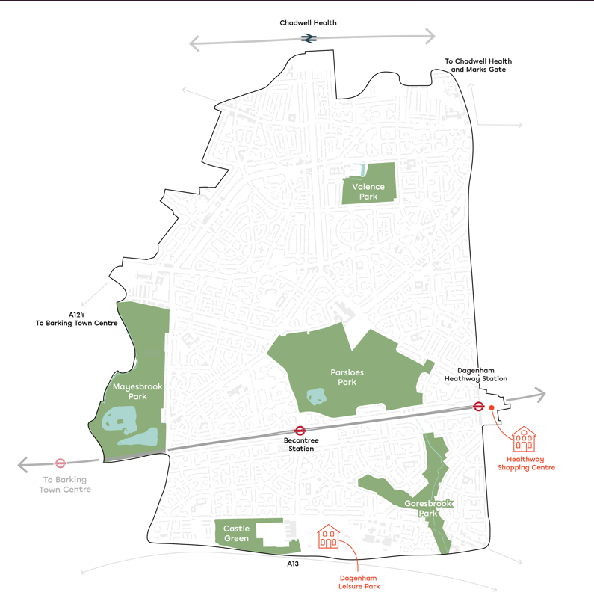  Development potential  Policy SPP6  74. In this area there is indicative capacity for 1,990 1,194 new homes in the Pplan period. Within the Tall Building Locations identified on the Policies Map, buildings up to 50 metres may be appropriate. Outside of these locations, developments over 18 metres would not generally be appropriate due to the low density and sensitivity of this area. The key site allocations are illustrated in Figure 17.  Insert Table of Site Allocations below  8. This policy allocates the following sites as identified on the Policies Map (with further details and requirements for individual sites available in the site proformas in Appendix 2 and in the Housing Trajectory in Appendix 4):  Site Ref Site Name Indicative Net Minimum Capacity  Housing and Housing-Led Allocations  AD Dagenham Leisure Park 600  BS St Marys Parish Church, Grafton Road 6  CV Land North of Becontree Station 49  DB Former Sacred Heart Convent 29  DM Dagenham Heathway Mall 860  DZ Dagenham Labour Hall 13  HT Dagenham Heathway Station 178  HU Land To Rear Of 127 -133 Becontree Avenue 8  SR 2-20 Seabrook Road and 1-27 Shipton Close 84  YS 2 Stamford Road and Woodward Road 56  ZB 497-515 Gale Street, Dagenham 31  ZN Brocklebank Lodge, Becontree Avenue, Dagenham 76  Economic Allocations  E005 79 Whalebone Lane South 1,488 sq.m (floorspace)  Dagenham Heathway Transformation Area (as shown on the Policies Map)  95. To deliver our vision (see figure 16) development proposals should be consistent with the following principles:  a) a comprehensive mixed-use redevelopment of Dagenham Heathway shopping centre to comprise of modern retail accommodation which better services the needs of local residents  b) ensure that the redevelopment of the shopping centre provides continuity of trade by encouraging the retention of retaining existing retailers in the new scheme  c) improved public realm and permeability of the shopping centre to provide a more accessible and pedestrian friendly environment  d) deliver a coordinated approach with the surrounding area, including incorporation of the Lidl store, and Iceland stores and BT locations  e) improvements to transport and connectivity, with new cycle lanes, improved bus priority and improved road junctions including Gale Street and Reede Road  f) Dagenham Heathway station access improvements  g) deliver outstanding design and have regard to its context, making a positive contribution to local character within its neighbourhood  h) minimise car parking in the location in line with Policy DMT 2 to create liveable or low-traffic neighbourhoods, with measures to improve safety, health and air quality.  Becontree Estate  10. 6. All development (including any extensions) must integrate with the existing character of the area and enable preservation and restoration of the historic fabric of the estate. A detailed design code is being may be prepared to support the delivery of the Local Plan to supplement this Ppolicy. The Council will also support development that contributes to:  a) inclusion of the urban ‘set pieces’ and street types that are unique to the area  b) improvements to the public realm, including regreening and tree planting, street furniture, signage and lighting  c) improvements to Parsloes Park including the expansion of sports facilities  d) rationalised car-parking and improved cycle links to the new Elizabeth Line connection Crossrail Station at Chadwell Heath  e) retention of small local shops and services unless applications are able to justify that they no longer meet a community need, services where they meet community needs  f) improvements to shopfronts and reintroducing reintroduction of awnings  g) improvement to the Ggreen infrastructure network, including the east-west green grid route (Porters Avenue and Parsloes Avenue)  h) improvements to transport and connectivity, including Becontree Station access improvements  i) creation of liveable or low-traffic neighbourhoods, with measures to improve safety, health and air quality including measures to reduce speeding and rat-running  j) digital iInfrastructure improvements e.g. fast broadband  k) early years facilities, primary and secondary school places  l) special education needs school provision  m) parks and open spaces  n) indoor and outdoor sports facilities  o) community centres and faith spaces  p) children’s play and youth facilities.  A Masterplan SPD for Dagenham Heathway is proposed and will provide further details and policy guidance to shape proposals for this part of the Transformation Area including the approach to the design and delivery of the required supporting infrastructure.  Development within the Masterplan SPD area is only to come forward in accordance with the adopted Masterplan SPD.  11. Development proposals will be expected to demonstrate how they deliver comprehensive and co-ordinated redevelopment in accordance and accord with Area Policy SPP6, having regard to any relevant supplementary planning document for the area. with the Masterplan SPD. Proposals for piecemeal development which may undermine the delivery or viability of the comprehensive and co-ordinated redevelopment of the area in accordance with the Masterplan SPD will be not be supported. Development proposals should include a statement setting out how they align with the strategy for the area.
MM11 | SPP7 | AREA POLICY SPP7: Becontree Heath and Rush Green  Justification  1. Becontree Heath is home to Coventry University London and provides a thriving community and commercial hub. Within the Becontree Heath and Rush Green Policy Area (as identified on the Policies Map), Tthis will be strengthened with spot redevelopment interventions delivered as part of a programme to identify opportunities to deliver more and better homes.  2. Becontree Heath is also home to the borough's only Gypsy and Traveller site. A small amount of Green Belt land is being released to allow for future delivery of a proposed extension to the current site to help meet the needs of our Gypsy and Traveller community (see also Policies DMH 6, SP 6 and DMNE 1).  3. This Plan makes provisions for the extension of the existing Gypsy and Traveller site (see 'Eastbrookend Country Park' proforma in Appendix 2). A total of 33 Gypsy and Traveller pitches are needed over the Plan period (as set out in DMH 6), with the extension at the Eastbrookend Country Park allocation catering to 12 of these pitches.  4. There are no Tall Building Locations in this area due to the low density of the area. This means buildings taller than 18 metres would not generally be appropriate.  Delete Figures 18 and 19.  Development potential  Policy SPP7  52. In this area there is indicative capacity for the development of 203 258 new homes and an additional 12 Gypsy and Traveller pitches. The key site allocations are illustrated in Figure 19. As there are no Tall Building Locations in this area, this means that buildings taller than 18 metres would not generally be appropriate.  Insert Table of Site Allocations below  6. This policy allocates the following sites as identified on the Policies Map (with further details and requirements for individual sites available in the site proformas in Appendix 2 and in the Housing Trajectory in Appendix 4):  Site Ref Site Name Indicative Net Minimum Capacity  Housing and Housing-Led Allocations  DH Oxlow Lane (previously 265-285 Rainham Road North) 46  CW 90 Stour Road 150  WE Fels Farm Dagenham Road Rush Green Romford 7  Gypsy and Traveler Site Accommodation  Eastbrookend Country Park Eastbrookend Country Park 12  73. The Council will support environmental and connectivity improvements across the area and build on the successful integration of Coventry University’s new campus by expanding education and other social infrastructure. The Council will also support development that contributes to:  a) smaller-scale development of new homes (including infill) that are well-integrated with the existing area  b) improvements to pedestrian routes through the area including strengthening east-west walking and cycle links  c) a continuous walking or cycling route, running through the green belt edge and waterways that follow the eastern edge through to Hainaut Country Park  d) restoration and improvements that preserve or reinstate original features in existing 1930’s suburban homes that are characteristic of the northern part of Rush Green  e) active ground floors in development that comes forward on Dagenham Road and public realm improvements throughout the area, in particular Rainham Road High and the area of Dagenham Civic Centre and other key points of interest in this area  f) improvements to the Green Infrastructure Network, including a new Ggreen Iinfrastructure grid route at Wood Lane and Rainham Road North and improved linkages to Thames Chase Community Forest  g) compensatory improvements to the remaining Green Belt Land in-line with Policy DMH 6.  84. Infrastructure that is required to support sustainable development, identified in the Infrastructure Delivery Plan will be supported, including:  a) transport and connectivity improvements, for example, Wood Lane roundabout  b) improvements to bus services and connections to ensure good public transport access  c) digital infrastructure improvements  d) fire and rescue service  e) early years facilities, primary and secondary schools  f) parks and open space  g) community centres and faith spaces  h) children’s play and youth facilities.
MM12 | Chapter 4 Justification Text | Chapter 4: Design  Justification Introduction  4.1. The purpose of this chapter is to set out clear design policies for creating well-designed places in the borough. The following defines our approach.  - We promote high quality design as an essential part of the transformation of our town centres, transport stations and development sites.  - We require new developments to respect and enhance the existing urban fabric (including existing cultural and heritage assets), strengthen and reinforce local identity, and foster a sense of place.  - We will sustainably manage the historic environment within the borough. This includes conservation areas, designated and non-designated heritage assets and local views.  - We are committed to improving our residents’ health and well-being by creating safe, convenient, accessible and well-designed built environments, interesting public spaces, and social and green infrastructure.  - We will encourage community participation and social inclusion in line with the Healthy New Town Principles.  - We help applicants provide high-quality design developments by using masterplans, design codes and local design guidelines, along with pre-application advice.  - We encourage applicants to undertake proactive meaningful public consultations with the local community and potential end users to inform design in advance of submitting a planning application.  Tall Buildings  - The Council has ambitious proposals for regeneration within the borough and the delivery of high-quality tall buildings will be a core part of the strategy to revitalise and renew areas for the benefit of local residents. The main driver for any tall building will therefore be quality, in terms of high-quality design, how it relates to its surroundings and the benefits it will bring for local communities as well as internally for those living and working within it.  - We encourage the optimising of density. In Barking Town Centre, appropriate height for developments coming forward within the Tall Building Location has been determined considering the heights of developments already in the area. We therefore have assessed that buildings up to 95m may be appropriate. However, in certain parts of the Tall Building Location in SPP1, heights of up to 50m may be more appropriate to mitigate the impacts on cultural assets views, such as the views of Barking Abbey, or to align with the character of the area, where the surrounding developments are a much smaller scale (e.g., terraced housing nearer to Becontree).  - This Plan uses the London Plan 2021 definition of tall buildings, and in areas outside of Tall Building Locations, the Plan uses the minimum tall building height of 18m set out in the London Plan 2021.  - Tall Building Locations have been targeted at the areas of the borough expecting to undergo the most transformation through significant increases in density. These are Barking Town Centre, Dagenham Heathway, Chadwell Heath, the Thames Riverside SPP area and the Dagenham Dock and Freeport SPP area. The latter, along with parts of Barking Town Centre and the River Roding SPP area, also form part of the London Riverside Opportunity Area where heights of up to 50 metres may be appropriate. For the relevant Tall Building Locations appropriate heights in each area, see the relevant SPP Strategic Area Policy.  - Development proposals for buildings taller than the appropriate heights set out in each SPP area policy will be considered on a case-by-case basis taking into consideration the criteria set out in Policy DMD 2 for Tall Buildings.  Replace Figure 20 with new figure 12 below and move to justification text section:  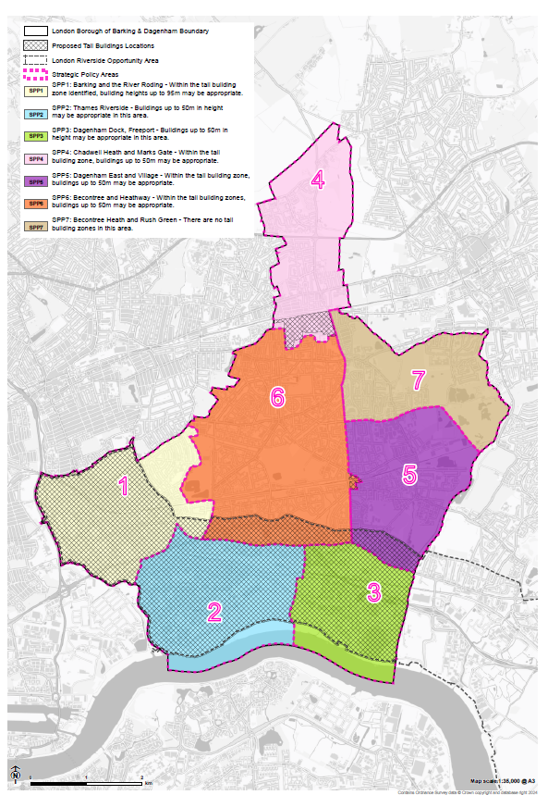  Town Centres  - Policy DMD 3 focuses solely on development within town centres. Town centres, for the purposes of DMD 3, encompass the Town Centre, District Centre and Neighbourhood Centre designations. The Town Centre hierarchy can be found in Policy DME 3.  Advertisements  - The Town and Country Planning (Control of Advertisements) (England) Regulations 2017 (as amended) sets out the different classes of advertisements and groups according to whether they require consent. Advertisements that do not fall into one of the classes in Schedule 1 or Schedule 3 of the regulations will need to be subject to an application for consent from the Council.  - An excessive amount of signage can lead to visual clutter in the street scene and negatively impact on visual, amenity and public safety.  - Free-standing signs, such as ‘A” boards on the public highway (which includes the pavement) will require a separate consent under the Highways Act for any temporary or permanent obstruction on the highway.  4.2. This chapter outlines the following policies:  Policy SP 2: Delivering a well-designed, high-quality and resilient built environment  Policy DMD 1: Securing high-quality design  Policy DMD 2: Tall buildings  Policy DMD 3: Development in town centres  Policy DMD 4: Heritage assets and archaeological remains  Policy DMD 5: Local views  Policy DMD 5 6: Householder extensions and alterations  Policy DMD 6 7: Advertisements and signage  4.3. The policies are mainly supported by the key evidence set out in the table below:  Key evidence documents Date produced  LBBD Townscape and Socioeconomic Characterisation Study 2017  Abbey and Barking Town Centre Conservation Area Appraisal and Management Plan 2020  Historic England’s Independent Heritage Review of the Industrial Land to the South of the Borough 2016  Historic England’s Independent Archaeological Review of the Borough 2016  Historic England Tall Buildings Advice Note 4 2015  Heritage Strategy 2016-2020 2016  Barking Town Centre Strategy 2020
MM13 | SP 2 | STRATEGIC POLICY SP 2: Delivering a high-quality designed and resilient built environment  1. The Council will promote high-quality design, providing safe, convenient, accessible and healthy inclusive developments and interesting public spaces for all through:  a) adopting a design-led approach to optimising density and site potential by responding sensitively to local distinctiveness  b) ensuring that developments relate to their local context, incorporating and interpreting local character and, where applicable, using this to inform detail, materials and landscape, which will reinvent the borough as a distinctive place in its own right  c) ensuring developments create well-designed homes that are accessible and flexible enough to accommodate different ways of living and respond to social infrastructure needs over time  d) supporting development that aims to create attractive, engaging spaces which are more likely to be well-used and resilient for the future  e) supporting development that improves and facilitates active lifestyles, and improves the wellbeing of new and existing communities  f) supporting development that harnesses the potential for improved quality and innovative Modern Methods of Construction (MMC), and adheres to the Local Plan policy Policy DMSI 1: sustainable design and construction  g) adopting the Circular Economy principles in the design of developments, demonstrating actions taken to reduce resource use and embodied carbon throughout the building lifecycle and aiming to achieve net zero-waste. A Circular Economy Statement should be submitted with referrable planning applications, in line with the principles and requirements of the London Plan 2021 Policy SI 7: reducing waste and supporting the circular economy  h) preserving or enhancing the borough’s heritage such as Eastbury Manor House, Valence House Museum, the Abbey Ruins and Dagenham Village, as well as conservation areas, and both designated and non-designated heritage assets in accordance with the Local Plan policy Policy DMD 4: visitor accommodation Heritage assets and archaeological remains.  i)protecting important identified views and vistas within the borough in accordance with the Local Plan policy DMD5: local views.
MM14 | DMD 1 | POLICY DMD 1: Securing high-quality design  1. The Council will support development proposals that make a positive contribution to the character of the surrounding area, have regard to the National Design Guide and/or its updated equivalent, design codes developed in accordance with the National Model Design Code and other local guidance.  2. All development proposals should expect will be expected:  a) where appropriate, to be required to use mechanisms such as Section 106 agreements and planning conditions, to ensure that design quality is carried through into the detailed design and construction of the development. Amendments to the design of major applications may be subject to appropriate Section 106 monitoring contributions if the original architects or landscape architects are not retained for the detailed design stage  b) where appropriate, to demonstrate high-quality design and to work as a result of early engagement with Planning Officers and, where recommended, with the Barking and Dagenham Quality Review Panel (QRP)²⁰²³ in accordance with its Terms of Reference, or its equivalent  c) where appropriate, to enable active lifestyle by designing for walkable neighbourhoods with attractive public realm and supporting infrastructure for walking and cycling²¹²⁴, taking inspiration from Barking Riverside, London’s first healthy new town²²²⁵; and Active Design Principles and guidance²³²⁶ (or its updated equivalent)  d) to be creative and innovative, recognising that existing local character and accommodating change is not mutually exclusive. Architecture should be responsive, inclusive, authentic, engaging, and have an enduring appeal  e) to seek to maximise opportunities for urban greening and biodiversity, and demonstrate that appropriate measures have been taken to protect or enhance the natural environment in accordance with Local Plan pPolicies: DME 2: providing flexible, affordable workspace and DME 3: encouraging vibrant, resilient and characterful town centres  f) to consider the impact on the amenity of neighbouring properties  g) to take a coordinated approach to development by respecting existing site constraints including utilities situated within sites  hg) to assess how development may affect a site’s archaeology in accordance with the using the required Archaeological Priority Areas Appraisal (or its updated equivalent) and best practice guidance²⁴²⁷ to explore archaeological heritage as a cue for design, interpretation and presentation opportunities in a successful design of a development proposal  ih) to demonstrate how avoidance or minimisation of harm to the local character, and setting heritage assets and their heritage significance, as well as to broader townscape character has been achieved through design and or mitigation; and agree appropriate mitigation with Planning the Council Officers.  3. Major and strategic development proposals (including estate regeneration schemes) should must:  a) provide a Health Impact Assessment (HIA) in the design process to identify opportunities for maximising potential health gains, minimising harm, and addressing health inequalities and detail the measures taken to achieve these  b) clearly demonstrate consideration of the individual and cumulative impact on amenity, neighbouring buildings, skyline, infrastructure and the natural and historic environments, provision of public realm and amenity space (private, communal and child play space)  c) provide a range and mix of publicly accessible open spaces that promote biodiversity, safety, health and well-being. Where on site contributions cannot be delivered, a financial contribution towards off-site provision of infrastructure elsewhere or a commuted sum may be accepted, to be determined in discussion with the Council  d) seek to achieve the highest standards of construction (e.g. MMC), and adhere to the Local Plan policy Policy DMSI 1: sustainable design and construction.  2320For details, please visit: https://www.lbbd.gov.uk/quality-review-panel https://www.lbbd.gov.uk/planning-building-control-and-local-land-charges/planning-guidance-and-policies/quality-review  2421Please refer to the Council’s latest walking and cycling strategy for information: https://www.lbbd.gov.uk/planning-guidance-and-policies  2522The 10 Healthy New Town Principles are available at: https://www.england.nhs.uk/ourwork/ innovation/healthy-new-towns/  2623https://www.sportengland.org/how-we-can-help/facilities-and-planning/design-and-costguidance/active-design https://www.sportengland.org/guidance-and-support/facilities-and-planning/design-and-cost-guidance/active-design  2724London Borough of Barking and Dagenham Archaeological Priority Areas Appraisal (July 2016), Historic England is available at: https://historicengland.org.uk/content/docs/planning/apa-barking-and-dagenham-pdf/
MM15 | DMD 2 | POLICY DMD 2: Tall buildings  1.Unless otherwise specified in localised Masterplan SPDs, Tall Buildings in the borough, are buildings that are taller than six storeys (or 18 metres) measured from ground to the floor level of the uppermost storey, as defined in Policy D9 of the London Plan 2021. The area specific policies define appropriate building heights for their respective areas, with SPP1-SPP6 having Tall Building Locations within them (as shown on the Policies Map).  2. Development of tTall bBuildings will be directed towards appropriate Tall Building Locations (as shown on the Policies Map and Figure 20 below) and must accord with latest relevant national policy guidance, London Plan policies and relevant policies within Chapter 3 of the Local Plan.  3. Any proposals that include Tall Buildings will be assessed on their own merits and will need to respond appropriately to identified sensitive locations including natural and built heritage assets.  4. Developments that include Tall Buildings must demonstrate how they:  a) will deliver benefits for the surrounding area and communities, including delivering high quality and accessible public ream realm, as well as promoting legibility and wayfinding; and  b) will create mixed and integrated communities and aim to appear “tenure blind”  c) do not constrain development potential on adjoining sites including sites within adjoining boroughs. Specific consideration should be given to the impacts on the amenity of existing residential neighbourhoods and publicly accessible and private open spaces.  d) Incorporate mitigation measures to help prevent suicide and accidental falls for example anti-climb methods, fences, barriers and rails. These will be well designed and should be integrated into the overall design of the building  e) address visual impacts of Tall Buildings, consistent with Policy D9 Tall Buildings of the London Plan 2021.  5. Development proposals that include Tall Buildings should be supported by:  - an appropriate townscape analysis (including verified views to demonstrate how they positively contribute to the skyline) and must involve an assessment of impact upon the significance (including setting) of nearby heritage assets which demonstrates how any adverse impacts have been addressed, and  - a compatible modelling tool in agreement with the Council, which provides an accurate visual representation of what the change will look like, and the cumulative effect for the borough and surrounding areas.
MM16 | DMD 3 | POLICY DMD 3: Development in town centres  1. Proposals for development within town centres (designated boundaries are as defined shown on the Policies Map) should, where relevant and appropriate:  a) respect the building lines of the existing urban environment and, where appropriate, build up to the edge of the curtilage  b) co-ordinate and consolidate elements of street furniture, such as seating, bins, bollards, cycle stands and lighting, to streamline the appearance of the public realm and avoid visual clutter  c) avoid the creation of inactive frontages and contribute positively to the street scene and public realm to coordinate the design of development around town centres consider street widths, crossings locations; integration of bus stands along with other public realm elements (as mentioned in b) above) and focus on reducing vehicle dominance along with promoting a safe walking and cycling environment  d) provide clearly defined public and private space, placing servicing away from street frontages, for example at the rear of the building  - provide level access and ensure new development is fully accessible.  2. New or replacement shop fronts are required to be robust and well-designed. Proposals must ensure that:  a) they retain or restore traditional shop fronts and existing architectural and heritage features  b) active shop fronts are well maintained in order to contribute positively to the building, street-scene and public realm  c) a sensitive relationship is maintained between the shop front and the upper floors, with neighbouring shop fronts and surrounding buildings  d) the use of materials is appropriate to and enhances the local character and value of existing architectural and historic features  e) the use of external mounted shutters or solid roller shutters are avoided.  3. Development outside town centres is set out in the Local Plan policy DME 3: encouraging vibrant, resilient and characterful town centres.
MM17 | DMD 4 | POLICY DMD 4: Heritage assets and archaeological remains  1. The borough’s designated and non-designated heritage assets²⁵²⁸, conservation areas and Archaeological Priority Area (APA) are identified on the Policies Map.  2. Other heritage assets and the wider historic environment will be identified, celebrated and promoted where relevant through the Council’s heritage strategy²⁶²⁹ (or its updated equivalent).  3. The Council will seek to ensure that new development sustains and enhances the significance of the borough’s historic environment, taking takes into account the wider social, cultural, economic and environmental benefits that the historic environment can bring. Developments should make a positive contribution to local character and distinctiveness while recognising the role of the historic environment to the character of the place.  Heritage assets  4. Development proposals affecting designated and non-designated heritage assets of local significance³⁰ importance should, where appropriate: will be granted provided they:  a) describe the significance of any heritage assets affected and set out how the application accords with the latest relevant national guidance and London Plan policies  b) demonstrate that the proposed development is appropriate in terms of height, scale and massing, form, materiality and detailing and its relationship to the surrounding context  c) preserve the setting of the asset/s and its historic significance, and include hard and soft landscape proposals, where appropriate, that respect the character and appearance of the heritage asset; and  d) demonstrate that the proposed use is the optimum viable use, which causes mitigates any the least harm to the significance of the asset and its setting, unless clear and convincing justification is provided, and secures its long-term viability  e) agree an appropriate strategy for conserving, and where appropriate, enhancing in a manner appropriate to their significance as key and distinctive elements of the areas’ character having regard to the relevant Conservation Area Appraisal and Management Plan, as well as the Townscape and Socioeconomic Study (2017)(or its updated equivalent)  ef) seek to remove heritage assets from the Heritage at Risk Register in collaboration with Historic England and other relevant stakeholders.  5. Development proposals that affect the significance of any heritage assets must be accompanied by a Built Heritage Statement. The Built Heritage Statement must provide:  ag) a description of the significance of any affected heritage assets and their settings  bh) how the application accords with the latest relevant national guidance and London Plan policies  ci) how the application justifies any harm to the significance of designated heritage assets, in terms of how the harm or loss is outweighed by the benefit of the proposal  dj) how the application positively responds to the relevant heritage themes (as set out in the Council’s latest heritage strategy) in their design.  6. Where a development proposal would lead to harm to designated or non-designated heritage assets, they will be assessed against the relevant criteria in the National Planning Policy Framework, taking into account the scale of harm and the impact on the significance of the heritage asset.  Other heritage assets  7. k) Development within or affecting any heritage feature assets (including non-designated heritage assets), should respect its local context and avoid materially detracting from its significance, including its archaeological, architectural, historic, landscape or biodiversity interest, or harming its setting.  Conservation areas  8. l) dDevelopment proposals affecting conservation areas or their settings will be supported where they preserve or enhance the character and appearance of the area including, the established local character of individual buildings and groups of buildings in accordance with having regard to the relevant Conservation Area Appraisal and Management Plan, as well as the Townscape and Socioeconomic Study (2017) (or its updated equivalent) and subject to proposals adhering to other relevant Local Plan policies.  9. m) dDemolition of buildings or structures that are considered to make a positive contribution to a conservation area will not generally be permitted. In exceptional circumstances, where this is permitted, replacement buildings or structures must demonstrably preserve or enhance the conservation area’s distinct character or appearance.  Archaeological heritage  10. n) aAll new development must protect, or enhance, and promote archaeological heritage (both above and below ground) within the borough Proposals that would adversely affect or have the potential to adversely affect archaeological heritage assets or their setting will be not supported. o) Where development is proposed on sites of archaeological significance or potential significance, the Council will require appropriate assessments or appropriate level of investigation and recording within an Archaeology Impact Statement before development proposals are determined. the submission of an archaeological desk-based assessments to inform a planning decision and, where necessary, the results of a field evaluation. Proposals that would adversely affect or have the potential to adversely affect archaeological heritage assets or their setting will be not supported unless they are accompanied by appropriate and proportionate measures to investigate, manage and, where necessary, advance understanding and interpretation of them.  Scheduled monuments (designated heritage assets)  11. p) The site of Barking Abbey is Barking and Dagenham’s only scheduled ancient monument. It includes the ruins of the Abbey and most of Abbey Green. Works affecting the scheduled ancient monument (including repair works) are subject to a statutory consent regime administered by Historic England on behalf of the Secretary of State²⁷³¹. Development proposals must preserve or enhance the significance, including any contribution to that significance by its setting, of Barking Abbey.  12. Development proposals that bring into use or improve an asset so it is no longer deemed ‘at risk’ on the Heritage at Risk Register will be supported where appropriate to their significance³².  2825London Borough of Barking and Dagenham’s conservation areas and listed buildings are available at: https://www.lbbd.gov.uk/conservation-areas-and-listed-buildings  2926London Borough of Barking and Dagenham’s Heritage Strategy is available at: https://modgov.lbbd.gov.uk/internet/documents/s103565/Heritage%20Strategy%20Report%20 -%20App.%201%20Strategy.pdf  30 For more detail, refer to section on Listed buildings, https://www.lbbd.gov.uk/planningbuilding-control-and-local-land-charges/planning-guidance-and-policies/conservation-areas  31 The relevant information about Scheduled Monument Consent is available at: https://historicengland.org.uk/advice/planning/consents/smc/  32 https://historicengland.org.uk/advice/heritage-at-risk =
MM18 | DMD 5 | POLICY DMD 5: Local views  1. The Council will protect the borough’s local views identified on the policies map and set out as follows:  a) view 1: The main view of the Malthouse south from the Mill Pool  b) view 2: 360-degree views from junction of Station Parade, London Road and Ripple Road, north along Station Parade, east along Ripple Road and west along Linton Road  c) view 3: From Town Quay across Abbey Green towards St Margaret’s Church and Barking Town Hall  d) view 4: From the front of the Curfew Tower along East Street  e) view 5: From the Ripple Road entrance of Vicarage Field shopping centre, Ripple Road, to 2 Town Square  f) view 6: From in front of 32 East Street (currently the National Westminster Bank) towards the Curfew Tower, this gives a glimpse of the Abbey Green area and a hint of the Abbey beyond  g) view 7: From the A406 across Town Quay towards St Margaret’s Church and Barking Town Hall  h) view 8: From the Mill Pool west towards Canary Wharf and south east towards Shooters Hill  i) view 9: From the bridge on the A13 which crosses the River Roding towards the town centre and the Clock Tower.  2. Development must seek to positively contribute to the characteristics and composition of identified local views of significant landmarks relevant to the development proposal within Barking and Dagenham.  3. Development that affects the borough’s local views (its updated equivalent) should provide Accurate Visual Representations (AVRs) to demonstrate the impact of the proposal upon them.
MM19 | DMD 6 | POLICY DMD 5 6: Householder extensions and alterations  1. Householder extensions and alterations will need to be designed in a sensitive and appropriate manner.  12. Proposals must not significantly impact on quality of life for neighbouring residents. All dDevelopment proposals for extensions and alterations will need to be designed in a sensitive and appropriate manner, and must respect and complement the character of the area in which they are located and the appearance of the original house and the group of buildings of which it forms a part. The Council will expect that:  a) any proposed extension or alteration to a property should be sympathetic and subordinate to the design of the original dwelling with regards to scale, form, materials and detailing  b) an extension should not cause harmful visual impact upon the street scene, for example, the space between proper ties should be considered and any loss of such spaces should be avoided  c) extensions should be designed to be respectful of neighbouring privacy, considering the impact on the amenity of neighbouring properties  d) extensions should take into account the positive aspects of the existing roofscape of the area and seek to apply the same style as the roof of the original proper ty including the pitch, eaves treatment and materials used  e) an extension should be well laid out, bright, spacious and accessible for all  f) any proposed extension or alteration should promote and enhance biodiversity  fg) where practicable, any extension or alteration should be energy efficient and incorporate renewable energy sources.
MM20 | DMD 7 | POLICY DMD 6 7: Advertisements and signage  - The Town and Country Planning (Control of Advertisements) (England) Regulations 2017 (as amended) sets out the different classes of advertisements and groups according to whether they require consent. Advertisements that do not fall into one of the classes in Schedule 1 or Schedule 3 of the regulations will need to be subject to an application for consent from the Council  - An excessive amount of signage can lead to visual clutter in the street scene and negatively impact on visual, amenity and public safety. The amount of signage must therefore be appropriate to the character of the area and must consider proximity to conservation areas and listed buildings.  13.Proposals for advertisements and signage are required (individually and cumulatively) to:  a) avoid adverse impacts on amenity, including its visual and aural, being appropriate to the character of the area impact and impact on trees or other aspects of the natural and historic environment  b) avoid adverse effects arising from an accumulation of advertisments in a location  c) consider any visual amenity impact on the natural environment, and on any conservation areas, listed buildings or other heritage assets  db) design for fascias and projecting signs, to be sensitively designed of an appropriate size and depth in relation to the host building and to respect its architectural features and  e) be designed for public safety relevant to the safe use and operation of any form of traffic or transport for all users.  24. For illuminated displays (including LEDs), the illumination levels of advertisements should be in accordance with the guidance set by the Institute of Lighting Engineer s PLG05 The Brightness of Illuminated Advertisements or its updated equivalent. The Council will resist the illumination of hoardings where it is a nuisance or out of character with the area.  35. All outdoor advertisements are expected to be of high quality, well suited to the building or street for which it is proposed and makes a positive contribution to the appearance and character of an area; and to comply with the standard conditions outlined in the DCLG’s Outdoor Advertisements and Signs: A Guide of Advertisers (2007)²⁸³³, or its updated equivalent.  46. Free-standing signs, such as ‘A” boards on the public highway (which includes the pavement) will require a separate consent under the Highways Act for any temporary or permanent obstruction on the highway.  57. Proposals for new or replacement shop fronts must ensure that:  a) signage location and design are sensitive and not overly dominant to the shop fronts and the surrounding area, and  b) out of hours lighting is incorporated to enhance a well-lit, safe and secure streetscape.  3328The guide is available at: https://www.gov.uk/government/publications/outdooradvertisements-and-signs-a-guide-for-advertisers
MM21 | Chapter 5 Justification Text | Chapter 5: Housing  Justification Introduction  5.1. The purpose of this chapter is to set out clear and robust housing policies. The following defines our approach to these policies.  • We are committed to delivering new homes to meet the needs of local people on the Council’s housing register and other working Londoners including local working people who struggle to afford private rents or to access homeowner ship.  • The Local Plan sets out a strategy to meet London Plan 2021 housing requirements to deliver 19,440 new homes (minimum 2,121 1,944 units per year) between 2019 2020 and 2028/29, 2,876 units per year between 2029/30 and 2033/34, and 2,085 units per year between 2034/35 and 2036/37) in the borough. Beyond 2029, the requirements are have been rolled forward to 2037 in line with the GLA’s Strategic Housing Land Assessment (2017), delivering 19,424 new homes between 2030 and 2037.  • Some of these new homes will be on small sites. The NPPF requires development plans and brownfield registers to identify land to accommodate at least 10 per cent of the housing requirement on sites no larger than one hectare. The London Plan 2021 sets out a small site target of 199 units per year for the borough. We are looking to stimulate small site development and build capacity for local and community-led housing development by the Council’s regeneration company – Be First. This includes identifying small infill sites such as vacant garage sites and Council-owned land which could be suitable for small scale residential development.  • Our policy approaches are informed by the LBBD Strategic Land Availability Assessment (SLAA) and reflect identified housing need based on the LBBD Strategic Housing Market Assessment (SHMA). The SHMA adopts the ‘standard method’ for calculating housing need in line with national planning guidance.  • We have identified the size, type and tenure of housing needed for different groups which includes, but is not limited to: older people, householders with disabled members (including wheelchair users);, vulnerable groups, the LGBTQ+ community, students, families and private rented sectors (PRS).  • Our Strategic Housing Market Assessment (SHMA) estimates we need to build 1,557 1,581 affordable homes each year. Our approach to securing affordable housing is set out in this chapter.  • In the past, we lost much needed family housing through the conversion to houses in multiple occupation (HMO). To reverse this trend, we have established an Article 4 Direction²⁹³⁴ since May 2012, which withdraws permitted development rights for small HMOs across the borough and means we can manage, and where appropriate limit, conversions through the planning process.  Affordable Housing  - The SHMA and Housing Needs Survey (HNS) (2020 Update) shows a need for 1,581 affordable homes per year. Recent delivery shows that we have been unable to meet this figure³⁵ and it is likely this will continue to be the case due to viability constraints. To meet this need as best we can, the Council have taken the 2021 London Plan policy approach of aiming for a strategic target of 50% affordable homes (with a 35% threshold on most sites) across all housing developments over 10 units, and following the 2021 London Plan policy to target at least 50% affordable housing on public sector sites and industrial land (including sites like Beam Park).  - Be First are also leading by example and the current portfolio of housing schemes is set to deliver 78% affordable housing across current Be First schemes (2564 affordable vs. 568 market rent).  - Several larger developments in the borough are also above 35% including Dagenham Green (Former Ford Stamping Plant – Site XJ, where 46% of the 3502 are planned to be affordable), Barking Riverside (Site AA, where 40.3% of the 3504 homes with Reserved Matter consent to date are planned to be affordable) and Beam Park (Site AE, of which 50% of 3,119 will be affordable). We will also continue to seek out further funding opportunities for affordable homes through Government and Greater London Authority (GLA) programmes.  Older Persons Housing  - The borough’s SHMA and HNS 2020 found that the supply of, and demand for, sheltered accommodation is considered to be adequate, though condition is an issue. A Stock Condition Survey currently underway should provide evidence to target an asset investment strategy. As such, supply and demand are roughly in balance.  - There is currently considered to be a deficit of extra care accommodation (180 units between 2018 and 2028). The Council’s ‘Towards a Better Housing Pathway for Older People’ sets out a proposal to commit to 180 units of extra care units by 2028. This should be enough to meet forecast need.  - The Council is also adopting the 2021 benchmark for specialist older persons housing for Barking and Dagenham (70 units per year between 2017-2029).  Wheelchair accessible housing  - The 2020 SHMA and HNS estimated an unmet need for wheelchair accessible accommodation of 330.  - There is some mismatch between the numbers needing social/affordable wheelchair accessible stock, and the allocations to that stock when it becomes available. There are a number of reasons for this including the need to minimise void periods and mismatches between locational preferences and the available stock. However, the development of council-controlled land is a key mechanism by which the policy ambitions set out in the Local Plan and the London Plan 2021 for this type of housing will be achieved in the borough.  - Currently, in the Be First housing scheme pipeline alone, there are 288 M4(3) homes planned (of which 171 will be fit out at practical completion and the remainder have the appropriate service and size to fit out at a later point). As such, we believe we remain in a strong position to meet the unmet need for wheelchair accessible accommodation in the borough even before the 10% requirement is taken into consideration for non-Be First schemes.  - Furthermore, the Plan subscribes to the criteria for new accessible housing development laid out in the London Plan 2021 Policy D7. This states that at least 10% of dwellings should meet Building Regulation requirement M4 (3) ‘wheelchair user dwellings’, i.e., designed to be wheelchair accessible, or easily adaptable for residents who are wheelchair users, and all other dwellings meet Building Regulation requirement M4 (2) ‘accessible and adaptable dwellings.  Student housing  - The 2019 SHMA and HNS set out that there are likely to be around 6,000 students requiring independent accommodation studying at Barking and Dagenham-based Higher Education establishments, suggesting there may be scope for more purpose-built developments. The 2020 update noted that the expansion plans of Coventry University (in Barking and Dagenham) had reduced and therefore we expect this need to be less. Policy DHM 4 encourages new purpose-built shared housing schemes where they meet relevant policy requirements, including meeting an identified need in the borough. This could include student housing.  - Furthermore, BRL is now looking to diversity the range of developers to include specialist build to rent, student housing and care. It is therefore anticipated that some student housing need could be met at Barking Riverside.  Self-and-custom build housing  - As of November 2023, there are a total of 328 individuals and 4 groups on the Barking and Dagenham Self-and-Custom Build Register. Whilst we have not delivered specific sites to meet the self-and-custom build need, policy SP3 in the submitted Local Plan encourages these to come forward.  - In terms of supply, the SHMA only considers sites which are anticipated to provide for 5 units or greater, however, we are currently undertaking work to bring forward smaller, Council owned sites, that would be suitable for this type of development.  - The delivery of small sites is an area the Council is actively trying to address through its Innovative Sites Programme. The key objective is to help diversify the type of delivery of homes in the borough.  - This is broken down into 3 work streams: 1) sites for disposal for SME developers and housebuilders, 2) disposal for community led housing, and 3) disposal for Be First non-general needs housing. As part of workstream 1 and 2, we will be welcoming of people interested in delivering self and custom build homes. We will monitor the delivery of our Innovative Sites Programme to see the impact this has on self-and-custom build delivery, whilst also monitoring the CIL forms that accompany new dwelling planning application forms.  - We also intend to utilise the changes to regulations made in 2016 to set a local eligibility test so that we can focus our self-and-custom build efforts on those with a local connection. As part of this work, we intend to reach out to those on our register and confirm who would still like to remain on it.  Gypsy and Traveller Pitches  - The London Borough of Barking and Dagenham Gypsy and Traveller Accommodation Assessment (GTAA) identified a need of 24 pitches up to 2034. When considering current household formation rates, and including households who previously fell outside the 2015 Planning Policy for Traveller Sites (PPTS) definition for planning purposes³⁶, this would mean meeting a need of for 25 33 pitches by the end of Plan period in 2037, with the need for 22 of these pitches to be delivered in the first five years (2023/24-2028/29) following adoption of the Plan.  - We have considered the need for Gypsy and Traveller accommodation in line with Planning Policy for Traveller Sites (the PPTS³⁰³⁷) and aim to explore explored all options of site allocations to meet this need over the pPlan period. This extensive site assessment review exercise concluded that an extension of the existing Eastbrookend site is the only feasible location in the borough where some of the need for Gypsy and Traveller accommodation can be met in the first 5 years of the Plan.  - This will provide an additional 12 pitches which, although a significant contribution, does not meet the in full the currently assessed five year need of 22 pitches.  - Given this shortfall, the Council is committed to an early review of the Policy after adoption of the Local Plan. This will provide an opportunity to take into account consideration of the London Wide Gypsy and Traveller Needs Assessment expected for publication in 2024, and any further updates to the evidence base that may be required to understand the need in the borough. To support proposals for addressing the shortfall in provision, planning applications for suitable sites (see criteria in Policy DMH 6) will be supported. The Plan also identifies a broader, longer term site allocation proposal at Castle Green (site CF in Appendix 2) to meet the borough’s Gypsy and Traveller needs in the latter part of the Plan period.  5.2. This section contains the following policies:  Strategic Policy 3 Delivering homes that meet peoples’ needs  Policy DMH 1 Affordable housing  Policy DMH 2 Housing mix  Policy DMH 3 Specialist housing for older persons  Policy DMH 4 Houses in multiple occupation (HMO)  Policy DMH 5 Gypsy and Traveller accommodation  5.3. The policies are mainly supported by key evidence set out in the table below:  Key evidence documents Date produced  LBBD Strategic Housing Market Assessment and Update 2020  LBBD Strategic Land Availability Assessment 2021 2020  Housing Evidence Paper 2021 2020  LBBD Towards a Better Housing Pathway for Older People (Draft) 2018 2019  LBBD Gypsy and Traveller Accommodation Assessment and its Update 2020  LBBD Local Plan Viability Study 2020  LBBD Strategic Land Availability Assessment Addendum 2021  Barking Residential Absorption 2018  Gypsy and Traveller Site Selection Topic Paper (as updated) 20230  3429The Article 4 for HMOs is available at: https://www.lbbd.gov.uk/sites/default/files/ attachments/Article4-Direction-HMO.pdf https://www.lbbd.gov.uk/planning-building-control-and-local-land-charges/planning-guidance-and-policies/article-4  35 Net delivery: 666 affordable homes delivered in 2022/23, 295 affordable homes delivered in 2021/22, 291 affordable homes delivered in 2020/21  36 Annex 1 of the PPTS was updated on 19th December 2023 to revise the definition of Gypsy and Travellers for planning purposes. This definition now includes those who cease to travel permanently for the reasons set out in Annex 1 of the PPTS.  3036The planning policy for travellers sites PPTS are is available on at: https://assets.publishing.service.gov.uk/government/uploads/system/uploads/attachment_data/ file/457420/Final_planning_and_travellers_policy.pdf https://www.gov.uk/government/publications/planning-policy-for-traveller-sites
MM22 | SP3 | STRATEGIC POLICY SP 3: Delivering homes that meet peoples’ needs  - In line with Policy SPDG 1, the The Council's housing requirement is will support the delivery of at least 38,864 44,051 new homes across the borough between 2019 2020 and 2037. The housing requirement for each year of the Plan period is:  Years Annual Housing Requirement  2020/21-2028/29 2,121  2029/30-2033/34 2,876  2034/35-2036/37 2,085  2. This housing requirement will be met achieved through:  a) focusing the majority of new housing in the identified Transformation Areas and site allocations, as set out in the Place policies (see Chapter 3: Transforming Barking and Dagenham)  b) building council homes by developing residential-led schemes on council-owned land, and ensuring that these council-led schemes can also deliver the highest design standards in accordance with the Council’s design guidelines  c) supporting planning applications for self-build and custom-build, as well as purpose built shared housing through innovative approaches, subject to proposals adhering to other relevant Local Plan policies  d) continuing to actively promote development of Build to Rent in accordance with London Plan 2021 Policy H11: Build to Rent  e) continuing to monitor housing delivery effectively to resolve any anticipated shortfalls with the Mayor of London, and publish an annual update on housing trajectories³¹³⁷  32. In order to address the borough’s specific housing needs, the Council will:  a) seek a 50% strategic target for on affordable housing on all private sector housing schemes (in line with Policy H4 in the London Plan 2021)  b) prioritise self-contained family housing, followed by PRS, and then other forms of housing, to ensure that new residential development does not undermine limit the supply of self-contained housing, in particular family housing  c) require development which impacts on delivery of the most needed forms of housing (as set out by priority in criterion b above) to thoroughly demonstrate a need for this type of housing and align with other Local Plan policies  dc) require provision of wheelchair accessible accommodation across all tenures in conformity with the requirements of Policy D7 of the London Plan 2021  d) support the delivery of quality new homes that accord with policy DMD 1: securing high quality design, and the Mayoral supplementary planning guidance  e) support planning applications that are in line with other policies in this Local Plan and meet the needs of specific communities, including older people, disabled and vulnerable people, the LGBTQ+ community, students, families and private rented sectors (PRS) and Gypsies and Travellers ,  f) support planning applications that help to meet the accommodation needs of the Gypsy and Traveller community, in line with the accommodation needs assessment and criteria set out in DMH 6  gf) encourage community groups and local organisations to take on leading roles in the delivery of new homes through the Council’s programme of housing innovation³²³⁸, taking the opportunity to test and trial innovations around sustainability and construction  hg) work proactively with developers to ensure that, proposals demonstrate how they will benefit people who live and work in Barking and Dagenham. This could be, for example, through providing homes for local people and services and infrastructure that benefit the local community –wherever possible, homes delivered are marketed to, and occupied by, people who live and work primarily in Barking and Dagenham.  i) seek to deliver the London Plan 2021 target of 70 homes a year for specialist older persons housing by collaborating with providers to identify suitable sites, in conformity with Policy H13 of the London Plan 2021  j) seek to meet the borough’s small sites target through the identification of small infill sites, vacant garage sites and Council-owned land, including the exploration of areawide housing design.  3731 Appendix 4 sets out a summary of the expected housing supply over the pPlan period.  3832The Council is undertaking a further review of wider potential sites for housing development and also considering approaches in which homes will be delivered within the programme.
MM23 | DMH1 | POLICY DMH 1: Affordable housing  - All development with the capacity to provide 10 or more self-contained units, or which have a gross internal residential floor space of more than 1,000 sqm, will be required to provide affordable housing (measured in habitable rooms) in accordance with Part 2 a) of the Local Plan Policy SP3: delivering homes that meet people’s needs as follows:  a) applying the threshold approach to viability in accordance with the most up to date London Plan 2021 Policy H5: threshold approach to applications, and/or guidance  b) providing early and advanced stage review mechanisms in line with Mayoral guidance to applications taking the Viability Tested Route (VTR) and those schemes where an agreed level of progress has not been reached in a specified time for Fast Track Route (FTR) applications, to maximise the delivery of affordable housing where development viability improves  c) Maximizing the delivery of affordable housing on-site and where appropriate, ensuring that all new dwellings contribute to the delivery of a range of housing tenures in accordance with the following tenure split as shown in Figure 1322 below, (or in any subsequent updates on affordable housing products)  d) as set out in Figure 1423, below, affordable housing should be genuinely affordable for the people they are intended for. Applicants will be required to include homes that are affordable to households on a range of incomes, including the local average income levels in the borough. Applicants will also be required to demonstrate, through their Affordable Housing Statement, how the affordability of the proposed tenure mix compares to average income levels in the borough³³³⁹.  2. Off-site affordable housing or payments in-lieu will only be acceptable in exceptional circumstances where:  a) it can be robustly demonstrated that affordable housing cannot be delivered on-site and other sites may be more appropriate to provide affordable housing than the site of the proposed development to better deliver mixed and inclusive communities. If a suitable site cannot be found, a cash in lieu contribution towards the off-site provision of affordable housing may be accepted. The target for schemes delivering off-site affordable housing or in lieu contributions is 50% provided across the main site and any linked sites when considered as a whole. The applicant will need to clearly demonstrate that:  i) it is not practical to deliver affordable housing on-site, and off-site options have been explored but are not acceptable,  ii) it must result in additional affordable homes and all sites are expected to deliver at least the threshold level of affordable housing and any cash in lieu or off-site contribution should deliver units in addition to this,  iii) agreements for off-site provision or in lieu contributions should provide no financial benefit to the applicant relative to on-site provision and should include review mechanisms in line with the Viability Tested Route,; and  iv) it will not result in an over-concentration of a particular size of unit in any one local area, and  v) it can provide a greater yield of family sized affordable rent product subject to individual site characteristics, viability, and location.  3. As per point 1 above, Affordable Housing will not generally be sought on housing schemes of under 10 units. Exceptions to this are:  - where additional homes are proposed through amended planning applications within four years of the commencement of the original planning permission, affordable housing requirements will apply to the total number of net new homes), and  - where development sites are split, or separate proposals are brought forward on neighbouring or nearby sites which are physically or functionally linked, affordable housing requirements will be assessed on the total number of net residential units proposed across all related sites.  Figure 22 13: LBBD tenure split  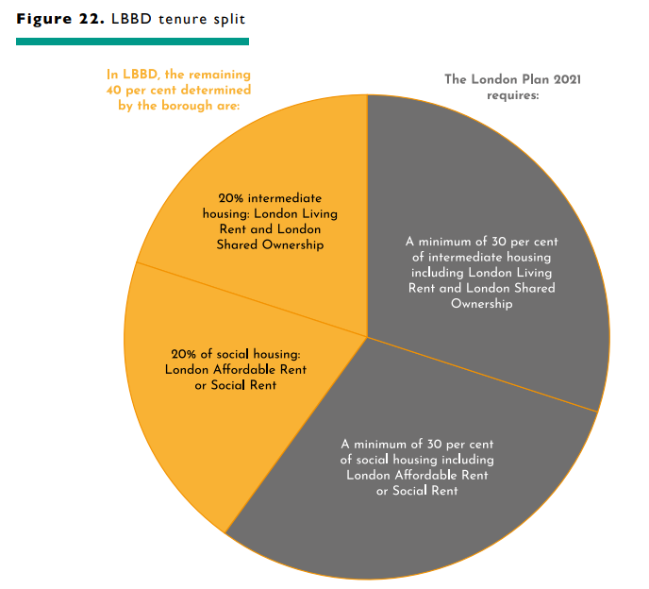  Figure 1423. Forms of affordable housing  London affordable rent Social rent Affordable rent London living rent London shared ownership  Capped Target Rents set in accordance with government guidance. Capped rent level based on the formulas in the government guidance. Capped target rents at 65% to 80% below the market rate. Benchmark Rents set in accordance with GLA guidance. Household purchases at least 25% stake and pays rent on the retained equity.  Affordable to most households but limited to eligible households who have been assessed and accepted onto the Housing Register by the Council. Affordable to most households but limited to eligible households who have been assessed and accepted onto the Housing Register by the Council. Affordable to households who are in employment, but can’t afford to buy or rent privately and have limited access to social housing. Affordable to households on medium incomes who are renting privately and wish to save for a deposit and who can afford to spend one third of their gross income on rent. Maximum income of £60,000 subject to annual review under the London Plan. Maximum income cap of £90,000 applies subject to annual review under the London Plan.  3339The average income levels in the borough is available on the government website: https://www.ons.gov.uk/peoplepopulationandcommunity/personalandhouseholdfinances/incomeandwealth/bulletins/smallareamodelbasedincomeestimates/financialyearending2018#average-house-hold-income-by-local-area
MM24 | DMH2 | POLICY DMH 2: Housing mix  - Development proposals will be required to provide a range of unit sizes (including family housing) in accordance with having regard to the Council’s preferred housing size mix table below, or in any future subsequent affordable housing needs evidence, and Policy H10 of the London Plan.  Bedrooms/Dwelling Size Private Intermediate Social  1 bed 39% 17% 10%  2 bed 26% 44% 40%  3 bed 25% 19% 40%  4+ bed 10% 19% 10%  2. The Council will only consider a different housing mix, having regard to the following factors where a developer demonstrates:  a) that the proposal must meets the tenure split requirements outlined in the Local Plan Policy DMH 1: affordable housing, and  b) the applicant will be expected to provides up-to-date evidence of housing needs by taking account of the Council’s latest local evidence identified by the LBBD Strategic Housing Market Assessment along with the local Housing Register.
MM25 | DMH3 | POLICY DMH 3: Specialist older persons housing  - Existing specialist older persons housing will be protected. Loss of existing supported and specialist housing will be resisted unless re-provided elsewhere in the borough with at least the equivalent number of bed spaces, and would result in improved standards and quality of accommodation, or where it can be demonstrated that there is no local need for its retention in current or refurbished format.  - Development proposals for specialist older person housing should:  a) meet the relevant London Plan 2021 policy (Policy H13) requirements indicative benchmark (Policy H13: specialist old persons housing ) of 70 new homes a year and criteria for new accessible or adapted housing (Policy D7 and H14), or its updated equivalent  b) deliver affordable housing in accordance with the Local Plan policy Policy DMH 1: affordable housing  c) meet an identified need within the borough based on an up-to-date evidence base, through providing a diverse range of tenures to meet varying needs, including opportunities to rent and buy, as well as schemes with varying levels of support and care (e.g. specialist support for mental health needs in Extra Care provision)  d) be co-designed with service users and their families and other key stakeholders to satisfy user requirements  e) is be supported by a legal agreement for occupation by a relevant operator where appropriate.
MM26 | DMH4 | POLICY DMH 4: Large-scale Purpose-built shared housing  - The Council will support new large-scale purpose-built shared housing schemes where they:  a) meet the London Plan 2021 pPolicy H16: Large-scale purpose-built shared living and London Plan planning guidance, including space standards, for this form of accommodation, and London Plan 2021 Policy D6: space standards requirements alongside any GLA guidance on this matter  b) meet an identified need within the borough based on up-to-date evidence base by taking account of the Council’s latest local evidence identified by the LBBD Strategic Housing Market Assessment, and along with the local Housing Register  c) are located within transformation areas as identified in SPDG 1 and shown on the Policies Map. preferred areas in accordance with Place policies (see Chapter 3: Transforming Barking and Dagenham).  d) do not undermine the supply of self-contained housing
MM27 | DMH5 | POLICY DMH 5: Houses in multiple occupations (HMOs)  - New houses in multiple occupation (HMOs) will only be supported where they:  a) meet an identified need  b) do not result in the loss of housing capable of accommodating families with children, existing family housing, or dwelling houses capable of accommodating a small family with children  c) do not result in the loss of character or amenity to the area as a consequence of increased traffic, noise or general disturbance  d) are located in an area of high transport accessibility  e) comply with relevant standards, including those set out in the East London HMO Guidance⁴⁰, and satisfy the housing space standards outlined in the London Plan 2021 pPolicy D6: housing quality and standards, and/or its relevant guidance.  2. The number of houses that have been converted to flats or HMOs in any road (including unimplemented but still valid planning permissions) must not exceed 10 per cent of the total number of houses in the road; and no two adjacent properties apart from dwellings that are separated by a road should be converted  23. Proposals for conversions or loss of existing family housing, or dwelling houses capable of accommodating a small family with children, will be resisted.  40https://www.lbbd.gov.uk/sites/default/files/2022-07/HMO-East-London-guidance.pdf
MM28 | DMH6 | POLICY DMH 6: Gypsy and Traveller accommodation  - The Council will endeavour to meet the identified current and future accommodation needs of Gypsies and Travellers and Travelling Showpeople in Barking and Dagenham by:  - retaining and protecting the existing Gypsy and Traveller sites at Eastbrookend Country Park  - delivering a maximum of 12 pitches by expanding the existing public site at Eastbrookend Country Park within the first five years of the pPlan period. This will require the release of Green Belt land, and therefore compensatory improvements to the surrounding Green Belt land will need to be provided for this site in line with the NPPF, and could include the delivery of improvements to the existing green infrastructure, additional woodland planting, wider biodiversity improvements, and new and enhanced walking and cycling routes.  - delivering the remaining identified need by the end of the plan period at Collier Row Road and/or Choats Road  c. delivering a Gypsy and Traveller site in the wider Castle Green area. A more specific location within the site should come forward as part of a wider masterplan process for the area.  - The Council will consider granting temporary planning permission for proposals that come forward in advance of the allocated sites being developed and will be addressed against the criteria set out below.  2. The Council acknowledges it is currently unable to meet the site accommodation needs of the borough's Gypsy and Traveller community, and it encourages unallocated Gypsy and Traveller sites to come forward to help address this need. Development of a site to provide additional short-stay (including temporary sites which could help meet the unmet need in the short- term)/or permanent Gypsy and Traveller accommodation to meet the long-term needs of these communities will be supported where:  a) the site is able to accommodate the number of pitches identified in an up to date and robust needs assessment  b) the site is accessible to public transport, safe, convenient walking and cycling environment, essential services and facilities (e.g. water, power, sewerage and waste disposal) and be capable of supporting being supported by local social infrastructure and does not place undue pressure on local infrastructure and services (such as healthcare, schools and shops)  c) it provides safe access to and from the public road network  d) the site is a safe location (e.g. not located in an inappropriate area of high flood risk, including functional floodplains, given the particular vulnerability of caravans)  e) the proposal would not result in significant adverse impacts on the amenity of other site occupants and the occupiers of neighbouring sites  f) the proposal supports the health and wellbeing of the occupiers of the site by providing appropriate facilities, layout and design quality and is supported by a Health Impact Assessment  - arrangements can be put in place at the planning application stage, to ensure the proper management of the site in line with the policy requirements above.  Table 1: New pitches needed for Gypsy and Traveller households that meet the PPTS (2015) definition.  2020–2024 2025–2029 2030–2034 Total  19 2 4 25  Gypsy and Traveller Need (December 2023)* 2023-28 2029-34 2035-37 Total  LBBD Gypsy and Traveller Pitch Needs 22 9 2 33  Source: LBBD GTAA updates, 2020, with 2023 updates to reflect the position from December 2023 (with the projections for those that previously fell outside of the 2015 PPTS definition for 2035-37 averaged, and subject to policy review)  *The PPTS definition of Gypsy and Travellers for planning purposes was updated by Government on 19th December 2023. This now includes those who cease to travel permanently for the reasons identified in the PPTS. LBBD intends to meet all the need set out in this table.  Replace Figure 24 with new illustrative Figure 14 showing the Eastbrookend Country Park Gypsy and Traveller site + proposed extension (listed in key as ‘Allocated Gypsy and Traveller Sites’), and a circle to indicate a general vicinity at Castle Green for a broad, longer-term site as follows:  Figure 14: Illustrative Map showing Existing Gypsy and Traveller Site and Future Proposals  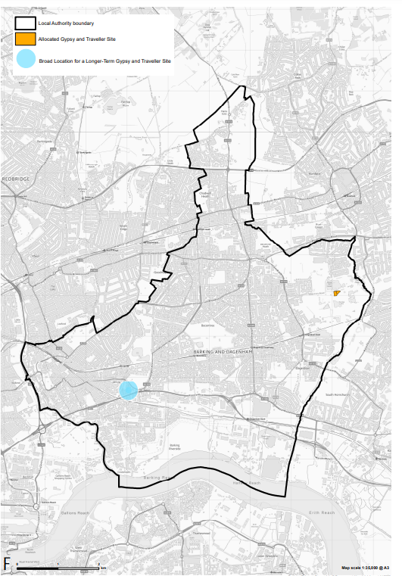
MM29 | Chapter 6 Justification Text | Chapter 6: Social infrastructure  Introduction Justification  6.1. The purpose of this chapter is to set clear social infrastructure policies. The following defines our approach.  • We will ensure that planned growth will be supported by a range of social infrastructure in the right location over the pPlan period.  • We are committed to protecting existing facilities from inappropriate loss while guiding new developments to provide the appropriate social and community facilities such as health provision, emergency services, community (including recreation and sports facilities) and cultural, play, recreation and sports and leisure facilities, places of worship etc.  • We are committed to frequently updating the Infrastructure Delivery Plan as to enable us to achieve strategic delivery of the critical, necessary and important physical, social and green infrastructure required to support growth across the borough. We will continue to calculate and consider the need for social infrastructure in collaboration with social infrastructure providers and identify social infrastructure needs within the Infrastructure Delivery Plan.  • We are preparing a Planning Obligations Supplementary Planning Document, which will set out more detail around the contributions that should be provided to mitigate the impact of development.  6.2. This section contains the following policies:  Strategic Policy 4 Delivering social infrastructure, in the right location  Policy DMS 1 Protecting and enhancing existing facilities  Policy DMS 2 Planning for new facilities  Policy DMS 3 Public houses  6.3. The policies are mainly supported by the key evidence set out in the table below.  Key evidence documents Date Produced  LBBD Infrastructure Delivery Plan 2020  Strategic Estates Plan (East London Health 2018 & Care Partnership) 2018  Strategic Estates Plan (East London Health 2018 & Care Partnership) 2018  GLA School Place Demand Projections 2018  LBBD Parks and Open Spaces Strategy 2017  Strategic Assessment of Need – Artificial Grass Pitch (AGP) Provision in London 2017-41 (Sport England) 2017  Strategic Assessment of Need – Swimming Pools Provision in London 2017-41 (Sport England) 2017  Strategic Assessment of Need – Sports Hall Provision in London 2017-41 (Sport England) 2017  LBBD Faith groups and meeting places: Evidence base study 2017  LBBD Playing Pitch Strategiyes LBBD Playing Pitch Strategy Update LBBD Playing Pitch Strategy 2016  An Audit of London Burial Provision – A report for the Greater London Authority 2011  GLA London Cultural Infrastructure Plan 2019
MM30 | SP 4 | STARTEGIC POLICY SP 4: Delivering social and cultural infrastructure facilities in the right locations  1. The Council will seek to ensure that a range of new high-quality social and cultural infrastructure facilities for existing and new residents, visitors and workers are provided in appropriate locations throughout the borough, and that existing social facilities are safeguarded, by:  a) protecting existing social and cultural infrastructure facilities in accordance with pPolicy DMS1 Protecting and Enhancing Existing Facilities  b) securing the delivery of, or contributions towards, enhanced or new social and cultural infrastructure facilities to meet the needs arising from development, including affordable or no cost spaces, and including projects that:  - promote the growth and expansion of educational facilities (early years, mainstream and special needs) to meet an identified need and demand. Any development on a playing field should have regard to the requirements of Sport England’s Playing Field Policy, and  - improve sustainable connectivity through walking, cycling and public transport, and  - work in partnership with health authorities and other key stakeholders to improve healthcare access and support people’s overall health and well-being, and  - utilise innovative approaches to the delivery and operation of social infrastructure; for example creating multi-functional spaces, or  - make provisions for playspace and open space.  c) working with service providers and other stakeholders to identify funding sources for the long-term management and maintenance of both new and existing social and cultural infrastructure  d) supporting proposals for new and enhanced social and cultural infrastructure facilities where they:  - meet an identified need in line with the Council’s latest Infrastructure Delivery Plan, taking account of the needs of the future local community, and  - contribute to the capacity, quality, usability, sustainability and accessibility of existing and enhanced facilities and services, particularly where development will increase demand, and  - should be are delivered in advance to support new development, where possible.  - promoting the growth and expansion of educational facilities (both mainstream and special needs) to meet an identified need and demand.  - increasing sustainable connectivity through walking, cycling and public transport  - working in partnership with health authorities and other key stakeholders to improve healthcare access and support people’s overall health and well-being  - undertaking innovative approaches to the delivery and operation of social infrastructure; for example creating multi-functional spaces.
MM31 | DMS 1 | POLICY DMS 1: Protecting and enhancing existing facilities  1. Development proposals involving the net loss of existing social and community facilities (excluding sports facilities, playing fields, and recreational buildings and land) will be resisted, unless:  a) the existing facility is being re-provided, whether on site or in a nearby location, that would continue to provide for and enhance the needs of existing local users  b) there is no longer an identified need or demand for the existing use of the facility or use. In such circumstances, the applicant must provide robust documental evidence to demonstrate:  i. the loss of the facility or use would not lead to a shortfall in provision for the specified use for the community that it serves, and  i ii. active marketing has occurred over a period of not less than 12 months for its continuous use and at be based on a realistic price/rent which is supported by the Council, or  ii iii. if the facility can be refurbished or used by multi occupiers to prevent the loss.  - the loss of the facility or use would not lead to a shortfall in provision for the specified use for the community that it serves.  c) development proposals where the loss of social infrastructure is part of a wider public sector transformation programme are excluded from the requirements set out in Part a, and Part b clause ii and iii (and further detailed in clause 2 below).  2. The Council will expect applicants to submit competitive marketing evidence in accordance with Part 1b), which should:  a) outline where and how marketing has been undertaken, with details also provided to demonstrate that the asking rent has been at a realistic rate for the type, size and condition of the property or unit³⁴⁴¹,  b) submit a report detailing the level of interest in the property over the agreed marketing period, details of any viewings and offers and details of why any interest had not been taken forward.  3. Notwithstanding the provisions of Part 1 of this policy, development proposals that would result in the net loss of sports and recreational buildings and land, including playing fields, will not be considered acceptable, unless it meets the requirements set out in the NPPF (or its updated equivalent) and by Policy DMNE 1 of this Local Plan. The Council will consult with Sport England where required on any proposed loss of facilities. and the loss is supported by Sport England.  4. Extensions to existing schools should demonstrate there is an identified need to support the expansion and that it would not result in any shortfall of child play space overall.  5. The Council will allow six months for bidding to buy a community or cultural facility that is listed on the Assets of Community Value (ACV) register. The marketing statement could be reduced from 12 months to 6 months in accordance with part 1 and 2 above to take into account the period of time that the community has to prepare a bid to buy it.  4134The Council would be expected expect that the property or site has been actively marketed, including appearing on local and national commercial property websites and visible display boards being displayed at the site.
MM32 | DMS 2 | POLICY DMS 2: Planning for new facilities  1. Development that is within, or part of, a site allocation is expected to accommodate supporting infrastructure requirements alongside the identified land uses and other development principles, or where appropriate contribute to provision or expansion off site (as part of an agreed strategy).  2. New facilities will be located across the borough, to support growth in each sub-area (see Chapter 3: Transforming Barking and Dagenham).  3. Development proposals for residential and mixed-use development including provision of social, community and cultural facilities will need to submit a community needs strategy to accompany the planning application, demonstrating how the community space needs generated by the development have been met.  4. Development proposals should deliver high-quality design that:  a) is accessible and inclusive to all sections of the community  b) adheres to the latest national, regional and local design guidelines  c) provides opportunities to make space multipurpose and open to different sections of the community.  5. Development proposals for faith facilities in employment and industrial areas will only be permitted if they are in accordance with other policies of the Local Plan, and where conflicts between employment and industrial use and faith use can be avoided (i.e. meeting the other policies of the Local Plan, with regards to increased traffic and parking issues, congregations of people, and noise; and the safety of users or workers will not be compromised). Applicants will be expected to engage in pre-application discussions with the Council before making a formal planning application.  6. To support the endeavours of the sports organisations, dDevelopment proposals that provide for improved leisure and sports facilities (including any essential ancillary facilities³⁵⁴²) to use these facilities will be acceptable subject to other Local Plan policies and discussions with Sport England.  4235These facilities could include uses such as changing rooms, clubhouses, public toilets and nature education facilities.
MM33 | DMS 3 | POLICY DMS 3: Public houses  1. The Council will protect generally resist the change of use of public houses within the borough in accordance with the London Plan 2021 pPolicy HC 7: protecting public houses.  2. Where a public house is replaced or re-provided, the new development:  a) should make an equal or greater contribution to preserve or enhance local character  b) where appropriate, incorporates a community use in the redevelopment or contribute towards enhancing community facilities in the local area  c) where applicable would be subject to a sequential site assessment where applicable if the public house is re-provided off-site, to establish that the public house will continue to serve the original community  d) must provide adequate floorspace to ensure the continued viability of the public house, demonstrate that all reasonable efforts have been taken to preserve the facility as a public house, including evidence of appropriate maintenance and upkeep and efforts to diversify the business. A full detailed marketing report demonstrating that the public house has been continuously marketed for at least 24 months as a public house at a reasonable market rent and free of tie and restrictive covenant.  3. Where the public house is considered to be a heritage asset (see policy DMD4 ‘Heritage Assets and Archaeology Remains’) or to make a valued contribution to the borough’s history and its loss is considered justified, the applicant will be required to send significant architectural and historic components relating to the building’s use for archiving or public display to the Council, in line with Historic England’s guidance.
MM34 | Justification Text | Chapter 7: Economy  Introduction Justification  7.1. The purpose of this chapter is to set out clear employment land and town centre policies. The following defines our approach to these policies.  • Setting out a clear economic vision involving a borough-wide industrial land strategy, which positively and proactively encourages sustainable economic growth through promoting intelligent use of industrial land within the borough.  • Identify strategic sites for mixed-use development, which support anticipated employment needs over the Local Plan period.  • In response to the latest government planning reforms, our policy defines a network and hierarchy of town centres and promotes their long-term vitality and viability, while recognising the importance of being flexible in setting policies to respond to future needs and supporting a diverse and mixed economy providing around at least 20,000 new jobs by 2037, focusing on supporting growing sectors and SMEs. These jobs are expected to come forward through the intensification of industrial land at sites like Industria, and the key opportunities presented by our transformation areas including Eastbrook Film Studios, the Thames Freeport, and the relocation and colocation of London’s Wholesale Markets. Current proposals and the planning application pipeline suggest that new development is already planning to bring forward 12,880 jobs within the Plan period, and we would expect this to increase further as planning applications for developments later in the Plan period come forward.  Employment Strategy - Job Creation  - As set out in SPDG 1, there is an estimated requirement of ~200,000 sqm of floorspace and ~50ha of land to provide for the projected job growth in the borough's industrial sector. The employment strategy established in this Plan was informed using the Industrial Land Strategy 2021 (ILS) data/recommendations as a starting point, and then further developed upon through the collation of employment numbers coming forward through planning applications. The borough is experiencing significant growth not only in housing, but in the amount of industrial development (and in the diversification of opportunities provided by said development) coming forward over the Plan period.  - The ILS used Experian projections as a baseline. This estimated that 10,777 new jobs would be created between 2020 and 2040. Using this projection, the ILS then calculated an estimated requirement of ~200,000 sqm of floorspace and ~50ha of land to provide for the projected job growth in the industrial sector.  - As the Industrial Land Strategy estimates a steady growth of jobs to occur, an average has been taken of the 10,777 figures to estimate the number of jobs expected to be delivered within the Plan period (up to 2037). This equates to around 538 jobs a year (or 9,160 over the Plan period 2020/21-2036/37). Whilst the ILS does look to 2040 (slightly beyond the Plan period), the borough is already seeing a substantial pipeline of job growth coming forward through new developments, with the ILS expecting growth to remain relatively steady over the remainder of the Plan period. This is also unlikely to have a significant impact on the floorspace and land requirements as the borough is expecting an oversupply of 650,000+ sqm floorspace over the Plan period.  - Using the minimum expected job creation figure of 9,160, and taking into account the anticipated oversupply, intensification/densification strategy (explained in more detail below) and current jobs pipeline (as of November 2023 there are already proposals for 1,800 jobs at Dagenham Film Studios and just over 11,000 identified through planning applications excluding any coming forward as a result of the freeport), an ambitious (but achievable) objective of around 20,000 jobs has been set for the Plan. In addition, the increased transport infrastructure (e.g., the already delivered Barking Riverside Station and Thames Clipper extension, and the proposed Beam Park and Castle Green stations) also serve as catalysts for an increase in employment opportunities and job creation in the borough.  - This means that between 2020 and 2037, it is expected that between 9,160 and 20,000 jobs will be created in the borough.  - The ILS also identified specific areas of the borough that would be best placed for intensification/densification. These are Dagenham Dock, Castle Green, Chadwell Heath, River Road/Thames Road and the Kingsbridge Estate. Although the ILS did also propose the release of a total of 172.3ha of industrial land (679,383sqm of employment space), the Local Plan only proposes a full release (i.e., the land no longer has any industrial designation) of 7.6ha of industrial land at the eastern part of Thames Road, and less than 1ha of Locally Significant Industrial Land at Wantz Road. However, to ensure general conformity with the London Plan 2021, significant emphasis has been placed in Policy DME 1 on protecting/re-providing Strategic Industrial Land.  Expected Sectoral Growth in Barking and Dagenham  - To calculate projected job and sectoral growth, the Industrial Land Strategy utilised the latest Experian Employment Forecasts (September 2020). The Experian data was translated from 38 categories into 5-digit SIC codes covering 729 industries and profiled over the period 2021-2040 to understand the change in employment in the different industrial sectors. The Experian data was also rebased in line with the Business Register Employment Survey (BRES) 2019 to give accurate employment forecasting. This modelling data showed that there would be an additional 10,777 jobs in Barking and Dagenham in 2040 in comparison to 2020. The figure below shows this employment growth by sector:  Figure 14: LBBD Employment Growth 2020-2024  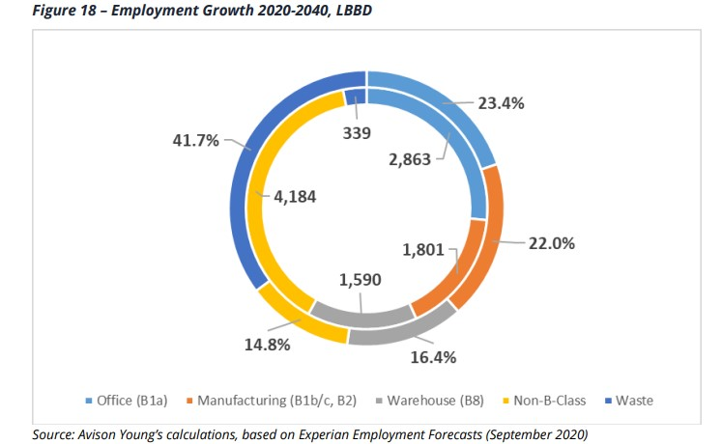  - From this, standard employment land density and plot ratio assumptions were made for each use class sector to give a quantum of employment land required over the plan period. It is concluded that, based purely on baseline data, employment growth in industrial activities could generate a requirement for circa 18.41 ha of manufacturing land (B1b/c, B2) and 31.15 ha of warehousing land (B8) by 2040 (for a total of 49.56 ha). The figure below sets this out in more detail:  Table 3 - Sectoral Floorspace and Land Requirements 2020-2040, LBBD  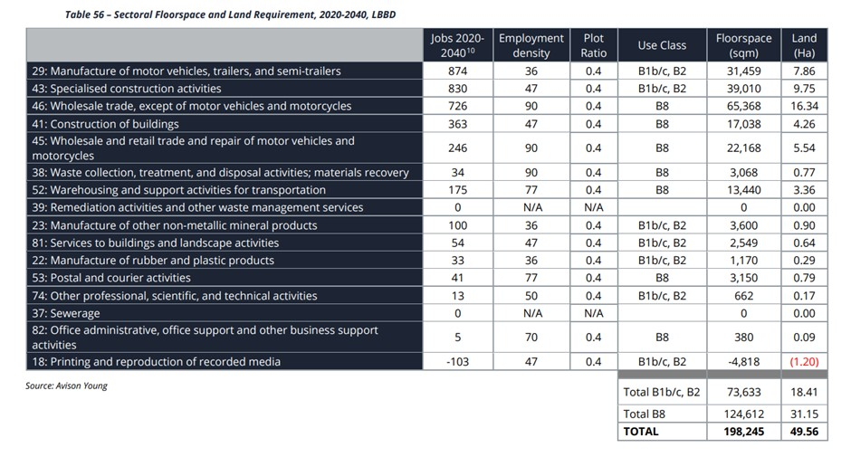  Safeguarded Wharves  Figure 15 is provided below for illustrative purposes to identify the borough's safeguarded wharves, as shown on the Policies Map.  Move Figure 25 to justification text section and rename as Figure 15.  Figure 15  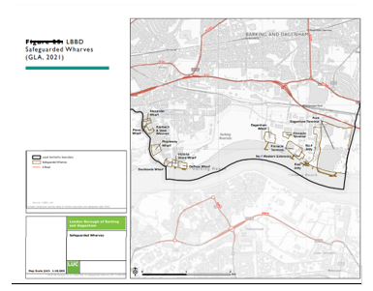  Industrial Land  Figure 16 is provided below for illustrative purposes to show the distribution of designated industrial land across the borough, as shown on the Policies Map.  Replace current Figure 26 (and rename as Figure 16) and replace with the following and move to justification text section:  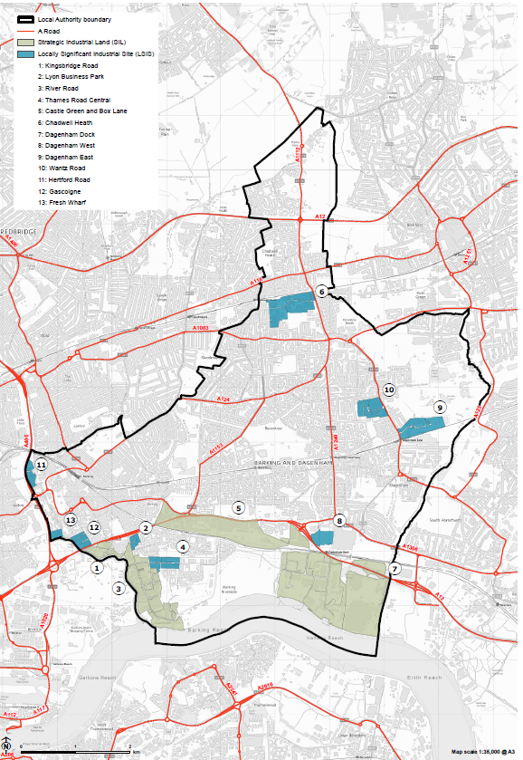  Affordable Workspace  - Policy DME 2 sets out requirements for affordable workplace provision and what is required if these are not judged to be practicable or viable for a particular development. Whether affordable workspace is practicable should be covered in a planning statement - the justification would need to be based on the specific circumstances of the scheme (e.g. where sub-division to provide a separate affordable workspace unit would be difficult to achieve or where the small amount of affordable workspace floorspace generated would make finding a provider very difficult). Where on-site affordable workspace is deemed not viable, this would need to be demonstrated through a viability report.  Town Centres and Impact Assessments  - For impact assessments, the Council will apply a 500 sqm gross threshold, which is consistent with the retail floorspace projections within the borough. The Barking and Dagenham Town Centres and Retail Strategy sets out the rationale behind this policy approach.  7.2. This chapter includes the following policies:  Strategic Policy 5 Promoting inclusive economic growth  Policy DME 1: Utilising the borough’s employment land more efficiently  Policy DME 2: Providing flexible, affordable workspace  Policy DME 3: Encouraging vibrant, resilient and characterful town centres  Policy DME 4: Visitor accommodation  Policy DME 5: Evening economy  7.3. The policies are mainly supported by the key evidence set out in the table below.  Key evidence documents Date produced  Be First Industrial Land Strategy 2021  Be First Industrial Land Strategy Addendum 2021  Barking and Dagenham Retail and Town Centre Study Update and Addendum Report 2020  GLA Safeguarded Wharves Review 2019 2020  GLA Hot Food Takeaways Topic Paper 2018  LBBD Economic and Temporary Use Strategy 20189  Projections of Demand and Supply for Visitor Accommodation in London 2017  The Value of Workspace (Institute of Public Policy Research) 2016
MM35 | SP 5 | STRATEGIC POLICY SP 5: Promoting inclusive economic growth  1. The Council will focus on growing a thriving and productive enterprise and small business economy, alongside new business investment, and ensuring the delivery of around at least 20,000 new jobs and a wider employment base.  2. The Council will protect office floor space in accordance with London Plan 2021 Policy E1: Offices of the London Plan.  3. The Council will meet its identified additional demand of circa 203,000sqm. of industrial floorspace over the Plan period (as identified in the Industrial Land Strategy) and protect, strengthen and intensify land within the designated Strategic Industrial Location (SIL) and Locally Significant Industrial Sites (LSIS) boundaries through:  a) retention of suitable locations (see illustrative Figure 26 16 within the policy justification text) to accommodate future employment growth including supply of suitable industrial capacity to meet identified need  b) promoting efficient use of employment industrial land to support economic growth sectors through managed renewal and intensification of industrial sites, alongside plan-led managed release and reprovision, and within LSIS co-location of existing industrial land with other sympathetic and appropriate uses  c) promoting efficient use of industrial land to support strategic sectors, including: Transport & Logistics, Advanced Manufacturing, Green Technology and Digital Cultural Creative Industries etc.  4. Over the Plan period, the Council is de-designating 14ha of land on Thames Road from SIL to LSIS to allow colocation to come forward and releasing 7.6ha of SIL on Thames Road for residential use. The resultant loss of SIL industrial floorspace will be re-provided nearby in the borough. The new designations are reflected on the Policies Map.  54. All safeguarded wharves and maritime infrastructure will be protected and retained in line with Ministerial Safeguarding Directions, supported by Mayoral policy and the Marine Management Organisation. The locations are defined in set out on the Policies Map and shown for illustrative purposes in Figure 1525below. Opportunities for intensification of wharf use, or rationalisation of wharves and infrastructure, will require discussions consultation with the Mayor (in line with the Safeguarding Directions), with the Port of London Authority and the Marine Management Organisation at an early stage. Proposals that come forward on sites adjacent to wharves must recognise the importance of the agent of change policy in accordance with London Plan 2021 Policy D13 so that future development is designed to ensure that there are no conflicts of use and freight capacity is not reduced. Existing rail freight sites including those at Ripple Lane Stora, Ripple Lane West, Renwick Road Rail Terminal and Eurohub, Box Lane will be safeguarded for rail related uses in line with National and Mayoral policy. These locations are shown on the Policies Map. Opportunities for intensification of rail uses, or rationalisation of rail sites and infrastructure, will require discussions with the Network Rail and the rail freight operator DB Cargo at an early stage. Proposals that come forward on sites adjacent the rail freight sites must accord with the agent of change principle in line with London Plan 2021 Policy D13 so that future development is designed to ensure that there are no conflicts of use and freight capacity is not reduced.  65. The Council will support a new town centre hierarchy for the borough. with There is an expectation that major office development directed to should generally be directed towards Barking town centre (as shown on the Policies Map), before and secondary provision directed to office provision in District Centres, and following that, neighbourhood centres (both shown on the Policies Map) are considered. Developers will be expected to demonstrate need for major office proposals outside of these areas. Barking Town Centre and the borough’s District Centres are set out on the Policies Map. as set out in the town centre hierarchy on the Policies Map.  76. The Council will encourage the provision of affordable workspace within developments for new employment in accordance with Policy DME 2: providing flexible, affordable workspace, alongside the London Plan 2021 pPolicy E3: affordable workspace.  87. The Council will support businesses who seek to evolve, diversify, and contribute to a more thriving and more inclusive local economy through:  a) supporting a range of appropriate town centre uses, not limited to traditional retail, which could include residential uses above existing commercial, social infrastructure and transport infrastructure uses, temporary or ‘meanwhile’ uses³⁶⁴³ of vacant properties, affordable workspace and educational facilities  b) supporting new development and redevelopment that stimulates the evening economy, contributing to the vitality of district centres and supporting a balanced and socially inclusive evening and night-time economy  c) supporting the provision of flexible, affordable, modern employment spaces in suitable locations; ensuring the design of employment space is flexible and adaptable to the changing needs of different types of potential user  d) avoiding vacant or under-utilised buildings and spaces by encouraging better utilisation of industrial sites, and where appropriate and in line with London Plan 2021 Policy E7 supporting the re-use of surplus industrial land and floorspace for other uses  e) providing new high-quality employment and training opportunities for local people, and procurement opportunities for local businesses, focusing on investment in physical improvement, but also in the long-term social infrastructure and education required for producing talented, entrepreneurial individuals locally.  4336In London, meanwhile use sector ranges from property guardianship, housing (e.g. manufactured homes) small community gardens to large workspaces (Centre for London, 2018).
MM36 | DME 1 | POLICY DME 1: Utilising the borough’s employment land more efficiently  1. SIL/LSIS Land release will only be considered in accordance with the London Plan 2021 Ppolicy E7: industrial intensification, co-location and substitution.  2. Over the course of the Plan period, it is the Council’s intention to only release three parcels of SIL. These are within Thames Road, which is located within the River Road Employment Area. Proposed industrial land designations are clearly illustrated in Figure 16 and on the Policies Map. The clusters are listed in Table 2 as RR8, RR9 and RR10 and these will be clearly defined on an interactive policies map. Part of RR8 will be de-designated from SIL to LSIS and part will be intensified as SIL. RR9 will be de-designated from SIL to LSIS and RR10 will be released completely for residential. The reconfiguration of this industrial land will result in a loss of 21.6ha of SIL.  32. Development proposals must minimise noise impacts and/or neighbour amenity issues in line with London Plan 2021 Policy ensure neighbourly development is achieved, in line with the Local Plan policy DMSI 2: Energy, Heat and Carbon Emissions and must not jeopardise the functioning of any remaining or re-provided employment industrial uses, including those incorporated within the redevelopment.  43. Any development on-site or surrounding SIL, LSIS or Non-Designated Industrial Sites must not compromise their continued efficient function, access, service arrangements and days/hours of operation, in line with Policies E5 and E7 of the London Plan 2021. Particular regard should be made to the design of residential development adjacent to SILs to ensure that existing or potential industrial activities within these locations are not compromised or curtailed.  5. The Council will ensure that there will be no deficit of industrial capacity through a regular process of planning, monitoring and reviewing industrial development throughout the Plan period. The Council will monitor the capacity of LSIS and SIL land and floorspace as well as undesignated industrial land within the Borough and review this annually through the Authority Monitoring Report (KPI 12). The Council is committed to sharing this monitoring information with the GLA to support decision making when considering proposals which affect industrial designations and in particular any which affect SIL. Monitoring of the borough’s industrial capacity will help to ensure that industrial need is identified, reviewed and met ahead of any planned release. It will help facilitate the effective operation of the Plan’s industrial policies.  64. The Council may prepare masterplan supplementary planning documents (SPDs) to guide development. Where adopted, development proposals must behave regard to any accordance with an relevant SPD.  Strategic Industrial Locations (SIL)  75. SIL provides strategic protection and intensification for warehousing and logistics uses, which often require larger spaces, in line with Policies E4 and E5 of the London Plan 2021.  86. Industrial intensification may involve placing smaller industrial units above or alongside larger warehouses and hybrid office/ industrial activity in multi-use buildings accommodated at higher plot ratios to deliver additional capacity.  97.Proposals for residential elements will be refused. Planning conditions or legal agreements may be required to prevent subsequent conversion of SIL sites to residential use.  8.Applicants should clearly demonstrate how their proposal contributes to meeting the future industrial floor space capacity targets (as set out in Table 1) on site, through setting out all options explored for intensification as part of the Planning Application.  Locally Significant Industrial Sites (LSIS)  109.The Council will protect local business’ needs, and support development that is in accordance with this Local Plan or an adopted localised planning framework.  1110.The Council will support co-location of industrial and nonindustrial land uses (including employment and residential uses) where appropriate and where this would meet the requirements of Policy E7 of the London Plan 2021. This could involve a mix of industrial and residential and/or other uses on the same site, either side-by-side or through vertical stacking.  1211. OIn Locally Significant Industrial Sites, Classes B2, B8 and E(g)iii uses the following uses for industrial type activities and relation functions, including ancillary facilities, will be permitted and safeguarded.:  a) Class B2 and B8  b) Class E(g)(i), E(g)(ii) and E(g)(iii), only where the permitted function cannot change to any other E use class.  SIL and LSIS  1312. For both SIL and LSIS, Applicants must clearly demonstrate that the proposal:  a) contributes to meeting the indicative future industrial floorspace capacity targets (as set out in Table 12 and Appendix 5 below) ,. Where industrial capacity will be re-provided off-site, relocation arrangements should be secured through a legal agreement to ensure that the delivery of operational industrial capacity is prioritised over other uses The Council will seek to exceed the indicative future floorspace capacity where appropriate.  b) can deliver at least 50 per cent affordable housing where the scheme includes residential uses and would result in a net loss of industrial capacity (as required by London Plan 2021 policy Policies H4 and H5)  c) can provide a mix of unit sizes and adequate servicing and delivery space in accordance with Policy DMT4: deliveries, servicing and construction  d) are well designed for their intended purpose in accordance with DMD1: securing high quality design, having regard to providing flexibility for incorporating innovative typologies, such as smaller scale, cleaner type industrial uses that are more compatible with residential uses.  Outside designated SIL or LSIS  1513. Outside designated SIL or LSIS, the Council will direct industrial or warehousing uses towards areas of the borough that are designated for SIL or LSIS. Development proposals that would result in the net loss of viable employment floor space outside of SIL or LSIS areas will be required (in accordance with London Plan 2021 Ppolicy E7: industrial intensification, co-location and substitution) to demonstrate that the site has ‘no reasonable prospect’ for industrial related purposes and will be required to comply with London Plan 2021 Policies H4 and H5 in respect of affordable housing.  Monitoring  16. The Council will facilitate the delivery of the identified intensification potential to meet all its identified industrial need through a focus on publicly owned land and work with landowners as well as particular details proposed as part of individual site allocations and through Masterplans at Thames Road and Chadwell Heath.  17. In line with key performance indicator 11 of Appendix 3 of this Plan, the Council will monitor the capacity of LSIS and SIL land within the borough.  Replace Table 1 on page 118 with the following table (Table 2) to correct errors highlighted in updated Statement of Common Ground with the GLA (EX121), to remove 2,400sqm floorspace capacity from KB1 (E_022) due to SIL boundary correction, and to correctly state SIL/LSIS designations:  Table 12: Proposed Future Industrial Capacity across London Borough of Barking and Dagenham³⁷⁴⁴ (Industrial Land Strategy, 2021)  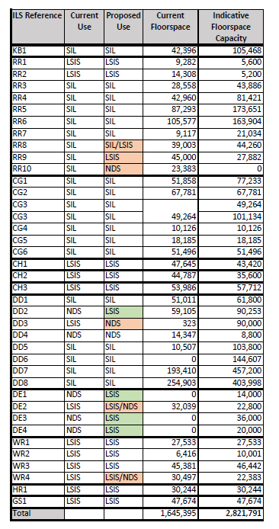  ³⁷⁴⁴For guidance on minimum and targeted plot ratio for each area, please refer to the Borough Industrial Land Strategy 2021.
MM37 | DME 2 | POLICY DME 2: Providing flexible, affordable workspace  1. Development creating of 1,000 sqm employment floorspace³⁸⁴⁵ or greater will be required to incorporate an appropriate provision of affordable workspace³⁹⁴⁶ on-site, offered at below market rate, for shared workspace or small business units through Section 106 agreements, subject to development viability. This must meet the needs of local start-ups, small-to-medium enterprises and creative industries. The applicant should establish robust management links with registered workspace providers agreed by the Council and be able to:  a) demonstrate that there is sufficient critical mass to ensure the sustainability of any provision  b) provide units in turnkey form which are accepted by the Council or the registered workspace provider following completion. To be considered as acceptable turnkey spaces, the Council will expect the workspace units to be secure, vacant, and fully glazed, with smooth sealed concrete finishes to ceiling and walls, functional lighting, running water, sanitary facilities, and having capped essential services such as electricity and gas, as well as access provision of wired and wireless broadband technologies delivering the highest speeds to provide a wide range of services. These works will avoid substantial fit out costs for potential occupiers and enable the workspace to be more affordable for smaller businesses.  2. In circumstances where it is not practicable or viable feasible to meet Part 1 of the policy, a payment in lieu may will be required accepted to support delivery of affordable workspace in other parts of the borough, focusing primarily in identified Transformation Areas (see Chapter 3: Transforming Barking and Dagenham).  4538This policy applies to applications for Planning Use Class E: Commercial, Business and Service.  4639Workspace are: E(g) Uses which can be carried out in a residential area without detriment to its amenity.
MM38 | DME 3 | POLICY DME 3: Encouraging vibrant, resilient, and characterful town centres  1. The location of town, district and neighbourhood centres are defined on the Policies Map, with the Town Centre Hierarchy also shown in the table below. The boundaries clearly relate to the application of the sequential and impact tests, which seek to direct main town centre uses to town centres, and proposals for large retail development in edge, or out of town centre locations to be considered against the sequential approach in accordance with the most up to date NPPF.  Barking and Dagenham Town Centre Hierarchy  Town Centre Barking Town Centre  District Centres Chadwell Heath Dagenham Heathway Green Lane Barking Riverside  Neighbourhood Centres • The Merry Fiddlers • Andrews Corner • Martin’s Corner • Gale Street, Becontree • The Round House • Oxlow Lane / Hunters • Hall Road • Goresbrook Road /Chequers Parade • Chequers Parade • Royal Parade / Church Street • Farr Avenue • Faircross Parade • Broad Street • Dagenham East (South) • Dagenham East (North) • Rush Green • Eastbury • Robin Hood • Marks Gate Shops • Tolworth Parade • Whalebone Lane South • Matapan Shops • Althorne Way • Stansgate Road • Princess Parade, New Road • The Triangle • Fanshawe Avenue 36 • Edgefield Court • Gibbards Cottages • Reede Road • Westbury • Gascoigne • Eastbrook • Movers Lane • Five Elms • Lodge Avenue  2. Development proposals should seek to deliver and maintain active ground floor frontages. This includes, but is not limited to, shops, markets, community, cultural and civic uses⁴⁰⁴⁷.  3. When considering applications for town centre uses the applicants are expected to take account of the flexibility which may be required to meet changing needs in terms of what contribution the new development will make to the success of our town centres. This could include the potential need for temporary or ‘meanwhile or interim’ space to support the creative industries or serve needs in the early phases of a business.  4. ‘Meanwhile’ uses of buildings in designated town centres must not have an unacceptable impact on residential amenity or prevent development sites from being brought forward for development in a timely fashion. Meanwhile use of sites for housing uses should be consistent with other Local Plan policies in relation to the residential amenity.  5. Outside the designated town centres, development proposals for retail and leisure development exceeding 500sq.m⁴¹⁴⁸ gross (or its updated equivalent) will be required to submit an impact assessment in accordance with the NPPF and NPPG.  6. Development proposals for a new local shopping centre outside designated town centres Barking Town Centre and the borough’s district and neighbourhood centres (as shown on the Policies Map) must seek to meet the needs of local residents based on up to date documental evidence⁴²⁴⁹. The applicant should submit information which considers factors including:  a) the relative size of a local parade and the range of shops and services each centre can offer  b) the proximity of other town centres, local centres and ‘standalone’ shops, which may mean that local need may be met at an alternative location within walking distance and local needs are therefore still being met  c) the quality of the shopping centre or parade, in terms of its environment, type and range of retailers, affecting how it is perceived and used by local residents  d) the relative accessibility of each centre since this is an important factor in how local people use the local shops and services. The reasonable and maximum walking distances as prescribed in GLA’s Town Centre SPG and its equivalent update should be considered in the statement or assessment.  e) Demonstration that the design of the walking route(s) are safe and wide, and include greenery and rest areas, where possible, to enable convenient walking for all ages and abilities.  7. Development proposals for new hot food takeaways (sui generis), new betting shops, casinos and amusement arcades (sui generis) and pay day loan shops (sui generis) within the designated town centres should be discussed with the Council in advance of any application, must accord with Local Plan Policy DMD1: securing high quality design, and where appropriate, be supported by:  a) a cumulative impact assessment of other existing uses of hot food takeaway, or betting shop or pay day loan shop (including extant but unimplemented planning permissions)  b) a health impact assessment (HIA) to demonstrate how the proposal mitigates its impacts to acceptable levels and contribute to reducing health inequalities as far as reasonably possible  4740Uses which offer a service to the general public.  4841The Council will apply a 500 sqm gross threshold for impact assessments, which is consistent with the retail floorspace projections within the borough. The Retail and Town Centre Study Topic Paper sets out the rationale behind this policy approach. The revised floorspace capacity projections in this Addendum are lower than the 2019 Update and the need for a lower impact threshold (500 sqm gross) is reinforced. The Council will keep the retail impact analysis threshold under review in light of future circumstances.  4942The local needs index provides a useful indicator of whether a local centre or important local parade is meeting some or all the needs of local residents.
MM39 | DME 4 | POLICY DME 4: Visitor accommodation  1. Proposals for new visitor accommodation will be supported where they accord with Policy DME 3, must be in accordance with Policy DME3 of the Local Plan, and where they meet the following criteria they should:  a) accord with principal land uses and not compromise regeneration visions (see the Local Plan Place Policies in Chapter 3)  b) the size, scale and nature of the proposal is proportionate to its location  c) it does not create an over-concentration of such accommodation, taking account of other proposals and unimplemented consents in the local area  d) it does not have significant adverse impact on surrounding amenity or local character.  e) would be subject to a sequential assessment and impact assessment where applicable  2. Applications for serviced apartments must demonstrate that they meet the criteria stated in Part (1) of this policy and will be managed appropriately as short-term accommodation (i.e. accommodation for up to 90 days in any 365 day period).
MM40 | DME 5 | POLICY DME 5: Evening economy  1. The Council will support development that contributes to the vitality of the borough Barking town centre, and supports a balanced and socially inclusive evening and night-time economy⁵⁰, subject to the following considerations:  a) cumulative impact – in areas where a concentration of night-time uses may be detrimental to the character or vitality and viability of the centre, there will be a presumption against further facilities. For example, the existing number of similar establishments in the immediate area and their proximity to each other; and the potential impacts of the proposal on the wider community  b) residential amenity – the proposed use should not create an unacceptable impact on neighbouring uses in terms of noise, traffic and disturbance. For example, the type and characteristics of other uses, such as housing, shops and public houses; any known unresolved amenity, traffic or safety issues arising from existing uses in the area  c) balance – new uses in centres should support both the day-time and evening and night-time economies whilst not undermining the role and function of the designated town centres in accordance with DME3 Encouraging Vibrant, Resilient, and Characterful Town Centres.  50Examples of development that contributes to the night-time economy include: bars, cafes, nightclubs and restaurants (see Glossary definition for 'Evening Economy)
MM41 | Chapter 8 Justification Text | Chapter 8: Natural environment  Justification Introduction  8.1. The purpose of this chapter is to set out clear policies related to the borough’s natural environment. The following defines our approach to these policies.  • We aim to protect and enhance parks, open spaces, Green Belt, Metropolitan Open Land (MOL), allotments, ponds, rivers and waterways, and the natural environment, and maintain clean, green environments.  • We are making sure that the borough’s public open space, and its green and blue infrastructure, is of high-quality and able to fulfil a number of functions, including providing play opportunities, improving health and wellbeing, mitigating and adapting to climate change, and increasing biodiversity.  • We seize opportunities for creating, enhancing and connecting green infrastructure. and iImproving access to existing open spaces and nature are strongly supported in this Local Plan.  • We want to make the most of the borough’s blue infrastructure, including the River Roding, the River Thames and the River Beam.  • The borough’s target open space provision requirement is 2.4 hectares per 1,000 head of population, as identified in the Council’s Parks and Open Spaces Strategy. The Council will keep this standard under review⁵¹.  8.2. This section contains the following policies:  Strategic Policy SP6 Green and Blue Infrastructure  Policy DMNE 1: Parks, open spaces and play space  Policy DMNE 2: Urban greening  Policy DMNE 3: Nature conservation and biodiversity  Policy DMNE 4: Water environment  Policy DMNE 5: Trees  Policy DMNE 6: Local food growing, including allotments  8.3. The policies are mainly supported by the key evidence base set out in the table below.  Key evidence documents Date produced  LBBD Habitats Regulations Assessment 2020  LBBD Infrastructure Delivery Plan 2020  LBBD Green Infrastructure and Biodiversity 2019 Strategy 2019  London Environment Strategy 2018  LBBD Parks and Open Spaces Strategy 2017  LBBD Playing Pitch Strategy 2016  LBBD Biodiversity Survey 2016  LBBD SINCs Citation 2016  LBBD Green Belt Review 2015  All London Green Grid SPG 2012  Ecological Assessment of mounded land to the east of Padnall Lake 2020
MM42 | SP 6 | POLICY SP6: Green and blue infrastructure  1. The Council will protect and enhance the quality of the natural environment (including the borough’s parks, public open spaces and playing fields pitches) and will work with a range of stakeholders to maximise the creation of new and improved green and blue infrastructure and address deficiencies⁴³⁵¹ in quantity, quality and access. This will be achieved through:  a) protecting and enhancing the borough’s Green Belt and Metropolitan Open Land (MOL) to maintain its function, quality and openness. Any release of Green Belt land will only occur in exceptional circumstances and come forward as part of the Local Plan process, as is the case with the release of small amount of Green Belt land to allow for future delivery of the proposed Gypsy and Traveller site extension at Eastbrookend Country Park.  b) The delivery of a maximum of 12 pitches by expanding the existing public site at Eastbrookend Country Park will require the release of Green Belt land, and therefore compensatory improvements to the surrounding Green Belt land will need to be provided for this site in line with the NPPF, and could include the delivery of improvements to the existing green infrastructure, additional woodland planting, wider biodiversity improvements and new and enhanced walking and cycling routes.  bc) ensuring development protects and enhances significant ecological features, achieves biodiversity net gain, and maximises opportunities for urban greening through appropriate landscaping schemes, green roofs and the planting of street trees  cd) working with local partners, the Environment Agency, Natural England and other key stakeholders including the Wildlife Sites Board officers to resurvey and review SINCs, ecological corridors and areas of biodiversity (as shown on the Policies Map) every 5 to 10 years,. This will to ensure development contributes as appropriate to the borough’s overall biodiversity and environmental quality  de) improving the quality, character, value and accessibility of existing publicly accessible open space across the borough, in line with the Council’s Parks and Open Spaces Strategy, Green Infrastructure and Biodiversity Strategy and has regard to Sport England’s Active Design Guidance (or updated equivalent)  ef) maximising the opportunity to deliver an improved network of green grid links to enhance access through walking, cycling and public transport to key destination points such as town centres, community facilities and publicly accessible open spaces, and along rivers and waterways  fg) protecting, improving and enhancing blue spaces, to create a coherent blue network, improving walking and cycling accessibility to the water environment and improving the relationship with the river⁴⁴⁵² (including public realm, habitats and waste heat energy sources). Where possible, opportunities should be sought to ‘naturalise’ riverbanks and water features by removing hard engineered walls and introducing new habitats and sustainable flood management  gh) protecting and enhancing the existing residential moorings located on the River Roding and explore opportunities for part of the River Roding in the borough, north of the existing safeguarded wharves as a potential residential mooring opportunity zone in line with local and regional planning policies  hi) maximising opportunities to create and increase publicly accessible open space (including playing fields pitches and ancillary sporting facilities) with a range of sizes and for a range of users, particularly in locations which experience the highest level of open space deficiency within the borough (as shown on the Policies Map)  ij) protecting and enhancing the borough’s habitat and wildlife, including linking green spaces with coherent ecological corridors, protecting species and habitats identified in the London Biodiversity Action Plan or updated equivalent, and creating new nesting and roosting sites  jk) supporting community food growing through protection of existing allotments, provision of space for urban agriculture in new developments and as a meanwhile use, and building partnerships with social enterprise and voluntary organisations that have already started working in the borough; and supporting communities that aspire to designate important local open spaces as local green spaces  kl) working with strategic partners, developers and the community to position the natural environment at the heart of estate regeneration and development, having regard to the any relevant Council’s latest park masterplans.⁴⁵⁵³  5143The borough’s open space provision requirement is 2.4 hectares per 1,000 head of population. The Council will keep this standard under review. https://yourcall.befirst.london/13753/widgets/39553/documents/21285  5244River Thames, River Roding, Gores Brook and the Beam.  5345The Council has been working on 10 masterplans for the borough’s most important parks. These masterplans will give us a framework for the future development of these sites that we can bring into effects as resource become available. Chapter 7 of the Borough’s Parks and Open Space Strategy provides information on these masterplans: https://modgov.lbbd.gov.uk/Internet/documents/s114608/Parks%20Strategy%20-%20App.%201b.pdf
MM43 | DMNE 1 | POLICY DMNE 1: Parks, open spaces and play space  1. The Council will protect and enhance the borough’s parks, public open spaces and playing fields pitches, working closely with a range of stakeholders to address deficiencies in quantity, quality and access. Public open spaces should be safe and easily accessible through walking, cycling, and public transport for all users, and supportive infrastructure such as crossings, cycle parking, bus stops and clear signage should be provided appropriately near the entrance of open spaces. To reduce car dominance, these should be provided in proximity to residential, commercial and social infrastructure.  2. The Council will prevent inappropriate development within the open spaces and other designated sites identified in the Parks and Open Space Strategy, areas and green space (Green Belt) and on Metropolitan Open Land (MOL), Development should not come forward on Metropolitan Open Land (MOL) or within the Green Belt except in very special circumstances, in line with the NPPF and Policy G3 of the London Plan. 2021, or where exceptional circumstances for changes to the Green Belt boundary have come forward as part of the Local Plan process (as is the case with the release of a small amount of Green Belt land to allow for future delivery of the Gypsy and Traveller site extension in Eastbrookend Country Park).  3. Existing open space, sports and recreational buildings and land, including playing fields, should not be built on unless: the requirements outlined in national policy are met.  a) an assessment has been undertaken which has clearly shown the open space, buildings or land to be surplus to requirement  b) the loss resulting from the proposed development would be replaced by equivalent or better provision in terms of quantity and in a suitable location  c) the development is for alternative sports and recreational provision, the benefits of which clearly outweigh the loss of the current or former use.  4. Major residential development Development of 100 dwellings or greater which falls within the 3 km to 6.2 km Recreational Pressure ‘Zone of Influence’ (ZoI) around the Epping Forest SAC (as shown on the Policies Map) may be required to complete a project level Habitat Regulations Assessment to address recreational impacts on the SAC, and may will be required to mitigate the impacts of recreational pressure upon the SAC. in compliance with Natural England’s Interim Mitigation Advice⁴⁶ and any subsequent Full Mitigation Strategy release. Applicants should provide mitigation in the form of Suitable Alternative Natural Greenspace (SANG) within the footprint of the development site. If this is not possible due to space constraints, contributions will be required for Strategic Access Management and Monitoring (SAMM) of the SAC. Any development which would cause an adverse impact upon the integrity of Epping Forest SAC will not be supported.  5. Development on non-designated open space not shown on the Policies Map, including amenity greens and amenity spaces with limited public access, will generally not be supported be resisted, except where proposals accord with an agreed Council regeneration strategy, and or include replacement space of higher quality to the open space that would be lost to mitigating this loss as part of any future works.  6. Development should not rely upon existing publicly accessible open space to contribute towards on-site communal amenity space and child play space. All major and strategic development should contribute to the delivery of sufficient new publicly accessible open space on-site which should:  a) meet the needs of current and any future residents  b) be of a high-quality that is accessible to all  c) provide multiple benefits, including recreation, food growing, SuDS, improvements to biodiversity and links to green infrastructure, as well as any blue infrastructure, on and adjacent to the development site  d) consider taking the form of new parks (including pocket parks), allotments or play space in accordance with the Council’s developed with regard to guidance as set out in the Parks and Open Spaces Strategy, the Green Infrastructure and Biodiversity Strategy, the Planning Obligations SPD (emerging) and any relevant park masterplans and their updated equivalents  e) comply with Policy G4 of the London Plan 2021 and the Council’s guidance in the design of new open space. In exceptional circumstances, where on-site provision cannot be adequately accommodated, the Council may agree a financial contribution towards improvements to existing or new open spaces within the borough via planning obligations.  7. Large m Major development proposals for schemes that are likely to be used by children and young people should increase opportunities for play and informal recreation in line with Policy S4 of the London Plan 2021.  8. Proposals for new playing fields pitches should be developed in accordance with Policy DMS1, the Council’s Playing Pitch Strategy (or updated equivalent) and in consultation with Sport England.  46Natural England 2019. Emerging strategic approach relating to the Epping Forest Special Area of Conservation (SAC) Mitigation Strategy. Interim advice following feedback from London Borough’s and Greater London Authority.
MM44 | DMNE 2 | POLICY DMNE 2: Urban greening  1. Development proposals will be supported where they:  a) maximise opportunities for urban greening, including landscaping, street trees, green and brown roofs, green walls, food growing, rain gardens and nature-based sustainable drainage  b) contribute to the All London Green Grid, the Council’s Green Infrastructure and Biodiversity Strategy and the Council’s Parks and Open Spaces Strategy.  2. The applicant is Major development proposals are expected to calculate the site’s Urban Greening Factor (UGF). Iin line with Policy G5 of the London Plan 2021, to demonstrate that the proposal will positively contribute to the greening of the borough. , a A target score of 0.4 should be achieved for developments that are predominately residential, and a target score of 0.3 should be achieved for commercial development (excluding B2 and B8 uses, which have no target but are required to quantify the UGF score and demonstrate measures to achieve urban greening on site).  3. Where major development does not meet the relevant UGF target score and a review confirms that the target score cannot be met (as set out in section 3.6 of the 2023 London Plan Urban Greening Factor guidance⁵³), development should provide robust justification to the Council regarding constraints to delivery, and work with the Council to identify suitable alternative offsite measures.  53https://www.london.gov.uk/sites/default/files/2023-02/London%20Plan%20Guidance%20-%20Urban%20Greening%20Factor.pdf
MM45 | DMNE 3 | POLICY DMNE 3: Nature conservation and biodiversity  1. Development should not lead to adverse effects on the integrity of Epping Forest Special Area of Conservation (SAC) in line with Policy DMNE 1, or loss or degradation of Sites of Importance for Nature Conservation (SINCs), including local nature reserves. All existing SINC boundaries and Areas of Deficiency in access to nature, are shown on the Policies Map.  2. All development proposals are required to:  a) minimise the impacts of development on biodiversity and nature in accordance with the mitigation hierarchy set out in Policy G6 of the London Plan 2021  b) demonstrate a minimum of 10% biodiversity net gain, even where development proposals do not result in biodiversity loss using the DEFRA Biodiversity Mmetric 4.0 (or updated agreed equivalent) in accordance with the Environment Act 2021 and associated regulations (or updated equivalent). Applications where loss or degradation of habitat would be negligible, such as for material change of use applications, alterations to buildings, and house extensions, are excluded from this requirement. In the event that Biodiversity Net Gain cannot be delivered on site, developers should work with the Council to deliver net gain off-site but within the borough  c) prepare a long-term monitoring and management plan of biodiversity net gain sites for a period of 30 years, preferably within the development area  d) provide wider environmental net gain benefits where possible.  3. The Council’s Green Infrastructure and Biodiversity Strategy identifies opportunities for habitat creation, wildlife corridors and Green Design Codes for different parts of the borough, which should be used to inform net gain proposals.  4. Major development proposals are required to:  a) contribute to the strategic network of green and blue spaces, as identified in the Council’s Green Infrastructure and Biodiversity Strategy (or updated equivalent) and in accordance with Policy G1 of the London Plan 2021  b) contribute to improving local access to nature, in accordance with national and London Plan 2021 requirements and taking account of Natural England’s latest Accessible Natural Greenspace Standards and having regard to areas of deficiency in access to nature, as defined by the London Plan 2021  c) submit an ecology assessment demonstrating biodiversity enhancements that contribute to the objectives of the latest Council’s strategies, as well as guidance and best practice for habitat creation  d) submit a habitat management plan setting out the long-term maintenance and monitoring of all biodiversity protection and enhancement measures  e) prioritise the use of only native species of local provenance particularly those which are climate resilient, in soft landscaping schemes within 250m of Sites of Importance for Nature Conservation, waterways, and wildlife corridors, and on green and brown roofs and roof gardens. Where the use of native species is not feasible, proposals should use local species with known benefit to local ecosystems. On all other sites, the use of native plants of local provenance should be at least 75% by area of the soft landscaping scheme  f) incorporate soft landscaping that minimises the risk of new plant diseases and avoids introducing invasive species by sourcing plants from stock grown in the UK and avoiding the use of plants listed in Schedule 9 of the Wildlife and Countryside Act (1981). Landscaping and planting around developments must control potentially invasive non-native species and eradicate these where possible as part of redevelopment  g) create new, appropriately located nesting and roosting sites for wildlife (for example through integrated nesting and roosting bricks, towers and boxes together with street trees, green walls and green roofs).
MM46 | DMNE 4 | POLICY DMNE 4: Water environment  Rivers, waterways and watercourses  1. Development proposals within and adjacent to rivers and waterways will be required to:  a) contribute to achieving the objectives of the Thames River Basin Management Plan, Water Framework Directive or updated equivalent and catchment partnership local measures  b) protect and enhance biodiversity and geomorphology in and along watercourses, banks and waterways, adjacent terrestrial habitats, the foreshore and the floodplain  c) improve water quality, including reducing or minimising pollution from adjacent land and roads (e.g. by using oil interceptors in car parks) and improve the ecological status of waterbodies (e.g. by investigating and rectifying misconnections, retrofitting sustainable urban drainage systems, fitting hydrocarbon interceptors and creating and restoring wetlands)  d) conserve the waterways and consider make them as part of a cohesive place-making strategy tailored to local context  e) avoid harm or negative impacts on navigation and use of existing waterways  f) conserve and enhance the existing character of the waterway and its setting  g) provide open space for recreation, habitat provision and increasing the blue space network, which can also be used to store excess floodwater, where appropriate  h) provide a naturalised buffer zone between the proposed development and the top of bank of any nearby watercourse, landward extent of a flood defence, and its underground structures (including tie rods and anchors) or body of water as follows:  - at least 16m for tidal watercourses  - at least 8m for fluvial main watercourses  - at least 8m for an ordinary watercourse  - at least 5m buffer around ponds or other standing water bodies  - buffer zones should not include development, hard standing, paths or lighting, underground structures (including tie rods and anchors), or be used for storage of materials. Land adjacent to flood defences should also be protected in line with Policy DMSI 5. Buffer zones should be designed to be dark (less than 1.0 lux) to protect their function as wildlife corridors; open up river corridors, making space for water through the creation of natural buffer zones adjacent to water courses, and increasing floodplain connectivity  - improve safe, public access to waterways and provide opportunities for enjoyment and understanding of the waterways; development will be expected to provide appropriate riparian lifesaving equipment (e.g. grab chains, access ladders and life buoys) alongside the riverside areas to a standard recommended in the 1991 Hayes Report on the Inquiry into River Safety  - encourage active travel (walking and cycling) through the provision of cycle and foot paths adjacent to the waterway (but outside of the buffer zone)  - have regard to the HM Government’s UK Marine Policy Statement (2011) or updated equivalent and the emerging South East Marine Plan, which applies to the River Thames and the River Roding  - identify and deliver natural flood management opportunities to help alleviate fluvial and surface water flooding, as well as measures to prevent litter entering waterways. On sites with culverted watercourses, proposals for new development will be expected to investigate and secure the implementation of measures to restore sections of the watercourse, with clear and robust justification provided, if considered unachievable  - maximise the use of the river for freight, including for the transportation of construction materials to, and waste from a development site either directly to and from the site or through the supply chain.  Thames Policy Area  2. The Thames Policy Area, including the River Roding, is designated on the Policies Map. Within this area, development will be supported where it meets the requirements above and it:  a) improves public access to and along the River Thames  b) protects and enhances views towards and along the River Thames  c) has regard to the recommendations facilitates and acts on the recommendations of the Thames Estuary 2100 Plan (or updated equivalent) for Action Zone 4⁵⁴ (which focuses on to taking further action to keep up with climate and land use change so that flood risk does not increase)., within which the borough lies  d) protects safeguarded wharves and jetties from any development that would prejudice their future use for river transport in accordance with policy SP5.  54https://yourcall.befirst.london/11324/widgets/38986/documents/29046
MM47 | DMNE 5 | POLICY DMNE 5: Trees  1. Development proposals should retain existing trees, and shrubs and ‘vegetation of value’ where possible unless it can be demonstrated that their removal would provide substantial public benefit or if they are considered unsuitable for retention (e.g., have a serious structural defect, are deceased, infected or showing signs of irreversible decline). considerably damaged or deceased. This value should be assessed by an appropriate valuation system, as agreed with the Council.  2. Trees, shrubs or vegetation must be retained where one or more of the criteria below are met:  a) it is considered to be of significant value, including ecological value, as per an agreed appropriate arboriculture valuation system (such as i-tree or CAVAT) and subject to consultation with the Council  b) it makes a significant contribution to amenity or local character  c) it is of special character, age, or has scope for screening other properties or features.  3. If existing trees and vegetation of value cannot be retained, a robust justification must be provided and they should be replaced by species of at least equivalent value with a preference for on-site planting.  4. Where it is agreed with the Council that it is not possible to provide adequate replacement trees as part of a development, the applicant will be required to make a financial contribution to the Council’s tree planting and maintenance programme dependent on the specific development and the value of the trees.  5. Major development is expected to incorporate planting including trees, shrubs and vegetation over and above any existing provision. Planting should use trees, shrubs and vegetation that are appropriate to the context and location of the development site and provide complementary habitat⁵⁵.  6. Applicants will be expected to demonstrate how a development has been designed to allow trees and other vegetation to grow and thrive, including during construction. This includes ensuring that urban planting allows tree roots to grow sufficiently, allows water filtration and avoids soil compaction around street planting.  7. When identifying locations for new trees, it is vital that eventual root and branch growth of a tree are taken into account when determining how much space will be needed in the future. This is to ensure the tree survives and thrives, and to prevent damage to existing properties and structures.  8. All trees and vegetation planted in close proximity to flood defences and within the ‘buffer zone’ must have appropriate root containment systems installed, to prevent future tree root growth negatively affecting flood defence structures.  55The LBBD 2019 Green Infrastructure and Biodiversity Strategy https://luc.maps.arcgis.com/sharing/rest/content/items/c3ed555572744311bfcd0cd79dcc8085/data provides further guidance on trees, shrubs and plants of local provenance in the borough and where different species are located across the borough
MM48 | DMNE 6 | POLICY DMNE 6: Local food growing including allotments  Existing allotments  1. Redevelopment of existing allotments will only be permitted in exceptional circumstances where it can be demonstrated that they are no longer needed by the community or existing allotment users are relocated to an alternative allotment that is within reasonable proximity to their homes and of a comparable quality.  Creation of new food growing opportunities  21. Proposals for community food growing and gardening will be encouraged in line with Policy G8 of the London Plan 2021, particularly where this forms part of the overall landscaping and open space strategy for residential development or as part of a school, playground or recreational area. Innovative food growing solutions, such as edible landscaping, rooftop growing, vertical and hydroponic growing and indoor growing will be strongly encouraged.  32. Major residential-led developments are expected to provide should consider community food growing opportunities and to provide a strategy for the ongoing management of this.  43. Proposals for new allotments will be supported where there is a demonstrable local need, demonstrated through appropriate engagement with key stakeholders and the local community, and where this does not prejudice alternative land uses from coming forward, including residential use.  54. All new community food growing areas should include access for disabled residents, access to water and irrigation and access to composting facilities.  6. Food growing is also encouraged as a meanwhile use on vacant or under-utilised sites.
MM49 | Chapter 9 Justification Text | Chapter 9: Sustainable infrastructure  Justification Introduction  9.1. The purpose of this chapter is to set out clear policies on sustainable infrastructure. The following are the reasons for defines our approach to the policies in this chapter.  • We will promote sustainable infrastructure and transform the borough to become the ‘green capital of the capital’, allowing for the rapidly changing regional policies surrounding energy and sustainability, and strengthening the borough’s resilience to the impacts of climate change,. through reducing the impacts of urban heat island effect, overheating within buildings.  • We are committed to creating a clean, green and sustainable borough with low emission neighbourhoods, reinforced by the Council’s climate emergency declaration, and targets to become a carbon neutral council. This will be achieved through:  - encouraging energy efficient design and reducing energy use  - utilising low-carbon heat  - supporting new district energy networks  - using low- and zero carbon electricity  - ensuring affordable energy  - delivering co-benefits, such as improved health and wellbeing  • The promotion of sustainable transport, including walking and cycling, and reduced car use, will also be critical in meeting the borough’s carbon neutral targets, as well as improving air quality.  • We believe that the creation of a sustainable and resilient future for residents and for businesses is central to the success of this Local Plan, through good planning and managing our resources (including land, energy, water and materials) in a sustainable manner.  • We are committed to reducing carbon emissions, improving air quality, conserving water, reducing waste, improving enhancing biodiversity, and mitigating flood and heat overheating risk. New development will be required to contribute to these objectives, for example with energy efficient design and on-site renewable energy technologies such as photovoltaics and heat pumps. This will be supported by the borough’s growing District Energy Networks (DENs), retrofitting programmes and decarbonisation initiatives.  • We encourage developments to be bold and strive for best practice approaches in sustainability and energy efficiency in the borough. This includes requiring the achievement of BREEAM as well as encouraging other innovative standards, such as the Home Quality Mark and Passivehaus. We are leading by example through schemes developed by Be First – our own regeneration company – and building healthy and sustainable neighbourhoods including a number of homes built to Passivhaus standards.  • We are committed to increasing opportunities to utilise low carbon communal energy through our District Energy Networks (DENs). The Barking Town Centre DEN supplies low carbon energy to residential properties and commercial spaces in the town centre and a similar smaller scheme is in operation in Becontree. There are also plans for further DENs in the borough, including in the South of the borough in the Barking Riverside area, to support new development and increase the supply of low carbon and renewable energy sources.  • We support the targets set out in Policy SI 7 and Policy SI 8 of the London Plan in order 2021 to embed Circular Economy principles and to manage London’s waste sustainably and self-sufficiently and deliver delivering the Mayor’s ambition for London to manage 100% of its own waste by 2026. This includes the borough-level apportionment of 6.1% for the London Borough of Barking and Dagenham (LBBD) for all household, commercial and industrial waste between 2021 and 2041 (505,000 tonnes by 2021 and 537,000 tonnes by 2041).  • LBBD adopted the Joint Waste Development Plan for East London in 2012 alongside the East London Wwaste Aauthority (ELWA) boroughs of Newham, Redbridge and Havering. The Joint Waste Plan sets out a waste management strategy to 2021. and an updated version will deal with wider strategic waste management issues. The ELWA boroughs are currently developing a new Joint Waste Plan, alongside their respective Local Plan work. Waste sites will need to be protected until the joint strategy is completed (expected completion in Spring 2025), at which point it will form part of LBBD’s Development Plan and will set out the strategic approach for the sustainable management of waste over the Local Plan period in accordance with the London Plan 2021.  • The whole borough is designated as an Air Quality Management Area (AQMA) for both nitrogen dioxide (NO2) and particulate matter (PM10). LBBD also have three designated Air Quality Focus Areas (see Policies map) – A13 Ripple Road, Barking Town Centre and Whalebone Lane North) where the EU annual mean limit value for NO2 has been exceeded.  • The Council encourages the use of circular economy principles in design, construction and development and supports sustainable waste management. The Council is supportive of approaches that look to maximise the value of existing resources and prioritises retention and reuse of buildings and materials before waste reduction, recycling or disposal. If a proposed material reuse scenario cannot meet the principles outlined in CL:AIRE:The Definition of Waste: Development Industry Code of Practice (DoWCoP), it will need to be managed in line with the requirements of the Environmental Permitting (England and Wales) Regulations 2010, or its updated equivalent.  9.2. This section contains the following policies:  Strategic Policy SP7 Securing a clean, green and sustainable borough  Policy DMSI 1 Sustainable design and construction  Policy DMSI 2 Energy, heat and carbon emissions  Policy DMSI 3 Nuisance  Policy DMSI 4 Air quality  Policy DMSI 5 Land contamination  Policy DMSI 6 Flood risk and defences  Policy DMSI 7 Water management  Policy DMSI 8 Demolition, construction and operational waste  Policy DMSI 9 Smart utilities  9.3. The policies are mainly supported by the key evidence base set out in the table below.  Key evidence documents Date produced  Be First Waste Needs Assessment 2021  LBBD Air Quality Action Plan 2020-2025 2020  LBBD Infrastructure Delivery Plan 2020  LBBD Inclusive Growth Strategy (draft) 2020  LBBD Waste Evidence 2018  London Environment Strategy 2018  London Waste Planning Forum: Monitoring Report 2018  London Plan Topic Paper: Waste 2018  GLA Energy Assessment Guidance 2018  LBBD Strategic Flood Risk Assessment L1 & L2 Strategic Flood Risk Assessment (SFRA) Level 1 & Level 2 2017  LBBD Local Flood Risk Management Strategy 2017  East London Waste Authority (ELWA) Joint Waste Development Plan 2012
MM50 | SP7 | STRATEGIC POLICY SP 7: Securing a clean, green and sustainable borough  1. The Council will:  a) encourage innovative approaches to tackling climate change, reducing air pollution, managing flood risk, heat risk and nuisance, and promoting sustainable infrastructure  b) expect major development to be net zero carbon and employ low carbon technologies in line with the London Plan 2021 Policy SI 2: minimising greenhouse gas emissions, and work with developers, landowners and other key stakeholders to ensure, where appropriate, development supports and connects into the borough’s strategic District Energy Networks and associated infrastructure, utilising low or zero carbon energy sources and heat recovery  c) expect all development to minimise the risk of internal overheating in line with the London Plan 2021 Ppolicy SI 4: managing heat risk  d) ensure all development manages nuisance (such as noise, vibration, artificial light, odour, fumes and dust pollution) during both construction and operation through appropriate design, planning and mitigation  e) improve the borough’s air quality in line with the Council’s Air Quality Action Plan; requiring new development to accord with policy SI 1 of the London Plan 2021; and promoting sustainable transport and green infrastructure  f) expect development and large-scale regeneration to facilitate the remediation of land affected by contamination  g) work with developers and key stakeholders to reduce flood risk (including through the use of Sustainable Drainage Systems), improve wastewater infrastructure in line with the Council’s Infrastructure Delivery Plan, and reduce mains water consumption  h) co-operate with other boroughs to jointly address cross-boundary flood risk issues  i) meet the borough-level apportionment target of household, commercial and industrial waste set out in Policy SI 8 of the London Plan 2021 within an updated joint waste development plan seek to maintain an appropriate landbank as per the apportionment for the Borough set out in the London Plan 2021 and review the approach until the new Joint Waste Plan⁴⁷ is adopted  j) seek to maintain an appropriate landbank as per the apportionment for the borough set out in the London Plan 2021 and review the approach through the new Joint Waste Plan,⁴⁷ meet the borough-level apportionment target of household, commercial and industrial waste set out in the London Plan 2021 within an updated joint waste plan  k) reduce waste and promote the circular economy principles as set out in policy SI 7 of the London Plan 2021, including through adopting a retrofit‐first approach, where any substantial demolition proposed has a robust justification  l) meet the municipal waste recycling target by 65 per cent by 2050  m) ensure that zero biodegradable or recyclable waste goes to landfill by 2026  n) seek to deliver secure, affordable and low carbon utilities and physical infrastructure.  47The constituent East London Waste Authority (ELWA) boroughs are currently developing a new Joint Waste Plan, alongside their respective Local Plan work. The programme for this is still to be finalised, however waste sites will need to be protected until the joint strategy is completed, at which point it will form par t of LBBD’s development plan and will set out the strategic approach for the sustainable management of waste over the Local Plan period in accordance with London Plan.
MM51 | DMSI 1 | POLICY DMSI 1: Sustainable design and construction  1. All development will be required to incorporate sustainable design and construction, relating to the scale, nature, orientation, layout and form of the proposal.  2. Major development proposals must demonstrate, in a supporting sustainability statement, how sustainable principles, standards, and materials and low carbon technologies are integral to the design, construction and operation of the development; and be accompanied by a pre-assessment, demonstrating how the following standards, or any future replacement standards, will be met.:  a) all new non-residential development over 500 sqm floor space (gross) must be designed and built to meet or exceed a BREEAM non-domestic refurbishment and Fit-out (FRO) ‘Excellent’ rating (or updated equivalent)  b) all non-residential refurbishment of existing buildings and conversions (including change of use) over 500sqm floor space (gross) must be designed and built to meet or exceed a BREEAM non-domestic Rrefurbishment and Fit-out ‘Excellent’ rating (or updated equivalent)  c) all residential refurbishment development of 10 dwellings or more must be designed and built to meet or exceed a BREEAM Domestic Refurbishment ‘Excellent’ rating (or updated equivalent).  3. All new major residential development should is strongly encouraged to meet a Home Quality Mark 3-star rating (or updated equivalent).
MM52 | DMSI 2 | POLICY DMSI 2: Energy, heat and carbon emissions  Carbon dioxide emissions  1. The Council will expect major development to contribute to, and where possible exceed, the borough’s target of becoming carbon neutral by 2050 by maximising energy efficiency and carbon reduction on-site. Major development will need to demonstrate and demonstrating the achievement of net-zero carbon buildings and neighbourhoods, in line with the Council’s latest guidance.  2. Major development proposals are required to submit a detailed Energy Assessment, which provides information on measures that have been put in place to minimise predicted energy demand, and carbon savings that can be achieved. Energy Assessments should be consistent with, following the most recent guidance from the GLA, demonstrating how the development has been designed in accordance with the energy hierarchy and relevant policies set out in Policy SI 2 of the London Plan 2021. Minor development proposals are also encouraged to submit an Energy Strategy should also submit an Energy Strategy that is proportionate to the proposal, determined in consultation with the Council.  3. Where it is clearly demonstrated that the zero-carbon target cannot be achieved on-site and there is a well-justified shortfall, applicants will be expected to make a financial contribution in agreement with the Council, either through a cash in lieu contribution to the Council’s Carbon Offset Fund, or agreement of sufficient alternative offsetting arrangements within the borough via planning obligations.  Connection to district energy networks  4. All development proposals will be expected to:  a) address an area’s energy infrastructure requirements, as identified in the Council’s latest Infrastructure Delivery Plan; and  b) prioritise decentralised energy.; and  c) adhere to the London Plan’s heating hierarchy (Policy SI 3).  5. All new major development proposals located within Heat Network Priority Areas, as set out by the GLA’s London Heat Map (or updated equivalent), are expected to adhere to the London Plan’s heating hierarchy, prioritising connection to local existing or planned heat networks in accordance with London Plan 2021 Policy SI 3. large-scale development (over 500 dwellings) should liaise with the Council about the creation of a new District Energy Network (DEN).  Low carbon and renewable energy technologies  6. Development proposals will be expected to incorporate as much maximise potential from low carbon and renewable energy technologies as possible with minimal impact on the environment, amenity, affordability/ operational costs and human health and wellbeing. They must demonstrate that the most appropriate and well-performing technologies are incorporated into new development and that any adverse effects on human health or the environment are avoided, or otherwise appropriately mitigated, including in respect of managing overheating risk and end user affordability.  Overheating risk  7. All development proposals should minimise adverse impacts on the urban heat island effect through design, layout, orientation, materials and the incorporation of green infrastructure.  8. All major development proposals will be expected to mitigate overheating risk (for example through orientation, shading, insulation, solar-controlled glazing, natural ventilation and efficient mechanical ventilation with heat recovery) and submit an Overheating Assessment in accordance with the requirements of policy SI 4 of the London Plan 2021 and the cooling hierarchy. This assessment must have regard to the Noise and Vibration Assessment in terms of managing both overheating risk and acoustics.
MM53 | DMSI 3 | POLICY DMSI 3: Nuisance  1. All Ddevelopment proposals are required to:  a) submit a noise and vibration assessment for all major applications to reduce any adverse impacts to an acceptable level using the most appropriate layout, orientation, design and use of buildings. This assessment must have regard to the overheating assessment in terms of managing both overheating risk and acoustics  ab) have regard to the Agent of Change principle (Policy D13 of the London Plan 2021)  c) submit and implement a construction management plan in order to avoid, minimise and mitigate significant adverse demolition, construction and operational impacts (such as noise, vibration, artificial light, odour, fumes and dust pollution) on people and the built and natural environment through the development  bd) manage nuisance resulting from development in areas where industrial and residential land uses are co-located; the emphasis onus should be on the new development to manage conflicts developer of the sensitive use to provide accommodation that provides an acceptable level of amenity without placing unreasonable restrictions on existing noise-generating uses, particularly where this sensitive use will be located nearby an established industrial area  c. manage and mitigate the impacts of nuisance generated through the operation of development (such as noise, vibration, artificial light, odour, fumes and dust pollution) on people and the built and natural environment over the life of the development  de) ensure noise-sensitive and air quality-sensitive development is directed to appropriate locations, and protect these against any existing and proposed sources of noise and air pollution through careful design, layout and use of materials and adequate insulation  ef) where appropriate, work with the Council to manage and mitigate adverse noise by identifying and protecting areas of tranquillity that have remained relatively undisturbed by noise and are valued for their recreational and amenity value for this reason.  2. Major development proposals, and other development proposals that are likely to result in a nuisance, are required to:  a) submit a noise and vibration assessment to reduce any adverse impacts to an acceptable level using the most appropriate layout, orientation, design and use of buildings. This assessment must have regard to the overheating assessment in terms of managing both overheating risk and acoustics  b submit and implement a Construction Environmental Management Plan in order to avoid, minimise and mitigate significant adverse demolition and construction (such as noise, vibration, artificial light, odour, fumes and dust pollution) on people and the built and natural environment through the development.  32. Development proposals which generate unacceptable levels of nuisance, either individually or cumulatively, will generally be resisted.
MM54 | DMSI 4 | POLICY DMSI 4: Air quality  1. The whole borough is designated as an Air Quality Management Area (AQMA) for both nitrogen dioxide (NO2) and particulate matter (PM10). LBBD also have three designated Air Quality Focus Areas (see Policies map) – A13 Ripple Road, Barking town centre and Whalebone Lane North) where the EU annual mean limit value for NO2 has been exceeded.  1.2 All major development will be required to provide an Air Quality Assessment as part of the planning application in accordance with the requirements of Policy SI 1 of the London Plan 2021: improving air quality. Large-scale development, as defined in the London Plan Air Quality Positive guidance, should also submit an Air Quality Positive Statement as set out in guidance⁵⁶.  2. Major development proposals must achieve or improve upon the ‘air quality neutral’ benchmark (in line with Policy SI 1 of the London Plan 2021, and LBBD’s latest Air Quality Action Plan and Air Quality Positive guidance) by avoiding people’s exposure to poor air quality. This should be achieved through:  a) effective design solutions  b) appropriate plant, machinery and technology  c) facilitating the use of low or zero emission transport and reducing the reliance on private motor vehicles, while promoting walking and cycling  d) improving traffic management  e) providing new green infrastructure in line with the Council’s Infrastructure Delivery Plan and Green Infrastructure & Biodiversity Strategy (or updated equivalents).  3. All major development will be required to provide an Air Quality Impact Assessment as part of the planning application in accordance with Policy SI1 of the London Plan: improving air quality.  3. 4 Development located within the borough’s designated Air Quality Focus areas will be closely scrutinised as to the approach to air quality and will be expected to help reduce air pollution in the area should demonstrate that design measures have been used to minimise exposure, in accordance with Policy SI 1 of the London Plan 2021.  4. 5. Where proposals do not achieve the air quality neutral benchmark, applicants will be expected to make a financial contribution in agreement with the Council, either through the Air Quality Fund, or through off-site measures within the borough, agreed via planning obligations. During demolition and construction, all developments must adhere to the requirements of the GLA’s Control of Dust and Emissions during Construction and Demolition SPG 2014 (or updated equivalent) including the emissions standards set for all Non-Road Mobile Machinery (NRMM) used on-site.  56https://www.london.gov.uk/sites/default/files/2023-02/Air%20Quality%20Positive%20LPG.pdf
MM55 | DMSI 5 | POLICY DMSI 5: Land contamination  1. All Ddevelopment proposals on, or adjacent to land potentially affected by previous contaminative land use will be required to apply the latest government guidance on land contamination⁴⁸⁵⁷.  2. Developers should consult with the Council to discuss land contamination issues at an early stage of the planning process.  32. Remediation proposals to deal with contamination must be agreed with the Council prior to the commencement of any works.  43. Development proposals mustwill:  a) ensure safe transportation, storage, and use of hazardous substances  b) protect neighbouring occupiers and the natural environment from remediation impacts  c) consult the Health and Safety Executive (HSE) and the Environment Agency (EA) on proposals involving hazardous substances where required.  54. Hazardous substances are to be located where they would not cause potential health and safety risks to neighbouring uses or to the environment. Other uses should be prevented from being located near potentially polluting substances where future users could be at risk.  5748The government guidance on land contamination is available at: https://www.gov.uk/government/publications/land-contamination-risk-management-lcrm
MM56 | DMSI 6 | POLICY DMSI 6: Flood risk and defences  Flood risk  1. Development should seek to deliver a neutral impact or reduction in flood risk from any source, on and off-site, by demonstrably giving sufficient consideration from the outset of the design, and during pre-application discussions with the Environment Agency (EA) and Thames Water and the Council.  2. Development is required to undertake Flood Risk Assessments for schemes meeting the thresholds set out in DEFRA and EA guidance:. Developments should a) adapt to climate change by planning for future flood risk. If a site is not currently shown to be within Flood Zone 2 or 3, but detailed modelling from the Environment Agency shows it is expected to be impacted once when climate change is assessed, then the same design considerations should be applied as if it was within the present-day Flood Zone.  b) consult the Environment Agency to obtain these models and any other updates to modelling that contribute to the Strategic Flood Risk Assessment (SFRA)⁴⁹.  3. Development proposals must comply with flood risk policy as set out in national policy and guidance. for vulnerable uses and sleeping accommodation must be located away from areas of high flood risk, and above the tidal breach level or fluvial 1 in 100 plus climate change flood level.  4. All development within sites at risk of flooding should be guided towards areas of lowest risk within the site and development should be designed in strict accordance with the Development Control recommendations set out in Section 7 of the Strategic Flood Risk Assessment (SFRA) Level 1 Report.  5. Basements, and any development not classified as water compatible, are not considered appropriate in Flood Zone 3b, and there are restrictions on their use and design within Flood Zones 2 and 3a with the Development Control recommendations set out in Section 7 of the SFRA Level 1 Report.  Flood defences  6. Development proposals along the Thames and tidal River Roding will be expected to:  a) maintain, repair, enhance or replace flood defence walls, banks and flood control structures to provide adequate protection for the lifetime of the development  b) protect land adjacent to, and set buildings back from, flood defences to allow future replacement of defences and provision of public amenity and biodiversity, having regard to in accordance with the Thames Estuary 2100 Plan  c) seek opportunities to raise existing tidal flood defences having regard to the required levels in the to the required levels in line with the Thames Estuary 2100 Plan (or updated equivalent) in preparation for future climate change impacts, or demonstrate how defences can be raised to the required levels in the future through submission of plans and cross-sections of the proposed raising  d) demonstrate the provision of improved access to existing defences, or where opportunities exist to realign or set back defences  e) provide landscape, amenity and habitat improvements, where appropriate, in line with the river side strategy approach  f) safeguard land for future defence raising  g) secure financial contributions from partners in order to enable flood defence works.  7. Where appropriate the Council will require proposals to include a condition survey of existing flood defences and watercourse infrastructure to demonstrate that it will adequately function for the lifetime of the development, and if necessary, make provision for repairs or improvements or replacement.  49Since the Council’s SFRA was completed, the Environment Agency has updated the hydraulic model of the Lower Roding and Loxford Water and intends to carry out further breach modelling downstream of the Thames Barrier.
MM57 | DMSI 7 | POLICY DMSI 7: Water management  Surface water management  1. As a minimum all development must:  a) utilise permeable surfaces (including on areas of public realm and on small surfaces such as front gardens and driveways) unless they can be shown to be unavoidable  b) have regard to seek advice from the Council as the Lead Local Flood Authority (LLFA) as to their preference and guidance on Sustainable Drainage Systems (SuDS).  2. Development proposals should aim to achieve greenfield run-off rates and ensure that surface water run-off is managed as close to its source as possible in line with Policy SI 13 of the London Plan 2021 and the drainage hierarchy. All major development must incorporate SuDS into proposals, where appropriate, having regard to the government’s latest Non-Statutory Technical Standards for Sustainable Drainage Systems and the Council’s latest Strategic Flood Risk Assessment (SFRA).  3. Minor developments are also expected to incorporate SuDS, where feasible. SuDS should be green, provide multiple benefits and integrate with the Council’s green infrastructure network.  4. Proposals for SuDS will also need to include a long-term SuDS Management and Maintenance Plan, including details of who is responsible for maintenance.  Wastewater  5. Major development is required to demonstrate that the local water supply and public sewerage networks have adequate capacity, both on and off-site, to serve the development, taking into consideration the cumulative impacts of current and proposed development.  Reducing water consumption Water infrastructure  5. 6. All new development is required to reduce minimise the use of mains water, water supplies and resources water consumption in residential and non-residential development in line with Policy SI 5 of the London Plan 2021: Water Infrastructure and the Optional Requirement of the Building Regulations (residential development). New residential development must achieve a maximum internal water use target of 105 litres per person, per day, and non-residential development must achieve at least the BREEAM ‘Excellent’ standard for the Wat 01 water category (or updated equivalent) in line with Policy SI 5 of the London Plan: water infrastructure. The use of rainwater and grey water to minimise the use of mains water will be encouraged.  6. 7. The Council will support development proposals where they:  a) consider the net increase in mains water and wastewater demand to serve their developments and also any engage with Thames Water through the free pre-planning service at an early stage to confirm that there is adequate capacity to serve the development. The outputs of the communication can be included as evidence to support a planning application  b) consider the impact the development may have off-site further down the network, in order to avoid no or low water pressure and internal or external sewage flooding of property  b) engage with Thames Water and use their free pre-planning service at an early stage to determine if there will be capacity in the Thames water or wastewater networks to serve the development, or what they will do if there is not. The outputs of the communication can be included as evidence to support a planning application.
MM58 | DMSI 8 | POLICY DMSI 8: Demolition, construction and operational waste  Demolition and construction waste  1. Prior to demolition and construction, all major development proposals will be expected to:  a) develop an appropriate construction waste management plan in order to reduce, reuse, recycle and recover waste and to mitigate environmental impact in accordance with Policy DMSI 1, of the Local Plan and Policy SI 7 of the London Plan 2021  b) where appropriate, consider the use of the river for freight, including for the transportation of waste, from a development site either directly to and from the site or through the supply chain in line with the Local Plan Policy DMNE 4: Water Environment.  2. The Council supports sustainable waste management, however there are instances where it is not appropriate to re-use materials on site and the principles defined in CL:AIRE:The Definition of Waste: Development Industry Code of Practice (DoWCoP) should be applied. If a proposed material reuse scenario cannot meet these principles, it is likely that material is waste, and its reuse will need to be managed in line with the requirements of the Environmental Permitting (England and Wales) Regulations 2010, or its updated equivalent.  Operational waste  23. All new and refurbishment development proposals must submit a strategy for the minimisation and collection of waste and recycling and include sufficient and accessible space in their design and layout for waste storage and collection within developments, in accordance with the London Waste Recycling Board’s (LWARB) latest guidance on recycling and storage. As a minimum, appropriate facilities must be provided, both within individual units and for the building as a whole, in order to separate and store dry recyclables (card, paper, mixed plastics, metals, glass), organic and residual waste.  34. Major residential developments are expected required to incorporate high-quality, on-site waste collection systems that are based on current best practice, designed using circular economy principles and do not include traditional methods of storage and collection, such as kerbside collections and wheeled bin methods where feasible. The type of systems could include compactors, underground storage containers, vacuum systems and automated or pneumatic waste collection systems. These systems require land to be set aside to store bulky waste materials, with the size and footprint of the space varying from system to system. Applicants should discuss options with the Council regarding waste collection prior to the submission of an application.  45. Non-residential proposals involving the use or disposal of hazardous substances must demonstrate that the risks to public safety and the environment are appropriately managed in line with Policy DMSI 3 Nuisance.
MM59 | DMSI 9 | POLICY DMSI 9: Smart utilities  1. Development proposals should accord with the London Plan 2021 Policy SI 6: digital connectivity infrastructure, and will be supported where they directly provide, and demonstrate in their design the flexibility and adaptability to:  a) incorporate smart technologies and approaches that enable resources, space, systems and materials to be monitored and managed efficiently, as well as support the balancing of the grid  b) adopt protocols and systems that are compatible with others used in the borough and London, such as the local planning authorities, statutory undertakers, independent distribution network operators, social infrastructure providers and other organisations that are responsible for managing the public realm and supply vital services to the area, in order to allow for the safe sharing of information and efficient service provision  c) ensure open access provision of to wired and wireless broadband technologies delivering the highest speeds to provide a wide range of services  d) work proactively with the Council to plan, deliver and manage development that supports economic growth and responds to community needs  e) give data access to the Council and service providers at no cost engage with telecommunications operators to communicate infrastructure needs and to provide joined-up and efficient services that respond to customer needs.  2. Development should prioritise connecting to strategic area-wide telecommunications networks when and where they are available.  3. Telecommunications development should be sited and designed in such a way to minimise the impact on that it does not adversely affect the appearance of the surrounding area. The adverse impacts of telecommunications development should be balanced with the benefits of infrastructure to economic growth and community need, and tThe Council will only support such high-quality telecommunications developments where:  a) the siting is not unacceptably intrusive in the street scene  b) the design is of a scale, height and appearance which does not disrupt the character of an area  c) the equipment has been designed to keep the size of the installation to the technical minimum and sited, so far as practicable, to minimise the impact on the environment  d) screening of equipment housing and other visually intrusive development associated with the proposal is provided  e) applicants have considered the need to include additional structural capacity to take account of the growing demands for network development, including that of other operators  f) the applicant has certified that the development will operate within the latest (ICNIRP) guidelines for public exposure.
MM60 | Chapter 10 Justification Text | Chapter 10: Transport  Justification Introduction  10.1. This chapter sets out the Council’s approach to delivering a cohesive, inclusive and healthy transport network which supports and connects over 40,000 44,051 new homes and around 20,000 new jobs over the Plan period next 20 years. Our approach is summarised below.  - We are committed to the visions and objectives identified in the London Plan 2021 and the Mayor’s Transport Strategy 2018 and similarly the Local Plan seeks to meet the target that of 75% of all trips in the borough being made on foot, by cycle or using public transport by 2041.  - To support the levels of growth identified in this Local Plan and ensure it is sustainable, we will enable and encourage a shift to walking and cycling and improve access to public transport and promote wider health benefits; with the aim to facilitate modal shift away from the use of the private car to help support good growth across the borough.  - The Council have produced a new Transport Strategy and Cycling and Walking Strategy to support our policies⁵⁰⁵⁸.  - In addition, our Transport Impact Assessment (TIA) 2020 demonstrates that controlling the level of traffic on the A13 and impact on the local road network is key to sustainable development across the borough. The A13 is a key economic artery for the borough and the region and the resultant increase in traffic resulting from London’s growth must be addressed in terms of access and its negative impact on severance, placemaking and air quality. We are working closely with TfL and the City of London as part of the new markets relocation scheme to improve the A13, see below.  - We want to improve access to public transport across the borough through our programme of bus and rail improvements. These will be strategically positioned to support the identified growth areas in the borough but also enhance options for existing residents and those working in the borough.  - We are also committed to exceeding London’s 2050 carbon neutral target by introducing new sustainable transport initiatives outlined in our Infrastructure Delivery Plan (IDP).  - Moreover, our aim is to programme the delivery of charging points and supporting infrastructure for electric vehicles. We will ensure that no one is left behind and will actively look at initiatives to ensure all can access charging.  - We support the use of alternative delivery and servicing practices, including freight consolidation, re-timing of deliveries away from peak, and the use of electric and low or zero-emission vehicles.  - We also support a sustainable approach to freight transport, including greater use of the river and rail as advocated in the Mayor’s Transport Strategy 2018 and the London Plan 2021.  - We have prepared a new Transport Strategy Topic Paper⁵⁸, which provides and overview of our strategic approach and lists key priorities which support the policies listed below.  - In line with the Borough Wide Transport Strategy, the Council will seek to create a cohesive transport network for the whole borough that prioritises sustainable transport modes. The Council will work proactively with the GLA, TfL, C2C, Network Rail, neighbouring boroughs and other network operators/stakeholder to develop strategic transport plans which enhance growth by improving local connectivity across the borough and the wider London area. The Council will promote sustainable active travel by extending current schemes including Low Emission Neighbourhoods & School Streets Programme.  - We recognise that the road network is currently at capacity and that transport provision is fundamental to growth.  - To unlock growth in the borough, we are planning for new/improved public transport, key road improvements, and more active travel. We also place emphasis on travel plans, and acknowledge that a move towards car-free and car-lite and other parking controls will play a necessary part in enabling new developments, without causing an unacceptable strain on the road network. We also recognise that providing the right supporting transport infrastructure is a key catalyst for behaviour change.  - As of 2023, we have already delivered on a number of the key transport infrastructure pieces committed to in this Plan. This includes:  - Barking Riverside Station (opened in July 2022)  - The extension of the Thames Clipper service to Barking Riverside Pier (opened April 2022)  - Wood Lane bus lane (completed March 2023)  - New Cycleway 42 route (launched July 2023)  - An additional thirteen school streets (launched between 2021 and 2023)  - Upgrades to Barking Station are in progress and due to complete late 2024.  - We are also actively working with our key transport and development partners including TfL, Network Rail, GLA, Barking Riverside the City of London, Ford and neighbouring boroughs to bring forward transport plans to unlock growth in LBBD and the wider London Riverside Opportunity area. These include:  - The TfL Local Improvement Programme with funding in place to bring forward key bus, cycle and walking improvements to Dagenham Heathway, Valence Avenue and Longbridge Road corridors.  - Plans have moved forward with TfL to develop improved connections to the south Barking area alongside the confirmed Lodge Avenue Flyover replacement starting later this year.  - We are also commencing a feasibility study for a new bridge over the River Roding at Creekmouth to connect Barking Riverside to the major riverside schemes in Beckton in LB Newham.  - Work with Ford and City of London to develop a transport masterplan to improve connections into the new market area and the freeport at Dagenham Dock  - Commencing work with Network Rail and key landowners to explore plans to improve utilisation & access to the Eurohub and adjacent rail freight sites.  Figure 17, provided for illustrative purposes, shows some of the delivered and planned future transport schemes.  Replace Figure 27 with new Figure 17 below and move to justification text section as follows:  Figure 27. Planned transport Infrastructure (LBBD.2021)  Figure 17: Delivered and Planned Transport Schemes  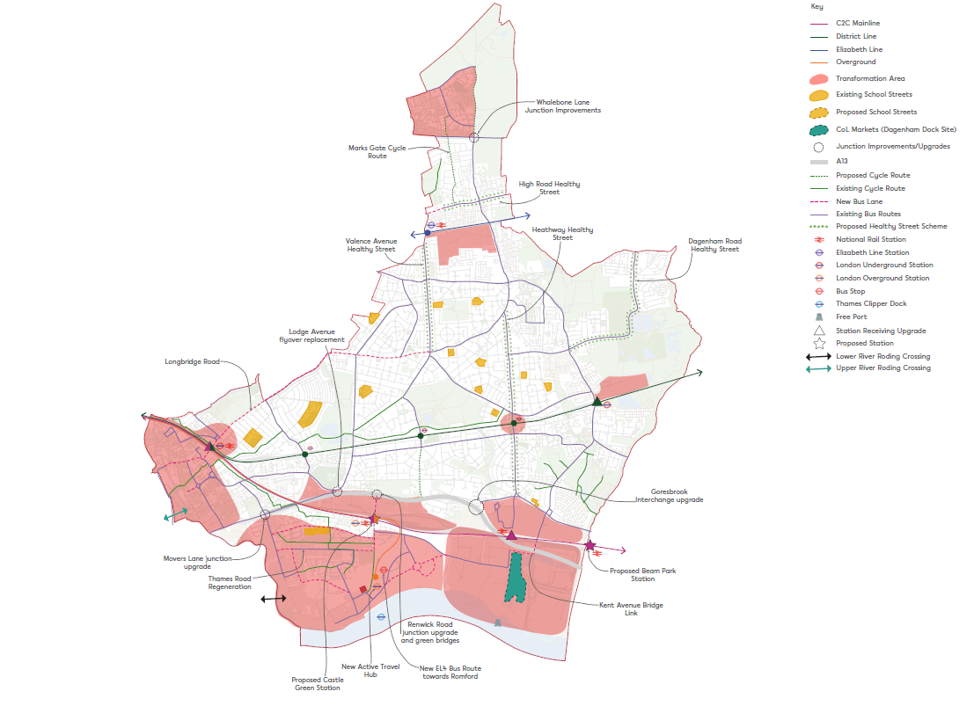  10.2. The section contains the following policies:  Strategic Policy SP8 Planning for integrated and sustainable transport  Policy DMT 1 Making better connected neighbourhoods  Policy DMT 2 Car parking  Policy DMT 3 Cycle parking  Policy DMT 4 Deliveries, servicing and construction  10.3. The policies are mainly supported by the key evidence below:  Key evidence documents Date produced  Barking Borough-wide Transport Strategy Topic Paper (ARUP) 2021  A walking and cycling strategy for LBBD 2021  LBBD Infrastructure Delivery Plan 2020  Local Implementation Plan 3 2019  LBBD Transport Impact Assessment and Evidence Base 2020  London Riverside Opportunity Area Transport Strategy (Jacob’s Consulting) with TfL and City of London 2020  5850Borough Transport Strategy Topic Paper, Be First/Arup, August 2021. LBBD Cycling and Walking Strategy, August 2021.
MM61 | SP8 | STRATEGIC POLICY SP 8: Planning for integrated and sustainable transport  1. In line with the borough-wide Transport Strategy Topic Paper the Council will seek to create a cohesive transport network for the whole borough that prioritises sustainable transport modes.  a) The Council will work proactively with the GLA, TfL, C2C , Network Rail and other network operators/stakeholders to develop strategic transport plans which enhance growth by improving local connectivity across the borough and the wider London area. The Council will promote sustainable active travel by extending current schemes including Low Emission Neighbourhoods & School Streets Programme. The Borough’s overall transport vision is outlined in Figure 25 below.  12. The Council will continue to follow the Mayor’s Transport Strategy through delivery of its Local Implementation Plan (LIP) and supporting programmes. This will be achieved by:  a) seeking improvements to and, where necessary, safeguarding existing land and buildings used for active travel (walking and cycling), public transport or related support functions critical for delivering the borough’s strategy for improving the transport network and services, as set out in the Local Implementation Plan and borough-wide Transport Strategy Topic paper  b) identifying and safeguarding new sites, space and route alignments, as well as supporting infrastructure which allow for We recognise the borough’s unique position as a rail freight hub containing several areas with rail freight infrastructure and excellent links to the continent and nationally. We will support the enhancement of these freight facilities and safeguard existing sites to promote modal shift of freight from road to rail or river. such as tThe proposed Dagenham FreepPort and the City Markets relocation at Dagenham Dock are key opportunities to do this. The rail sites at Castle Green also allow for future growth opportunities  c) seeking to adopt a multifaceted approach to sustainable transport which recognises the inter-relationship between successful placemaking, health and wellbeing, and the environment. We will develop an integrated, joined-up system that allows people to travel easily both within the borough and between other inner and outer London boroughs, prioritising active travel on key desire lines connected to new and existing public transport hubs  d) exploring the feasibility and business case of wider strategic schemes to improve the A13 and a potential future link across the River Roding that aim to reduce severance and improve environmental conditions  e) improve improving public transport access across the borough and into the town centres in respect of Policy DMD3: Development of Town Centres. This will include identifying locations for new bus priority infrastructure as well as the upgrading of existing services to meet future growth aspirations  f) supporting for consolidation of deliveries in town centres, logistics hubs and in new masterplans, with low or zero emission last-mile deliveries  g) working with rail operators, river freight operators, TfL and other partners to improve the operation and capacity of all stations, and maximising the use of rail sites, as well as safeguarded wharves in respect of Policy SP5: Promoting Inclusive Economic Growth  h) expanding the borough’s network of ‘School Streets’ where all motor vehicles, except those belonging to residents and school staff, are restricted from the immediate area during school drop-off and pick-up.  23. The Council will work to support the delivery of the Mayor’s two strategic targets in by 2041:  a) 75% of all trips (based on the citywide target of 80%) in Outer London to be made by walking, cycling or public transport  b) the Mayor’s Vision Zero ambition to eliminate all deaths and serious injuries on the roads.  34. In order to support the borough’s growth, the Council will seek where appropriate, schemes which are car-free or provide the minimum necessary offer a low level of parking provision in line with the London Plan 2021 parking standards. This will be supported by further development of local public transport networks and sustainable modes of travel such as wider footpaths, good cycling infrastructure and well-designed public realm walking and cycling routes.  45. We will also support developments to include the installation of electric vehicle charging points and supporting infrastructure, in line with London Plan 2021 targets. This will be further supported by the borough’s emerging EV vision.  56. In line with the borough’s Walking and Cycling Strategy the Council will support new and planned schemes such as Cycle Route CFR10, and the Barking to Chadwell Heath cycle route, which will reduce severance and improve connectivity across the borough. The Walking and Cycling Strategy also identifies existing routes to be upgraded, ensuring routes follow the Healthy Streets approach and are along key desire lines, which feed other transport modes.  67. The Council will seek a sustainable approach to freight by working with developers, local businesses, river and rail freight operators, and other partners to reduce highway congestion and environmental impacts. This will include the development of a Freeport on the River Thames to support planned industrial intensification and promote the enhancement and intensification of existing rail served sites within the borough.
MM62 | DMT 1 | POLICY DMT 1: Making better connected neighbourhoods  1. Strategic and major development proposals should be located where employment, housing and supporting facilities and services are within easy reach of each other by sustainable modes, reducing the need to travel and ensuring people are connected to places by, and with, high-quality, safe and attractive cycling and walking routes, both new and existing.  2. Active travel routes, which support walking and cycling, should connect to areas of Green and Blue Infrastructure as well as transport hubs around the borough, where possible. Walking routes must be suitable for wheelchairs, pushchairs and other users with limited mobility and must include places to stop and rest, with suitable and sufficient safe crossing points, where required, to reduce severance.  3. All proposals for new walking and cycling measures should be developed with an explicit understanding of how they promote use by women, children, elderly people, families, people from different ethnic backgrounds, and other people with protected characteristics as set out in the Equality Act.  4. Cycle routes should, where possible, be fully protected from road transport and walkways, following the best current design guidance (currently LTN 1/20 and LCDS). Routes should be attractive for users of all ages, and be designed for both leisure and commuter travel.  5. Active travel infrastructure proposals should demonstrate how they meet the Mayor’s Healthy Streets approach in line with TfL’s guidance⁵¹⁵⁹. Emerging schemes in the borough include: the Heathway Regeneration and Vallance Valence Avenue Healthy Streets, High Road Proposals, and Thames Road Regeneration.  6. Expanding the Sschool Sstreets Programme scheme will be considered in areas with low active travel method of travel to school mode shares.  Assessing Development Proposals  7. Development proposals should seek to reduce the dominance of vehicles on London’s streets whether stationary or moving, in line with the Mayor’s Transport Strategy.  8. Any development which is likely to have a significant impact on the borough’s transport network will be required to submit a robust Transport Assessment (TA) or Transport Statement (TS) and a Travel Plan⁵²⁶⁰, in accordance with Policy T4 of the London Plan 2021: assessing and mitigating transport impacts.  9. TA/TSs should be submitted with the development proposals outlined and ensure that any potential capacity effects on the transport network (including the walking and cycling network, public transport and road network) are fully assessed, in line with available best practice guidance for London. TAs / TSs should demonstrate how they accord with the Mayor’s ‘Healthy Streets’ approach.  10.Developments likely to generate significant amounts of movement should be supported by a Travel Plan (TP) as part of a planning application so that it can be considered in parallel to development proposals and readily integrated into the design and occupation of the new site, rather than retrofitted after occupation. TPs should include clear, measurable targets with a key focus on ongoing monitoring and evaluation of its effectiveness.  11.Applicants should also ensure they engage early with relevant stakeholders, including the borough, in order to establish the likely transport impacts and agree the assessment parameters and appropriate mitigation measures.  12.All developments will be required to demonstrate how they contribute to promoting sustainable modes of travel and limiting car use, particularly for short, local journeys.  13.Any development that will have an adverse impact on the highway and transportation network (for example, demonstrable disbenefits on congestion, safety, air quality and noise), as well as the operation of public transport (including crowding levels and journey times) will be required to contribute and deliver appropriate transport infrastructure or effective mitigation measures, including a reduction in vehicular parking spaces (in line with the London Plan 2021).  14.Where appropriate, conditions will be imposed or planning obligations secured through a Section 106 or S278 agreement. CIL contributions will also be expected, where appropriate, to fund larger schemes of a wider benefit such as improving the A13.  15.Developments in transformation areas as denoted by the Local Plan will be expected to contribute towards delivering the spatial strategies developed for that specific area, for instance the Barking Town Centre Movement Strategy.  16.Strategic developments should provide bus access and safeguard the land required for bus standing, which is vital for ensuring new services are operable. Developments should also design and implement new junctions and road connections to allow buses to travel through the site. The borough will also seek cycle facilities and local cycle routes to be provided within individual development sites to form a series of routes which would integrate locally into the borough and National Cycle Network (NCN). This will improve the borough’s permeability, removing severance by connecting people with places and helping to create one cohesive transport network through sustainable movement.  17.Development proposals will be required to include the installation of electric vehicle charging points and supporting infrastructure, in line with the London Plan 2021 Policy T6: car parking, Policy T6.1: residential parking, T6.2: office parking, T6.3: retail parking and T6.4 hotel and leisure parking.  5951 TfL has developed cycle route quality criteria to improve the standard of London’s cycle network. These criteria are designed to be consistent with recommendations in the London Cycling Design Standards and - working alongside other guidance and tools - should be used to shape the design of new cycling infrastructure. The criteria and tools are provided at https://tfl.gov.uk/corporate/publications-and-reports/cycling  6052Please refer to guidance available on TfL’s website: https://tfl.gov.uk/info-for/urban-planning-and-construction/transport-assessment-guide/transport-assessments
MM63 | DMT 2 | POLICY DMT 2: Car parking  1. All developments will be required to demonstrate how they contribute to promoting active, efficient and sustainable modes of travel and reducing car use by adopting the maximum complying with the car parking standards set out in the London Plan 2021. car parking standards (see Policy T6: car parking of the London Plan)  2. Car-free developments should be the starting point for all development proposals on sites that are (or are planned to be) well-connected to amenities by public transport, walking and cycling. (designated by an appropriate PTAL 5 or 6 rating). Car-free development will have no general parking but should still provide disabled persons parking in line with the London Plan. Developments in areas that are less well-connected will be required to provide the minimum necessary car parking (‘car-lite’) of poor/moderate transport accessibility will be required to be Car-lite, providing low-level car parking spaces on-site and a high-quality public realm that encourages walking, cycling and public transport use. Early engagement with the Council to discuss appropriate car parking levels that reflect eflect policy and based on the “LBBD Parking Guidance” is recommended.  3. Residential developments in the borough will be expected to adhere to the London Plan’s maximum car parking standards. In areas of poor public transport accessibility, car parking can help facilitate the building of family housing so developments may be required to provide a car parking provision nearer the London Plan maximum. Developers would be required to provide clear justification of the higher parking provision. Developers are required to provide clear justification when proposing the maximum permitted parking provision in less-well-connected areas. On larger strategic schemes early engagement with the Council and TFL is necessary encouraged.  4. Where parking is provided in a development it will be expected to:  a) provide a parking design and management plan, which follows the guidance provided by TfL’s best practice guidance on parking design and management, detailing mechanisms for leasing spaces, providing disabled parking to meet future demand and activating passive electric charge points  b) all parking provided by developments will be expected to be utilised by the development users and should have with strategies to convert car parking spaces to appropriate non-car parking uses, including pocket gardens, parklets, public realm spaces or cycleing parking. Oover time developments will be encouraged to actively convert their parking spaces into these uses, provided this does not have significant detrimental impacts on street parking, traffic and highways  c) include a car-free agreement within s106 agreements, restricting new residents from accessing parking permits within existing and proposed controlled parking zones  d) identify and measure local parking stress, and if deemed necessary contribute to a Controlled Parking Zone (CPZ) Programme where existing residents’ parking would be significantly impacted by the additional cars from a development, and this cannot be appropriately mitigated  e) Car Clubs should be proposed for all developments which are ‘car-free’ or ‘car-lite’ and considered for all other developments. In these cases, or if an existing Car Club is located within a reasonable distance of the development, free membership for residents will be required for at least the first two years after first occupation.  5. All developments are required to ensure that provision of on-street parking does not obstruct walking and cycling desire lines; all car parking spaces should be allocated with no potential for providing more spaces than planned for. Car parking, if required, should be designed in accordance with the London Plan and having regard to local masterplan SPDs, in line with the available best practice guidance.
MM64 | DMT 3 | POLICY DMTSI 3: Cycle parking  1. All developments must adopt the maximum minimum London Plan cycle parking standards (see Policy T5: cycling of the London Plan 2021). Any developments proposing a more generous provision of cycle parking and supporting infrastructure (e.g. changing rooms, maintenance facilities, lockers and shower facilities) will be supported, and this is actively encouraged.  2. The design and layout of cycle parking should be in accordance with the guidance contained in the London Cycling Design Standards, supported by appropriate on-site security measures. Accessible cycles parking should also be considered and designed for meeting minimum requirements as set out in the London Plan.  3. Where it is considered that proposed developments cannot accommodate sufficient cycle parking provision, developers will be obligated to work with borough officers to propose alternative solutions which meet the standards. These may include options such as providing spaces in secure on-street parking facilities such as cycle hangers or providing contributions to accessible Cycle Hubs in key areas identified in the Cycling and Walking Strategy. Developers in this situation should engage with the Council early in the planning process to discuss appropriate levels of provision and potential solutions.
MM65 | DMT 4 | POLICY DMTSI 4: Deliveries, servicing and construction  1. All major dDevelopment proposals must explore the use of alternative delivery and servicing practices and emerging technologies, including: freight consolidation and re-timing of deliveries; freight movements by water (see Local Plan Policy DMNE 4 Water Environment), the use of cargbo bikes, cycle freight, electric and low or zero-emission vehicles; and the use of delivery lockers in residential developments.  2. Where appropriate, all developments should maximise the use of the river for freight including the proposed freeport at Dagenham Dock. This includes operational needs as well as for the transportation of construction materials and waste to/from a development site, either directly via the site or through the supply chain.  3. All developments which may have construction impact will have to submit a Construction Logistics Plan (CLP) and Delivery and Servicing plan (DSP) as part of the planning process, having regard to in accordance with relevant TfL guidance.  4, All construction, demolition and major logistic activities within the borough will be required to work with the cCouncil in developing the scope and impact of their operations. In order to mitigate the impact of any additional traffic or potential disruption to the network, careful planning and co-ordination with the cCouncil is required to ensure the smooth operation of the highway network.
MM66 | Chapter 11 Justification Text | Chapter 11: Enabling delivery  Justification Introduction  1110.1. The purpose of this chapter is to set out our approach to enabling the delivery of the Local Plan. The following defines our approach.  - We want to ensure that individual and cumulative impacts of development are managed. Ensuring that infrastructure investment and delivery keep pace with growth is central to the delivery of our vision for inclusive growth. Our iInfrastructure dDelivery pPlan will be kept up to date and Infrastructure Funding Statements, setting out our priorities for the spend of developer contributions, will be published annually.  - We will undertake regular monitoring of permissions and developments to allow us to understand the effectiveness of the Local Plan and whether it is leading to the expected outcomes and remains an appropriate strategy. The annual Authority Monitoring Report will track the progress of the Local Plan aims.  - Engagement with our existing communities will continue through consultation on masterplans and other guidance and individual planning applications. Further details on our approach to engagement is provided in our latest Statement of Community Involvement published on our website.  - We will use the planning tools available to us including developer contributions secured through Planning Obligations (Section 106) and the Community Infrastructure Levy to achieve our development vision, which has been shaped by consultation with our communities. These, along with, the Mayor of London’s Community Infrastructure Levy (CIL) will help to fund infrastructure to support the development envisaged in this Local Plan, LIP and other supporting documents.  - We have assessed the impact of these charges, along with other policy requirements, to ensure development is viable. Further information and guidance will be set out in a Planning Obligations supplementary planning document (SPD).  - To enable the delivery of our vision, we are also clear that we give preference to comprehensive development to avoid the undermining of our wider delivery objectives.  1110.2. This chapter sets out and contains the following policies:  Strategic Policy 9 Managing and monitoring development  Policy DMM 1 Planning obligations (Section 106)  1110.3. The key evidence documents that this section relies on includes:  Key evidence documents Date produced  LBBD Whole Local Plan Viability Assessment 2020  LBBD Infrastructure Delivery Plan 2019  Barking Borough-wide Transport Strategy Topic Paper (ARUP) 2021  Barking Town Centre Transport Strategy 2021
MM67 | SP9 | STRATEGIC POLICY SP 9: Managing development  1. The Council encourages development proposals to come forward as early as possible to support the regeneration of the borough and which secure:  a) coordinated and comprehensive development  b) delivery of key infrastructure to ensure development is sustainable and encourages active travel and public transport usage.  2. Proposals which do not provide comprehensive and coordinated development should not undermine the wider delivery objectives and should have regard to any relevant SPD. In the absence of a relevant area SPD, all major developments (and minor developments where relevant and requested by planning officers) should include an indicative masterplan to show how development would not prejudice adjacent sites. This should be set out within the design and access statement.  32. The Council will work with private sector and public sector partners including Homes England, registered providers and, on cross boundary issues, neighbouring authorities, to front-load infrastructure investment and delivery and unlock development especially in the Transformation Areas identified in Chapter 3 of this Local Plan: ‘Transforming Barking and Dagenham’.  43. The Council’s Infrastructure Delivery Plan (IDP), which will be periodically reviewed, identifies the infrastructure necessary to support development and to connect it to its surroundings and integrate new and existing communities.  54. The Council and developers will be expected to proactively engage with residents and local businesses, using communications that best suit the communities, to ensure continued opportunity for local communities to inform and shape development in their area.  65. The Council will use planning tools, including preparation of masterplans and design codes, to support the delivery of the Local Plan and secure delivery of key community priorities, highlighted in the Barking Town Centre Transport Strategy and the borough-wide Transport Strategy  76. The Council may also use compulsory purchase powers to facilitate land assembly and the acquisition of all necessary rights to carry out development to enable delivery, including key infrastructure, as set out in this Local Plan and detailed in the latest IDP.  87. The Council will monitor the implementation of this Local Plan to assess whether growth targets and development outcomes are aligned and promote sustainability. A framework identifying the key indicators that will be monitored is included in Appendix 34.  98. The Council is committed to will undertakeing a full or partial update of this the Local Plan every 5 years, in line with national policy. However, if our we will continue to track our progress through the Annual Monitoring Report (which will assess our progress against the Key Performance Indicators set out in Appendix 3). assessment indicates that changes to policy would better support delivery or if our monitoring indicates an amended development strategy would be more effective. Where this suggests our policies are not being successfully implemented, we will consider whether an early review is necessary or whether other strategies (including the production of additional supplementary planning documents and guidance, and greater collaboration with developers and other key stakeholders, may be more appropriate to addressing the relevant area of concern, with recommendations to Cabinet where appropriate.
MM68 | DMM1 | POLICY DMM 1: Planning obligations (Section 106)  Indicative planning obligations  1. The Council will may use planning obligations to address a development’s impacts and to ensure it aligns with the Development Plan for the borough,. This may include Planning Obligations applied in line with the requirements set out in the rest of this Local Plan and , having regard to the Planning Obligations SPD and any other relevant SPDs. The list below shows what types of Planning Obligations are likely to be covered, but is not exhaustive:  a) affordable housing on-site or, if acceptable, an off-site financial contribution in place of this  b) carbon offset payment, where policy requirements are not met on-site  c) air quality measures off-site or a financial contribution if development does not meet the ‘air quality neutral’ benchmark  d) measures or payment to increase biodiversity where net gain is not feasible on-site  e) contributions to new green infrastructure and ecological resilience  f) highways works or payments towards addressing any impacts as a result of the development  g) other transport (including public transport, walking and cycling infrastructure) requirements arising from transport assessments, travel plans and growth projections. This will also include use of the waterways  h) construction-phase employment and procurement targets  i) occupation-stage employment and procurement targets  j) delivery of on-site social or physical infrastructure or payments necessary to mitigate the specific impacts of the development  k) affordable workspace, where required, or a payment in lieu  l) fees associated with the monitoring of any planning obligation secured which are separate and additional to any legal fees required to be paid to the Council for the preparation of the legal agreement or undertaking.  2. Other planning obligations may also be sought, where necessary, to mitigate the specific impacts of the development and where these cannot be secured by planning condition(s). Requirements for planning obligations will be assessed on a case-by-case basis and used where they meet the legal tests set out in Community Infrastructure Levy Regulations (2010) as amended.  3. Payments secured as planning obligations will normally be required at agreed trigger points, although some, for example monitoring fees, are paid upon signed agreement. prior to commencement of the development (or phase of development in the case of outline permissions) unless a financial appraisal demonstrates that later payment is acceptable. Where delivery of specific infrastructure or other works are required to enable development, the Council will use planning obligations to define the timing of development in relation to delivery of this.  Financial appraisals and viability review mechanisms  4. Developments which cannot meet the Local Plan requirements because of viability impacts will be expected to provide evidence of this in a financial appraisal submitted as part of their planning application. If a financial appraisal demonstrates that planning obligations cannot viably be afforded, the Council will prioritise affordable housing, sustainability, and necessary public transport and active travel improvements and employment. There is an expectation that contributions will be made to healthcare, education infrastructure, affordable workspace and culture and leisure facilities where there is an identified need. Contributions to employment and sustainability will continue to play a significant role in S106 agreements.  5. Where a financial appraisal has demonstrated any local plan requirements cannot be met, the Council may expect Planning Obligations to include a viability review mechanism, whereby viability is reassessed at an appropriate time based on up-to-date values and costs. Payments up to the level required by policy will be necessary if that viability review indicates these are viable. The Council may include a Planning Obligation requiring a viability review of a development including up-to-date values and costs. Payments up to the level required by policy will be necessary if the viability review indicates these can be supported when the review is undertaken.  6. Viability reviews will be required to have regard to comply with the GLA’s Homes for Londoners, Affordable Housing and Viability Supplementary Planning Guidance 2017⁵³⁶¹ (or its updated equivalent) and will typically be undertaken when:  a) substantial implementation, as agreed and defined in the legal agreement, of the scheme has not occurred within 24 months of grant of planning permission  b) 75 per cent of units are or have been sold or rented  c) prior to implementation of the second or defined phase of the development or on an annual basis for phased development.  Vacant Building Credit  7. Where a Vacant Building Credit is sought to reduce the affordable housing contribution, a Vacant Building Credit Statement must be submitted alongside a planning application and such schemes are not eligible for a Fast Track assessment. The statement should demonstrate that:  a) no part of the building has been in continuous use for any six months during the last five years up to the date of the planning application is submitted;  b) the building has not been vacated solely for the purpose of redevelopment; or  c) the building has been marketed for at least 24 months prior to the point of application.  - The Vacant Building Credit must define the existing gross internal floor area and the proposed gross internal floor area. Where the total proposed floor space is unclear at the time of application, such as may be the case for outline applications, the final calculation of any Vacant Building Credit will be deferred to a later phase of the development when details are available. This approach will be secured through a Section 106 agreement.  6153This is available at: https://www.london.gov.uk/what-we-do/planning/implementing-london-plan/ planning-guidance/affordable-housing-and-viability-supplementary-planning-guidance-spg
MM69 | Appendix 1 | Appendix 1: Relation with the existing planning policies  As set out below, all London Borough of Barking and Dagenham Core Strategy (2010) and Borough Wide Development Policies DPD (2011) policies, as well as site allocations in these and the Site-Specific Allocations (DPD) (2010), are superseded by this Plan.  Adopted Local Development Framework Policies Draft Local Plan Status of 2010 Core Strategy Policy  Core Strategy (DPD) (2010)  CM1: General principles for development SPDG1: Delivering growth; SPP1 – SPP7 Place policies Superseded  CM2: Managing housing growth SP3 4 : Delivering homes that meet peoples’ needs DME 1: Utilising the borough’s employment land more efficiently Superseded  CM3: Green Belt and public open space SP6: Green and blue infrastructure DMNE 1: Parks, open spaces and play space Superseded  CM4: Transport links SP8: Planning for integrated and sustainable transport DMT 1: Making better-connected neighbourhoods Superseded  CE1: Vibrant and prosperous town centres CM5: Town centre hierarchy SPDG1: Delivering growth SP5: Promoting inclusive economic growth DME 3: Encouraging vibrant, resilient, and characterful town centres DME 4: Over-concentration of hot food takeaways, betting shops and pay day loan shops DME 45: Visitor accommodation DME 56: Evening economy Superseded  CR1: Climate change and environmental management SP2: Delivering a well-designed, high-quality and resilient built environment SP7: Securing a clean, green and sustainable borough DMSI 1: Sustainable design and construction DMSI 2: Energy, heat and carbon emissions DMSI 4: Air quality DMSI 6: Flood risk and defences DMSI 7: Water management DMSI 8: Demolition, construction and operational waste DMSI 9: Smart utilities Superseded  CR2: Preserving and enhancing the natural environment SP6: Green and blue infrastructure DMNE 3: Nature conservation and biodiversity Superseded  CR3: Sustainable waste management SP7: Securing a clean, green and sustainable borough DMSI8: Demolition, construction and operational waste Superseded  CR4: Flood management SP7: Securing a clean, green and sustainable borough DMSI 6: Flood risk and defences Superseded  CC1: Family housing SP3: Delivering homes that meet peoples’ needs SP2: Delivering a well-designed, high-quality and resilient built environment DMH 2: Housing size mix DMH 4: Large-scale Purpose-built shared housing and DMH 5: hHouses in multiple occupations (HMOs) Superseded  CC2: Social infrastructure to meet community needs SP4: Delivering social and cultural infrastructure, facilities in the right location DMS 1: Protecting and enhancing existing facilities DMS 2: Planning for new facilities DMS 3: Public houses Superseded  CC3: Achieving community benefits through developer contributions DMM 1 SP9: Managing Development and monitoring DMM 12: Planning obligations (Section 106) DME 3: Encouraging vibrant, resilient, and characterful town centres Superseded  CE2: Location of office development SP5: Promoting inclusive economic growth DME 2: Providing flexible, affordable workspace Superseded  CE3: Safeguarding and release of employment land CE4: Mix and balance of uses within designated employment areas SP5: Promoting inclusive economic growth DME 1: Utilising the borough’s employment land more efficiently Superseded  Adopted Local Development Framework Policies Draft Local Plan Status of 2010 Core Strategy Policy or Borough Wide Development Policies 2011 DPD Policy  CP1: Vibrant culture and tourism DME 4: Visitor accommodation Superseded  CP2: Protecting and promoting our historic environment SP2: Delivering a well-designed, high-quality and resilient built environment DMD 4: Heritage assets and archaeological remains DMD 5: Local views Superseded  CP3: High-quality built environment SP24: Delivering a high-quality design in the borough and resilient built environment DMD 1: Securing high-quality design DMD 2: Tall buildings DMD 3: Development in town centres Superseded  Borough wide development policies DPD (2011)  BR1: Environmental building standards DMD 1: Securing high-quality design DMSI 1: Sustainable design and construction DMT 4: Deliveries, servicing and construction Superseded  BR2: Energy and on-site renewables DMSI 2: Energy, heat and carbon emissions Superseded  BR3: Greening the urban environment DMNE 1: Parks, open spaces and play space DMNE 2: Urban greening DMNE 3: Nature conservation and biodiversity DMNE 4: Water environment DMNE 5: Trees DMNE 6: Local food growing, including allotments Superseded  BR4: Water resource management DMNE 4: Water environment DMSI 6: Flood risk and defences Superseded  BR5: Contaminated land DMSI 5: Land contamination Superseded  BR6: Minerals N/A Superseded  BR7: Open space (quality and quantity) DMNE 1: Parks, open spaces and play space Superseded  BR8: Allotments DMNE 6: Local food growing including allotments Superseded  BR9: Parking DMT 2: Car parking DMT 3: Cycle parking Superseded  BR10: Sustainable transport DMT 1: Making better connected neighbourhoods Superseded  BR11: Walking and cycling DMT 1: Making better connected neighbourhoods Superseded  BR12: Hazardous development DMSI 5: Land contamination Superseded  BR13: Noise mitigation DMSI 3: Nuisance Superseded  BR14: Air quality DMSI 4: Air quality Superseded  BR15: Sustainable waste management SP7: Securing a clean, green and sustainable borough Superseded  BC1: Delivering affordable housing accommodation DMH 1: Affordable housing DMH 2: Housing size mix DMM 12: Planning obligations (Section 106) Superseded  BC2: Accessible and adaptable housing DMH 3: Specialist housing Superseded  BC3: Gypsies and Travellers DMH 65: Gypsy and Traveller accommodation Superseded  BC4: Residential conversions and houses in multiple occupation DMH 4: Large-scale Purpose-built shared housing and DMH 5: hHouses in multiple occupations (HMOs) DMD 65: Householder extensions and alterations Superseded  BC5: Sports standards DMS 1: Protecting and enhancing existing facilities DMS 2: Planning for new facilities DMNE 1: Parks, open spaces and play space Superseded  BC6: Loss of community facilities DMS 1: Protecting and enhancing existing facilities Superseded  BC7: Crime prevention DMD 1: Securing high-quality design DMD 2: Tall buildings Superseded  BC8: Mixed use development All Local Plan development management policies Superseded  BC9: Live-work units N/A Superseded  BC10: The health impacts of development DMD 1: Securing high-quality design Superseded  BC11: Utilities Chapter 2: Area development strategy Chapter 3: LBBD Strategic Development Strategy (linking with the Council’s latest infrastructure delivery plan) DMSI 2: Energy, heat and carbon emissions DMSI 9: Smart utilities Superseded  BC12: Telecommunications DMSI 9: Smart utilities Superseded  BE1: Protection of retail uses BE2: Development in town centres BE3: Retail outside of town centres DME 3: Encouraging vibrant, resilient, and characterful town centres DME 4: Over-concentration of hot food takeaways, betting shops and Pay Day Superseded  BE4: Managing the evening economy DME 56: Evening economy Superseded  BE5: Offices – design and change of use DMD 1: Securing high-quality design DME 2: Providing flexible, affordable workspace Superseded  BP1: Culture and tourism DME 45: Visitor accommodation DME 56: Evening economy Superseded  BP2: Conservation areas and listed buildings DMD 4: Heritage assets and archaeological remains DMD 5: Local views Superseded  BP3: Archaeology DMD 4: Heritage assets and archaeological remains Superseded  BP4: Tall buildings DMD 2: Tall buildings Superseded  BP5: External amenity space DMD 1: Securing high-quality design DMNE 1: Parks, open spaces and play space Superseded  BP6: Internal space standards N/A (This is covered in the London Plan 2021) Superseded  BP7: Advertisement control DMD 76: Advertisements and signage Superseded  BP8: Protecting residential amenity DMD 1: Securing high-quality design DMD 65: Householder extensions and alterations DMSI 3: Nuisance Superseded  BP9: Riverside development SP2 4 : Delivering a high-quality design in the borough and resilient built environment DMNE 4: Water environment Superseded  BP10: Housing density N/A (This is covered in the London Plan 2021) Superseded  BP11: Urban Design Chapter 4: Design Superseded  Barking Town Centre Area Action Plan (DPD) (2011) Status of Barking Town Centre Area Action Plan  Superseded  Site Specific Allocations (DPD) (2010) Status of Site Specific Allocations DPD (2010)  Chapter 3: Transforming Barking and Dagenham and Appendix 2: Site Allocations Superseded
MM70 | Appendix 2 | Appendix 2: Site allocations  (See separate ‘Appendix 2: Site Allocation Proformas’ document which also forms part of this Plan)  The purpose of this section is to identify and allocate key strategic development sites and small housing sites in LBBD, as well as the identified broad locations for Gypsy and Traveller sites.  This section should be read in conjunction with Chapter 3: Transforming Barking and Dagenham and the rest of the Local Plan policies.  The site proformas are enclosed in a separate document and are available to view online.  Site reference Site name Ward  1 AA Barking Riverside Thames  2 AC Marrielands Crescent Two Thames  3 AD Dagenham Leisure Park Goresbrook  4 AE Beam Park (South Dagenham East) River  5 AJ Gascoigne East Estate (3 phases) Gascoigne  6 AK Vicarage Field Abbey  7 AL Gascoigne Estate West (phased development) Gascoigne  8 AM Crown House & Linton Road car park Abbey  9 AU Abbey Retail Park (South) Gascoigne  9 BB Tesco car park Gascoigne  10 CD Land at the Corner of London Road and North Abbey Street (Former Site of White Horse PH and Omnibus Park) Abbey  11 CF Castle Green Thames and Eastbury  12 CH Chadwell Heath Industrial Estate Whalebone and Valence  13 CI Thames Road Thames  14 CM Gascoigne Industrial Area (phased development) Gascoigne  15 CO Padnall Lake Chadwell Heath  16 CW 90 Stour Road Heath  17 DJ Clockhouse Avenue Abbey  18 DM Dagenham Heathway Mall Village  19 DN Gascoigne South (phased development) Gascoigne  20 DO Town Quay Gascoigne  21 EA Barking Station Abbey  22 HA Wickes (Hertford Road) Abbey  23 HN Ripple Road and Methodist Church Abbey  24 RC Barking Rugby Club Thames  25 WF Sainsburys 97-131 High Road Chadwell Heath  26 XC Harts Lane Estate Abbey  27 XD 41-59 (Odd) Hepworth Gardens 38-64 (Even) Southwold Drive 1-32 Hepworth Court Hepworth Gardens Longbridge  28 XE Ibscott Close Estate and highways land at Rainham Road South and Ballards Road Village  29 XJ Former Ford Stamping Plant River  30 XK Riverside Gateway Thames  31 YM Phoenix House, 12-14 Wakering Road, Barking Abbey  32 ZZ GSR and Gill Sites – Land on the West side of Chequers Lane, Dagenham Thames  33 CV- Small housing site allocations North Becontree Station Becontree  34 CV – Small housing site allocations Salisbury Road car park Village  35 DZ – Small housing site allocations Dagenham Labour Hall Whalebone  36 HL – Small housing site allocations Hapag Lloyd House Abbey  37 HO – Small housing site allocations 14-34 London Road Abbey  38 WD – Small housing site allocations Former Victoria Public House Abbey  39 YG – Small housing site allocations Garages at Keir Hardie Way Eastbury  40 ZT – Small housing site allocations 58-62 Church Street Village  41 RA – School allocation New Pondfield School (special school) Albion  42 RB – School allocation Ford Polar (special school) Thames  43 XR – Employment allocations Barking Power Station River  44 XW – Employment allocations Plot 67 SEGRO Park River  45 XX – Employment allocations Plot 70 SEGRO Park River  46 XV – Employment allocations Plot 65 SEGRO Park River  47 XS – Employment allocations Plot 62 SEGRO Park River  48 XT – Employment allocations Plot 63 SEGRO Park River  49 XU– Employment allocations Plot 64 SEGRO Park River  50 ZW – Employment allocations Here East and Film Studios Eastbrook  51 Proposed Traveller Broad Location 1 Choats Road Thames  52 Proposed Traveller Broad Location 2 Collier Row Road Chadwell Heath
MM71 | Appendix 3 | Appendix 3: Local Plan Key performance indicators  The following key indicators will be monitored along with commentary on other key social, economic and environmental changes that impact on plan delivery and the delivery context as part of the authorities. Informed by the strategy in the Local Plan, they are grouped into five themes  • Design, heritage and conservation  • Housing  • Employment  • Infrastructure  • Environment  Number Key performance indicator Strategic policies Development management policies Target (if applicable) Source of monitoring information  Design, heritage and conservation  1 % of planning appeals allowed on design grounds. SP2: Delivering a high-quality design in the borough and resilient built environment DMD1: Securing high-quality design N/A Appeals Record from the Quality Review Panel, Local, national and international design awards Planning database  2 Number of designated or non-designated heritage assets: - Lost; - Subject to harm SP2: Delivering a high-quality design in the borough and resilient built environment DMD6: Heritage assets and archaeological remains N/A Reduction Planning database and Heritage Risk Register  3 Number of tall buildings within and outside of Tall Building Locations (for the purposes of this indicator, only developments referable to the Mayor of London for being over 30 metres in height will be looked at) SP2: Delivering a high-quality design in the borough and resilient built environment DMD2: Tall buildings N/A Planning database  Housing  4 Net and gross number of new homes completed, started and permitted within monitoring period. SPDG1: Delivering growth; SP3: Delivering homes that meet peoples’ needs N/A 19,440 between 2019-2029, including 1,990 small sites target Planning database and on-site monitoring  5 Net increase in Gypsy and Traveller Pitch Provision SPDG1: Delivering growth; SP3: Delivering homes that meet peoples’ needs DMH 6 33 over Plan period Planning database  65 Capacity for additional housing from developable sites for years 0-5, 5-10 and 10+ of the borough’s housing trajectory (including small sites below 0.25ha). SPDG1: Delivering growth; SP3: Delivering homes that meet peoples’ needs N/A To demonstrate a five-year supply for housing (on a rolling basis) and a fifteen year housing trajectory GLA SHLAA and LBBD Housing Land Assessment  76 Total number of completed, started and permitted within the monitoring period classified as affordable by unit size for including breakdown by: - Low cost rent (social rent or affordable rent); - Intermediate (London Living Rent or shared ownership). - Market. SP3: Delivering homes that meet peoples’ needs DMH1: Affordable housing Borough wide strategic target 50% Planning database and aAffordable Housing Team  87 Percentage of units approved and completed which are: M4(2): accessible and adaptable dwellings compliant and M4(3) wheelchair user dwellings compliant SP3: Delivering homes that meet peoples’ needs DMH3: Specialist housing N/A 10% of dwellings (which are created via works which Part M Vol 1 of the Building Regulations applies) must meet M4(3) ‘wheelchair user dwellings’ requirements and all others should meet M4 (2) requirements ‘accessible and adaptable dwellings’. Planning database and LBBD/Be First Housing  98 Number of beds provided as part of specialist housing schemes completed and permitted within the monitoring period, categorised by type and sub-area SP3: Delivering homes that meet peoples’ needs DMH3: Specialist housing GLA Target for specialist older persons housing: 70 units per annum between 2017-2029 Planning database and LBBD housing manager  109 Total number of Build-to-Rent units completed and permitted within the monitoring period. SP3: Delivering homes that meet peoples’ needs N/A N/A Planning database  1110 Number of student beds completed and permitted within the monitoring period, categorised by place, and the proportion of which are considered affordable. SP3: Delivering homes that meet peoples’ needs DMH4: Large-scale Purpose-built shared housing house and DMH 5: Houses in Multiple Occupation (HMOs) N/A Planning database  Employment  1211 Net gain and loss (sq.) SIL and LSIS within the borough (approved and completed) SP1: Delivering growth; SP5: Promoting inclusive economic growth DME1: Utilising the borough’s employment land more efficiently N/A No Net Loss of SIL Floorspace in line with Appendix 5 Planning database and VOA database and on-site  1312 Total affordable employment floorspace proposed in permitted and the proportion of overall employment space SP1: Delivering growth; SP5: Promoting inclusive economic growth DME2: Providing flexible, affordable workspace N/A Planning database  13 Number of new hotel rooms and floorspace granted planning permission and completed within the monitoring period and by sub-area SP1: Delivering growth; SP5: Promoting inclusive economic growth DME5: Visitor accommodation N/A Planning database  14 Monitoring jobs delivered by new development SP5: Promoting inclusive economic growth 20,000 jobs over plan period Planning database  Environment  1514 Total amount of new publicly accessible open space, new parks (part of a large-scale development) and play space by sub-area SP6: Green and blue infrastructure DMNE1: Parks, open spaces and play space N/A Net increase LBBD Parks Team  15 Net area of designated SINCs through permitted schemes. SP6: Green and blue infrastructure DMNE1: Parks, open spaces and play space DMNE3: Nature conservation and biodiversity N/A Planning database  16 Percentage of permitted schemes achieving at least 10% Biodiversity Net Gain SP6: Green and blue infrastructure DMNE3: Nature conservation and biodiversity N/A 100% of major schemes achieving at least 10% Biodiversity Net Gain Planning database  17 Number of permitted schemes achieving at least a Minimum Urban Greening Factor of 0.4 SP6: Green and blue infrastructure DMNE2: Urban Greening Minimum UGF of 0.4 on average across permitted schemes Planning database  Sustainable Infrastructure  1817 Number of permitted and completed major development schemes designed to achieve the net zero carbon target SP7: Securing a clean, green and sustainable borough DMSI2: Energy, heat and carbon emissions N/A Net increase Planning database and on-site monitoring  1918 Total sum of Carbon Offset Funds secured and received through Section 106 Agreements SP7: Securing a clean, green and sustainable borough DMSI2: Energy, heat and carbon emissions N/A Section 106 Monitoring database  20 Net change in the total number of social and community facilities (including health) SP4: Delivering social and cultural infrastructure facilities in the right locations DMSI 1: Protecting and enhancing existing facilities DMSI 2: Planning for new facilities Increase Planning database  21 Monitoring of gross new or improved social and community infrastructure floor space (m2). SP4: Delivering social and cultural infrastructure facilities in the right locations DMSI 2: Planning for new facilities Increase Planning database  Transport  2219 Net loss and gain of depots and wharves SP8: Planning for integrated and sustainable transport SP5: Promoting inclusive economic growth DMT3: Deliveries, servicing and construction No net loss Planning database  2320 Number of car-free developments permitted SP8: Planning for integrated and sustainable transport DMT1: Making better connected neighbourhoods Increase Planning database  24 Number of car club bays delivered by developments SP8: Planning for integrated and sustainable transport DMT 2: Car Parking N/A Transport Team Monitoring  25 Number of EV charging points delivered by developments SP8: Planning for integrated and sustainable transport DMT 1: Making better connected neighbourhoods N/A Transport Team Monitoring  Sustainable Transport Indexes (Collected by others)  26 Increase the number of bus passengers by reducing delays on the network SP8: Planning for integrated and sustainable transport DMT 1: Making better connected neighbourhoods Net increase TfL bus delay reporting  27 Reduce the number of people killed or seriously injured on London’s transport system SP8: Planning for integrated and sustainable transport DMT 1: Making better connected neighbourhoods Vision Zero TfL’s collision statistics database
MM72 | Appendix 4 | Replace current Appendix 4 with the below to reflect the latest housing trajectory.  Appendix 4: Housing trajectory  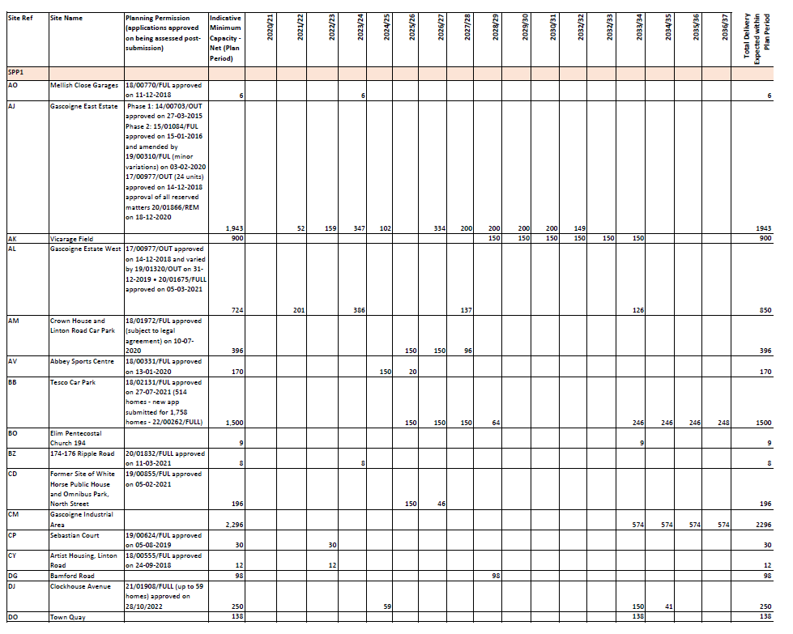  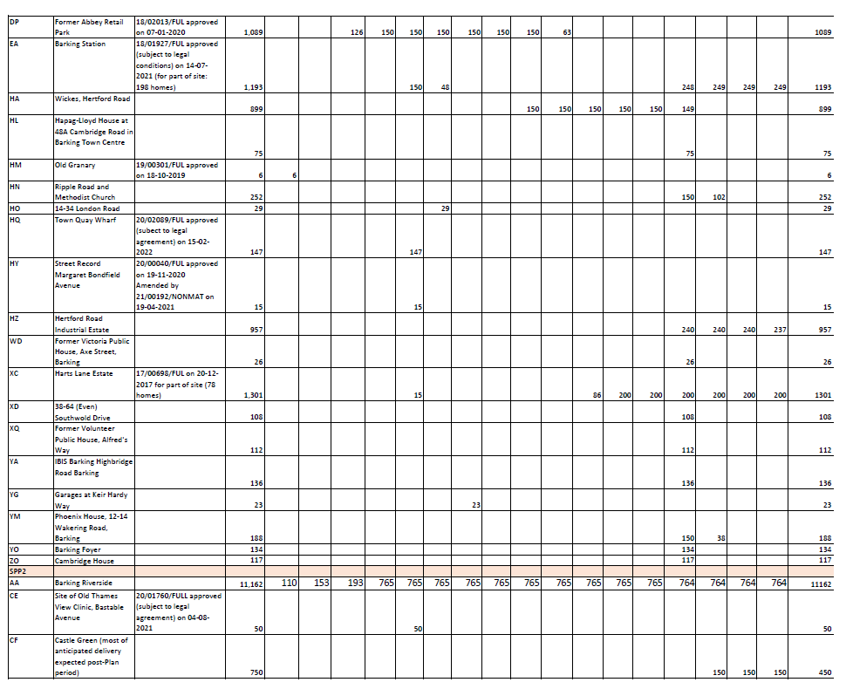  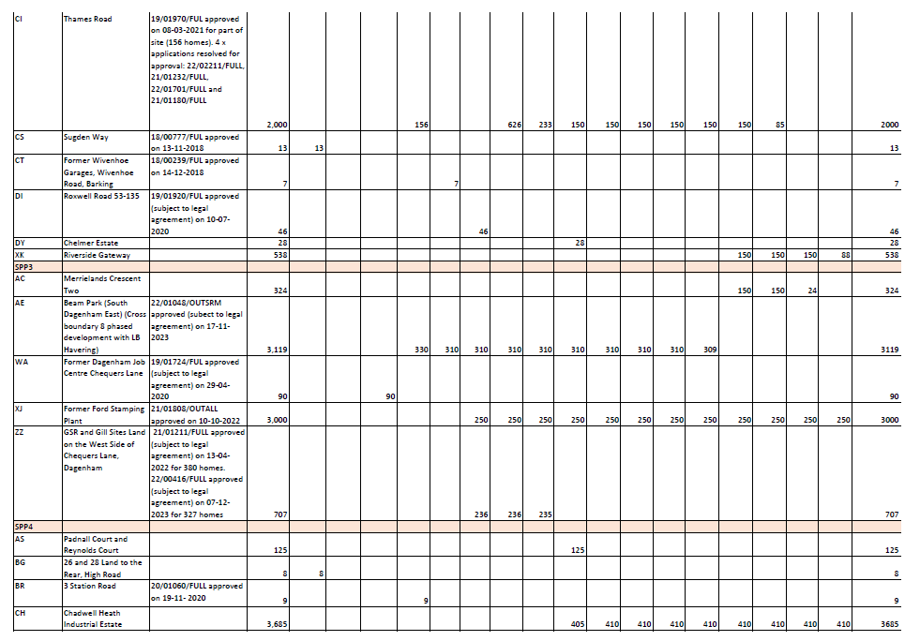  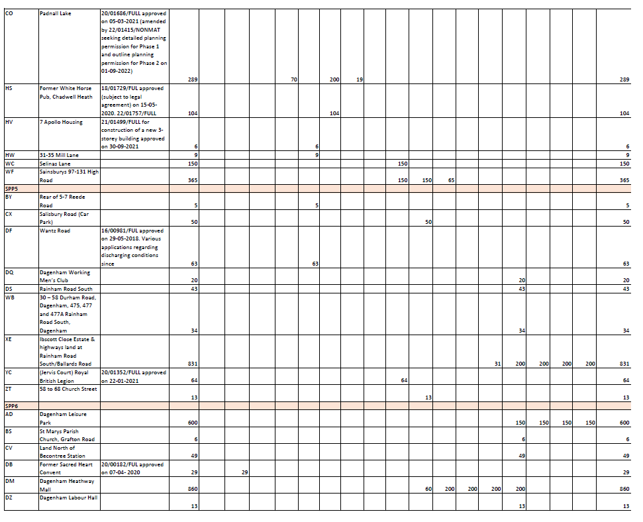  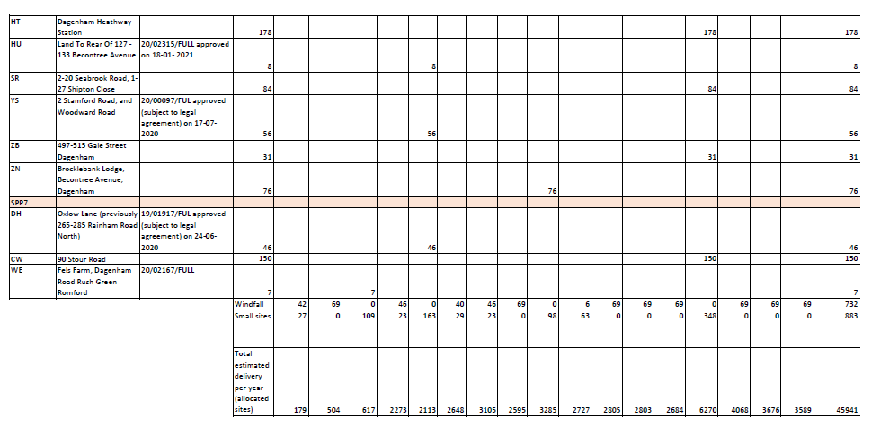
MM73 | Appendix 5 | Replace Appendix 5 with new Appendix 5 as follows:  Appendix 5: Table to support KPI12 of Appendix 3  The Borough's industrial land will be monitored using the table below. Development proposals should include a statement showing how they will contribute to meeting the indicative future floorspace capacity set out below for the reference area that their proposed development/redevelopment lies within. These areas are shown in the borough's 2021 Industrial Land Strategy: https://yourcall.befirst.london/13753/widgets/39553/documents/21220  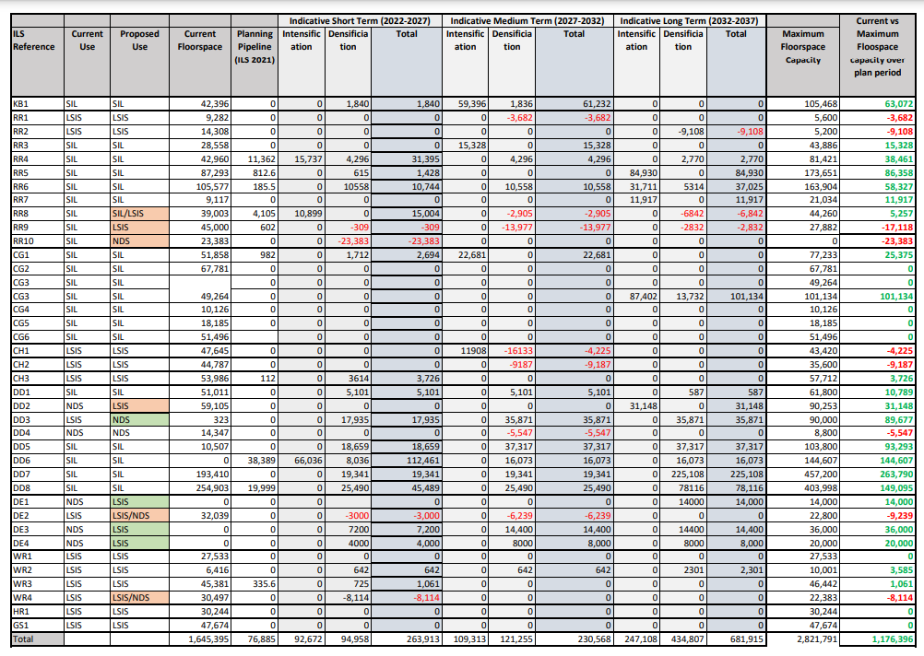
MM74 | Glossary | Add the following amendments to the Glossary  Term Definition  Borough-wide Development Policies (2011) A Development Plan Document within the Local Development Framework, which contains detailed development policies focused on the implementation of the 2010 Core Strategy. This document has been replaced by the new Local Plan (2019)  Designated Sites Includes parks and open space, green space, Sites of Importance for Nature Conservation or other designations identified within the Borough's Parks and Open Space Strategy (2017, or updated equivalent)  District Energy Network (DEN) Combine both District Energy Network definitions on page 181 in the submission Plan as follows: An energy network which extends over a wider area. A District Energy Network provides an area with a low carbon energy source that is generated in a central location, which is then converted to hot water and pumped through a network of underground pipes and delivered to a heat exchanger within buildings. The Council supports DENs and the Council’s energy company (B&D Energy) has undertaken extensive heat mapping and energy master-planning of the entire borough. They have identified district energy opportunity areas where there is significant potential to create area-wide heat networks, the largest of which will be in Barking town centre, with Phase 1 already under construction.  District Energy network (DENs) An energy network which extends over a wider area. The Council supports DENs and the Council’s energy company (B&D Energy) has undertaken extensive heat mapping and energy master-planning of the entire borough. They have identified district energy opportunity areas where there is significant potential to create area-wide heat networks, the largest of which will be in Barking town centre, with Phase 1 already under construction.  Family Housing/Housing Capable of Accommodating a Family with Children A dwelling that by virtue of its size, layout and design is suitable for a family with children to live in and generally has two or more bedrooms three, four, five, or more bedrooms.  Modern Methods of Construction A range of off-site, near site and on-site pre-manufacturing, process improvements and technology improvements that provide alternatives to traditional building methods. It has the potential to deliver significant improvements in productivity, efficiency and quality for both the construction industry and public sector.  Public open space Public Open Space includes areas defined by the London Plan Open Space Hierarchy (District Parks and Local Parks and Open Space, Small Open Spaces, Pocket Parks and Linear Open Spaces) in addition to allotments protected from development as detailed in the Site Specific Allocations DPD.  Specialist Older Persons hHousing For the purpose of this Plan, specialist older persons housing is defined as housing designed to meet the diverse range of needs of older people homes for older people, households with specialist needs, supported housing, hostels and student accommodation. Examples of specialist older persons housing include: - sheltered housing – commonly self-contained homes with limited on-site support; - retirement homes (– including age restricted dwellings where no care is provided or small communities of older persons living together as a single household with some degree of support; - residential care homes – commonly bedsit rooms with shared lounges and eating arrangements; - nursing homes – similar to residential care, but accommodating ill or frail elderly people, and staffed by qualified nursing staff; - dual-registered care homes – residential care homes where nursing care is provided for those residents who need it; - extra-care homes – combinations of the above providing independent living alongside care and support, and sometimes also offering support for older people in the wider community; - staff accommodation ancillary to a relevant use; and - hostels - a form of shared accommodation.  Well-connected In the context of Barking and Dagenham, a well-connected location is one that has good access to public transport, active travel infrastructure, and other amenities and services. This typically means that the location is in PTAL 3 or above, but there may be instances where locations are well-connected with a lower PTAL, such as where active travel infrastructure supplements connectivity by public transport. NB. A location not meeting the above definition is considered a 'less-well connected' location for the purposes of this Plan.
Appendix 2: Proposed Site Allocations (Main Modifications)
MM75 | Appendix 2 | Replace all the maps shown in the site proformas in Appendix 2: Proposed Site Allocations with maps aligned to new key proposed in the updated PDF Policies Map (January 2024)
MM76 | Appendix 2 | Remove all 'Anticipated Delivery Timescales (Years)' heading and subsequent '0-5', '5-10' and '11+' boxes from housing sites as housing delivery timescales estimates are covered by new housing trajectory proposed in Appendix 4.
MM77 | SPP1 | Insert new section heading page as follows:  Sites within Strategic Area SPP1: Barking and the River Roading Area  Insert contents page of sites for the SPP1 Area  Add sentence on contents page of sites setting out the following:  Housing Allocation 'Indicative Minimum Capacity' and 'Units' set out the net minimum number of new homes it is expected there is capacity to deliver within the Plan period.  Remove section heading as follows:  Strategic Sites for Housing
MM78 | SPP1  AO-Mellish Close Garages | Add new proforma as follows:  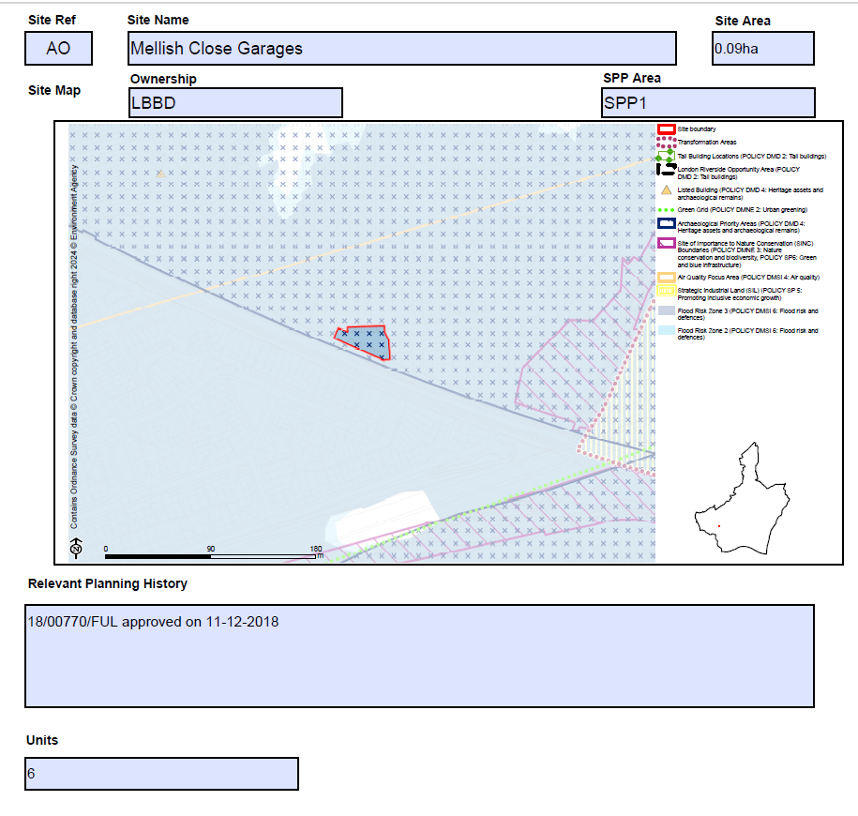
MM79 | SPP1  AJ-Gascoigne Estate East | Amend bullet two of the Proposed Use(s) section as follows:  - Capacity of delivering circa net 1,943 2,324 new homes and a Neighbourhood Centre with up to 1,850 sq.m of commercial, employment and community space.  Amend bullet point/s under 'Planning Constraints and Requirements' heading (now proposed to be entitled 'Development Requirements') as follows:  - Consideration of strengthening the relationship with adjacent land/areas, see Local Plan sub area policy Policy: SPP1  - For part of site within Flood Zone 3, providing flood mitigation and adaptation measures to comply with the Policies DMNE4 and DMSI 6, and having regard to the TE 2100 Plan  - In accordance with Policy DMSI 5: Land contamination, a preliminary risk assessment (PRA), such as a site walkover or conceptual model must be undertaken. Where contamination may have a pollution risk to controlled waters, Site Investigation and Remediation Strategy reports may be required.  Add to bullet point under 'Relevant Planning History' as follows:  - 20/01866/REM (all reserved matters for 526 dwellings) approved on 18-12-2020  Amend Indicative Minimum Capacity as follows:  2,324 1,943 new homes
MM80 | SPP1  AK-Vicarage Field | Amend bullet two of the Proposed Use(s) section as follows:  - Potential to deliver circa 900 new homes, with up to 138,000 sqm of GEA comprising of an increase of new high quality retail floorspace up to 25,650 30,900 sq.m of commercial, business and services floorspace (Use Class E) and, up to 1,250sq.m up to three-form entry primary school (Use Class F1), up to 7,750sqm hotel floorspace (Use Class C1), up to 81,750 sqm of residential floorspace (Use Class C3), and leisure and public house uses (Sui Generis).  Amend bullet point/s under 'Planning Constraints and Requirements' heading (now proposed to be entitled 'Development Requirements') as follows:  - Vicarage Field is located within Barking Town Centre, and is adjacent to Abbey and Barking Town Centre Conservation Area -comply to Local Plan policies Policies DME3 and DMD4.  - In accordance with Policy DMSI 5: Land contamination, a preliminary risk assessment (PRA), such as a site walkover or conceptual model must be undertaken. Where contamination may have a pollution risk to controlled waters, Site Investigation and Remediation Strategy reports may be required.
MM81 | SPP1  AH - Fresh Wharf Estate | Remove proforma as site completed prior to Plan period.
MM82 | SPP1  AL-Gascoigne Estate West | Amend bullet point/s under 'Planning Constraints and Requirements' heading (now proposed to be entitled 'Development Requirements') as follows:  - Consideration of strengthening the relationship with the adjacent land/areas, see Local Plan sub area policy Policy: SPP1  - Providing flood mitigation and adaptation measures to comply with Policies DMNE 4 and DMSI 6, and having regard to the TE 2100 Plan  - In accordance with Policy DMSI 5: Land contamination, a preliminary risk assessment (PRA), such as a site walkover or conceptual model must be undertaken. Where contamination may have a pollution risk to controlled waters, Site Investigation and Remediation Strategy reports may be required.  Amend bullet point/s under 'Relevant Planning History' as follows:  - 20/01675/FULL approved on 05-03-2021
MM83 | SPP1  AM-Crown House and Linton Road Car Park | Add new proforma as follows:  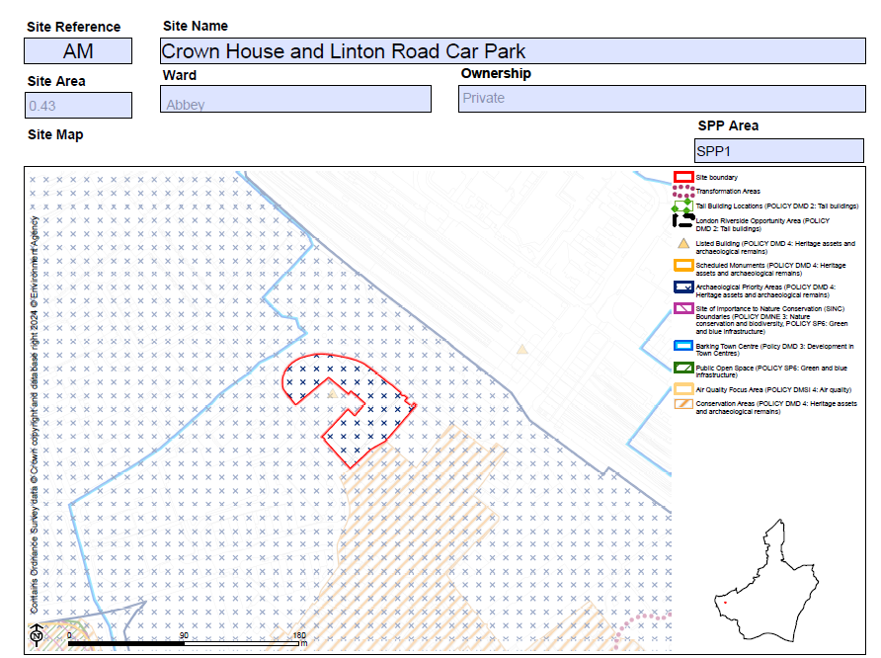  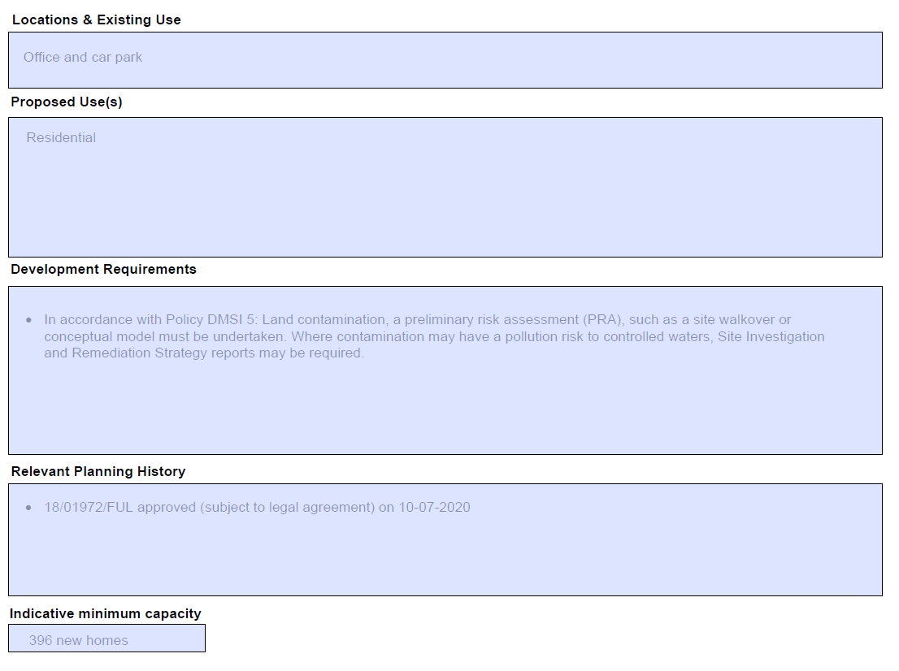
MM84 | SPP1  AV-Abbey Sports Centre | Add new proforma as follows:  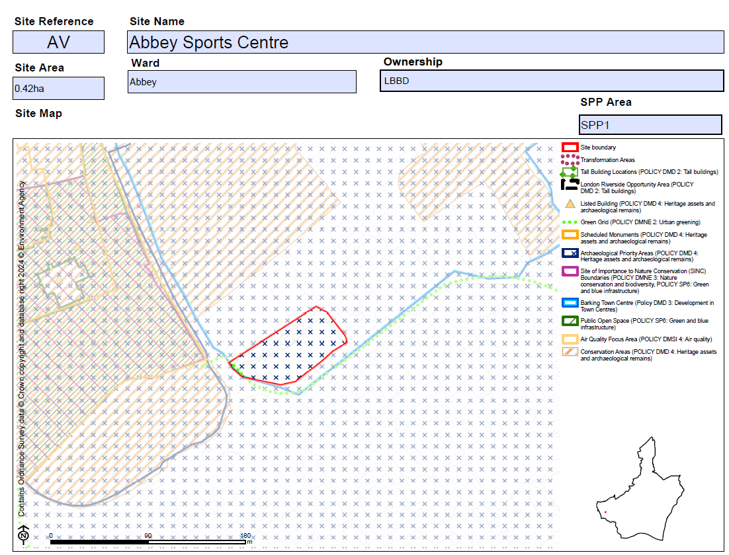  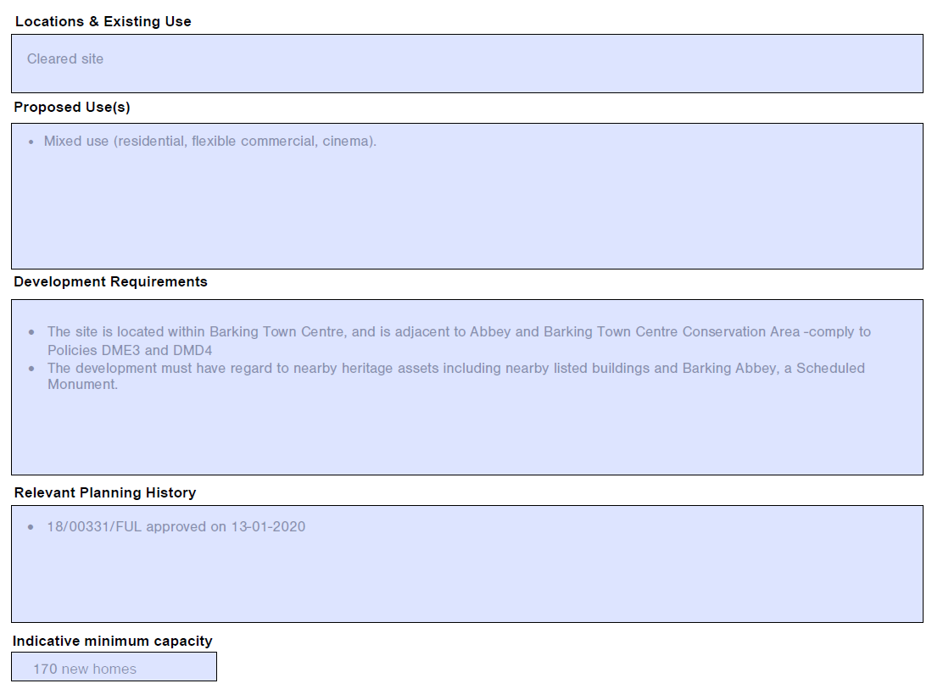
MM85 | SPP1  BB-Tesco Car Park | Amend bullet point/s under 'Proposed Use(s)' as follows:  - A comprehensive mixed-use development. Potential capacity of delivering circa 1,500 new homes., with opportunity to contribute to education provision  Amend bullet point/s under 'Planning Constraints and Requirements' heading (now proposed to be entitled 'Development Requirements') as follows:  - Consideration of the nearby conservation area/heritage assets in accordance with the Local Plan policy Policy DMD4.  - The site contains bronze age timber platforms and trackways which is likely to need appropriate archaeological evaluation.  - An archaeological assessment must be submitted in support of any planning application; this will inform how design can preserve or enhance any heritage asset.  - In line with Policy DMNE 4: Water environment, the development will need to consider ways to enhance the estuary and river edge for fish and other wildlife.  - In accordance with Policy DMSI 5: Land contamination, a preliminary risk assessment (PRA), such as a site walkover or conceptual model must be undertaken. Where contamination may have a pollution risk to controlled waters, Site Investigation and Remediation Strategy reports may be required.  - Providing flood mitigation and adaptation measures to comply with Policies DMNE4 and DMSI 6, and having regard to the TE 2100 Plan  - Tall buildings maybe appropriate in this location (see Local Plan policy DMD2), subject to other planning considerations.  - Development proposals for retail and leisure uses exceeding 500sq.m gross will be required to submit an impact assessment in accordance with the NPPF and NPPG  Amend bullet point/s under 'Relevant Planning History' as follows:  - 18/02131/FUL (for part of the site - car park only) approved on 27-07-2021
MM86 | SPP1  BO-Elim Pentecostal Church 194 | Add new proforma as follows:  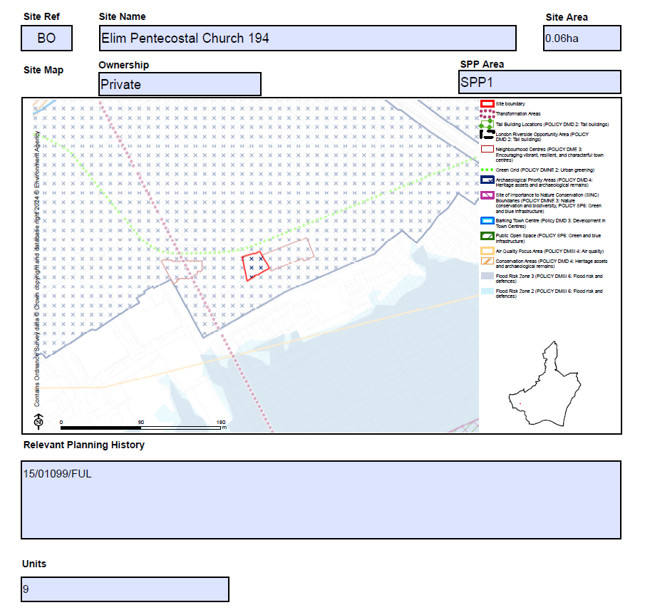
MM87 | SPP1  BZ- 174-176 Ripple Road | Add new proforma as follows:  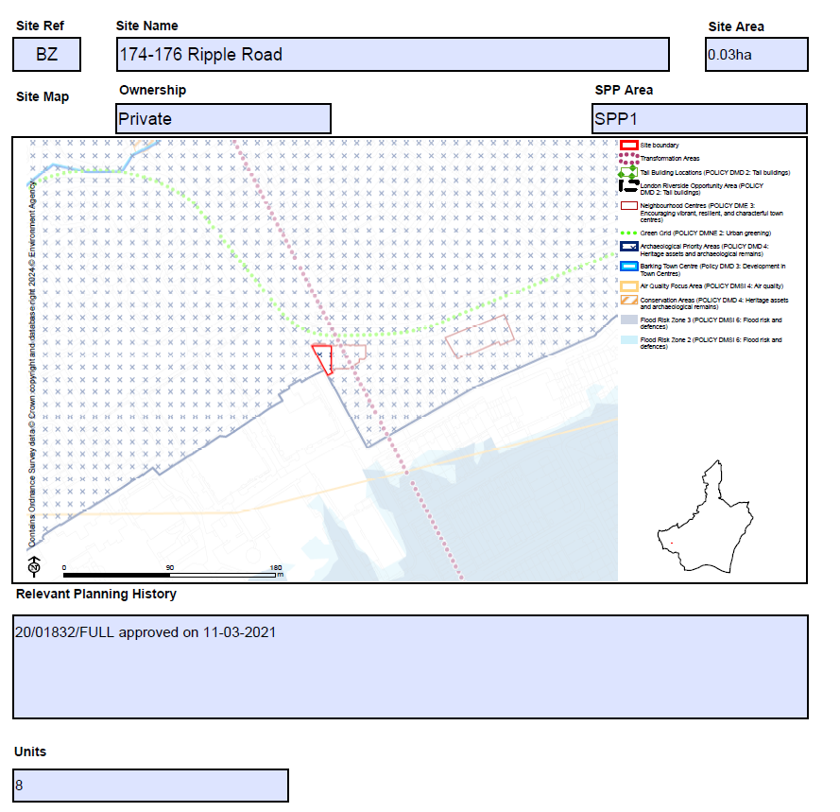
MM88 | SPP1  CD-Former White Horse Public House and Omnibus Park, North Street | Add new proforma as follows:  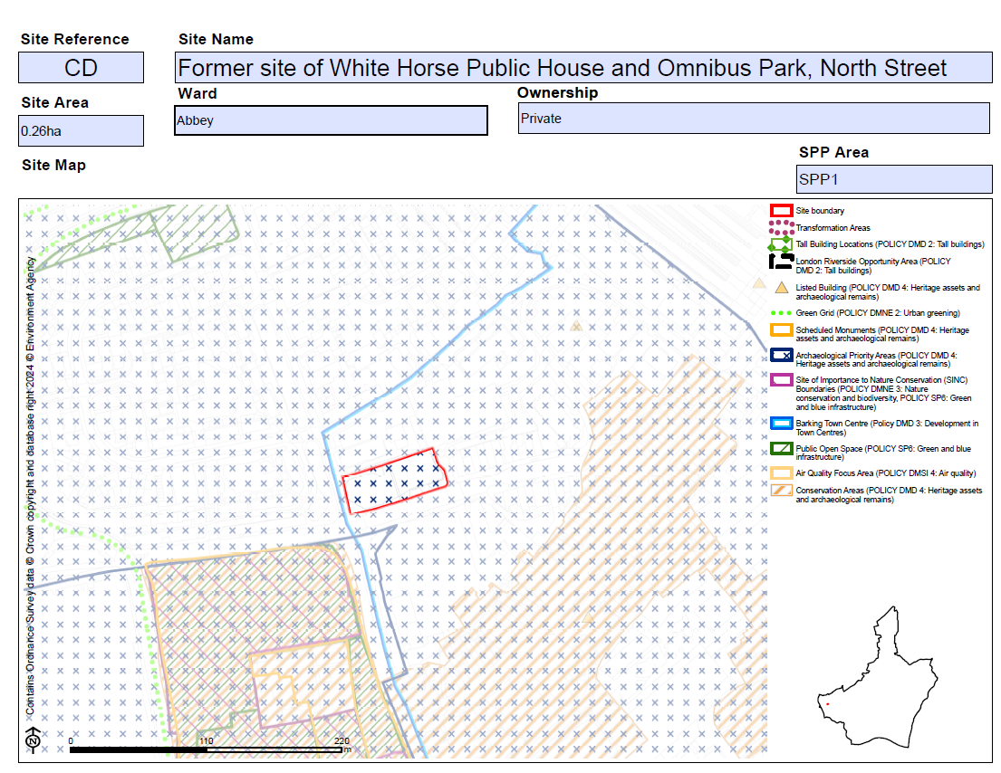  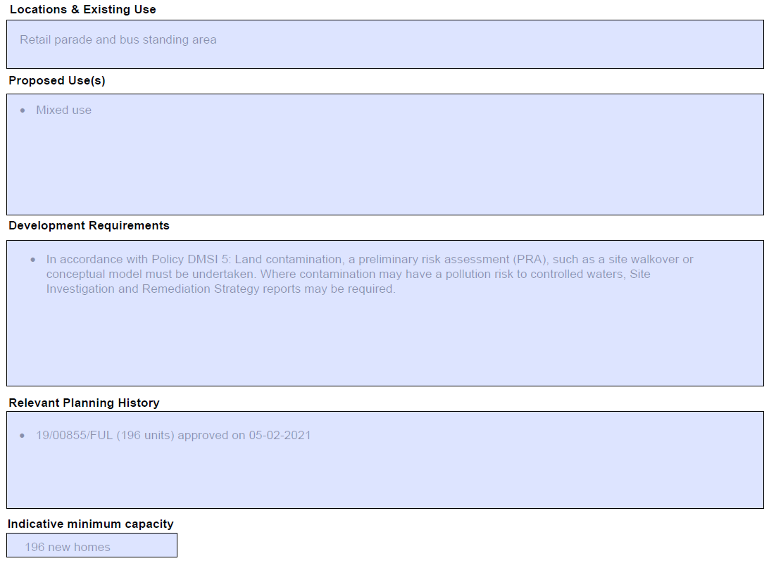
MM89 | SPP1  CM-Gascoigne Industrial Area | Amend bullet point/s under 'Proposed Use(s)' as follows:  - Potential capacity of delivering circa 2,296 2,289 new homes, 1 new primary school, with opportunity for co-location to accommodate the vision for redevelopment of the Gascoigne Estate.  Amend bullet point/s under 'Planning Constraints and Requirements' heading (now proposed to be entitled 'Development Requirements') as follows:  - Consideration of strengthening the relationship with the adjacent land/areas, see Local Plan sub area policy: Policy SPP1  - In line with Policy DMNE 4: Water environment, the development will need to consider ways to enhance the estuary and river edge for fish and other wildlife.  - In accordance with Policy DMSI 5: Land contamination, a preliminary risk assessment (PRA), such as a site walkover or conceptual model must be undertaken. Where contamination may have a pollution risk to controlled waters, Site Investigation and Remediation Strategy reports may be required.  - Providing flood mitigation and adaptation measures to comply with Policies DMNE4 and DMSI 6, and having regard to the TE 2100 Plan.  Add Indicative Minimum Capacity as follows:  2,296
MM90 | SPP1  CP-Sebastian Court | Add new proforma as follows:  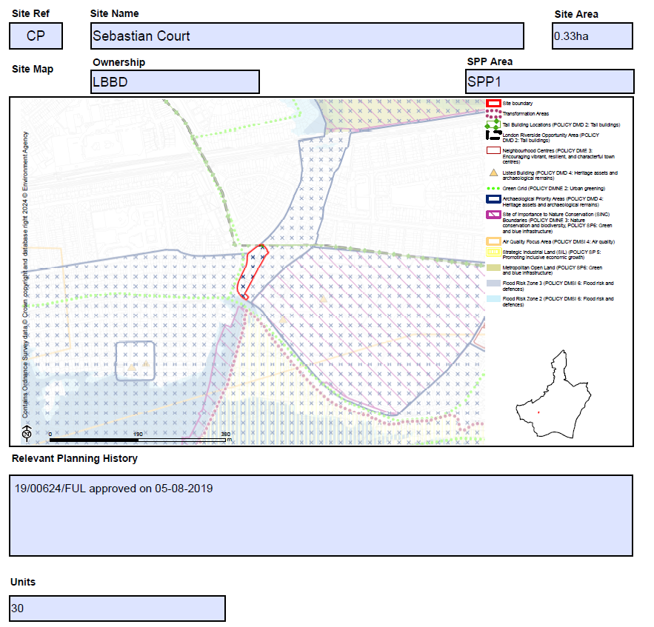
MM91 | SPP1  CY-Artist Housing, Linton Road | Add new proforma as follows:  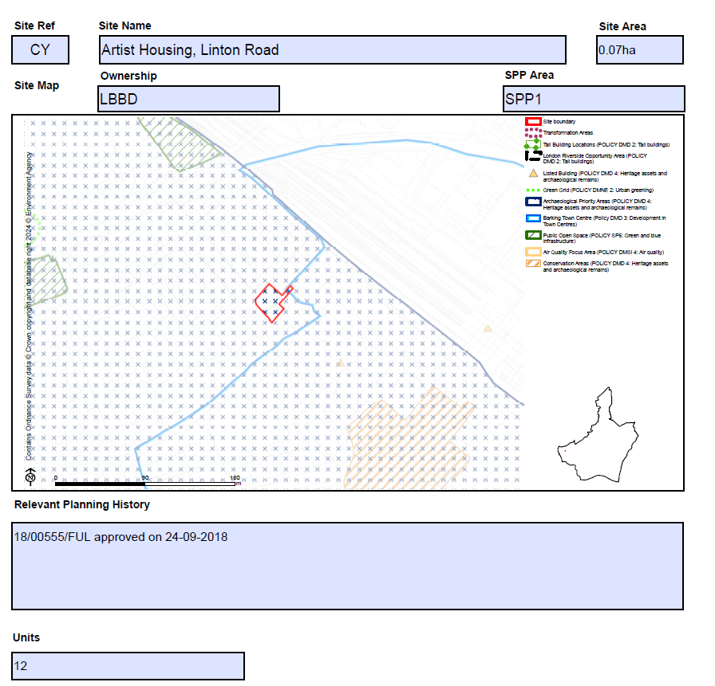
MM92 | SPP1  DG-Bamford Road | Replace proforma as follows:  Submission Plan Main Modification Version  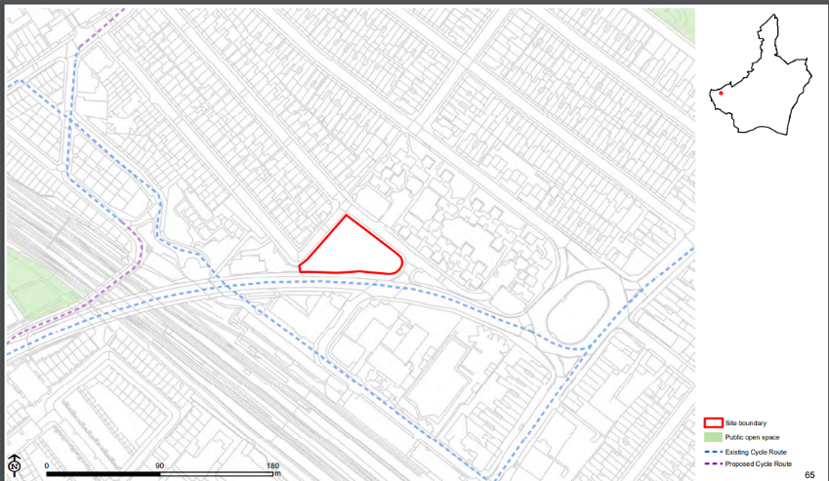  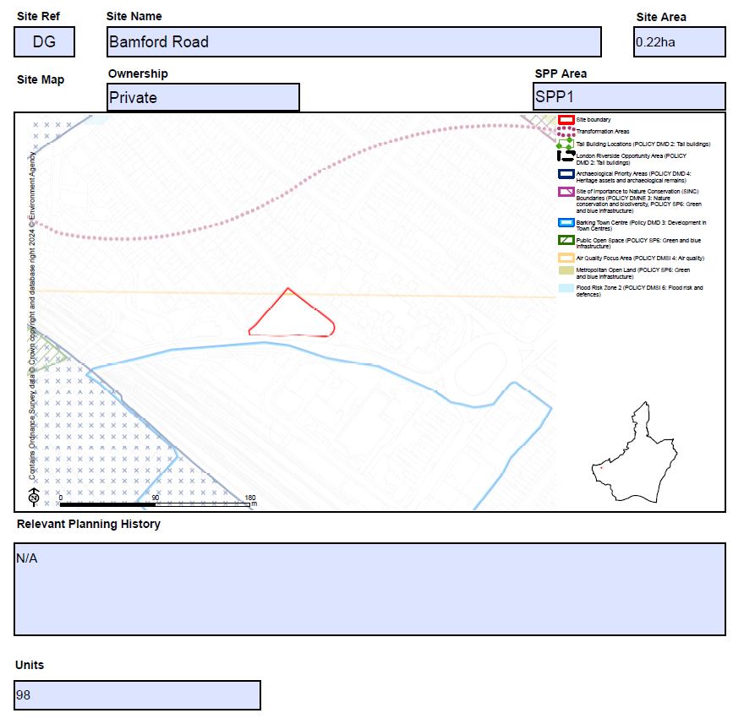
MM93 | SPP1  DJ-Clockhouse Avenue | Amend bullet point/s under 'Planning Constraints and Requirements' heading (now proposed to be entitled 'Development Requirements') as follows:  - The site is located within Barking Town Centre, and is located within the Abbey and Barking Town Centre Conservation Area - comply to the Local Plan policies DME3 and DMD4.  - Development must preserve or enhance the character or appearance of the Abbey and Barking Town Centre Conservation Area.  •Development should aim to deliver out-standing design through:  - Re-establishing the urban streetscape  - Defining the urban scale  - Extending east street market with a covered courtyard  - Ceating human-oriented space that prioritise the people who use the space daily  - Significantly improving the frontage, for example, ground floor functions of the facing Clockhouse building will be ac-tive use like cafes and shops  - Providing flexible spaces that can be adapted to a series of different typologies  Amend bullet point/s under 'Relevant Planning History' as follows:  - N/A 21/01908/FULL (up to 59 homes) approved on 28/10/2022
MM94 | SPP1  DO-Town Quay | Add new proforma as follows:  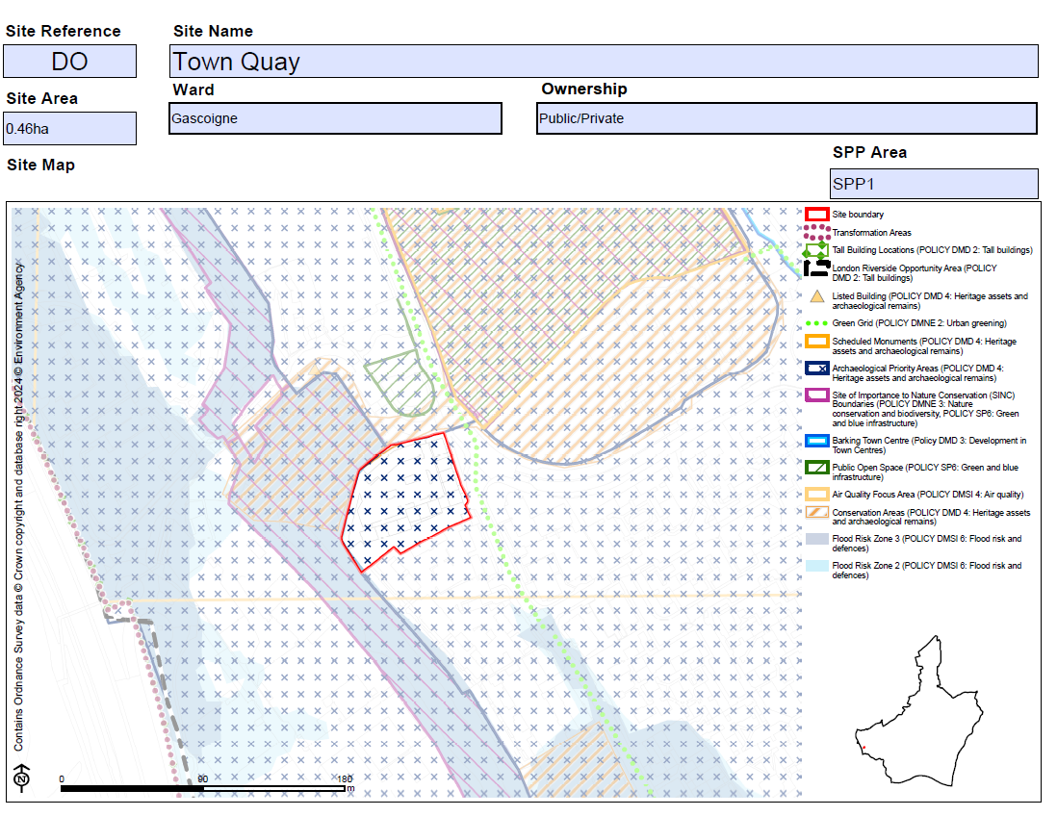  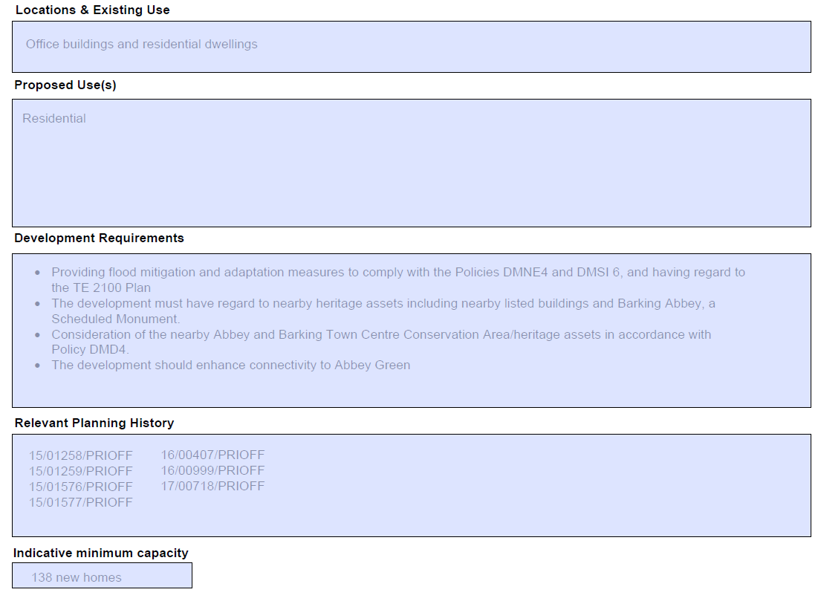
MM95 | SPP1  DP-Abbey Retail Park North | Amend site name as follows:  Former Abbey Retail Park North  Amend bullet point/s under 'Planning Constraints and Requirements' heading (now proposed to be entitled 'Development Requirements') as follows:  - Tall buildings maybe appropriate in this location (see Local Plan policy DMD2), subject to other planning considerations.  - Consideration of the nearby conservation area/heritage assets in accordance with the Local Plan policy Policy DMD4.  - Development proposals for retail and leisure uses exceeding 500sq.m gross will be required to submit an impact assessment in accordance with the NPPF and NPPG  - Providing flood mitigation and adaptation measures to comply with Policies DMNE4 and DMSI 6, and having regard to the TE 2100 Plan  Amend bullet point/s under 'Relevant Planning History' as follows:  - 18/02013/FUL approved on 07-01-2020
MM96 | SPP1  EA-Barking Station | Amend bullet point/s under 'Proposed Use(s)' as follows:  - A comprehensive mixed-use redevelopment. Potential capacity of delivering 1,182 1,193 new homes and flexible commercial floorspace, including affordable workspace.  Amend bullet point/s under 'Planning Constraints and Requirements' heading (now proposed to be entitled 'Development Requirements') as follows:  - Tall building development maybe appropriate in this location (see Local Plan policy DMD2), subject to other planning considerations.  - Consideration of the nearby Abbey and Barking Town Centre Cconservation Aarea/heritage assets in accordance with the Local Plan policy Policy DMD4.  - In accordance with Policy DMSI 5: Land contamination, a preliminary risk assessment (PRA), such as a site walkover or conceptual model must be undertaken. Where contamination may have a pollution risk to controlled waters, Site Investigation and Remediation Strategy reports may be required.  Amend bullet point/s under 'Relevant Planning History' as follows:  - 18/01927/FUL (Trocoll House) approved (subject to legal agreement) on 14-07-2021 (for part of site:198 homes)  Amend Indicative Minimum Capacity as follows:  198 1,193
MM97 | SPP1  HA-Wickes (Hertford Road) | Amend bullet point/s under 'Proposed Use(s)' as follows:  - A comprehensive residential-led mixed-use development. Potential capacity of delivering circa 899 734 new homes, flexible commercial/community floorspace and other supporting infrastructure.  Amend bullet point/s under 'Planning Constraints and Requirements' heading (now proposed to be entitled 'Development Requirements') as follows:  - In accordance with Policy DMSI 5: Land contamination, a preliminary risk assessment (PRA), such as a site walkover or conceptual model must be undertaken. Where contamination may have a pollution risk to controlled waters, Site Investigation and Remediation Strategy reports may be required.  - Providing flood mitigation and adaptation measures to comply with Policies DMNE4 and DMSI 6, and having regard to the TE 2100 Plan  - The development must have regard to nearby heritage assets including nearby listed buildings and Barking Abbey, a Scheduled Monument.  - An archaeological assessment must be submitted in support of any planning application; this will inform how design can preserve or enhance any heritage asset.  - Development should provide flood mitigation and adaptation measures  - Tall building development maybe appropriate in this location (see Local Plan policy DMD2), subject to other planning considerations  Amend Indicative Minimum Capacity as follows:  734 899
MM98 | SPP1  HL- Hapag-Lloyd House at 48A Cambridge Road in Barking Town Centre | Replace proforma as follows:  Submission Plan Main Modification Version  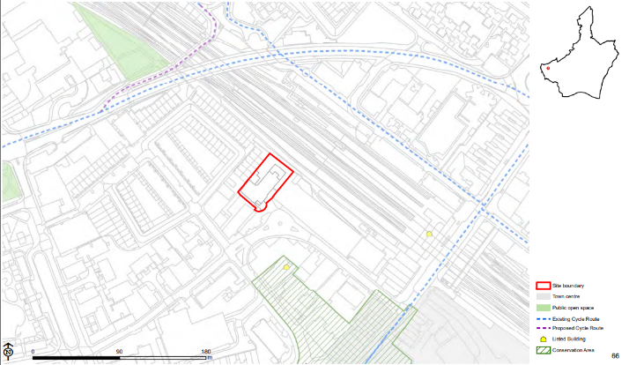  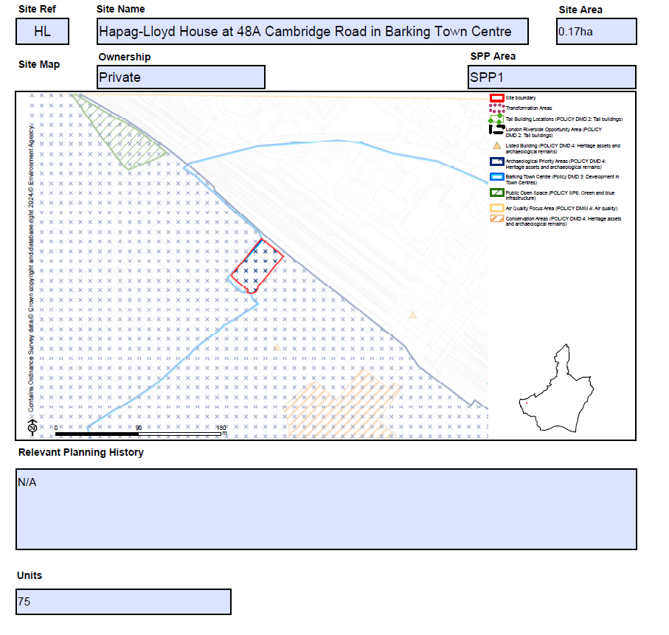
MM99 | HM-Old Granary | Replace proforma as follows:  Submission Plan Main Modification Version  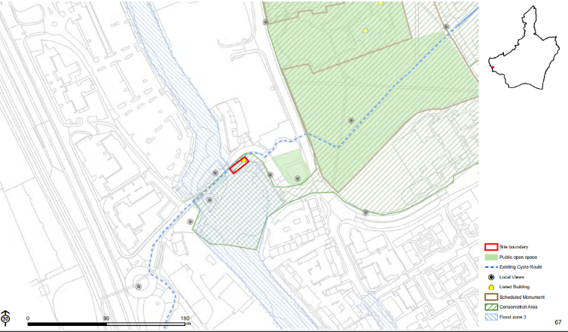  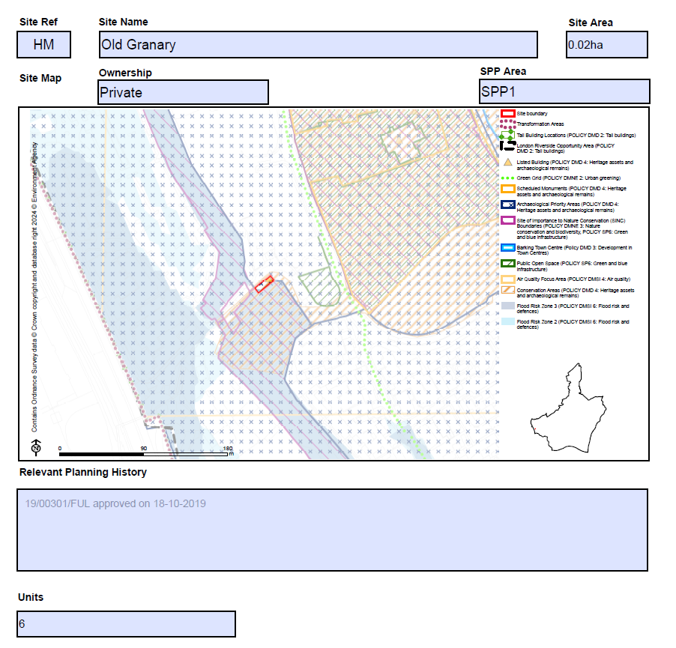
MM100 | SPP1  HN-Ripple Road and Methodist Church | Amend bullet point/s under 'Proposed Use(s)' as follows:  - Residential-led mixed-use development, with potential to deliver up to 252 250 new homes, reprovision of the places of worship space, 1 new primary school and flexible commercial/community uses, with improved local retail and office space and amenity space.  Amend bullet point/s under 'Planning Constraints and Requirements' heading (now proposed to be entitled 'Development Requirements') as follows:  - The site is located within Barking Town Centre, and is adjacent to Abbey and Barking Town Centre Conservation Area - comply to the Local Plan policies Policies DME3 and DMD4.  - Development should aim to deliver out-standing design and aims to improve the southern part of the Town Centre.  - In accordance with Policy DMSI 5: Land contamination, a preliminary risk assessment (PRA), such as a site walkover or conceptual model must be undertaken. Where contamination may have a pollution risk to controlled waters, Site Investigation and Remediation Strategy reports may be required.  - Tall building development maybe appro-priate in this location (see Local Plan poli-cy DMD2), subject to other planning considerations
MM101 | SPP1  HO- 14-34 London Road | Replace proforma as follows:  Submission Plan Main Modification  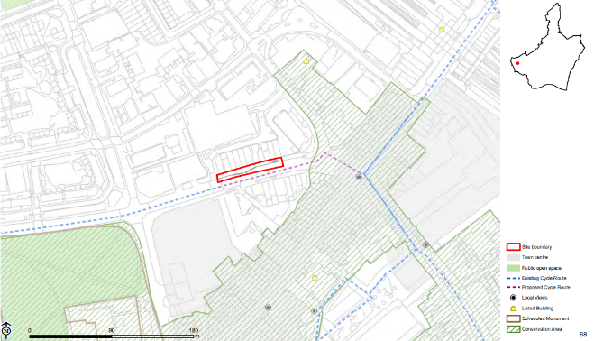  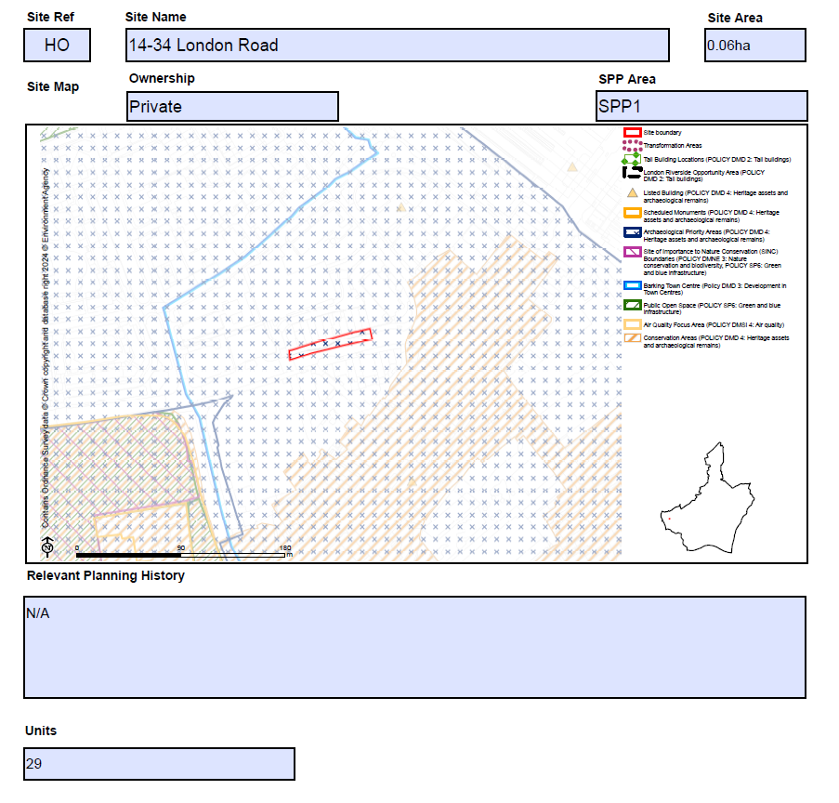
MM102 | SPP1  HQ-Town Quay Wharf | Add new proforma as follows:  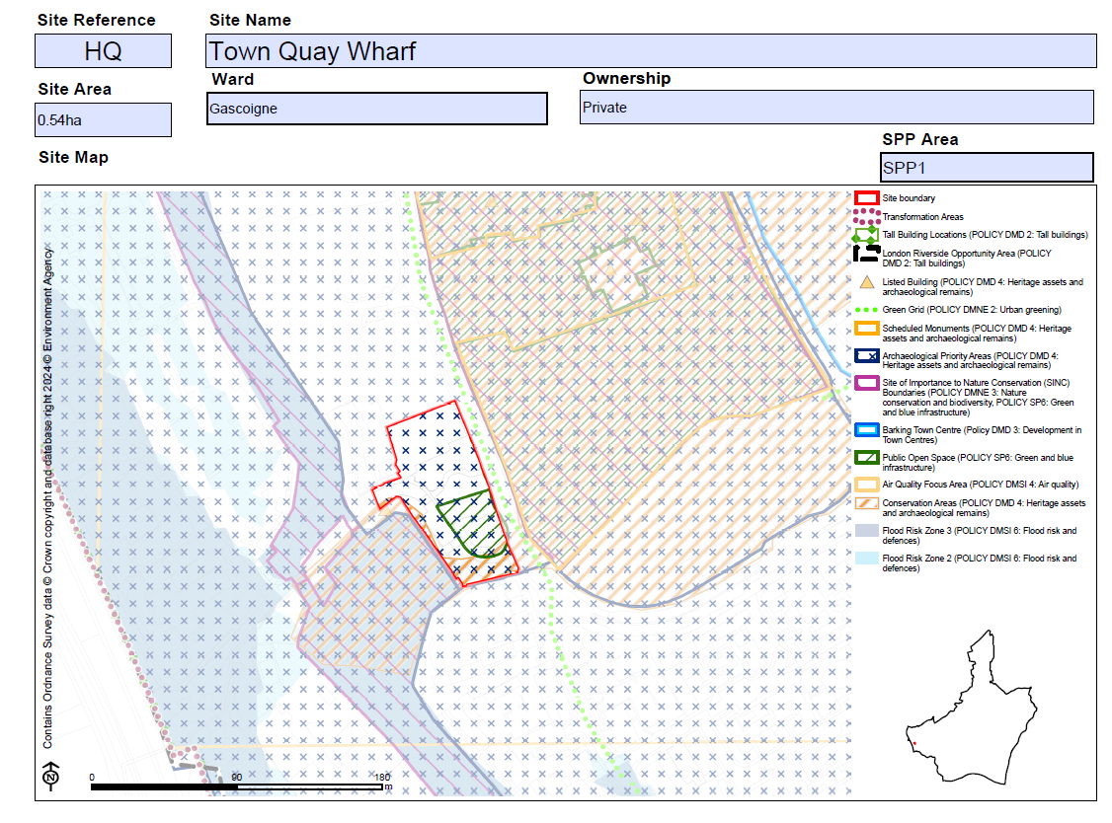  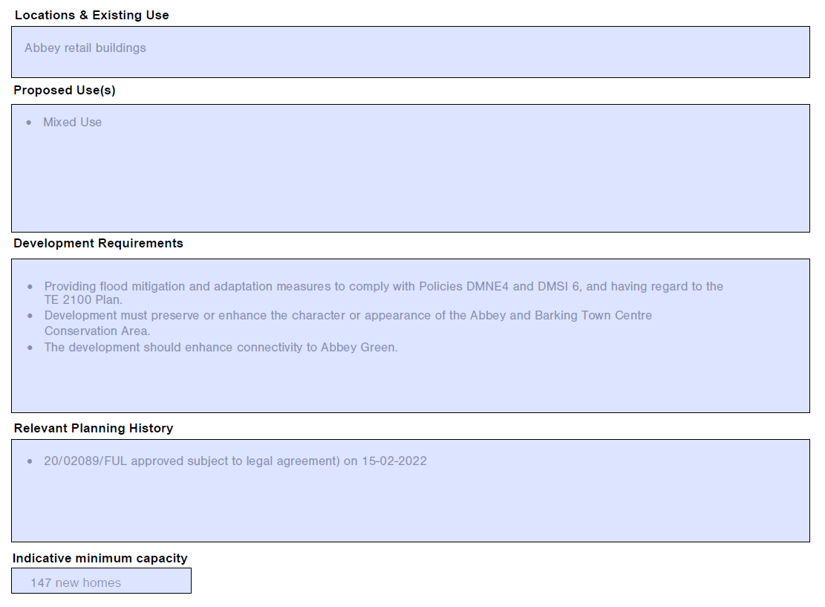
MM103 | HY-Street Record Margaret Bondfield Avenue | Add new proforma as follows:  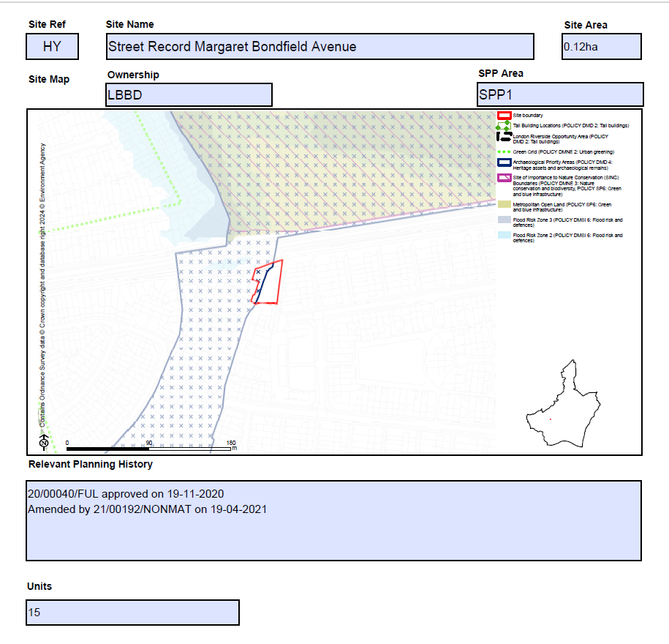
MM104 | SPP1  HZ-Hertford Road Industrial Estate | Amend bullet point/s under 'Proposed Use(s)' as follows:  - Delivery of a 2-3 FE Primary school  Amend bullet point/s under 'Planning Constraints and Requirements' heading (now proposed to be entitled 'Development Requirements') as follows:  - Tall building development maybe appropriate in this location (see Local Plan policy DMD2), subject to other planning considerations  - New developments should provide flood mitigation and adaptation measures to comply with the Local Plan policy DMNE4 and DMSI6  - Minimising parking in this location, early engagement with the Council is recommended to discuss appropriate car parking levels  - Providing flood mitigation and adaptation measures to comply with Policies DMNE 4 and DMSI 6, and having regard to the TE 2100 Plan
MM105 | SPP1  WD-Former Victoria Public House, Axe Street, Barking | Replace proforma as follows:  Submission Plan Main Modification Version  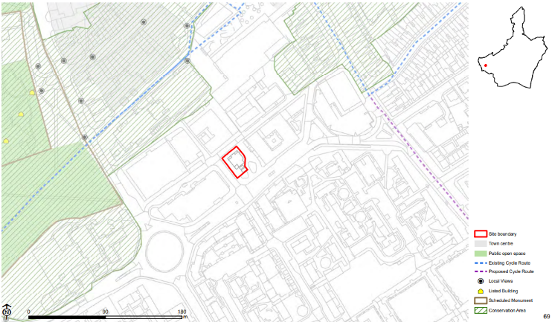  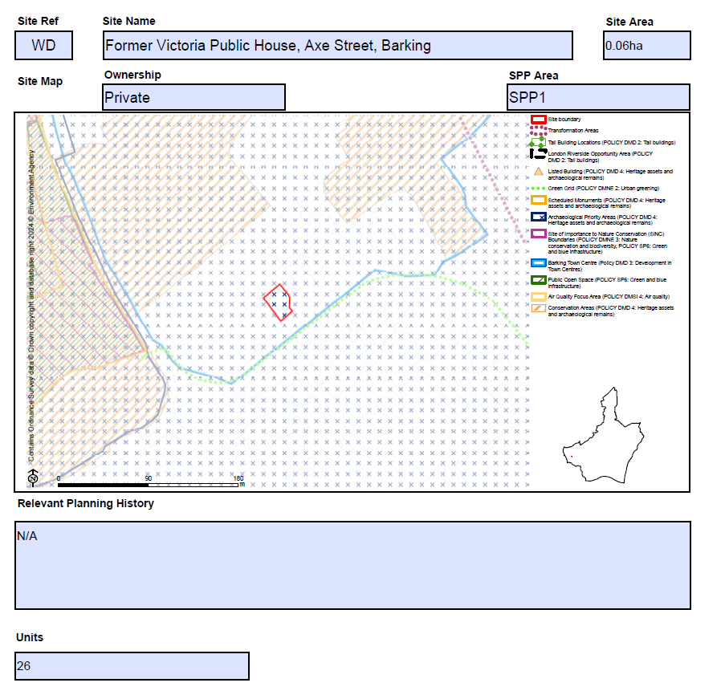
MM106 | SPP1  XC-Harts Lane Estate | Amend bullet one of the Proposed Use(s) section as follows:  - A comprehensive redevelopment for Harts Lane Estate. Potential capacity of delivering a minimum of 1,422 1,301 new homes.  Amend bullet point/s under 'Planning Constraints and Requirements' heading (now proposed to be entitled 'Development Requirements') as follows:  - A strategic delivery framework will be prepared to support the redevelopment of this site  - Development should provide flood mitigation and adaptation measures  - Development should Mmnimise parking in this location. Early engagement with the council is recommended to discuss appropriate car parking levels  - Providing flood mitigation and adaptation measures to comply with Policies DMNE4 and DMSI 6, and having regard to the TE 2100 Plan.  - In line with Policy DMNE 4: Water environment, the development will need to consider ways to enhance the estuary and river edge for fish and other wildlife.  - In accordance with Policy DMSI 5: Land contamination, a preliminary risk assessment (PRA), such as a site walkover or conceptual model must be undertaken. Where contamination may have a pollution risk to controlled waters, Site Investigation and Remediation Strategy reports may be required  Amend bullet point/s under 'Relevant Planning History' as follows:  - 17/00698/FUL approved on 20-12-2017 (part of the site - 78 dwellings)
MM107 | SPP1  XD- 38-64 (Even) Southwold Drive | Add new proforma as follows:  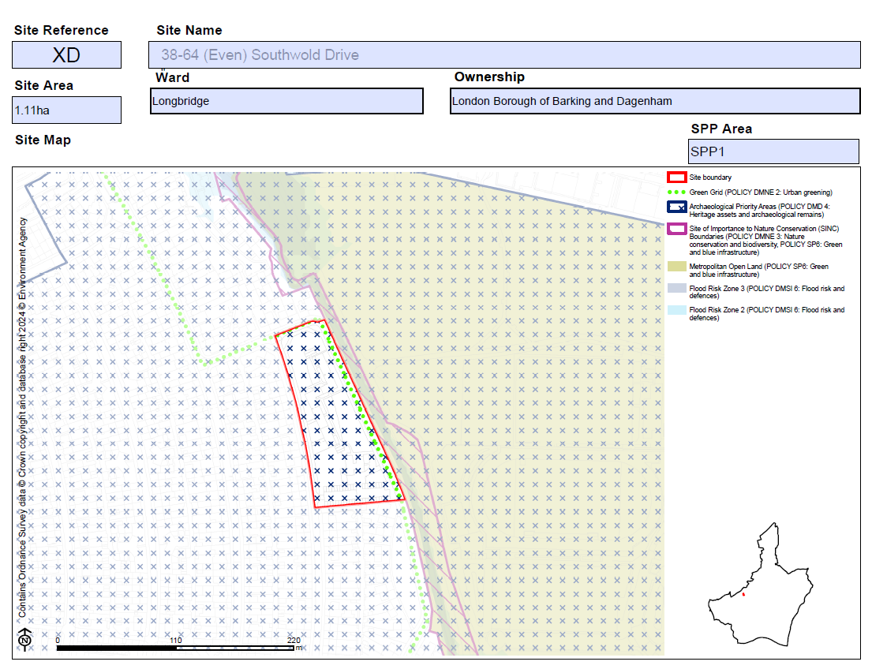  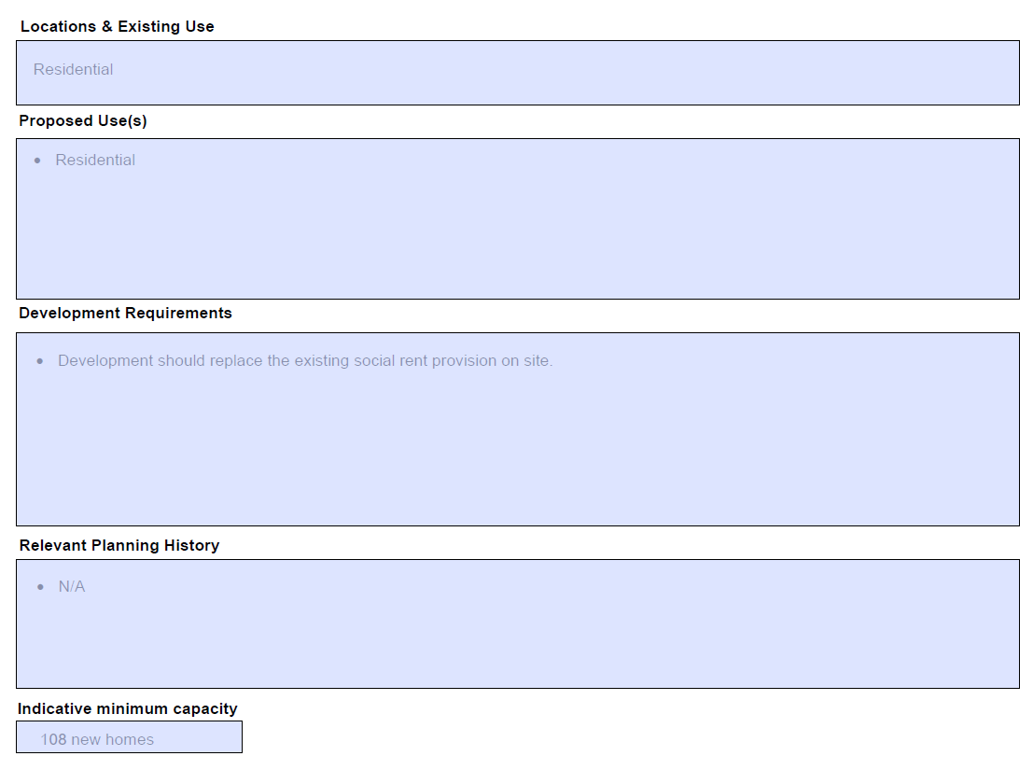
MM108 | SPP1  XQ-Former Volunteer Public House, Alfred's Way | Add new proforma as follows:  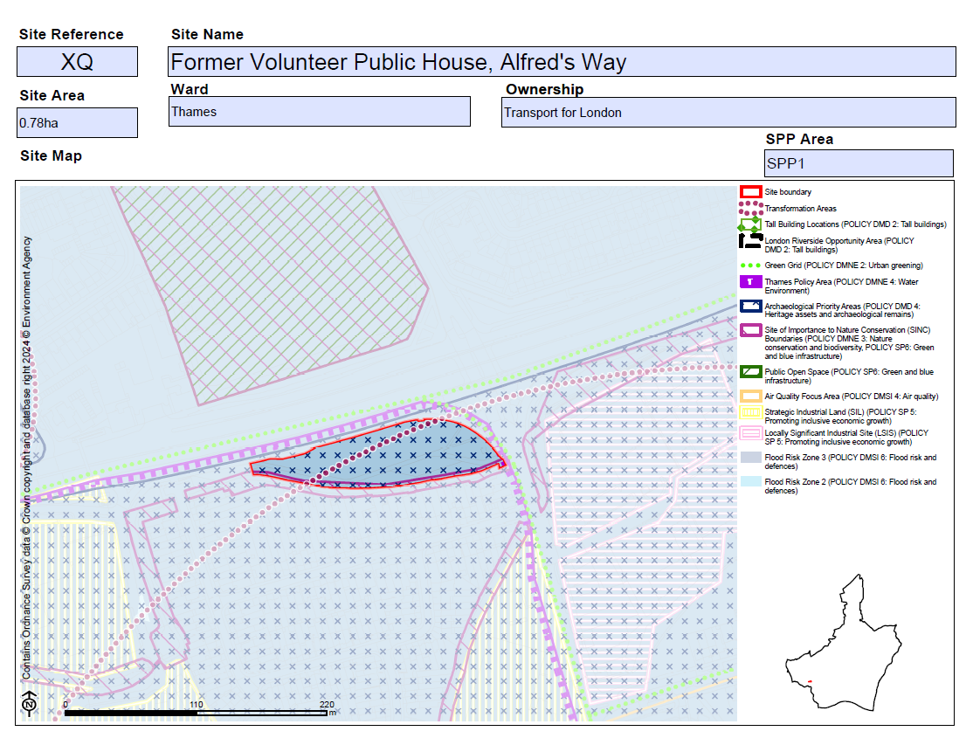  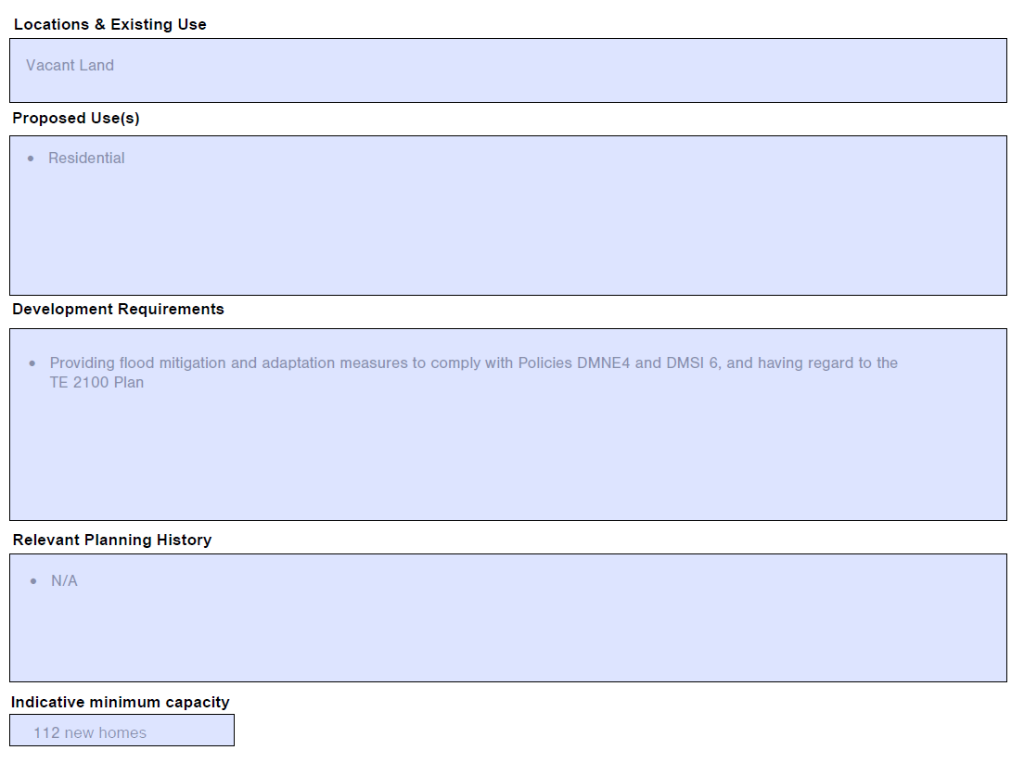
MM109 | SPP1  YA-IBIS Barking, Highbridge Road, Barking | Add new proforma as follows:  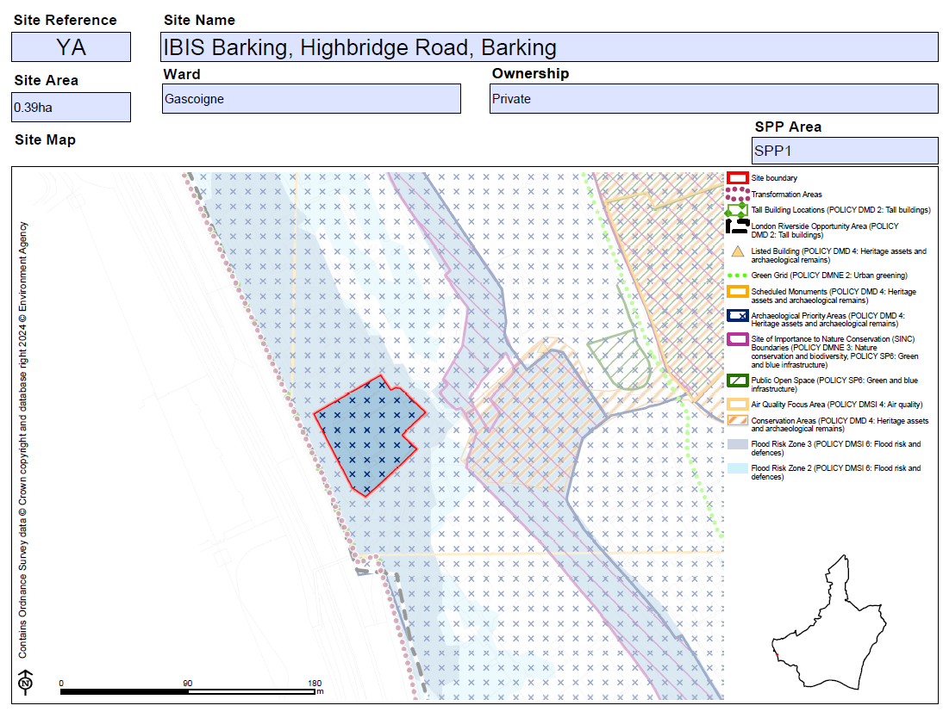  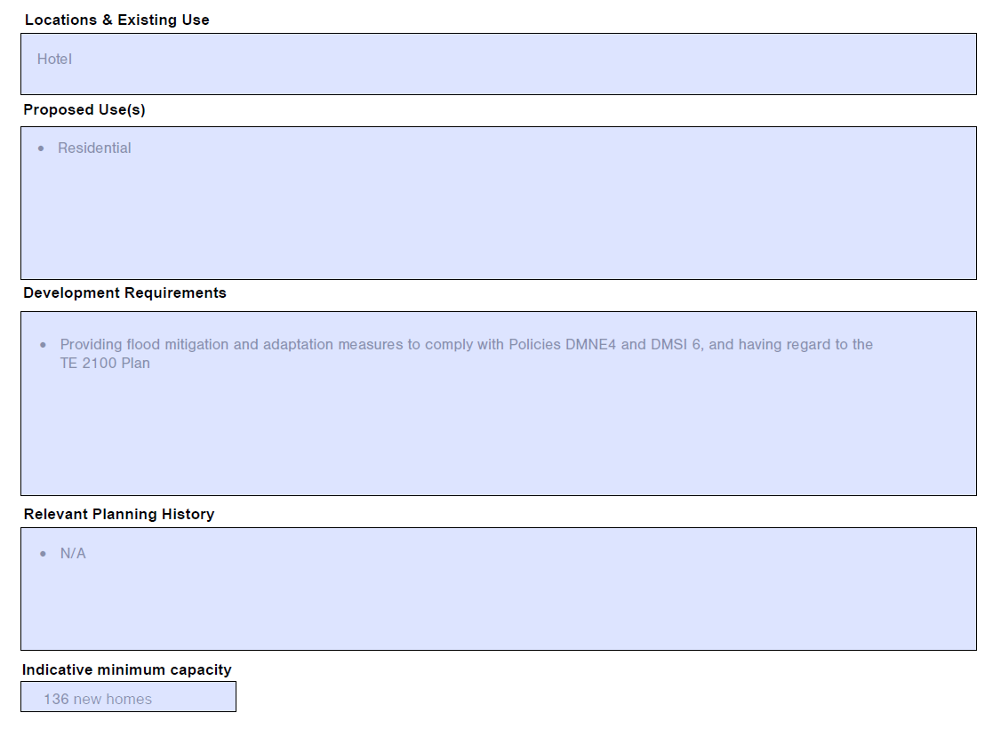
MM110 | SPP1  YG-Garages at Kier Hardy Way | Replace proforma as follows:  Submission Plan Main Modification Version  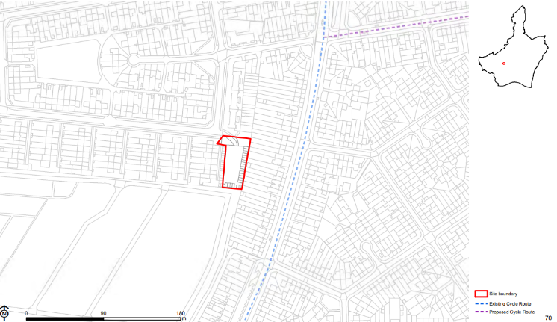  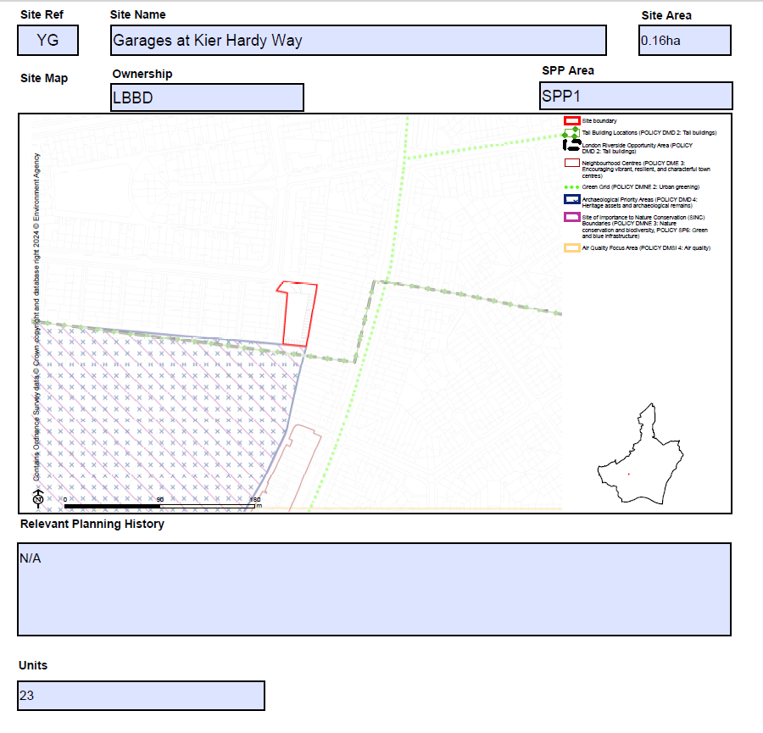
MM111 | SPP1  YM-Phoenix House, 12-14 Wakering Road, Barking | Add new proforma as follows:  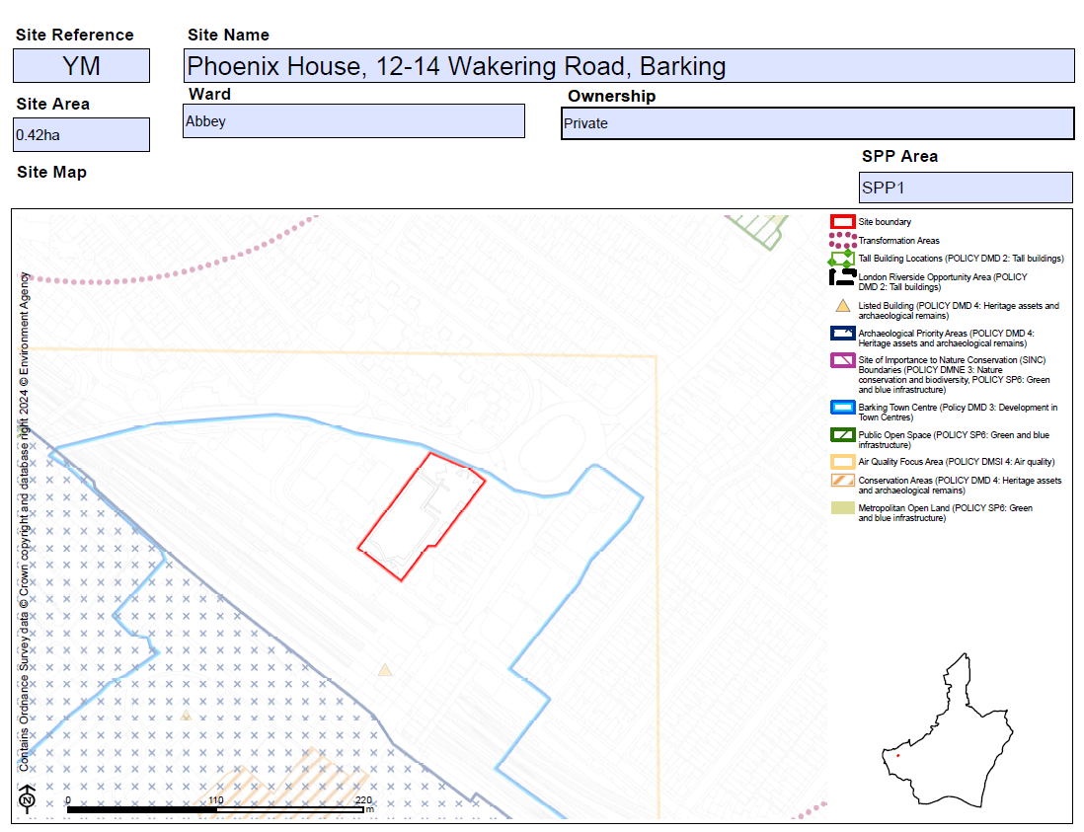  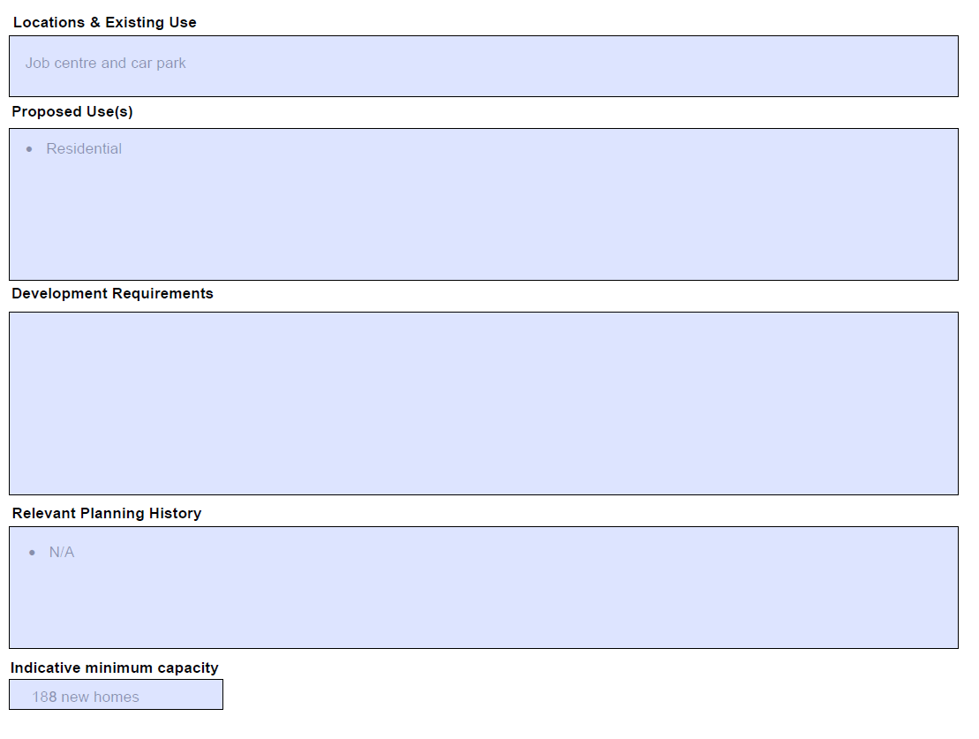
MM112 | SPP1  YO-Barking Foyer | Add new proforma as follows:  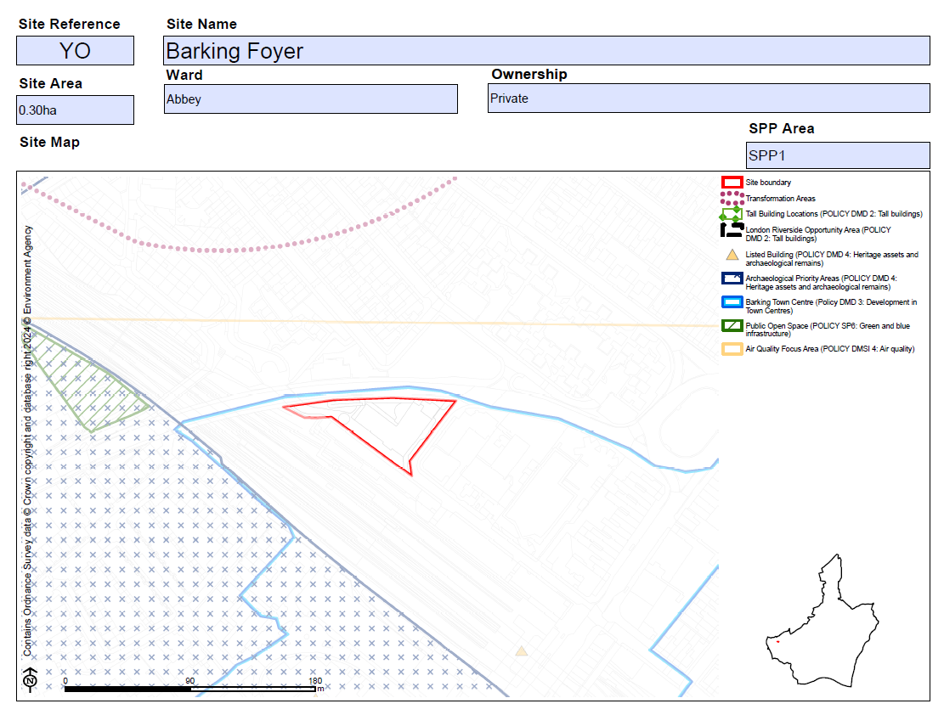  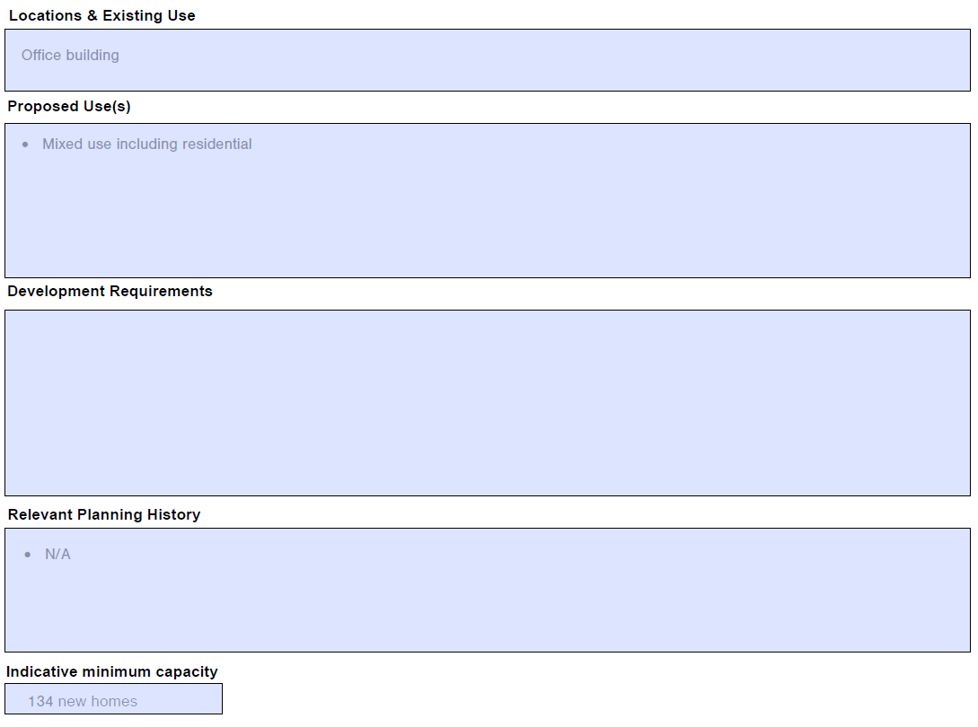
MM113 | SPP1  ZO-Cambridge House | Add new proforma as follows:  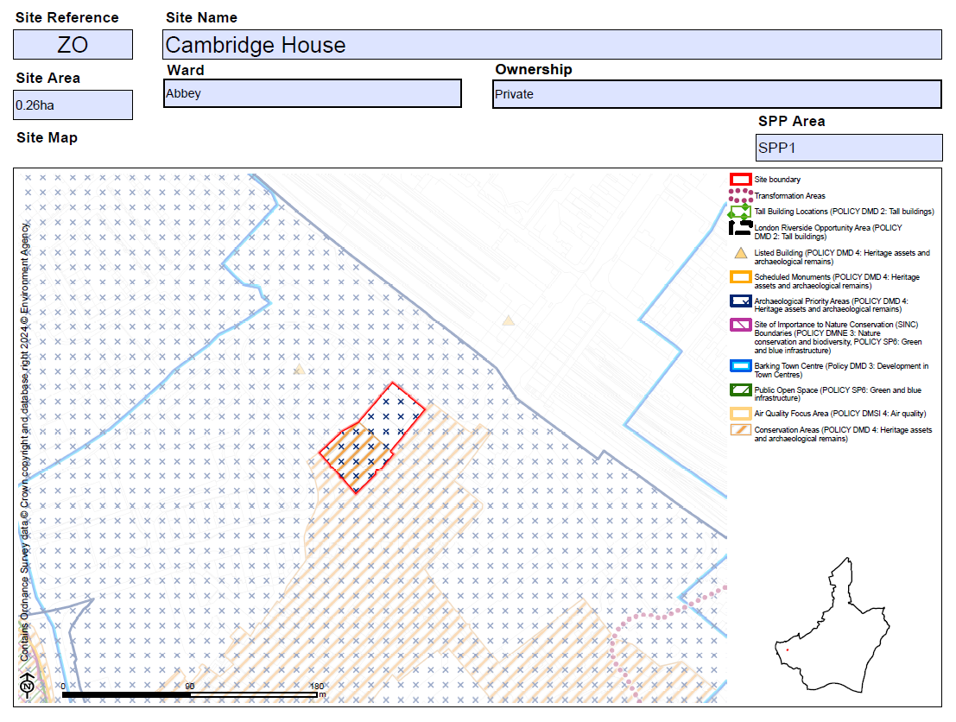  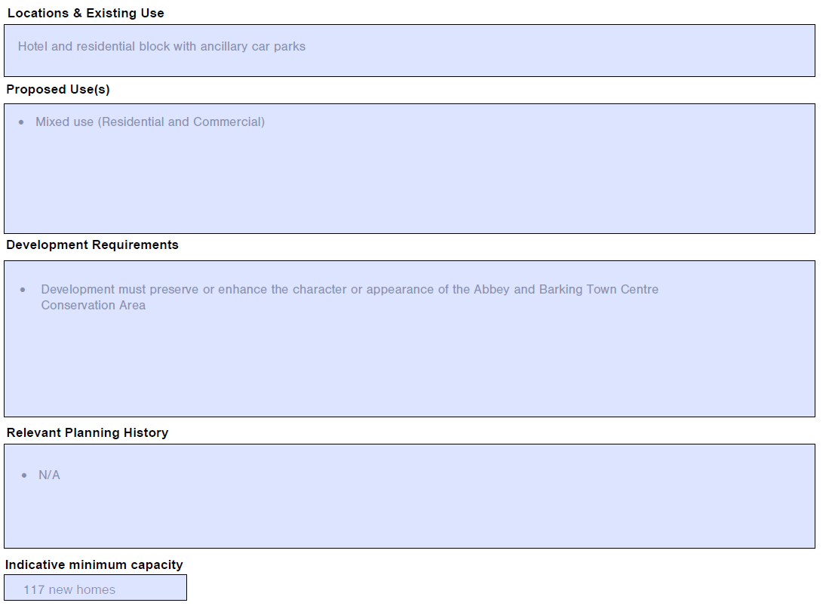
MM114 | SPP1  E022-Kingsbridge Estate | Replace site map as follows to correct site boundary and SIL designation boundary:  Submission Plan  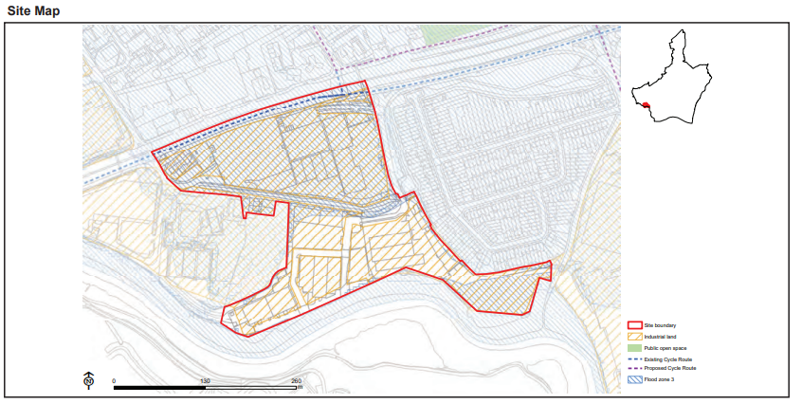  Main Modifications Version  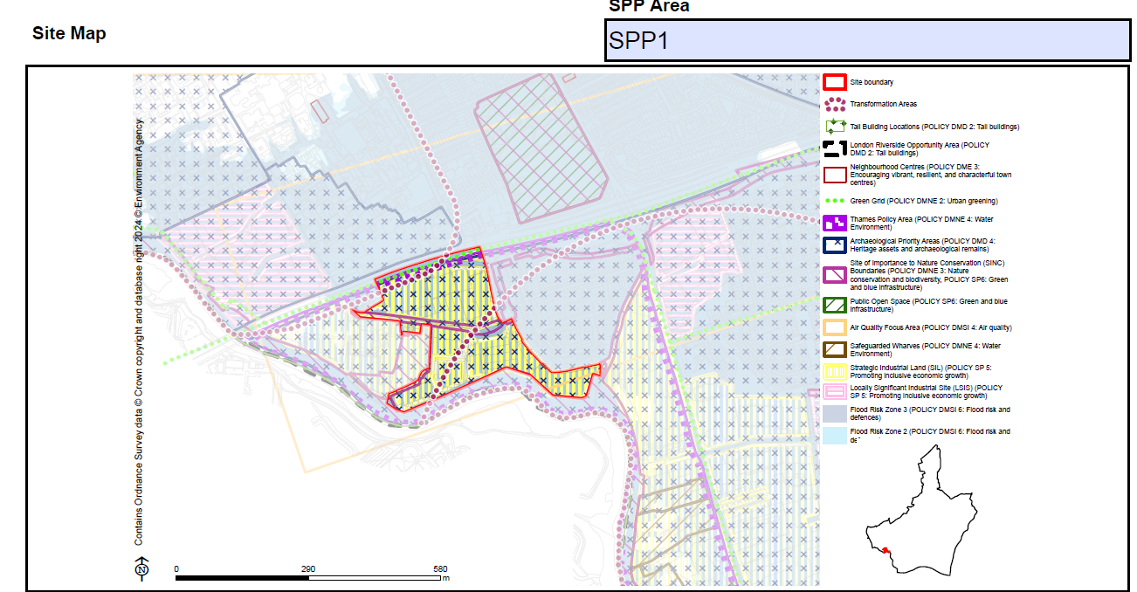  Correct Site Area as follows:  11.1 7.7ha  Amend bullet point/s under 'Proposed Use(s)' as follows:  - Accommodating industrial floorspace capacity relocation from Gascoigne South and accommodate demand of logistics industry serving the Greater London market. Potential to deliver up to circa 63,072 65,471sq.m industrial floorspace and contribute positively to the Council's vision for River Road Employment Area. Development must promote sustainable modes of transport including car lite and car free principles.  Amend bullet point/s under 'Planning Constraints and Requirements' heading (now proposed to be entitled 'Development Requirements') as follows:  - A draft Masterplan SPD has been prepared to provide detailed design guidance and delivery strategy in this Transformation Area. For details, please visit: https://www.lbbd.gov.uk/supplementary-planning-documents.  - Providing flood mitigation and adaptation measures to comply with Policies DMNE4 and DMSI 6, and having regard to the TE 2100 Plan  Amend Indicative Future Industrial Capacity as follows:  65,471 63,072 sq.m
MM115 | SPP2 | Insert new section heading page as follows:  Sites within Strategic Area SPP2: Thames Riverside  Insert contents page of sites for the SPP2 Area  Add sentence on contents page of sites setting out the following:  Housing Allocation 'Indicative Minimum Capacity' and 'Units' set out the net minimum number of new homes it is expected there is capacity to deliver within the Plan period.
MM116 | SPP2  AA-Barking Riverside | Amend 'Site Area' as follows:  179.33 179.94 ha  Amend 'Ward' as follows:  Thames Barking Riverside  Amend bullet point/s under 'Location and Existing Uses' as follows:  - Residential / Industrial / Storage / Riverside Barking sSchools / Retail  Amend bullet point/s under 'Proposed Use(s)' as follows:  - Residential-led mixed use development including retail, employment, education, open space, other community and leisure uses. Potential to deliver 11,162 new homes in the plan period with an overall site capacity of 20,000 homes (1,638 homes delivered on original planning permission for 10,800 homes. (with the Potential for additional 2000 9200 homes over and above original planning permission of 10,800 homes subject to further planning permission and provision for necessary supporting infrastructure).  - Residential use can also include care (Use Class C2 and C3), later life living and student accommodation, in addition to Build to Rent.  - Possible further primary school provision and potential education expansion provision to meet the needs arising from the development,. whilst making best use of the These will be in addition to education provision provided to date, which comprises a 10 - form entry secondary school, two 3 -form entry primary schools and two a Special Educational Needs schools).  Amend bullet point/s under 'Planning Constraints and Requirements' heading (now proposed to be entitled 'Development Requirements') as follows:  - Within the Riverside Opportunity Area and the Barking Riverside Transformation Area; consideration of strengthening the relationship with the adjacent land/areas, see Local Plan sub area policies: Policy SPP2.  - Safeguarded wharves : to comply with the Local Plan policy SP5.  - Providing flood mitigation and adaptation measures to comply with Local Plan policy Policies DMNE4 and DMSI 6, and having regard to the TE 2100 Plan  - Development will be required to provide a strategy for responding to the National Grid underground cables present within the site which demonstrates how the National Grid Design Guide and Principles have been applied at the masterplanning stage and how the impact of the assets has been reduced through good design.  - In line with Policy DMNE 4: Water environment, the development will need to consider ways to enhance the watercourse.  - Studies should be undertaken to understand what potential contamination there is on this site prior to any development taking place and where appropriate, a risk management and remediation strategy in accordance with Policy DMSI 5.  Amend bullet point/s under 'Relevant Planning History' as follows:  - 04/01230/OUT  - 08/00887/FUL  - 08/00896/REM 16/01971/REM  - 18/00940/FUL  - 20/00130/REM  - 16/00131/OUT  - TWA 16/APP/02  Replace Site Map as to show amended boundary lines as follows:  Submission Local Plan  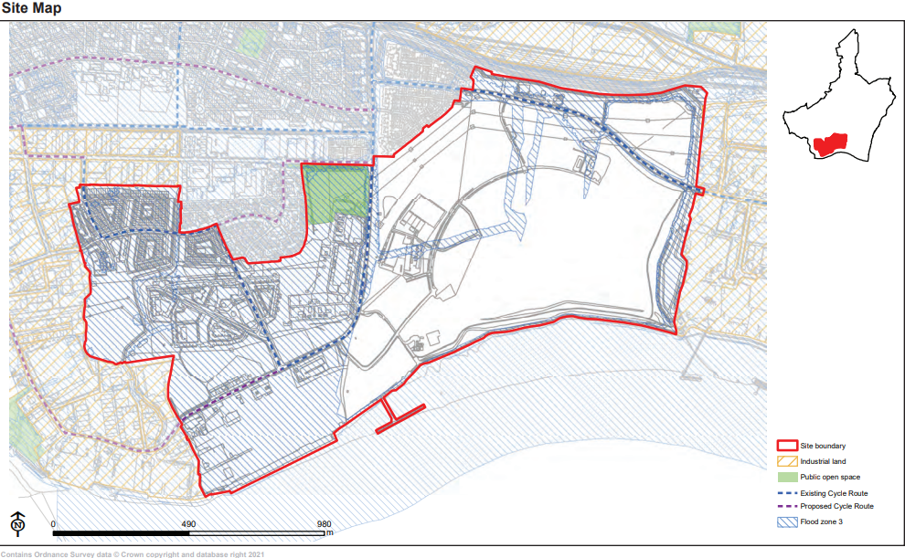  Main Modifications Version  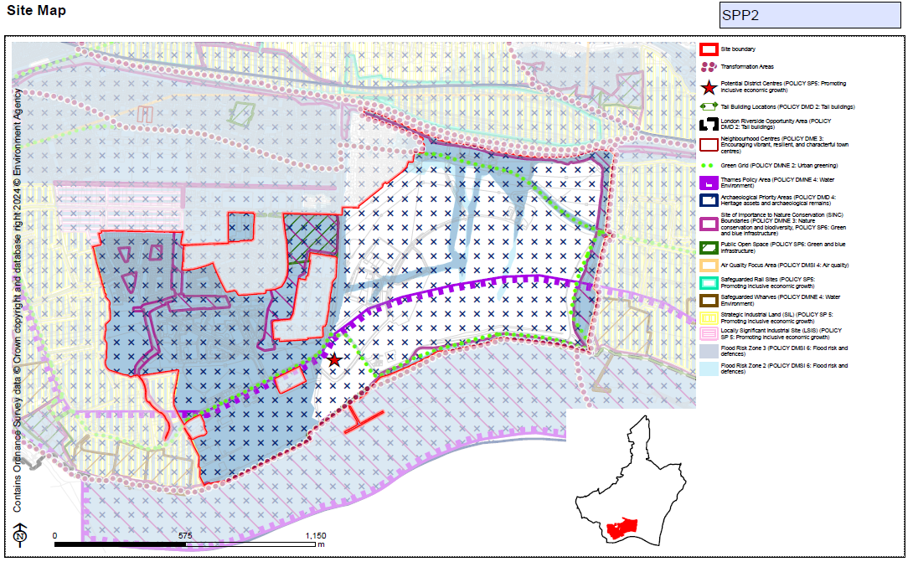  Amend Indicative Minimum Capacity as follows:  11,264 11,162
MM117 | SPP2  CE-Site of Old Thames View Clinic, Bastable Avenue | Add new proforma as follows:  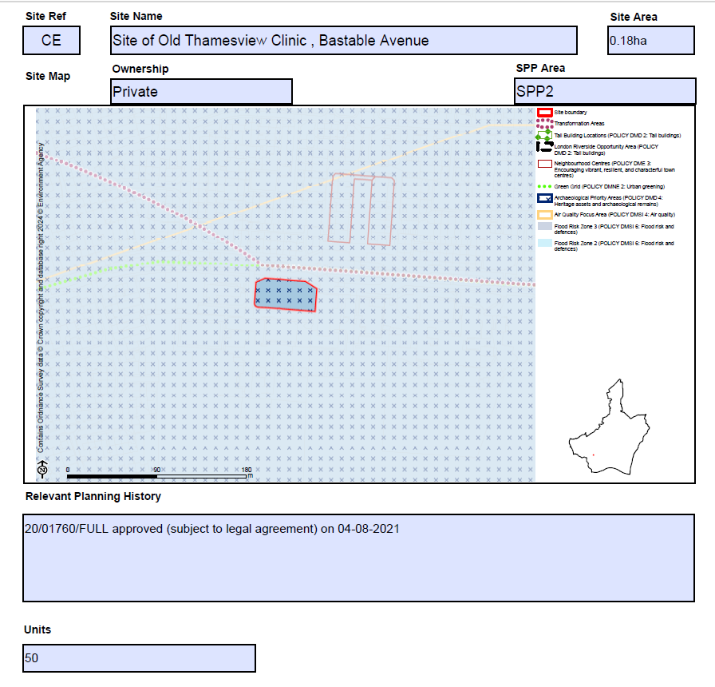
MM118 | SPP2  CI-Thames Road | Replace Site Map to show amended boundary line as follows:  Submission Local Plan  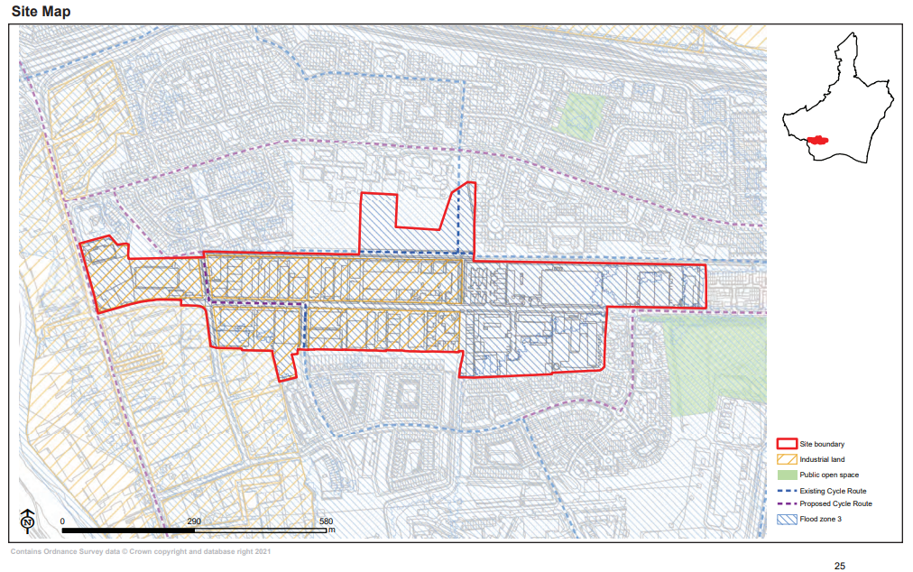  Main Modifications Version  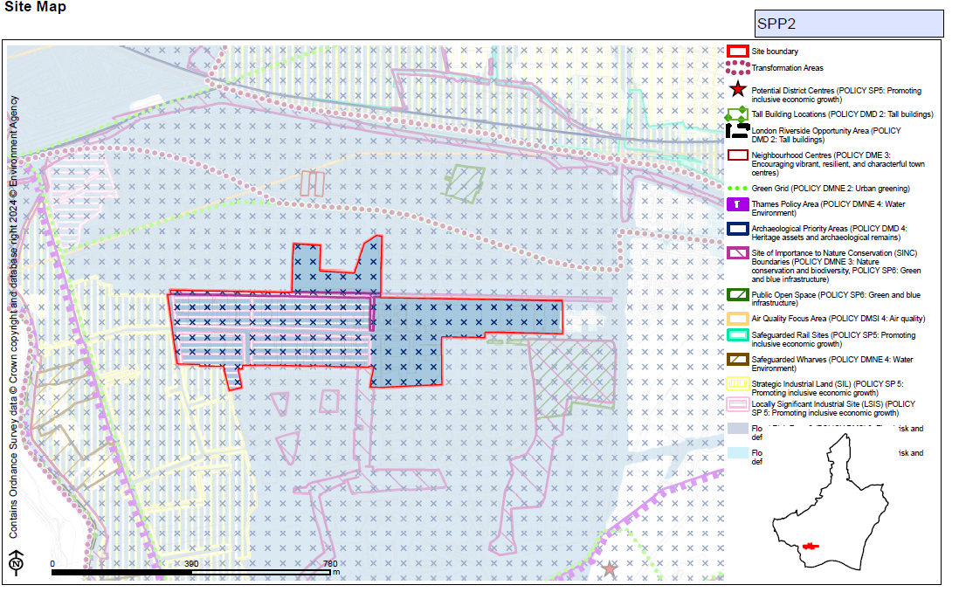  Correct 'Site Area' as follows:  22.86 23.26ha  Amend bullet point/s under 'Planning Constraints and Requirements' heading (now proposed to be entitled 'Development Requirements') as follows:  - A draft Masterplan SPD has been prepared to provide detailed design guidance and delivery strategy in this Transformation Area. For details, please visit: https://www.lbbd.gov.uk/supplementary-planning-documents  - The Council intends to release parts of the site from SIL to LSIS within RR8 and RR9 and from SIL to residential at RR10. This equates to 21.6ha of SIL industrial land (92,115sqm of floorspace). This is shown on the Policies Map and anticipated to be brought forward throughout the Plan period, in line with Table 2 and Appendix 5.  - The Council will prioritise the re-provision of SIL floorspace in the short term, in particular through the intensification of publicly owned industrial land at Dagenham Dock (DD6) in line with the recommendations of the Industrial Land Strategy. The implementation of planning permissions at Dagenham Dock (Plot 2 Segro, Dagenham Park: 21/00023/FUL and Plot 3 Segro, Dagenham Park: 21/01355/FULL) gives an indication of re-provision potential.  - Development will be required to provide a strategy for responding to the National Grid underground cables present within the site which demonstrates how the National Grid Design Guide and Principles have been applied at the masterplanning stage and how the impact of the assets has been reduced through good design.  - Providing flood mitigation and adaptation measures to comply with Policies DMNE4 and DMSI 6, and having regard to the TE 2100 Plan.  - In line with Policy DMNE 4: Water environment, the development will need to consider ways to enhance the watercourse.  Amend bullet point/s under 'Relevant Planning History' as follows:  - 19/01970/FUL approved on 08-03-2021 for part of site (156 homes)  - 19/00322/FUL approved on 16-08-2019 (non-residential)
MM119 | SPP2  CS-Sugden Way | Add new proforma as follows:  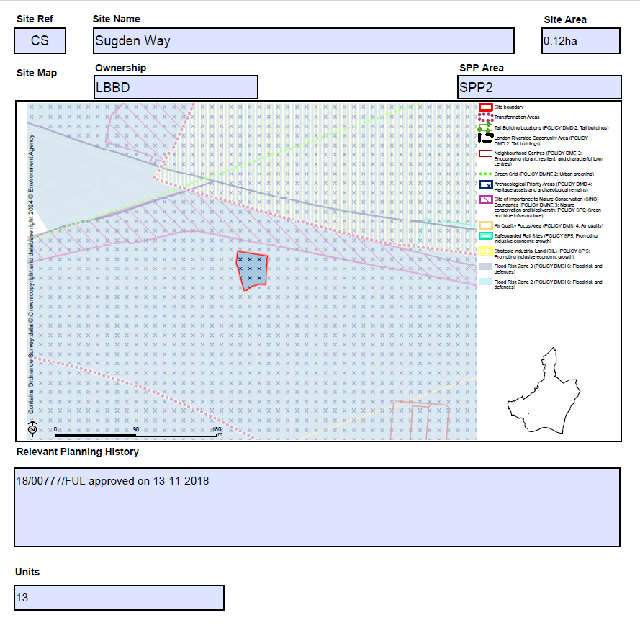
MM120 | SPP2  CT-Former Wivenhoe Garages, Wivenhoe Road, Barking | Add new proforma as follows:  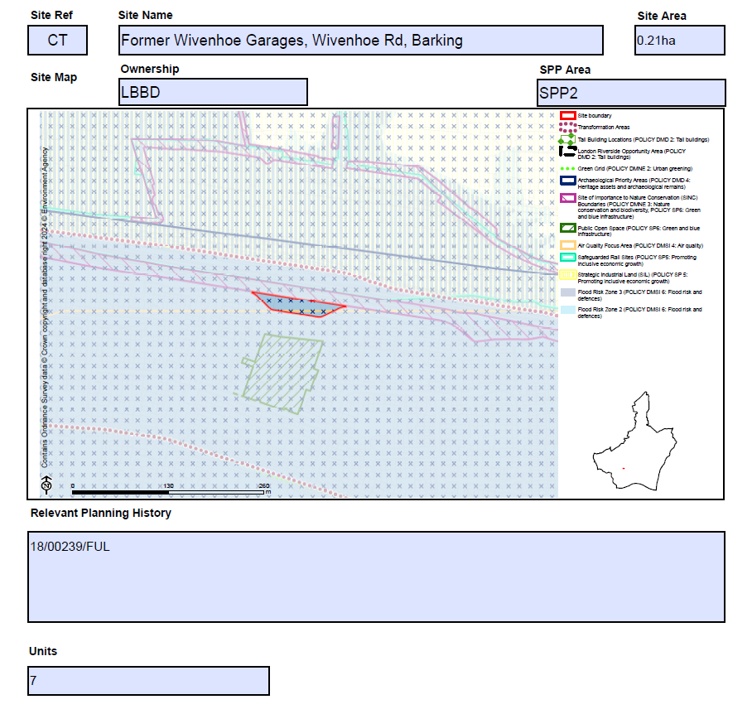
MM121 | SPP2  DI-Roxwell Road (53-135) | Add new proforma as follows:  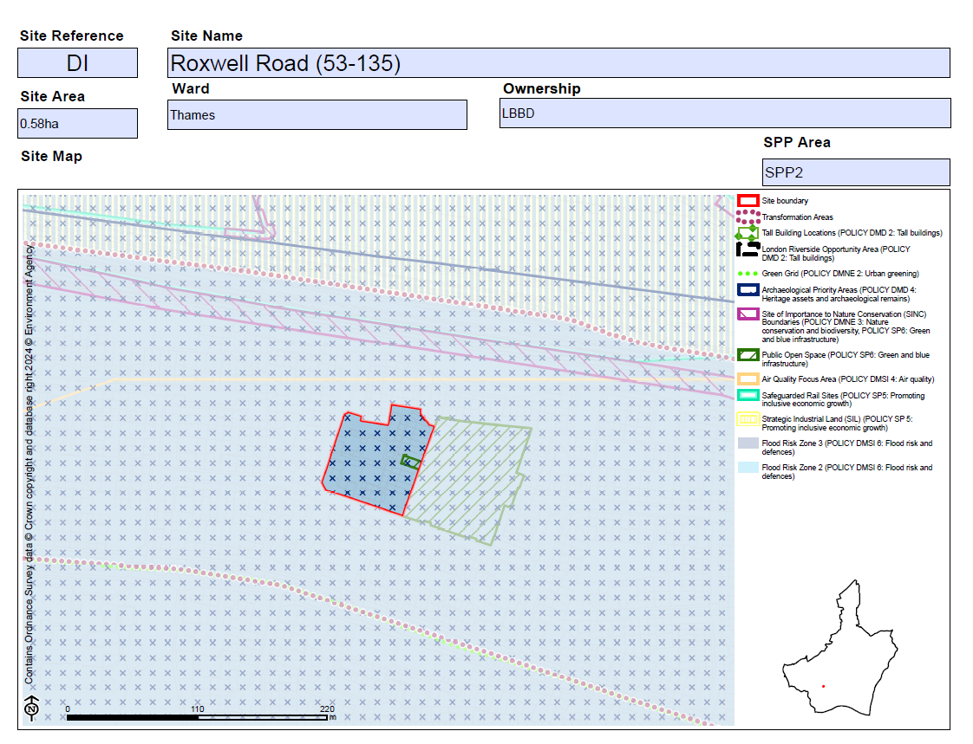  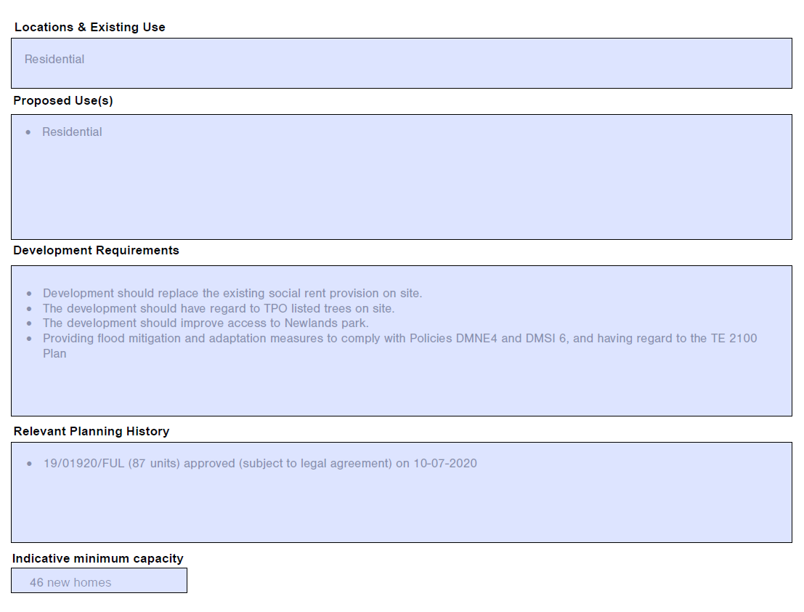
MM122 | SPP2  DY-Chelmer Estate | Add new proforma as follows:  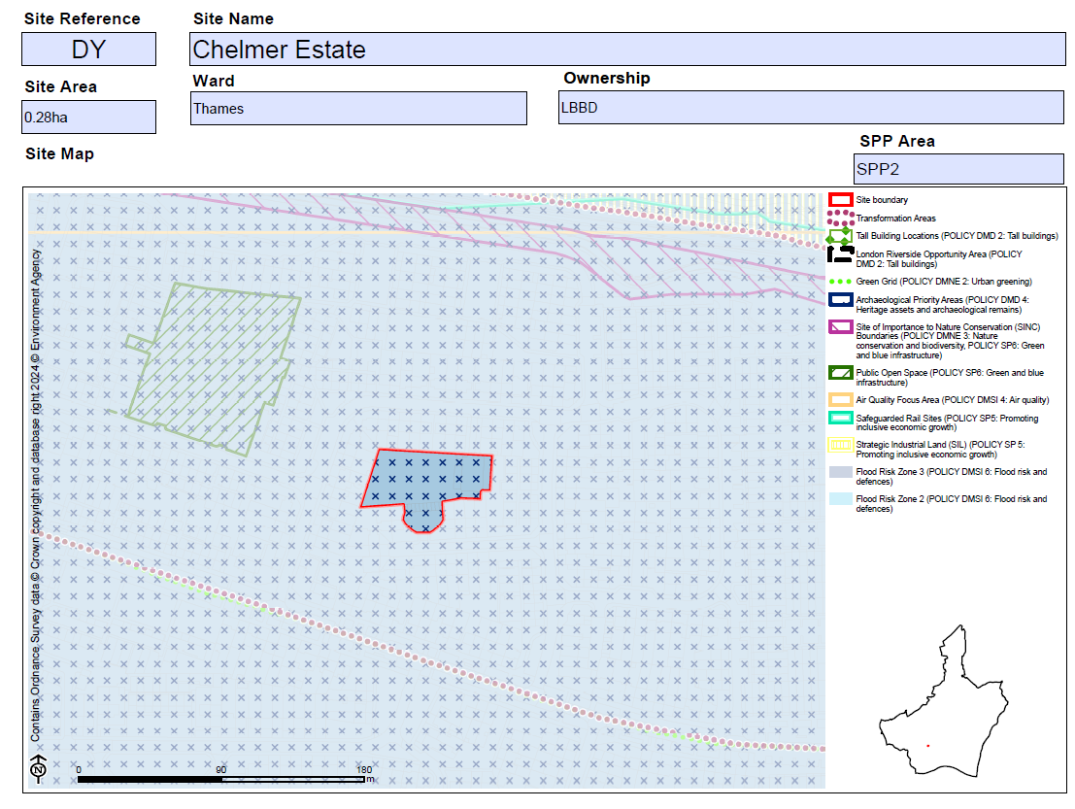  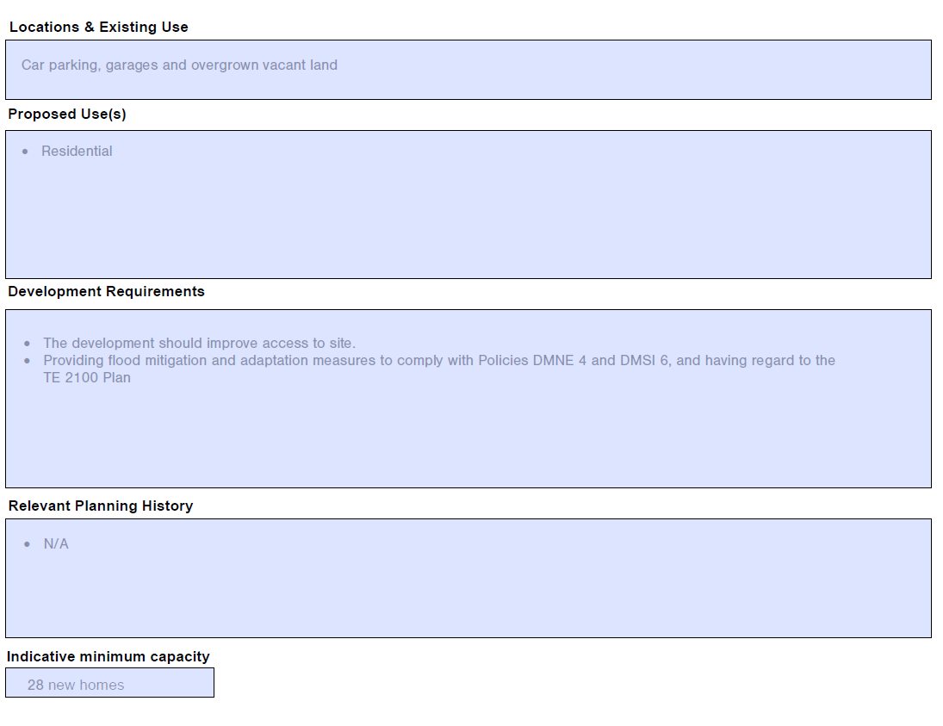
MM123 | SPP2  XK-Barking Riverside Gateway Zone | Amend site name as follows:  Barking Riverside Gateway Zone  Amend bullet point/s under 'Proposed Use(s)' as follows:  - Potential to deliver circa 538 new homes, and/or up to 10,800 sq.m industrial floorspace (including storage, distribution and logistics) to support lighter, van-based servicing with smaller service yards, alongside flexible community/commercial uses and supported infrastructure including educational provision  Amend bullet point/s under 'Planning Constraints and Requirements' heading (now proposed to be entitled 'Development Requirements') as follows:  - Development should aim to deliver outstanding design to have regard to its context, and make a positive contribution to local character within its neighbourhood  - Tall building development maybe appropriate in this location (see Local Plan policy DMD2), subject to other planning considerations  - The site is suitable for industrial space for Ccleaner industrial uses, supported by lighter, van-based servicing with smaller service yards as well as storage, distribution and logistics uses.  - In line with Policy DMNE 4: Water environment, the development will need to consider ways to enhance the estuary and river edge for fish and other wildlife.  - Providing flood mitigation and adaptation measures to comply with Policies DMNE4 and DMSI 6, and having regard to the TE 2100 Plan.  - In accordance with Policy DMSI 5: Land contamination, a preliminary risk assessment (PRA), such as a site walkover or conceptual model must be undertaken. Where contamination may have a pollution risk to controlled waters, Site Investigation and Remediation Strategy reports may be required.
MM124 | SPP2  E_027-Welbeck House/Welbeck Wharf | Amend bullet point/s under 'Planning Constraints and Requirements' heading (now proposed to be entitled 'Development Requirements') as follows:  - A draft Masterplan SPD has been prepared to provide detailed design guidance and delivery strategy in this Transformation Area. For details, please visit: https://www.lbbd.gov.uk/supplementary-planning-documents.  - Development must promote sustainable modes of transport including car lite and car free principles  - Providing flood mitigation and adaptation measures to comply with Policies DMNE 4 and DMSI 6, and having regard to the TE 2100 Plan.
MM125 | SPP2  E_029-Thames Road Economic Use | Correct 'Site Area' as follows:  3.9 39.36 ha  Amend bullet point/s under 'Planning Constraints and Requirements' heading (now proposed to be entitled 'Development Requirements') as follows:  - A draft Masterplan SPD has been prepared to provide detailed design guidance and delivery strategy in this Transformation Area. For details, please visit: https://www.lbbd.gov.uk/supplementary-planning-documents  - •Development must provide flood mitigation and adaptation measures to comply with the Local Plan policy DMNE4 and DMSI 6  - •Development must promote sustainable modes of transport including car lite and car free principles  - Providing flood mitigation and adaptation measures to comply with Policies DMNE4 and DMSI 6, and having regard to the TE 2100 Plan  - In accordance with Policy DMSI 5: Land contamination, a preliminary risk assessment (PRA), such as a site walkover or conceptual model must be undertaken. Where contamination may have a pollution risk to controlled waters, Site Investigation and Remediation Strategy reports may be required.  - Development will be required to provide a strategy for responding to the National Grid underground cables present within the site which demonstrates how the National Grid Design Guide and Principles have been applied at the masterplanning stage and how the impact of the assets has been reduced through good design.  Replace Site Map as to show amended boundary line as follows:  Submission Local Plan  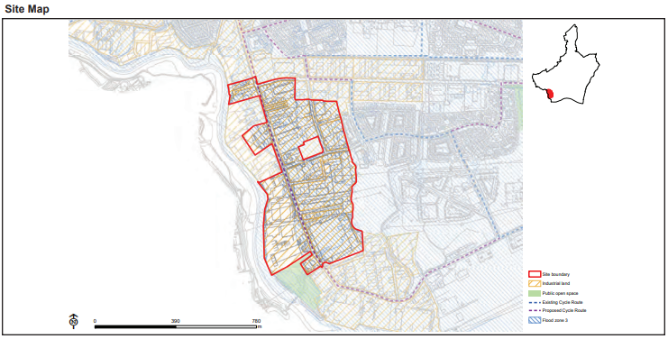  Main Modifications Version  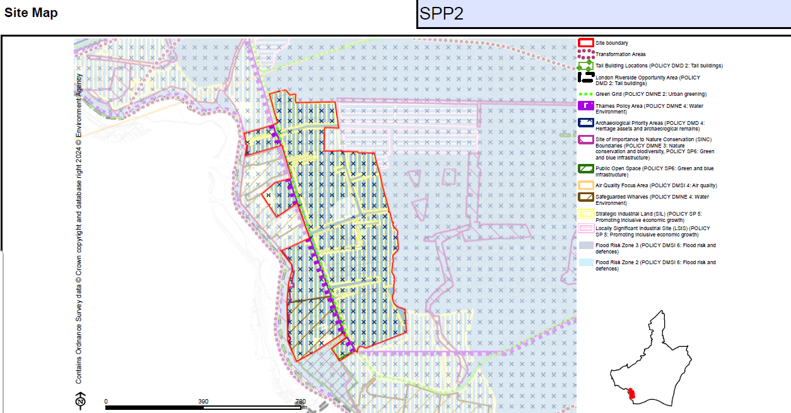
MM126 | SPP2  E_058-River Road | Add new proforma as follows:  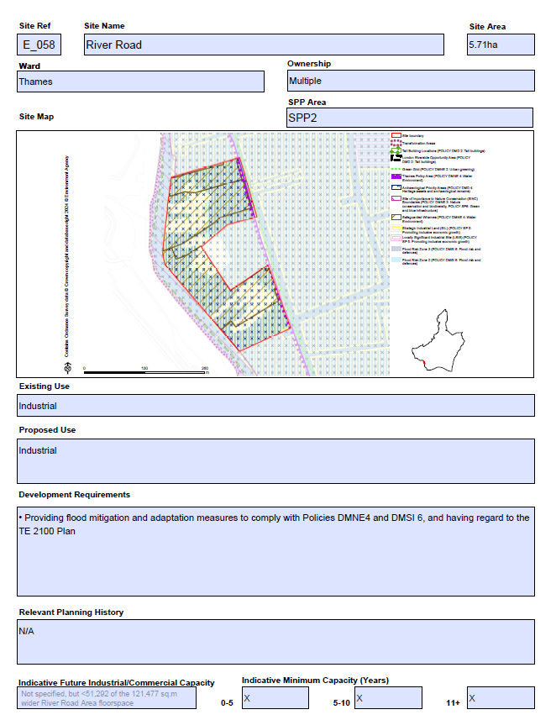
MM127 | SPP2  E_088-Unit A, Creek Road | Amend 'Proposed Use' as follows:  - Potential to deliver an exemplary, multi-story industrial building comprising circa 11,362 sq.m of flexible industrial space, mixture of unit typologies and sizes to cater for a varied and flexible industrial market and associated parking spaces and landscaping works  Amend bullet point/s under 'Planning Constraints and Requirements' heading (now proposed to be entitled 'Development Requirements') as follows:  - The site is identified as Strategic Industrial Land (SIL),providing strategic protection and intensification for warehousing and logistics uses, which often require larger spaces in accordance with Local Plan policy DME1  - A draft Masterplan SPD has been prepared to provide detailed design guidance and delivery strategy in this Transformation Area. For details, please visit: https://www.lbbd.gov.uk/supplementary-planning-documents  - Development must provide flood mitigation and adaptation measures to comply with the Local Plan policy DMNE4 and DMSI 6  - Development must promote sustainable modes of transport including car lite and car free principles.  - Providing flood mitigation and adaptation measures to comply with the Policies DMNE4 and DMSI 6, and having regard to the TE 2100 Plan.
MM128 | SPP2  E_089- 72-76 Land to the Rear of River Road | Add new proforma as follows:  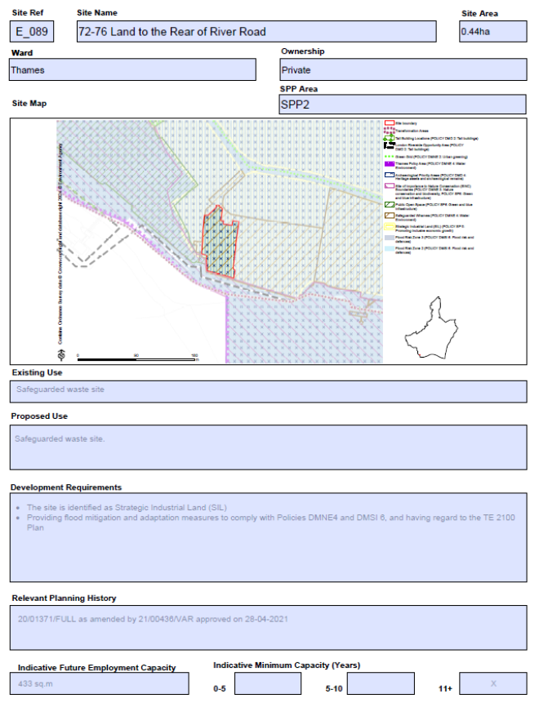
MM129 | SPP2  E_090-Alfreds Way Industrial Estate | Amend bullet point/s under 'Planning Constraints and Requirements' heading (now proposed to be entitled 'Development Requirements') as follows:  - The site is identified as Strategic Industrial Land (SIL),providing strategic protection and intensification for warehousing and logistics uses, which often require larger spaces in accordance with Local Plan policy DME1  - Development must provide flood mitigation and adaptation measures to comply with the Local Plan policy DMNE4 and DMSI 6  - Providing flood mitigation and adaptation measures to comply with Policies DMNE 4 and DMSI 6, and having regard to the TE 2100 Plan
MM130 | SPP2  CF-Castle Green (Include Box Lane Site for Integrity) | Amend site name as follows:  Castle Green (include Box Lane site for integrity)  Amend Site Map to show change to SIL designation boundary and safeguarded rail area as follows:  Submission Local Plan  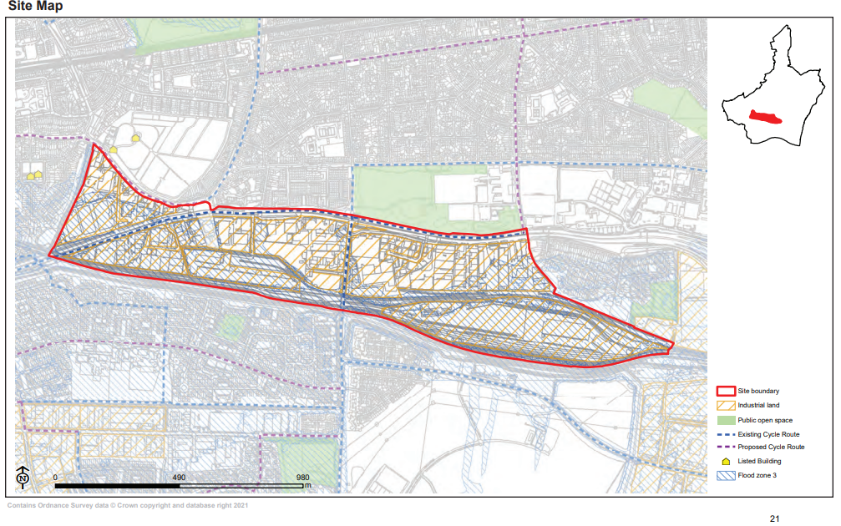  Main Modifications Version  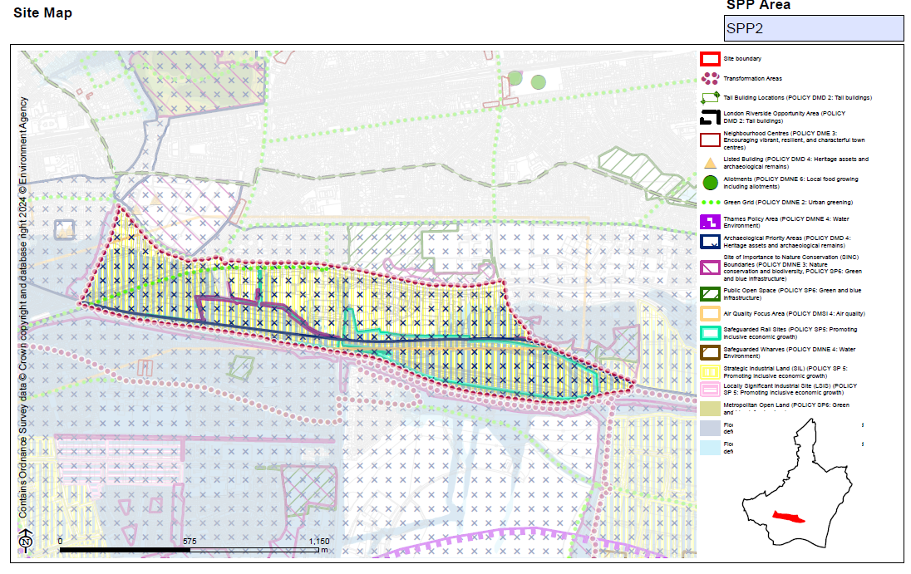  Amend bullet point/s under 'Location and Existing Uses' as follows:  - Industrial units across the whole site, with mainly single storey warehouses with large operational yards used for storage and wholesale and; two large rail deports comprising Ripple Lane Stora Site, Ripple Road and Eurohub at Box Lane and further rail infrastructure comprising Ripple Lane West Yard south of the Stora site and Renwick Road Rail Terminal west of Eurohub.  Amend bullet point/s under 'Proposed Use(s)' as follows:  - Aspiration to deliver a comprehensive mixed-use redevelopment subject to implementation of the Borough’s Industrial Land Strategy, as well as significant infrastructure improvements in the long term. A future review of the Plan is required to release Strategic Industrial Land at this site to enable housing to come forward in the latter part of the Plan period.  - Potential to deliver circa 12,000 7,000 new homes (around 450 of these within the Plan period) alongside flexible commercial uses, new schools, health care and community facilities, open space and a district energy centre/network linking to the adjacent Barking Riverside developments.  - The broader location has been identified for a future Gypsy and Traveller Site, for a minimum 21 pitches, to come forward following a review of the Local Plan (which intends to release Strategic Industrial Land at the site) and designed through a masterplanning process.  - Retention and safeguarding of existing rail infrastructure, comprising of Ripple Lane Stora, Ripple Lane West Yard, Renwick Road Rail Terminal and Eurohub sites.  Amend bullet point/s under 'Planning Constraints and Requirements' heading (now proposed to be entitled 'Development Requirements') as follows:  - A Masterplan SPD, when produced, will provide further details and policy guidance on the implementation of industrial land strategy in this Transformation Area. Please refer to Policy SPP2 for guidance. In addition to the guidance on future masterplanning set out in Policy SPP2, existing rail infrastructure and associated access should be retained and not compromised by any future development of the site.  - Should the envisaged 7,000 homes come forward there would be a requirement for new primary schools and secondary schools  - In line with Policy DMNE 4: Water environment, the development will need to consider ways to enhance the estuary and river edge for fish and other wildlife.  - In accordance with Policy DMSI 5: Land contamination, a preliminary risk assessment (PRA), such as a site walkover or conceptual model must be undertaken. Where contamination may have a pollution risk to controlled waters, Site Investigation and Remediation Strategy reports may be required.  - Providing flood mitigation and adaptation measures to comply with the Policies DMNE4 and DMSI 6, and having regard to the TE 2100 Plan  Amend the Indicative Minimum Capacity as follows:  12,000 450 new homes
MM131 | SPP3 | Insert new section heading page as follows:  Sites within Strategic Area SPP3: Dagenham Dock and Freeport  Insert contents page of sites for the SPP3 Area  Add sentence on contents page of sites setting out the following:  Housing Allocation 'Indicative Minimum Capacity' and 'Units' set out the net minimum number of new homes it is expected there is capacity to deliver within the Plan period.
MM132 | SPP3  AC-Merrielands Crescent Two | Amend bullet point/s under 'Planning Constraints and Requirements' heading (now proposed to be entitled 'Development Requirements') as follows:  - New development should provide flood mitigation and adaptation measures to comply with the Local Plan policy DMNE4 and DMSI6  - Consideration of strengthening the relationship with the adjacent land/areas, see Local Plan sub area policies: Policy SPP3. including a new district centre  - Tall buildings maybe appropriate in this location (see Local Plan policy DMD2), subject to other planning considerations. The scale and massing of development should contribute to the creation of new coherent townscape to respond positively to its existing and emerging context.  - Providing flood mitigation and adaptation measures to comply with Policies DMNE4 and DMSI 6, and having regard to the TE 2100 Plan  - An archaeological assessment must be submitted in support of any planning application; this will inform how design can preserve or enhance any heritage asset.
MM133 | SPP3  AE-Beam Park | Amend site name as follows:  Beam Park (South Dagenham East)  Amend bullet point/s under 'Proposed Use(s)' as follows:  - Mixed Use development. Potential to deliver circa 2,166 3,119 new homes, with circa 1,198 sq.m commercial and community floorspace, supported by education, health and leisure facilities and a new local park and other open spaces/parkland.  Amend bullet point/s under 'Planning Constraints and Requirements' heading (now proposed to be entitled 'Development Requirements') as follows:  - Providing flood mitigation and adaptation measures to comply with Policies DMNE4 and DMSI 6, and having regard to the TE 2100 Plan.  - In accordance with Policy DMSI 5: Land contamination, a preliminary risk assessment (PRA), such as a site walkover or conceptual model must be undertaken. Where contamination may have a pollution risk to controlled waters, Site Investigation and Remediation Strategy reports may be required.  Amend bullet point/s under 'Relevant Planning History' as follows:  - 22/01048/OUTSRM approved (subject to legal agreement) on 17-11-2023  Amend Indicative Minimum Capacity as follows:  2,166 3,119 new homes
MM134 | SPP3  WA-Former Dagenham Job Centre, Chequers Lane | Add new proforma as follows:  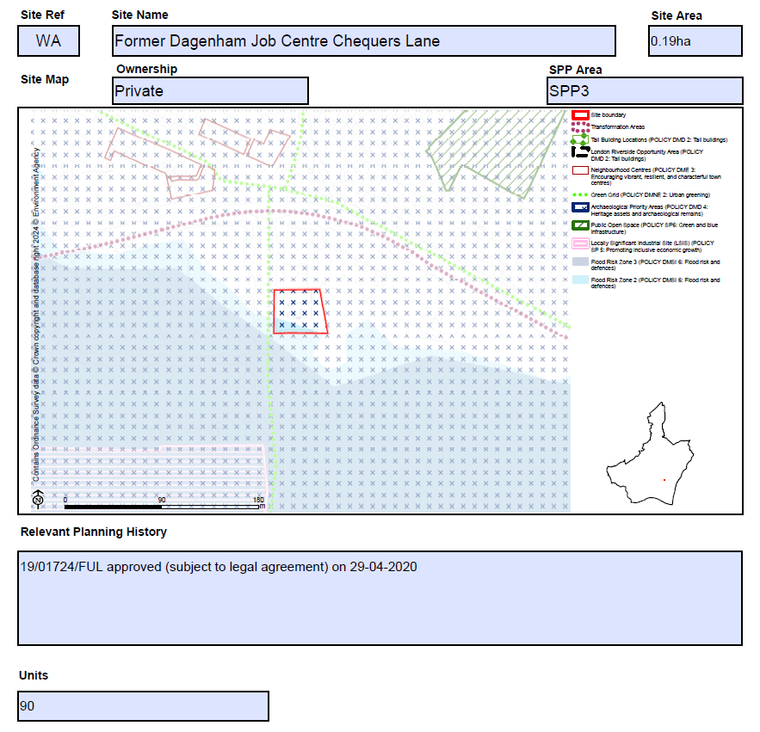
MM135 | SPP3  XJ- Stamping Plant | Amend site name as follows:  Former Ford Stamping Plant  Amend bullet point/s under 'Proposed Use(s)' as follows:  - A comprehensive residential-led mixed-use development. Potential capacity of delivering circa 3,000 new homes, flexible community/commercial floorspace and supported infrastructure including a 10-form intake secondary school to the north-western part of the site, cultural facilities 5 acres of land for a secondary school to the southern part of the site and open spaces etc.  Amend bullet point/s under 'Planning Constraints and Requirements' heading (now proposed to be entitled 'Development Requirements') as follows:  - New development should provide flood mitigation and adaptation measures  - Tall building development maybe appropriate in this location (see Local Plan poli-cy DMD2), subject to other planning considerations  - In accordance with Policy DMSI 5: Land contamination, a preliminary risk assessment (PRA), such as a site walkover or conceptual model must be undertaken. Where contamination may have a pollution risk to controlled waters, Site Investigation and Remediation Strategy reports may be required.  - Providing flood mitigation and adaptation measures to comply with Policies DMNE4 and DMSI 6, and having regard to the TE 2100 Plan  Amend bullet point/s under 'Relevant Planning History' as follows:  - 21/01808/OUTALL approved on 10-10-2022  Amend Site Map boundary as follows as per PMSPM46 and reflecting representation from site promoter:  Submission Plan  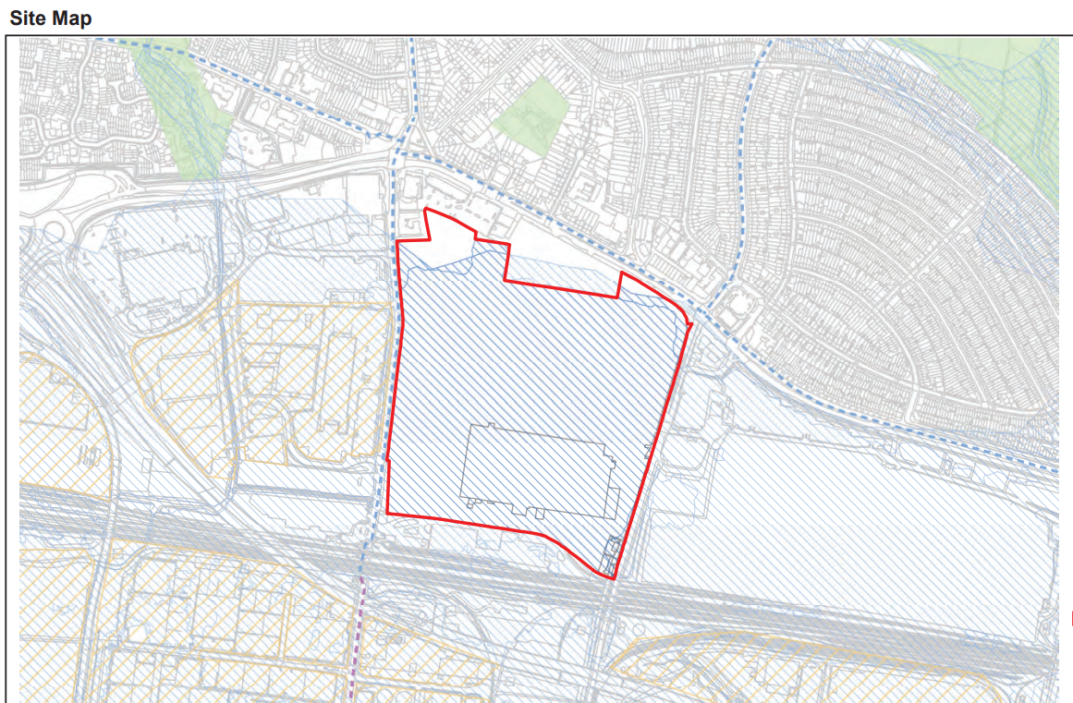  Main Modification  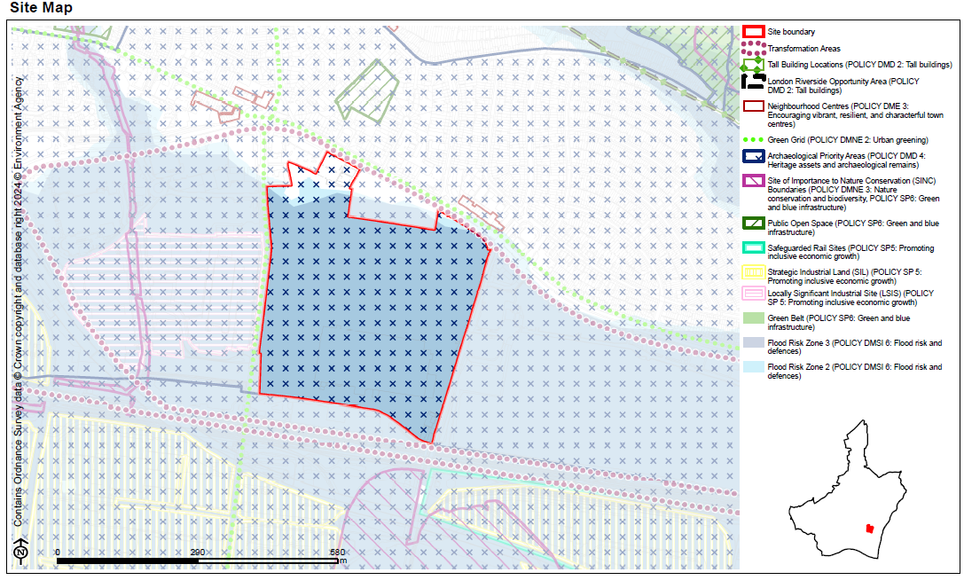
MM136 | SPP3  ZZ-GSR and Gill Sites | Amend site name as follows:  GSR and Gill Sites Land on the West side of Chequers Lane, Dagenham  Amend bullet point/s under 'Proposed Use(s)' as follows:  - Residential-led mixed-use development, with potential to deliver circa 707 400 new homes, circa 800 sq.m commercial floorspace and supported infrastructure including 1 new primary school.  Amend bullet point/s under 'Planning Constraints and Requirements' heading (now proposed to be entitled 'Development Requirements') as follows:  - New developments should provide flood mitigation and adaptation measures  - Tall building development maybe appropriate in this location (see Local Plan policy DMD2), subject to other planning considerations.  - In line with Policy DMNE 4: Water environment, the development will need to consider ways to enhance the estuary and river edge for fish and other wildlife.  - Providing flood mitigation and adaptation measures to comply with Policies DMNE4 and DMSI 6, and having regard to the TE 2100 Plan  - In accordance with Policy DMSI 5: Land contamination, a preliminary risk assessment (PRA), such as a site walkover or conceptual model must be undertaken. Where contamination may have a pollution risk to controlled waters, Site Investigation and Remediation Strategy reports may be required.  Amend bullet point/s under 'Relevant Planning History' as follows:  N/A  - 21/01211/FULL approved (subject to legal agreement) on 13-04- 2022 for 380 homes  - 22/00416/FULL approved (subject to legal agreement) on 07-12- 2023 for 327 homes  Amend Indicative Minimum Capacity as follows:  400 707 new homes
MM137 | SPP3  E_014-Barking Reach Power Station | Amend bullet point/s under 'Existing Uses' as follows:  - Industrial warehouses and refining plants The site currently comprises the disused Barking Reach Power Station, which ceased operation in October 2014  Amend bullet point/s under 'Proposed Use(s)' as follows:  - Opportunities to deliver up to 237,946 sq.m a 'Sui Generis' consolidated wholesale food market with ancillary uses, as well as connected/ supporting uses (including food processing, logistics, food education and retail), as well as improvement works to the Goresbrook Interchange, A13, local bus services and public realm enhancements at Dagenham Dock station; exploring the use of Using the River Thames to move freight to and from the markets.  Amend bullet point/s under 'Planning Constraints and Requirements' heading (now proposed to be entitled 'Development Requirements') as follows:  - The site is identified as within the London Riverside Opportunity Area, the London Sustainable Industries Park, as well as the Strategic Industrial Land (SIL)., providing strategic protection and intensification for warehousing and logistics uses, which often require larger spaces in accordance with Local Plan policy DME1  - The site falls within the Joint Waste Development Plan, which is currently being reviewed  - A strategic delivery framework may be prepared to support the redevelopment of this sub-area, visit: https://wholesalemarkets.co.uk/  - Development should contribute to the sub area vision and strengthen the relationship with the adjacent land/areas (see Local Plan sub area policies: SPP2 and SPP3), focusing on improving the public realm and contributing towards a safer local environment for pedestrians and cyclists.  - Tall buildings maybe appropriate in this location (see Local Plan policy DMD2), subject to other planning considerations (e.g. air quality, archaeological priority area); the scale and massing of development should contribute to the sub area vision and respond positively to its existing and emerging context.  - Development should provide flood mitigation and adaptation measures to comply with the Local Plan policy DMNE4 and DMSI 6.  - In line with Policy DMNE 4: Water environment, the development will need to consider ways to enhance the estuary and river edge for fish and other wildlife.  - Providing flood mitigation and adaptation measures to comply with Policies DMNE4 and DMSI 6, and having regard to the TE 2100 Plan  - In accordance with Policy DMSI 5: Land contamination, a preliminary risk assessment (PRA), such as a site walkover or conceptual model must be undertaken. Where contamination may have a pollution risk to controlled waters, Site Investigation and Remediation Strategy reports may be required.  Amend Indicative Minimum Capacity as follows:  Up to 237,946 sq.m 'Sui Generis' Not specified. Contributing to Dagenham Dock SIL - up to 647,636 sq.m
MM138 | SPP3  E_015-Plot 62 SEGRO Park | Amend bullet point/s under 'Planning Constraints and Requirements' heading (now proposed to be entitled 'Development Requirements') as follows:  - The site is identified as Strategic Industrial Land (SIL), providing strategic protection and intensification for warehousing and logistics uses, which often require larger spaces in accordance with Local Plan policy DME1  - A strategic delivery framework may be prepared to support the redevelopment of this sub-area  - The site is also identified in the Joint Waste Plan - comply to Local Plan policy DMSI8 and DMSI9  - Providing flood mitigation and adaptation measures to comply with the Local Plan policy Policies DMNE4 and DMSI 6, and having regard to the TE 2100 Plan  - Development should contribute to the sub area vision. Consideration of strengthening the relationship with the adjacent land/areas (see Local Plan sub area policies: Policy SPP3 and Policy SP9), focusing on improving the public realm and contributing towards a safer local environment for pedestrians and cyclists  - Tall buildings maybe appropriate in this location to allow multi-level industrial buildings (see Local Plan policy DMD2), subject to other planning considerations; tThe scale and massing of development should contribute to the sub area vision and respond positively to its existing and emerging context.  - In accordance with Policy DMSI 5: Land contamination, a preliminary risk assessment (PRA), such as a site walkover or conceptual model must be undertaken. Where contamination may have a pollution risk to controlled waters, Site Investigation and Remediation Strategy reports may be required.  Amend Indicative Minimum Capacity (Years) from 5-10 years and 10+ years to 0-5 years.
MM139 | SPP3  E_016-Plot 63 SEGRO Park | Amend bullet point/s under 'Planning Constraints and Requirements' heading (now proposed to be entitled 'Development Requirements') as follows:  - The site is identified as Strategic Industrial Land (SIL), providing strategic protection and intensification for warehousing and logistics uses, which often require larger spaces in accordance with Local Plan policy DME1.  - A strategic delivery framework may be prepared to support the redevelopment of this sub-area.  - The site is also identified in the Joint Waste Plan - comply to Local Plan policy DMSI8 and DMSI9  - Providing flood mitigation and adaption measures to comply with the Local Plan policy Policies DMNE4 and DMSI 6, and having regard to the TE 2100 Plan.  - Development should contribute to the sub area vision and strengthen the relationship with the adjacent land/areas (see Local Plan sub area policies: Policies SPP2 and SPP3 and Policy SP9), focusing on improving the public realm and contributing towards a safer local environment for pedestrians and cyclists.  - Tall buildings maybe appropriate in this location (see Local Plan policy DMD2), subject to other planning considerations; tThe scale and massing of development should contribute to the sub area vision and respond positively to its existing and emerging context.  - In accordance with Policy DMSI 5: Land contamination, a preliminary risk assessment (PRA), such as a site walkover or conceptual model must be undertaken. Where contamination may have a pollution risk to controlled waters, Site Investigation and Remediation Strategy reports may be required.
MM140 | SPP3  E_017-Plot 64 SEGRO Park | Amend bullet point/s under 'Planning Constraints and Requirements' heading (now proposed to be entitled 'Development Requirements') as follows:  - The site is identified as Strategic Industrial Land (SIL), providing strategic protection and intensification for warehousing and logistics uses, which often require larger spaces in accordance with Local Plan policy DME1.  - A strategic delivery framework may be prepared to support the redevelopment of this sub-area.  - The site is also identified in the Joint Waste Plan - comply to Local Plan policy DMSI8 and DMSI9  - Providing flood mitigation and adaptation measures to comply with the Local Plan policy Policies DMNE4 and DMSI 6, and having regard to the TE 2100 Plan  - Development should contribute to the sub area vision and strengthen the relationship with the adjacent land/areas (see Local Plan sub area policies: Policy SPP3 and Policy SP9), focusing on improving the public realm and contributing towards a safer local environment for pedestrians and cyclists.  - Tall buildings maybe appropriate in this location (see Local Plan policy DMD2), subject to other planning considerations; tThe scale and massing of development should contribute to the sub area vision and respond positively to its existing and emerging context.  - In accordance with Policy DMSI 5: Land contamination, a preliminary risk assessment (PRA), such as a site walkover or conceptual model must be undertaken. Where contamination may have a pollution risk to controlled waters, Site Investigation and Remediation Strategy reports may be required.  Amend Indicative Minimum Capacity (Years) from 5-10 years and 10+ years to 0-5 years.
MM141 | SPP3  E_018-Plot 65 SEGRO Park | Amend bullet point/s under 'Planning Constraints and Requirements' heading (now proposed to be entitled 'Development Requirements') as follows:  - The site is identified as Strategic Industrial Land (SIL), providing strategic protection and intensification for warehousing and logistics uses, which often require larger spaces in accordance with Local Plan policy DME1.  - A strategic delivery framework may be prepared to support the redevelopment of this sub-area.  - The site is also identified in the Joint Waste Plan - comply to Local Plan policy DMSI8 and DMSI9  - The site is located to the north of the East London Transit (ELT) and is adjacent to a Site of Importance for Nature Conservation to the west.  - Providing flood mitigation and adaption measures to comply with the Local Plan Policies policy DMNE4 and DMSI 6  - Development should contribute to the sub area vision and strengthen the relationship with the adjacent land/areas (see Local Plan sub area policies: Policies SPP2 and SPP3, and Policy SP9), focusing on improving the public realm and contributing towards a safer local environment for pedestrians and cyclists.  - Tall buildings maybe appropriate in this location to allow multi-level industrial buildings (see Local Plan policy DMD2), subject to other planning considerations; t The scale and massing of development should contribute to the sub area vision and respond positively to its existing and emerging context.  Amend bullet point/s under 'Relevant Planning History' as follows:  - 21/01355/FUL  Amend Indicative Minimum Capacity (Years) from 5-10 years to 0-5 years.
MM142 | SPP3  E_019-Plot 67 SEGRO Park | Amend bullet point/s under 'Planning Constraints and Requirements' heading (now proposed to be entitled 'Development Requirements') as follows:  - The site is identified as Strategic Industrial Land (SIL), providing strategic protection and intensification for warehousing and logistics uses, which often require larger spaces in accordance with Local Plan policy DME1.  - A strategic delivery framework may be prepared to support the redevelopment of this sub-area.  - The site is also identified in the Joint Waste Plan - comply to Local Plan policy DMSI8 and DMSI9.  - The site is located to the north of the East London Transit (ELT) and is adjacent to a Site of Importance for Nature Conservation to the west.  - Providing flood mitigation and adaption measures to comply with the Local Plan Policies policy DMNE4 and DMSI 6, and having regard to the TE 2100 Plan  - Development should contribute to the sub area vision and strengthen the relationship with the adjacent land/areas (see Local Plan sub area policies: Policies SPP2 and SPP3, and Policy SP9), focusing on improving the public realm and contributing towards a safer local environment for pedestrians and cyclists.  - Tall buildings maybe appropriate in this location to allow multi-level industrial buildings (see Local Plan policy DMD2), subject to other planning considerations; tThe scale and massing of development should contribute to the sub area vision and respond positively to its existing and emerging context.  - In accordance with Policy DMSI 5: Land contamination, a preliminary risk assessment (PRA), such as a site walkover or conceptual model must be undertaken. Where contamination may have a pollution risk to controlled waters, Site Investigation and Remediation Strategy reports may be required.  Amend bullet point/s under 'Relevant Planning History' as follows:  21/00023/FUL  Amend Indicative Minimum Capacity (Years) from 5-10 years to 0-5 years.
MM143 | SPP3  E_020-Plot 70 SEGRO Park | Amend bullet point/s under 'Planning Constraints and Requirements' heading (now proposed to be entitled 'Development Requirements') as follows:  - The site is identified as Strategic Industrial Land (SIL), providing strategic protection and intensification for warehousing and logistics uses, which often require larger spaces in accordance with Local Plan policy DME1  - A strategic delivery framework may be prepared to support the redevelopment of this sub-area  - The site is also identified in the Joint Waste Plan - comply to the Local Plan policy DMSI8 and DMSI9  - The site is located to the north of the East London Transit (ELT) and is adjacent to a Site of Importance for Nature Conservation to the west  - Providing flood mitigation and adaption measures to comply with the Local Plan Policies policy DMNE4 and DMSI 6, and having regard to the TE 2100 Plan.  - Development should contribute to the sub area vision and strengthen the relationship with the adjacent land/areas (see Local Plan sub area policies: Policies SPP2 and SPP3, and Policy SP9), focusing on improving the public realm and contributing towards a safer local environment for pedestrians and cyclists.  - Tall buildings maybe appropriate in this location (see Local Plan policy DMD2), subject to other planning considerations; tThe scale and massing of development should contribute to the sub area vision and respond positively to its existing and emerging context.  - Development will be required to provide a strategy for responding to the National Grid underground cables present within the site which demonstrates how the National Grid Design Guide and Principles have been applied at the masterplanning stage and how the impact of the assets has been reduced through good design.  - In accordance with Policy DMSI 5: Land contamination, a preliminary risk assessment (PRA), such as a site walkover or conceptual model must be undertaken. Where contamination may have a pollution risk to controlled waters, Site Investigation and Remediation Strategy reports may be required.  Amend Indicative Minimum Capacity (Years) from 5-10 years to 0-5 years.
MM144 | SPP3  E_052-Dagenham Dock | Add new proforma as follows:  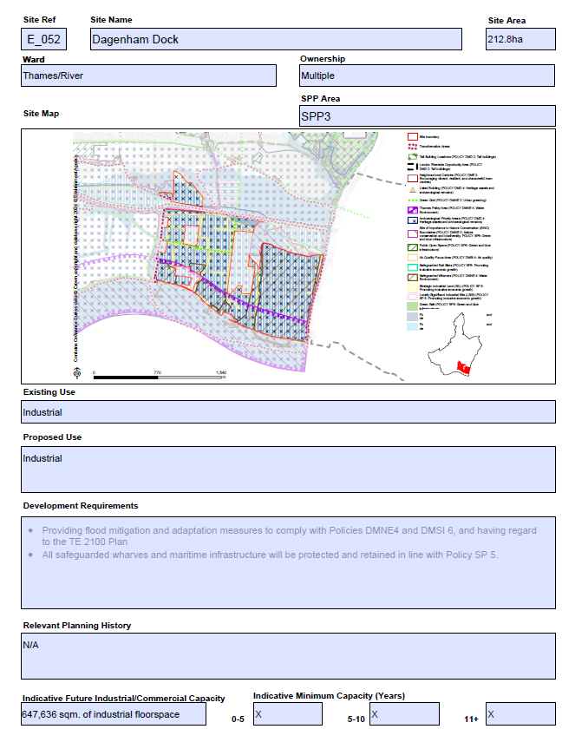
MM145 | SPP3  ED1-Polar Ford Special Educational Needs School | Amend Proposed Use as follows:  A Special Educational Needs school to support the growing population of the area of the area  Amend bullet point/s under 'Planning Constraints and Requirements' heading (now proposed to be entitled 'Development Requirements') as follows:  - The site is located within identified Strategic Industrial Land (SIL), providing strategic protection and intensification for warehousing and logistics uses, which often require larger spaces in accordance with Local Plan policy DME1  - A strategic delivery framework may be prepared to support the redevelopment of this sub-area  - The site is also identified in the Joint Waste Plan - comply to Local Plan policy DMSI8 and DMSI9  - Development should provide flood mitigation and adaption measures to comply with Local Plan policy DMNE4 and DMSI 6  - Providing flood mitigation and adaptation measures to comply with Policies DMNE4 and DMSI 6, and having regard to the TE 2100 Plan  - Tall buildings maybe appropriate in this location to allow multi-level industrial buildings (see Local Plan policy DMD2), subject to other planning considerations; tThe scale and massing of development should contribute to the the sub area vision and respond positively to its existing and emerging context.  Amend bullet point/s under 'Relevant Planning History' as follows:  N/A  21/01959/FULL approved on 13-04-2022
MM146 | SPP4 | Insert new section heading page as follows:  Sites within Strategic Area SPP4: Chadwell Heath and Marks Gate  Insert contents page of sites for the SPP4 Area  Add sentence on contents page of sites setting out the following:  Housing Allocation 'Indicative Minimum Capacity' and 'Units' set out the net minimum number of new homes it is expected there is capacity to deliver within the Plan period.
MM147 | SPP4  AS-Padnall Court and Reynolds Court | Add new proforma as follows:  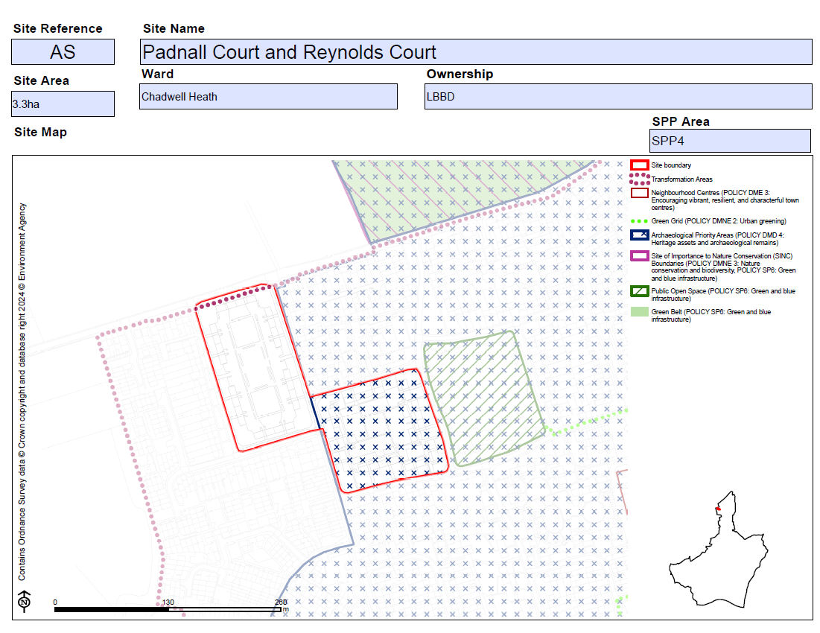  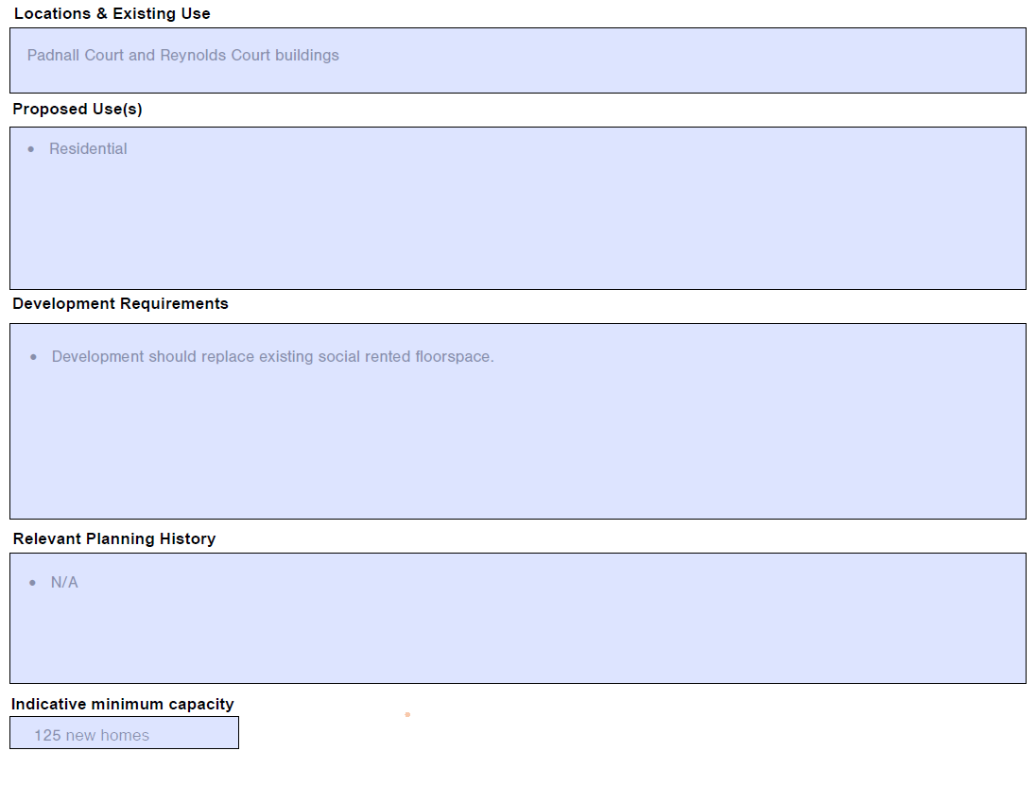
MM148 | SPP4  BG-26 and 28 Land to the Rear High Road | Add new proforma as follows:  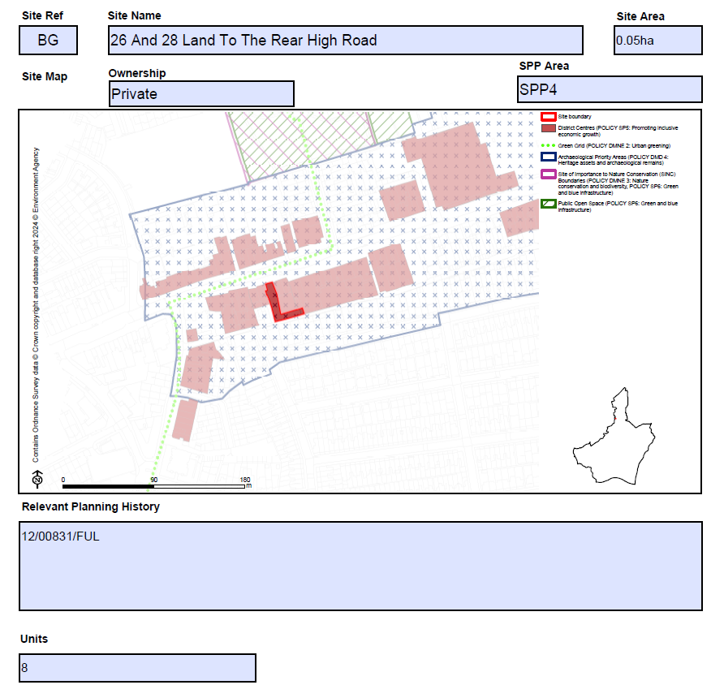
MM149 | SPP4  BR-3 Station Road | Add new proforma as follows:  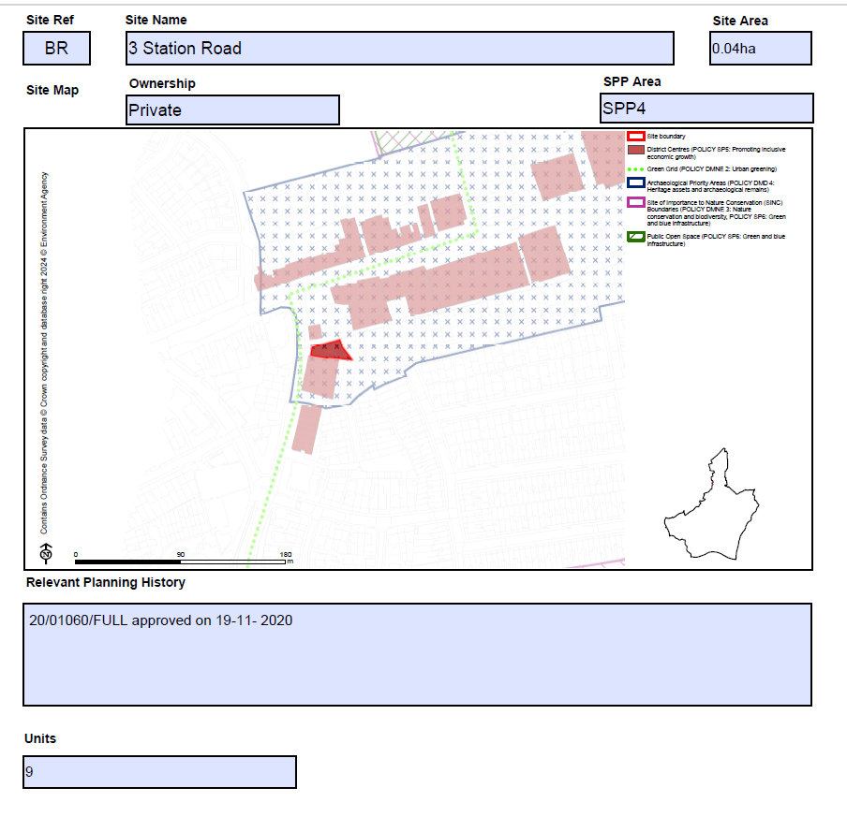
MM150 | SPP4  CH-Chadwell Heath Industrial Estate | Amend bullet two of the Proposed Use(s) section as follows:  - Potential to deliver circa 3,685 new homes, up to 136,732 sq.m industrial floorspace to support digital/cultural creative industries, and flexible commercial/community floorspace and supporting infrastructure including 2 3 FE primary schools and 1 8/10 FE secondary school, open spaces, healthcare and community facilities etc.  Amend bullet point/s under 'Planning Constraints and Requirements' heading (now proposed to be entitled 'Development Requirements') as follows:  - A Masterplan SPD will provide further details and policy guidance on the implementation of the industrial land strategy in this Trans-formation Area. Please refer to pPolicy SPP4 for guidance.  - Enhance connectivity and integration with Chadwell Heath district centre, maximizing the opportunities presented by the proximity of Chadwell Heath Station in co-operation with the London Borough of Redbridge.  - In accordance with Policy DMSI 5: Land contamination, a preliminary risk assessment (PRA), such as a site walkover or conceptual model must be undertaken. Where contamination may have a pollution risk to controlled waters, Site Investigation and Remediation Strategy reports may be required.  Amend bullet point/s under 'Relevant Planning History' as follows:  - 17/01011/OUT relates to 16 units on a small part of the site, refused but allowed on appeal on 12-12-2018.  - 16/00368/ FUL approved on 14-07-2016
MM151 | SPP4  CO-Padnall Lake | Amend bullet point/s under 'Proposed Use(s)' as follows:  - Residential-led mixed-use development. Potential to deliver 291 289 new homes, new public open spaces, with other supporting uses including community service facilities  Amend bullet point/s under 'Relevant Planning History' as follows:  - 20/01686/FULL approved on 05-03-2021 (amended by 22/01415/NONMAT seeking detailed planning permission for Phase 1 and outline planning permission for Phase 2 on 01-09-2022)  Amend Indicative Minimum Capacity as follows:  219 289 new homes
MM152 | SPP4  HS-Former White Horse Pub, Chadwell Heath | Add new proforma as follows:  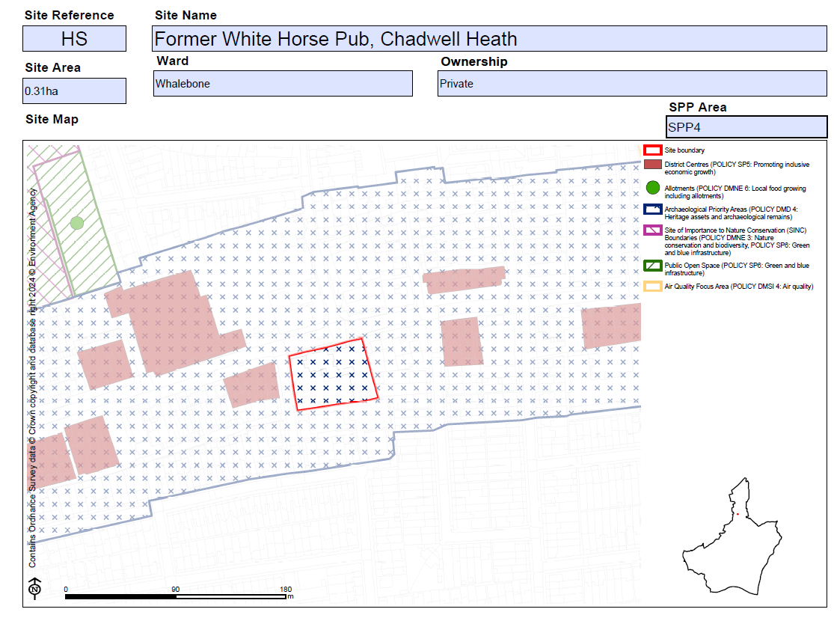  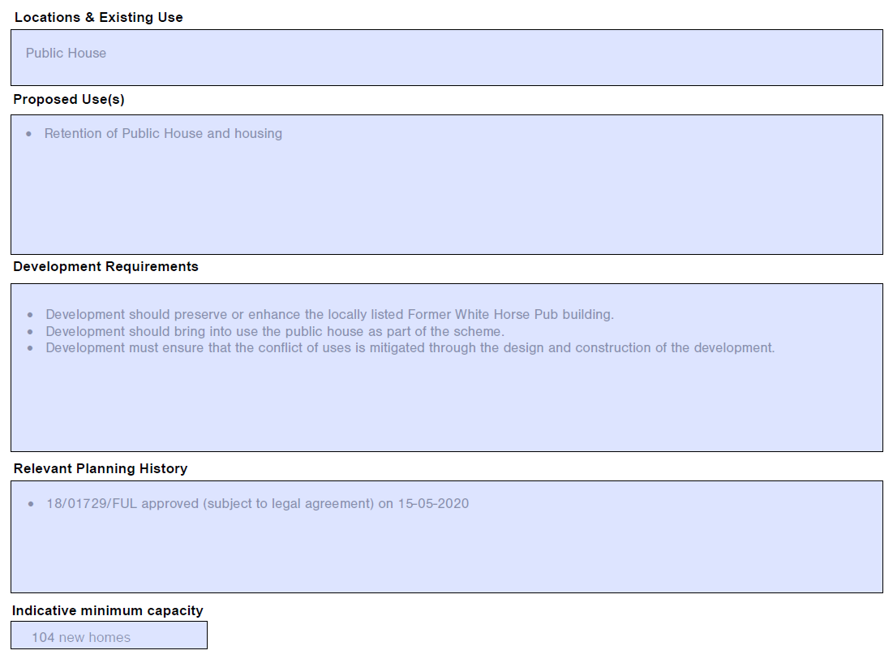
MM153 | SPP4  HV-7 Apollo Housing | Add new proforma as follows:  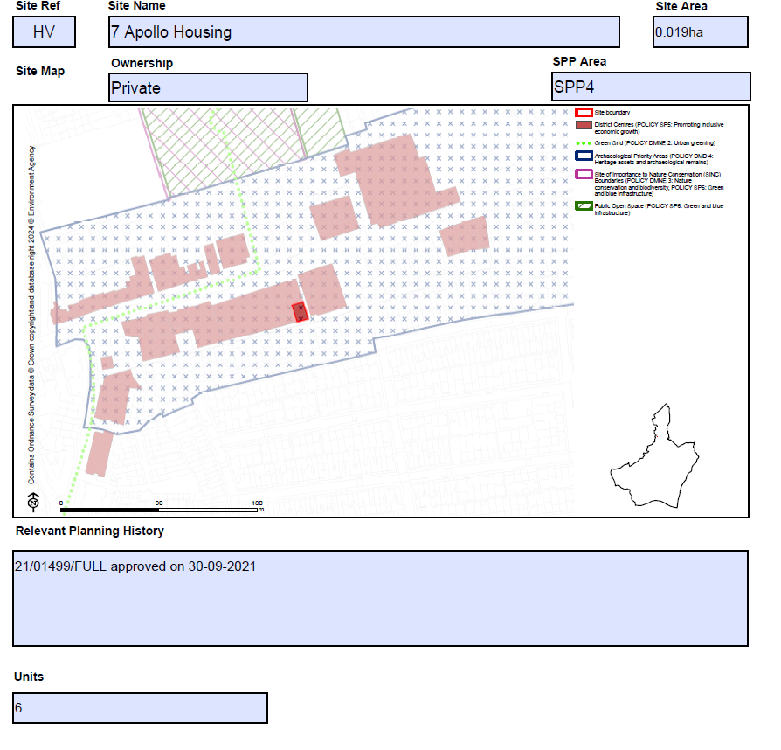
MM154 | SPP4  HW- 31-35 Mill Lane | Add new proforma as follows:  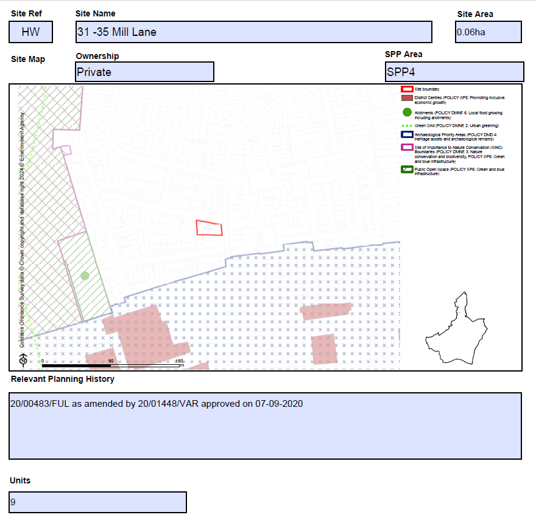
MM155 | SPP4  WC-Selinas Lane | Add new proforma as follows:  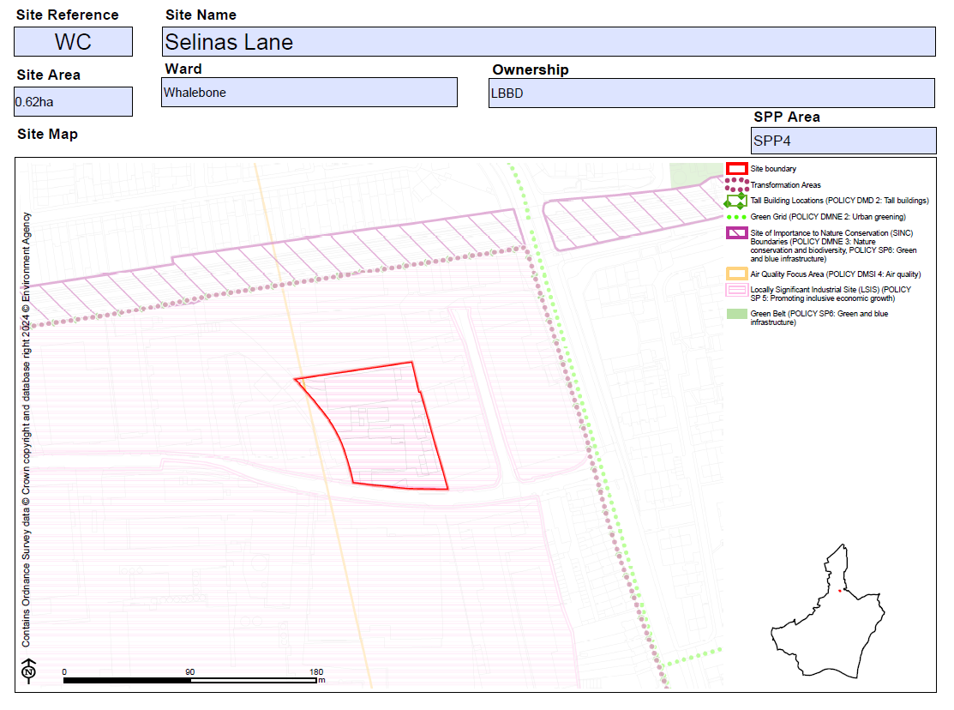  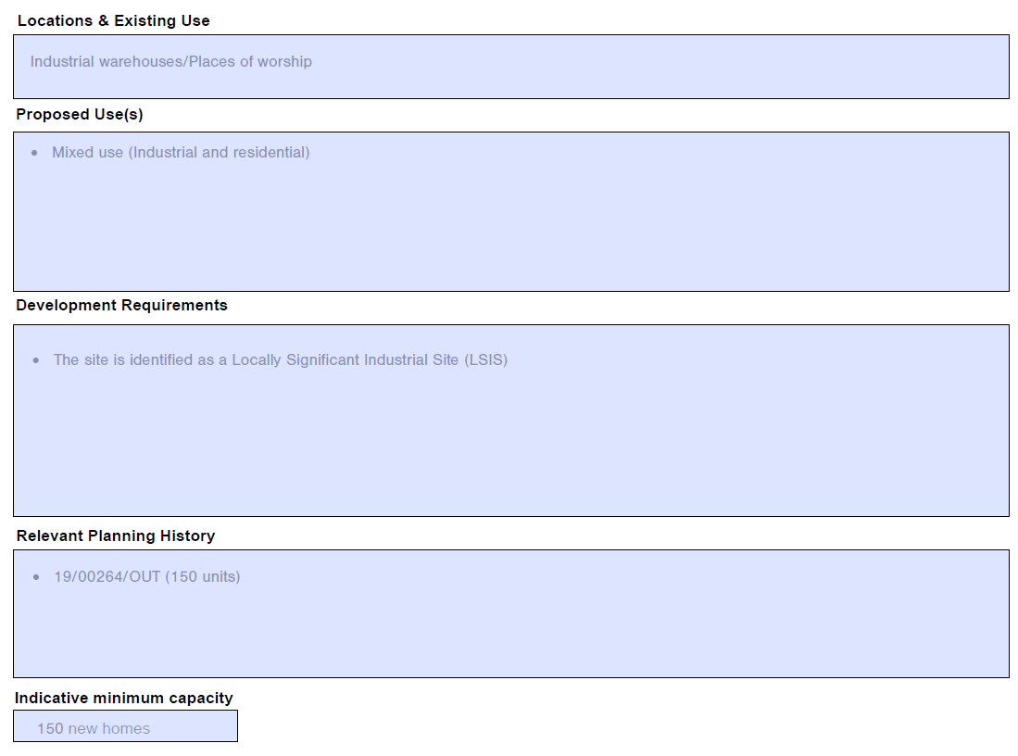
MM156 | SPP4  WF- 97-131 High Road | Amend red line site boundary for site WF – 97-131 High Road in Document C2 proforma as shown below:  Submission Version:  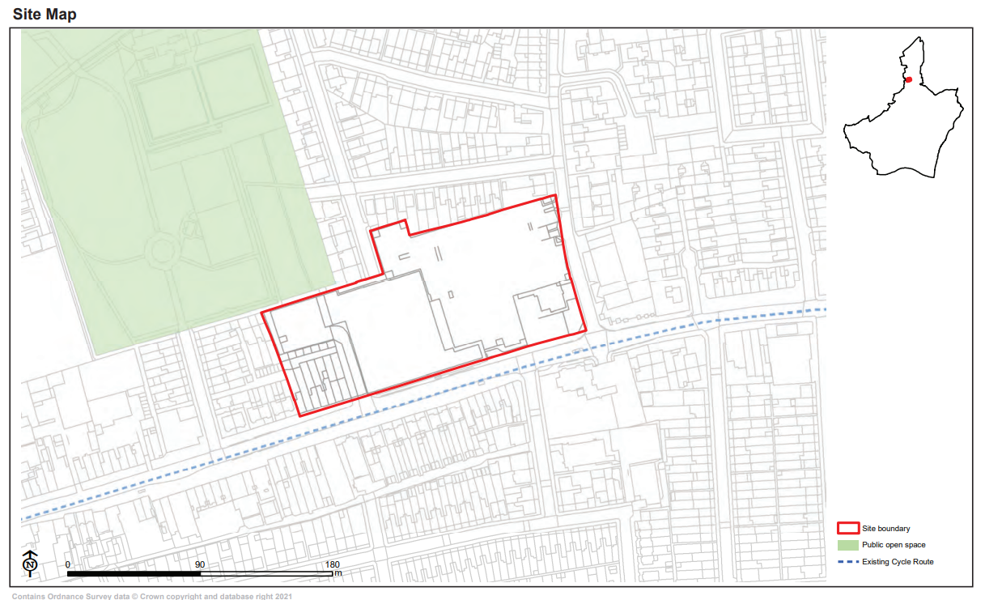  Proposed Change:  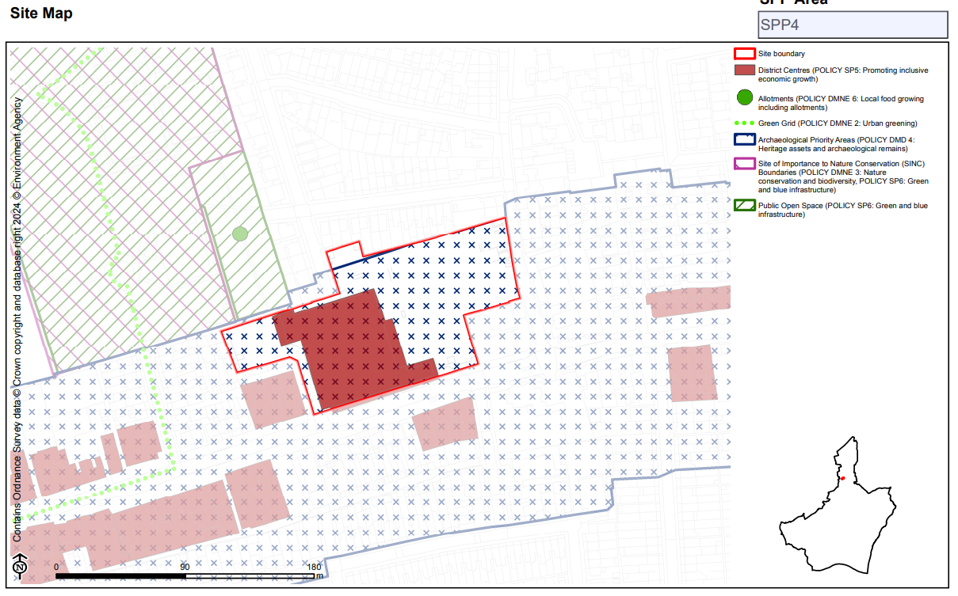  Amend bullet point/s under 'Planning Constraints and Requirements' heading (now proposed to be entitled 'Development Requirements') as follows:  - The site is located within the Chadwell Heath district centre - main town centre uses must be directed to Dagenham Heathway Town Centre boundary and proposals for large retail development in edge, or out of the boundary will be considered against the sequential approach in accordance with the most up to date NPPF.  - Development should aim to deliver out-standing design to have regard to its context, and make a positive contribution to local character within its neighbourhood.  - Tall building development maybe appro-priate in this location (see Local Plan poli-cy DMD2), subject to other planning con-siderations.  - Strengthening the relationship with the adjacent land/areas and the new Elizabeth Line Crossrail route as well as contributing to the delivery of Chadwell Heath Masterplan Area, see Local Plan sub area policies: SPP4.  - Development should minimise parking in this location. Early engagement with the Council is recommended to discuss appropriate car parking levels.
MM157 | SPP5 | Insert new section heading page as follows:  Sites within Strategic Area SPP5: Dagenham East  Insert contents page of sites for the SPP5 Area  Add sentence on contents page of sites setting out the following:  Housing Allocation 'Indicative Minimum Capacity' and 'Units' set out the net minimum number of new homes it is expected there is capacity to deliver within the Plan period.
MM158 | SPP5  BY-Rear of 5-7 Reede Road | Add new proforma as follows:  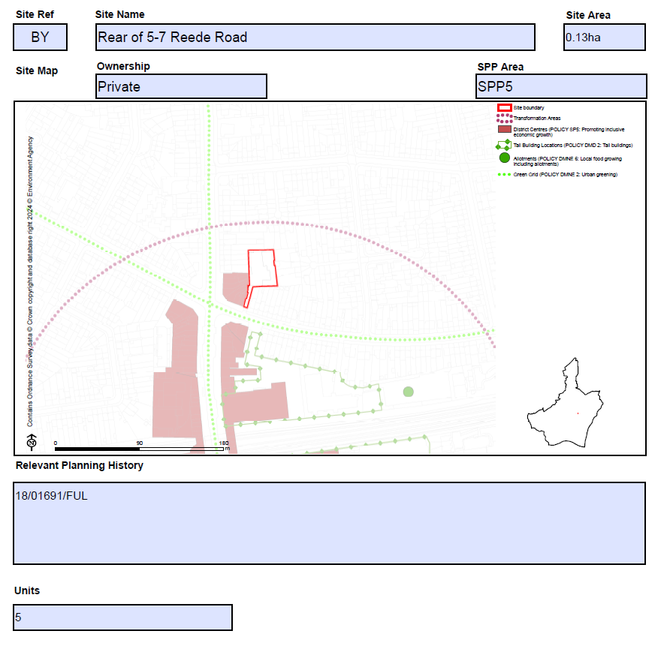
MM159 | SPP5  CX-Salisbury Road (Car Park) | Replace proforma as follows:  Submission Plan  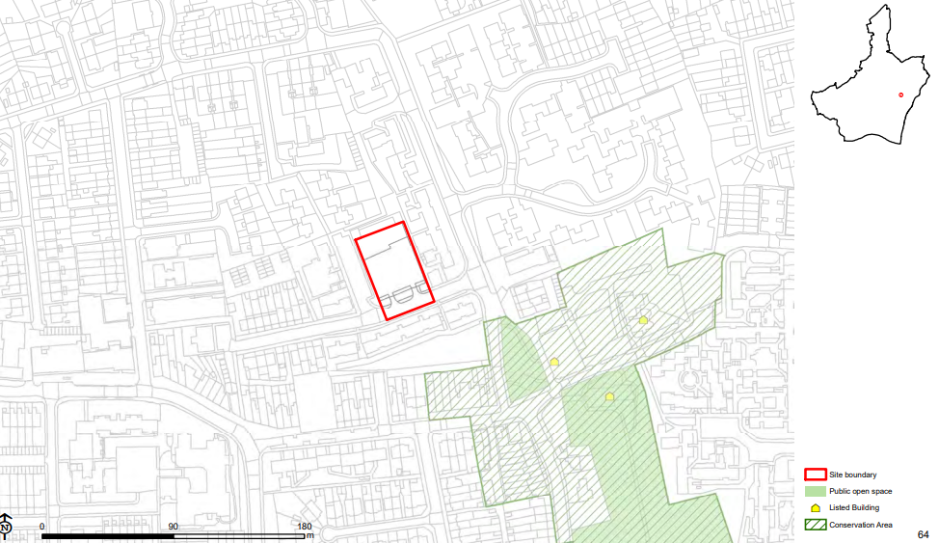  Main Modification Version  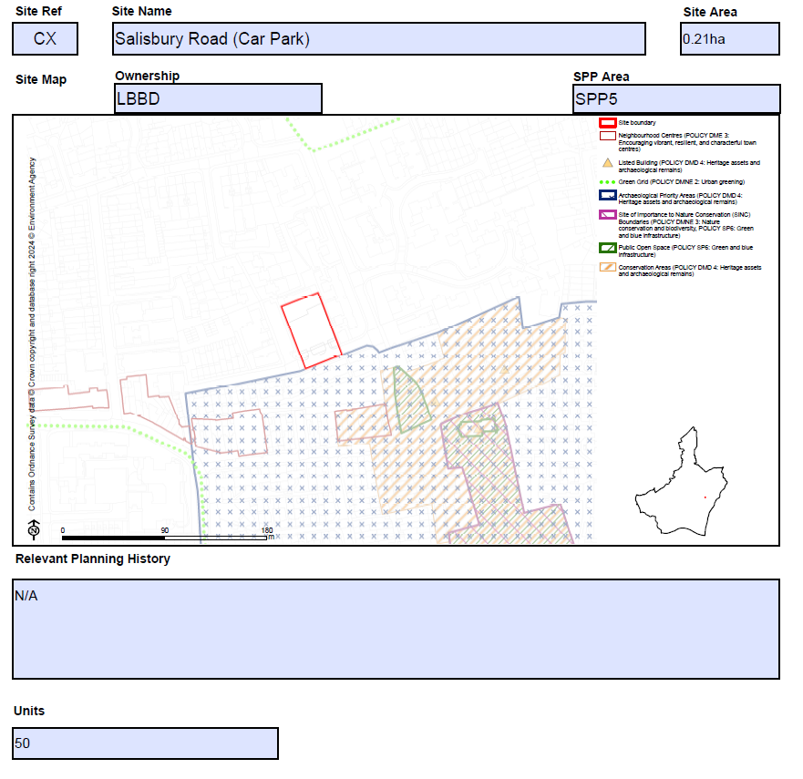
MM160 | SPP5  DF-Wantz Road | Add new proforma as follows:  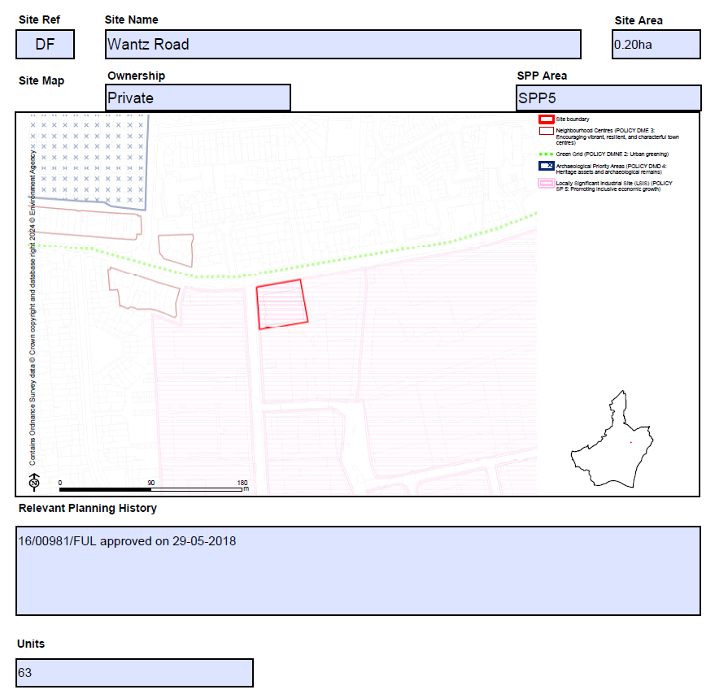
MM161 | SPP5  DQ-Dagenham Working Men's Club | Add new proforma as follows:  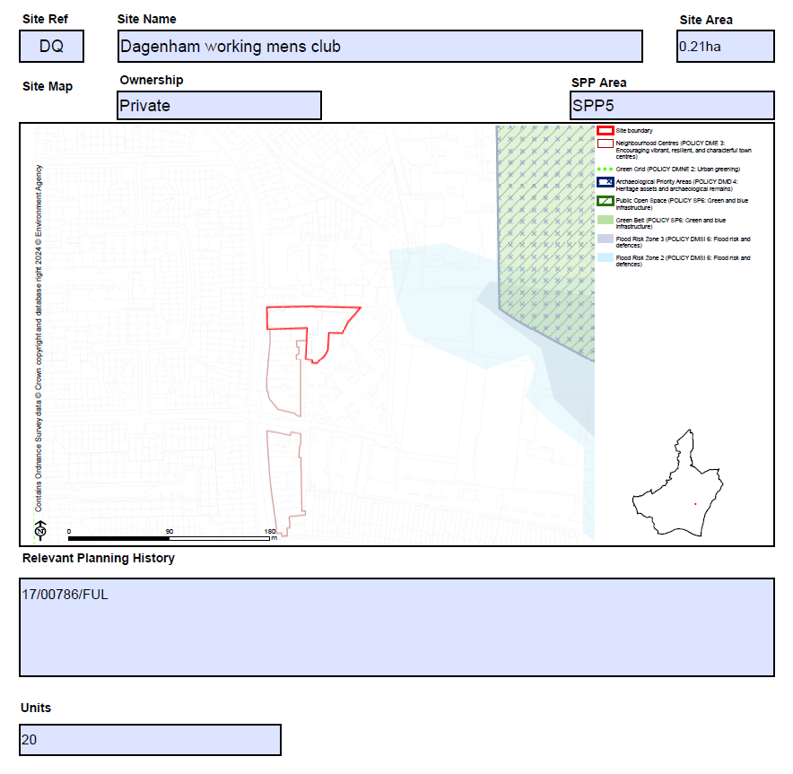
MM162 | SPP5  DS-Rainham Road South | Add new proforma as follows:  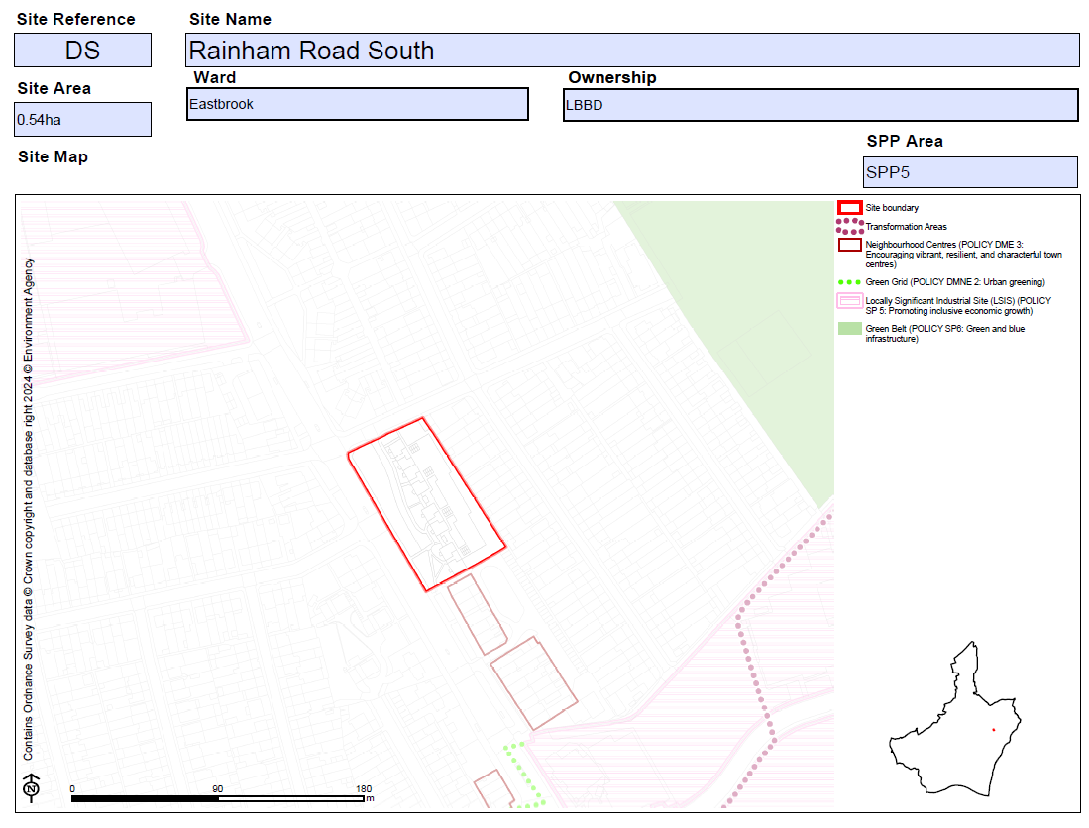  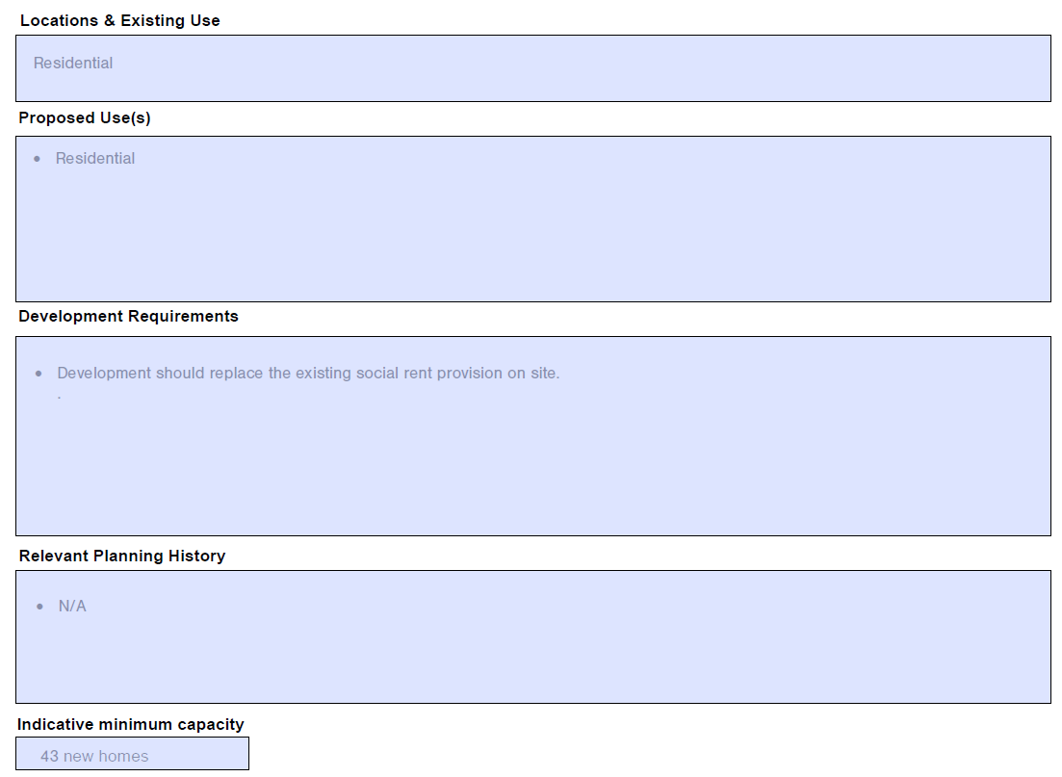
MM163 | SPP5  WB- 30-58 Durham Road, 475, 477 and 477A Rainham Road South, Dagenham | Add new proforma as follows:  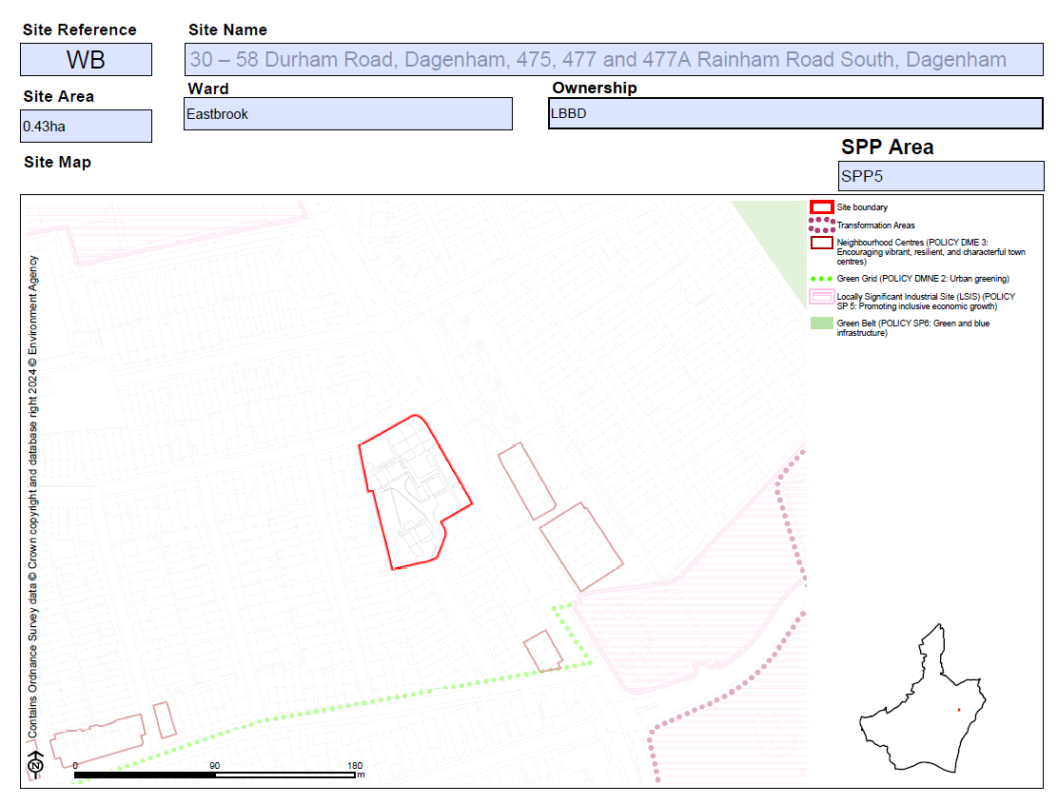  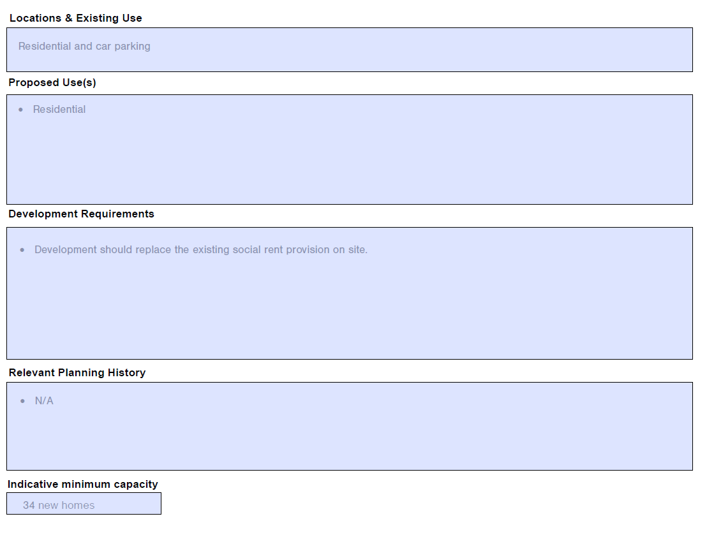
MM164 | SPP5  XE-Ibscott Close Estate | Amend site name as follows:  Ibscott Close Estate & highways land at Rainham Road South/Ballards Road  Amend bullet point/s under 'Planning Constraints and Requirements' heading (now proposed to be entitled 'Development Requirements') as follows:  - A strategic delivery framework may be prepared to support the redevelopment of this site.  - Development should aim to deliver out-standing design to have regard to its context, and make a positive contribution to local character within its neighbourhood.  - Tall building development maybe appro-priate in this location (see Local Plan poli-cy DMD2), subject to other planning considerations  - Development should minimise parking in this location. Early engagement with the Council is recommended to discuss appropriate car parking levels.  - In accordance with Policy DMSI 5: Land contamination, a preliminary risk assessment (PRA), such as a site walkover or conceptual model must be undertaken. Where contamination may have a pollution risk to controlled waters, Site Investigation and Remediation Strategy reports may be required.
MM165 | SPP5  YC-Royal British Legion | Add new proforma as follows:  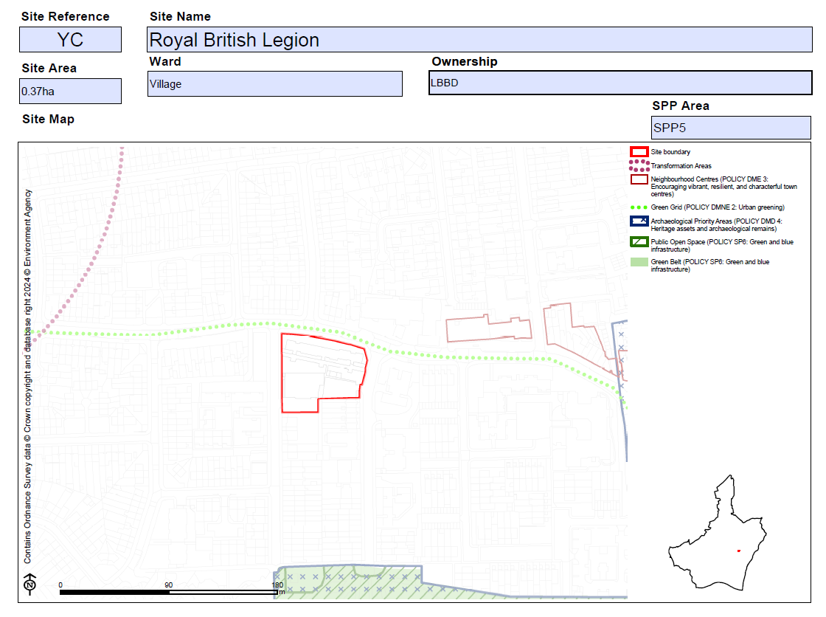  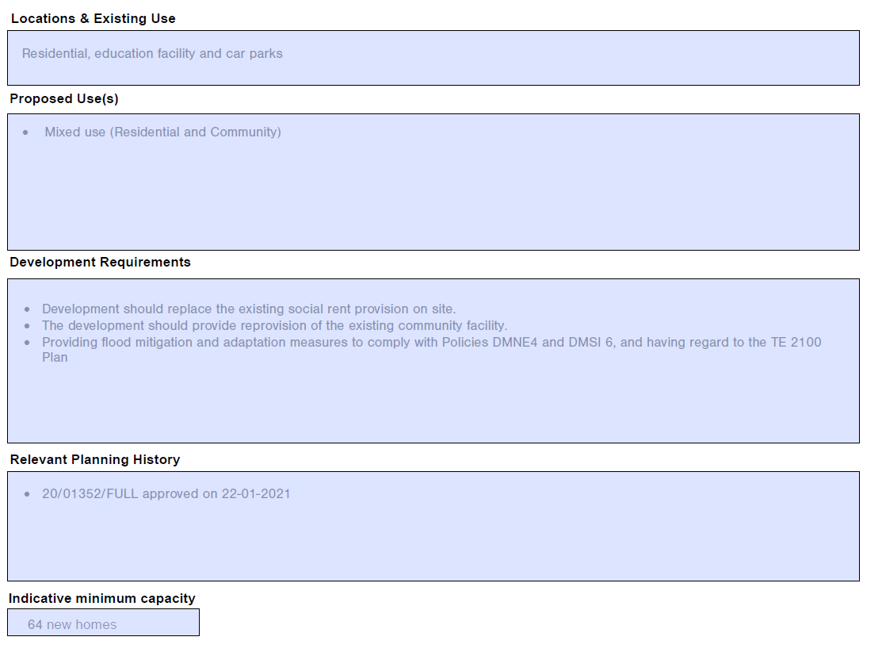
MM166 | SPP5  ZT- 58-68 Church Street | Replace proforma as follows:  Submission Plan  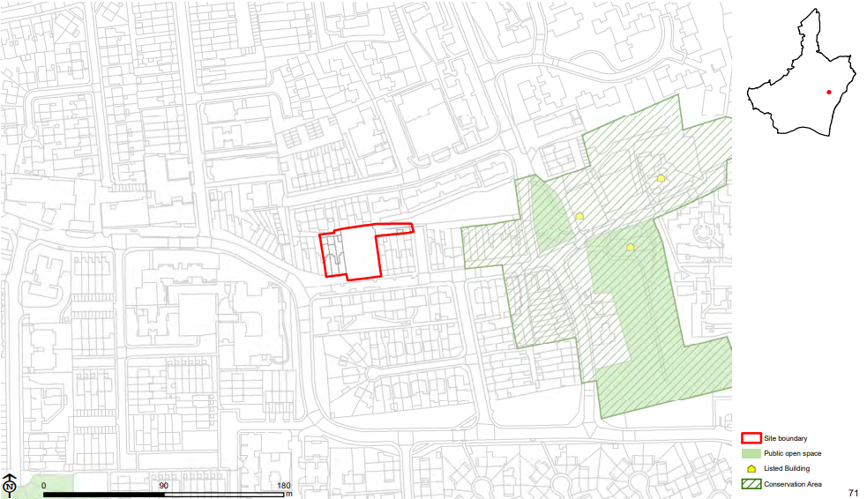  Main Modification Version  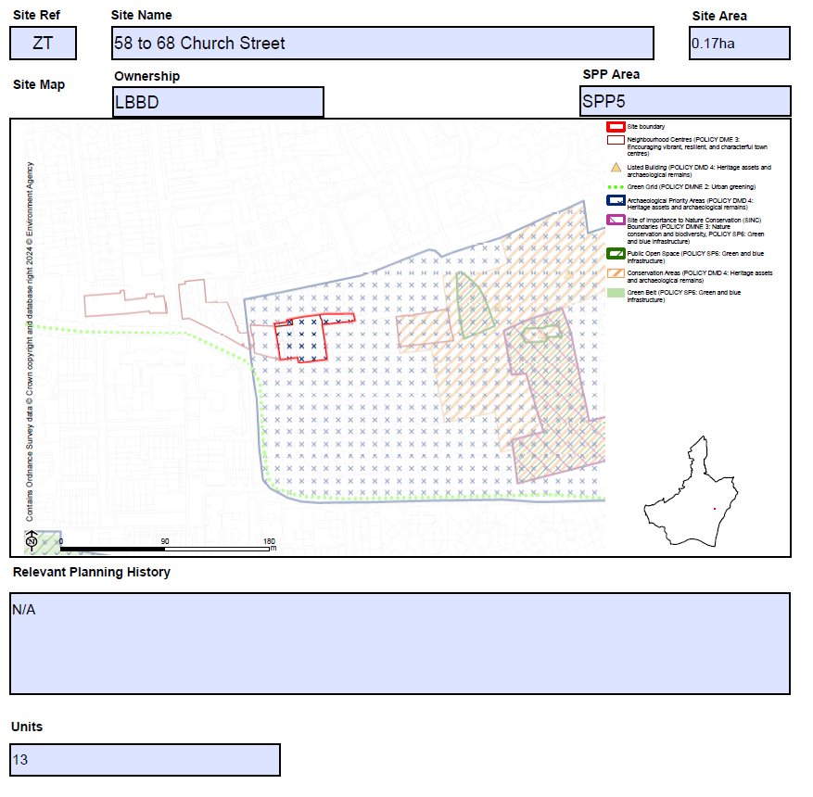
MM167 | SPP5  E_038-Here East and Film Studios | Amend site name as follows:  Here Dagenham East and Eastbrook Film Studios  Amend site area as follows:  13.9ha 18.98ha  Replace Site Map as follows:  Submission Local Plan:  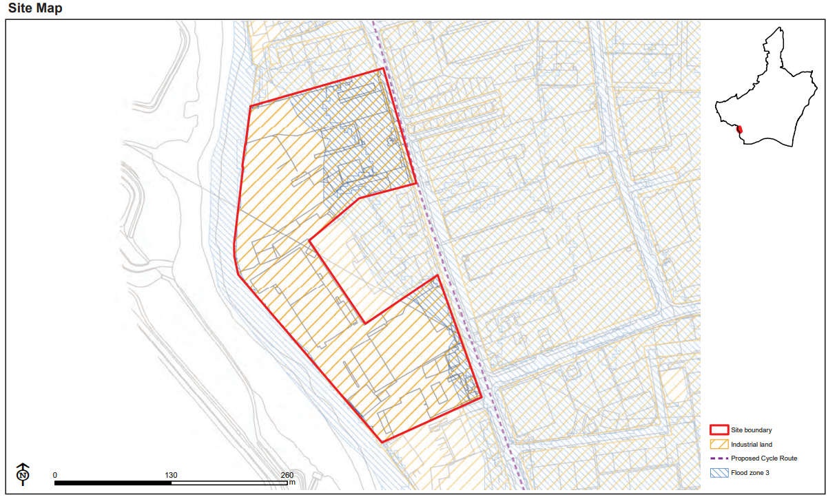  Main Modification Version:  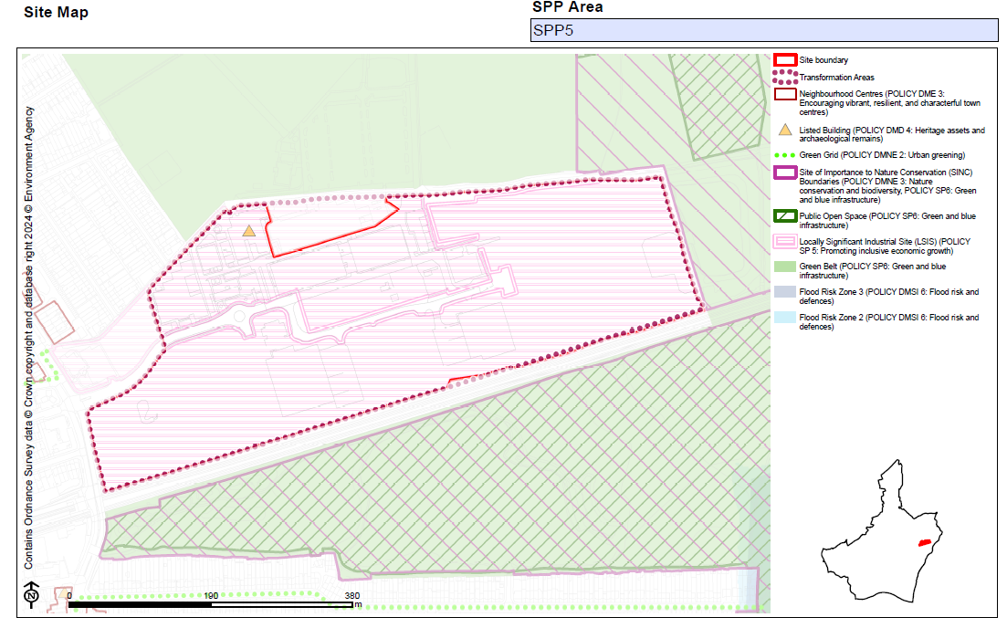  Amend bullet point/s under 'Planning Constraints and Requirements' heading (now proposed to be entitled 'Development Requirements') as follows:  - The site is identified as a Locally Significant Industrial Site (LSIS), protecting local business' needs, and supporting development that is in accordance with the Council's vision for the area in accordance with Local Plan policy DME1.  - The site is adjacent to Green Belt and Sites of Importance for Nature Conservation (SINCs) - developments need to be in accordance with Local Plan policies Policies DMNE1 and DMNE3.  - Development will be required to provide a strategy for responding to the National Grid underground cables present within the site which demonstrates how the National Grid Design Guide and Principles have been applied at the masterplanning stage and how the impact of the assets has been reduced through good design.
MM168 | SPP5  E_055-Dagenham East | Add new proforma as follows:  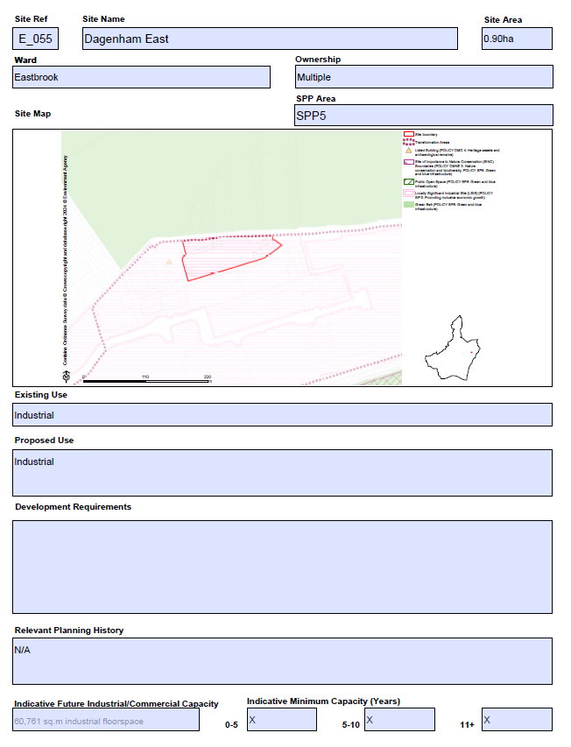
MM169 | SPP5  E_059-Wantz Road | Replace site map as follows, amending redline boundary to remove Site RA from within the Site E_059 site boundary, and removing shading designating LSIS at Site RA:  Submission Local Plan  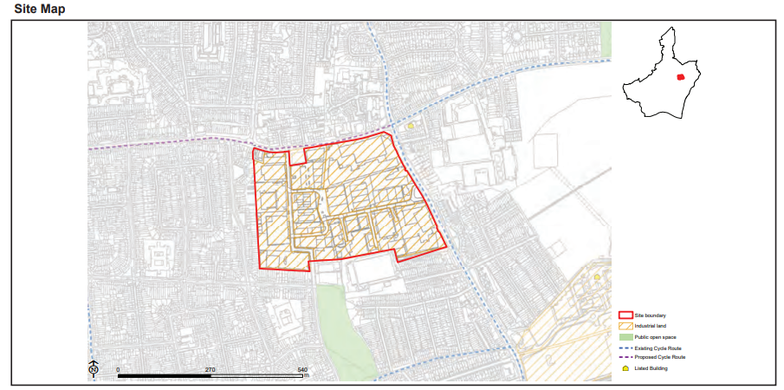  Main Modification Version  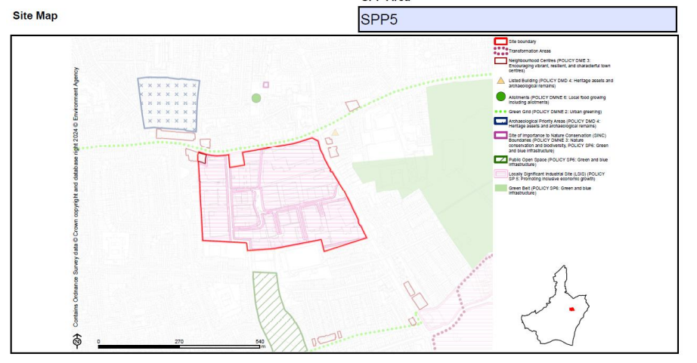  - The site is identified as a Locally Significant Industrial Site (LSIS)., protecting local business' needs, and supporting development that is in accordance with the Council's vision for the area in accordance with Policy DME1  - A strategic delivery framework may be prepared to support the redevelopment of this Transformation Area  - Development must promote sustainable mods of transport including car lite and car free principles
MM170 | SPP5  RA-Pondfield Special Education Needs School | Replace site map as follows, removing shading designating LSIS from site RA:  Submission Local Plan  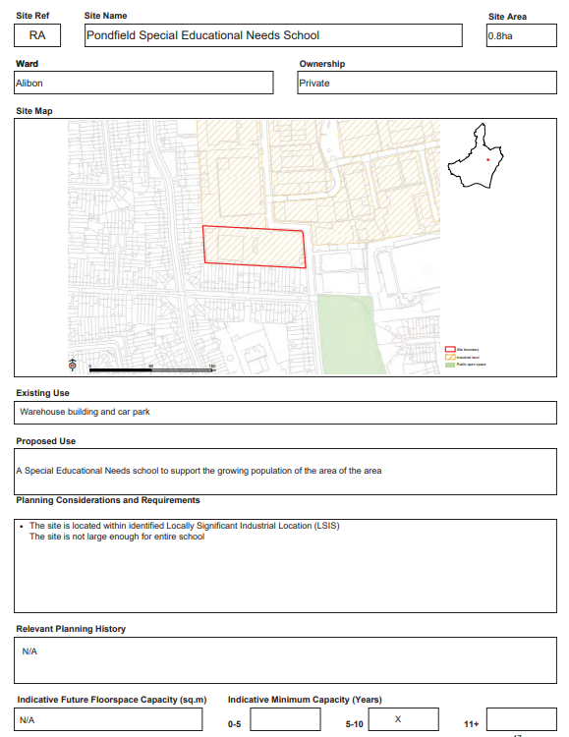  Main Modifications Version  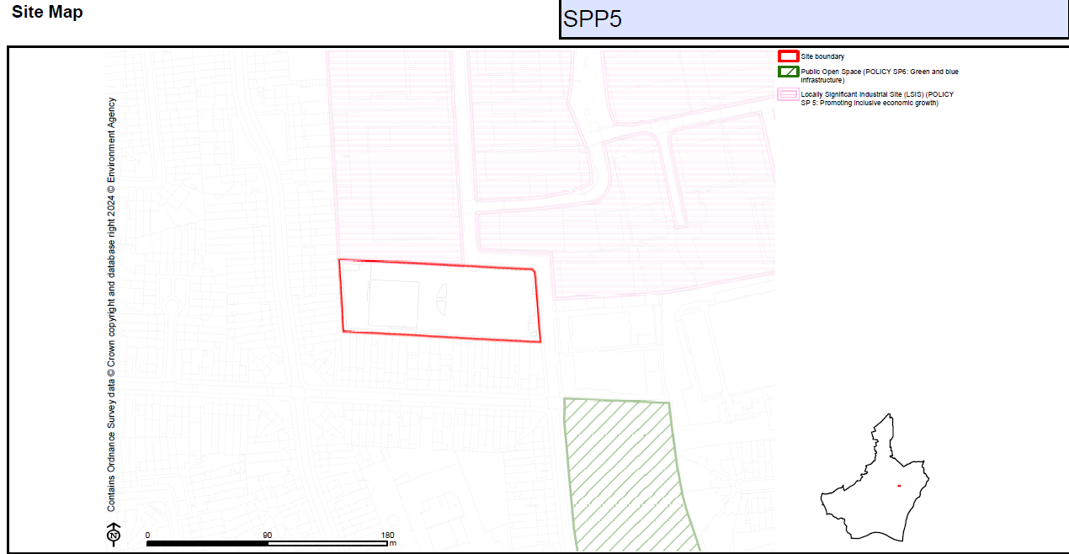  Amend bullet point/s under 'Planning Constraints and Requirements' heading (now proposed to be entitled 'Development Requirements') as follows:  - The site is located within identified Locally Significant Industrial Location (LSIS)  Amend bullet point/s under 'Relevant Planning History' as follows:  N/A  - 23/00631/FULL approved (subject to legal agreement) on 28-11-2023
MM171 | SPP6 | Insert new section heading page as follows:  Sites within Strategic Area SPP6: Dagenham Heathway and Becontree  Insert contents page of sites for the SPP6 Area  Add sentence on contents page of sites setting out the following:  Housing Allocation 'Indicative Minimum Capacity' and 'Units' set out the net minimum number of new homes it is expected there is capacity to deliver within the Plan period.
MM172 | SPP6  AD-Dagenham Leisure Park | Amend bullet point/s under 'Planning Constraints and Requirements' heading (now proposed to be entitled 'Development Requirements') as follows:  - Strengthening the relationship with the adjacent land/areas, including Castle Green Transformation Area, Beam Park Transformation Area and Dagenham Dock Transformation Area (see Local Plan sub area policies: Policies SPP2 and SPP3).  - Minimising parking in this location, early engagement with the Council is recommended to discuss appropriate car parking levels  - Tall buildings maybe appropriate in this location (see Local Plan policy DMD2), subject to other planning considerations. The scale and massing of development should contribute to the creation of new coherent townscape to respond positively to its existing and emerging context.
MM173 | SPP6  BS-St Mary's Parish Church, Grafton Road | Add new proforma as follows:  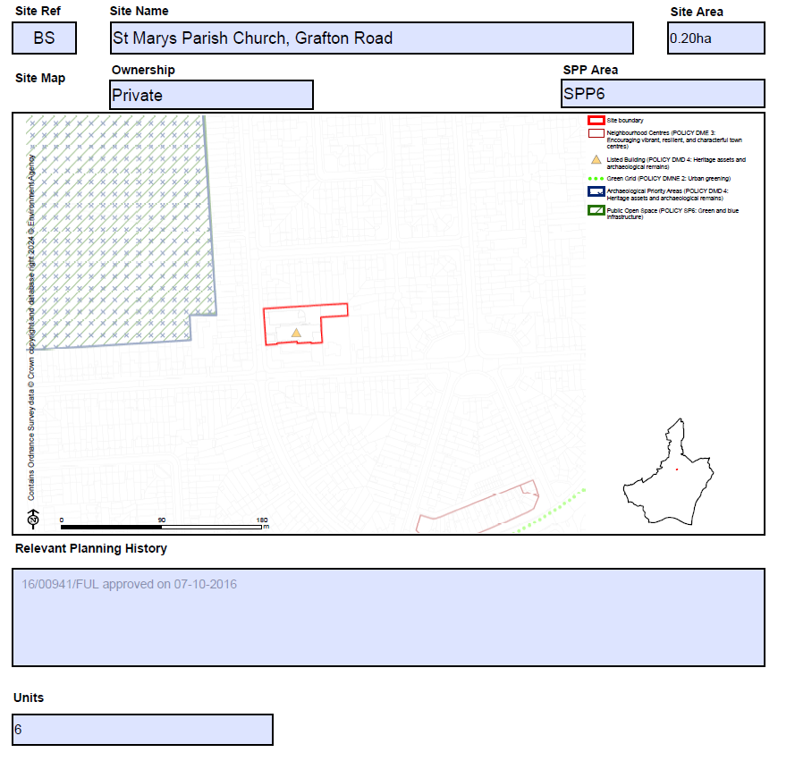
MM174 | SPP6  CV-Land North of Becontree Station | Replace proforma as follows:  Submission Plan  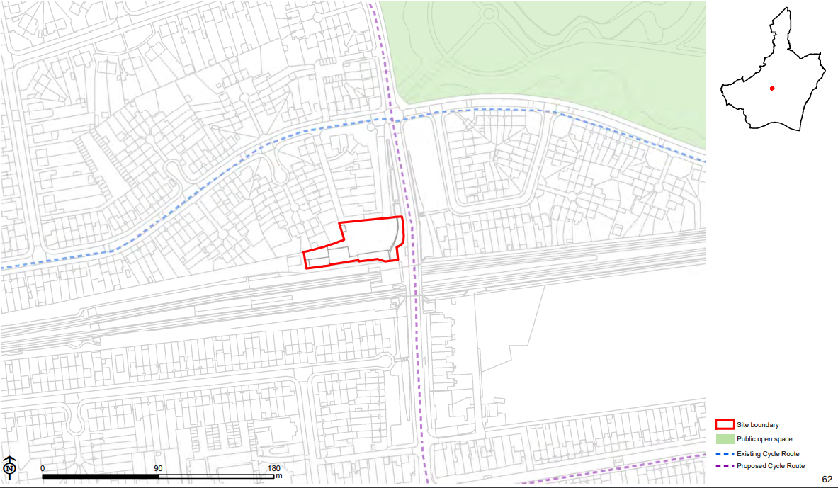  Main Modification Version  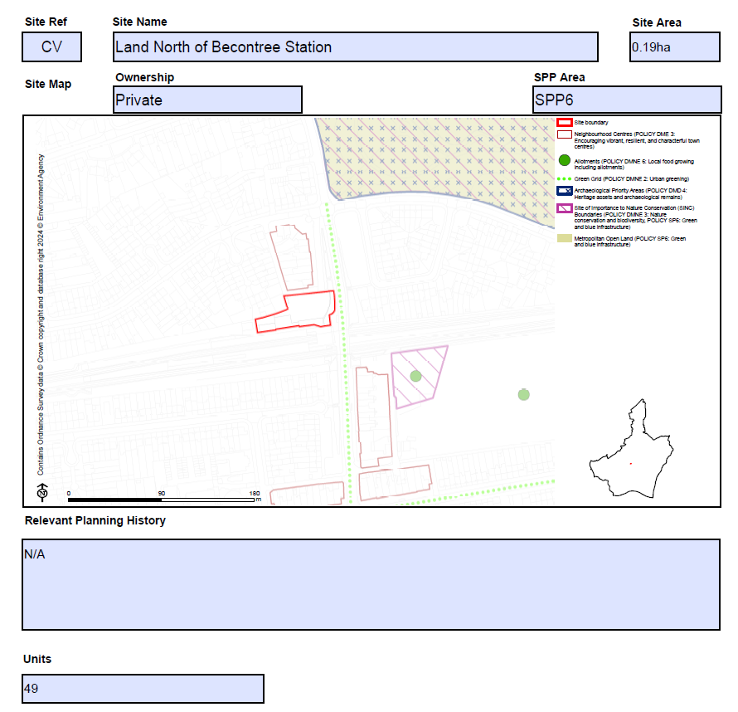
MM175 | SPP6  DB-Former Sacred Heart Convent | Add site proforma as follows:  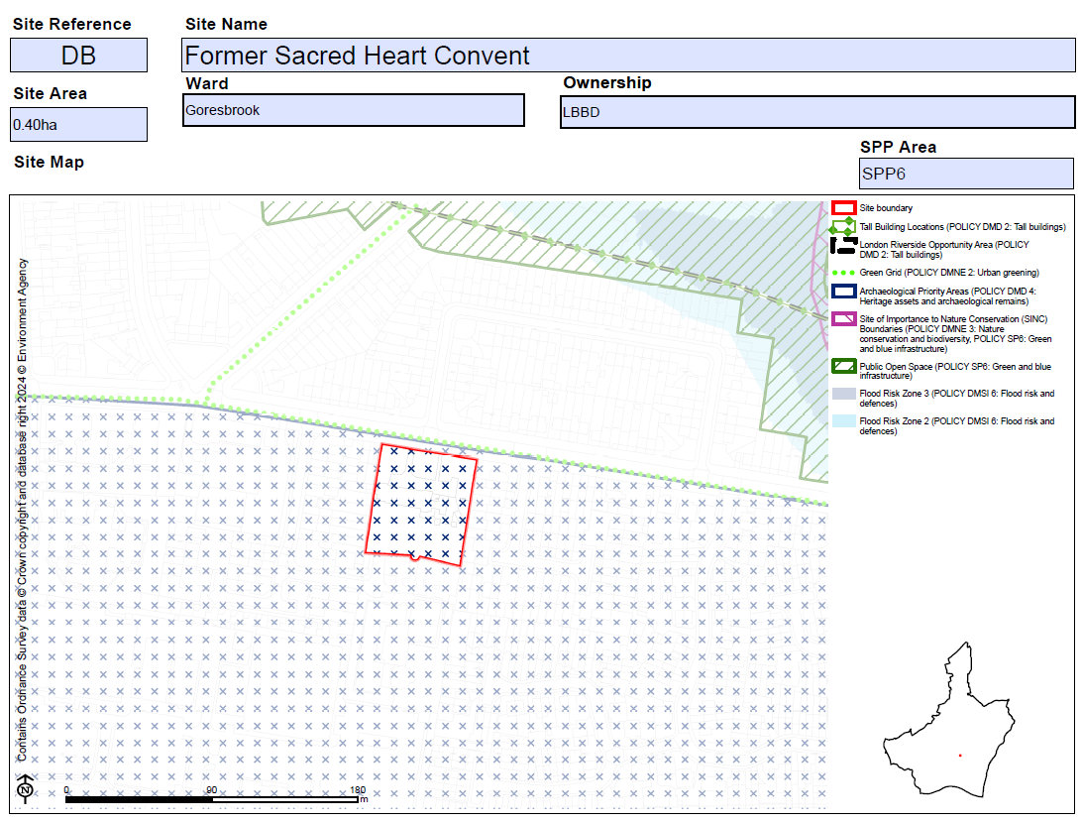  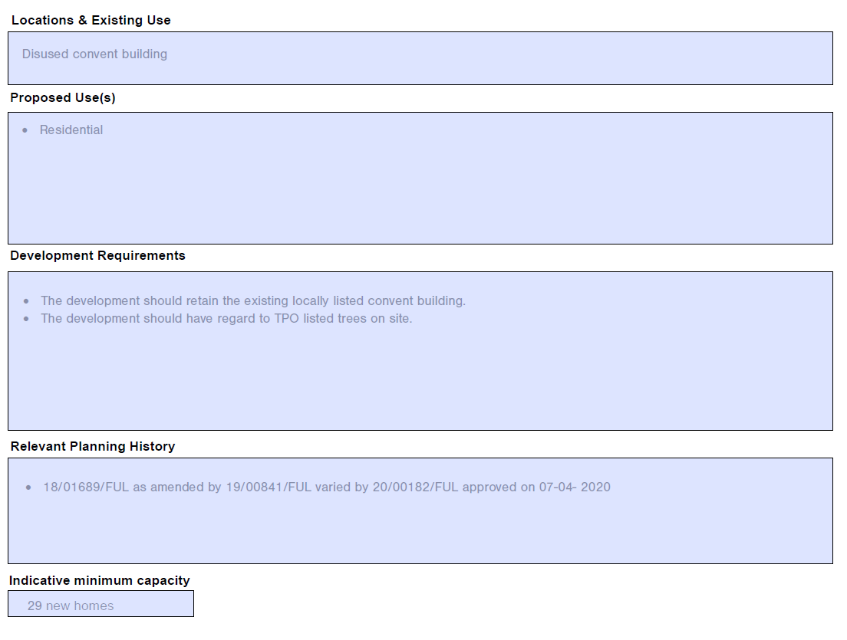  #
MM176 | SPP6  DM-Dagenham Heathway | Amend site name as follows:  Dagenham Heathway Mall  Amend site area as follows:  2.72 2.79ha  Amend Site Map boundary as follows as per PMSPM35 and reflecting representation from site promoter:  Submission Plan  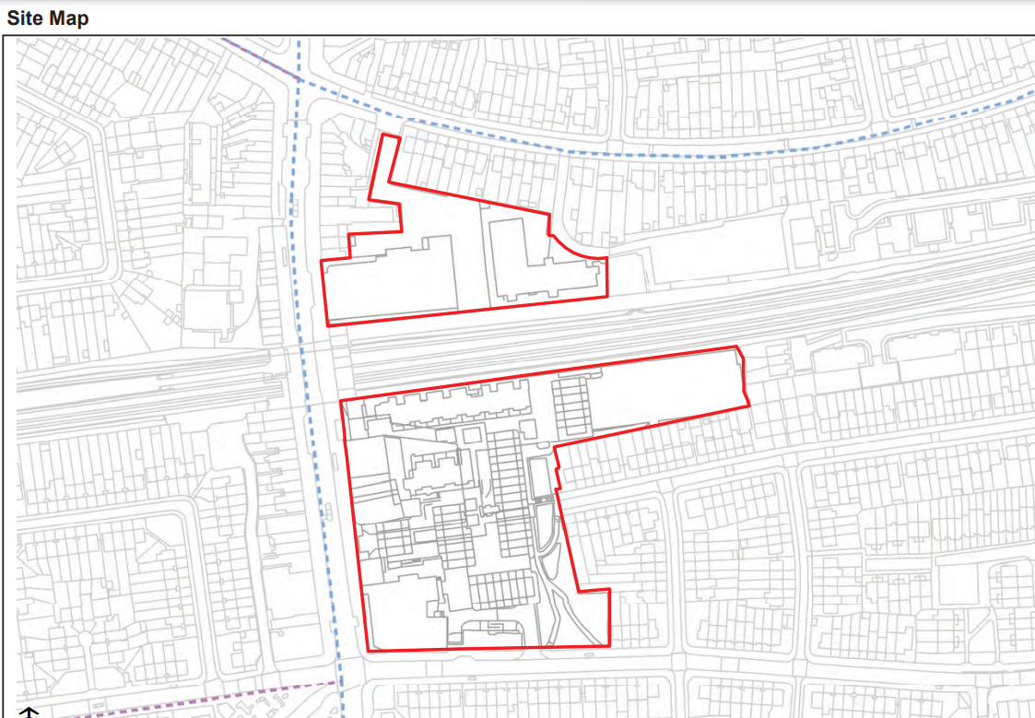  Main Modification  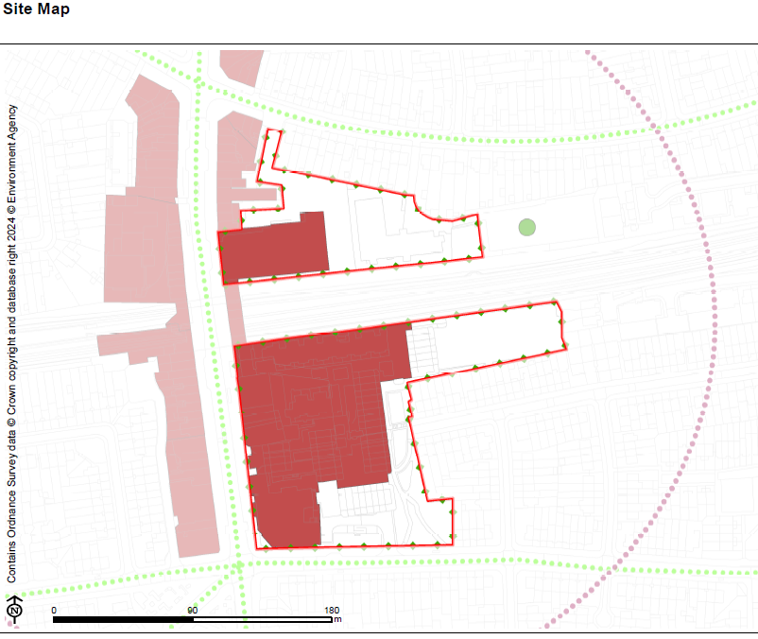  Amend bullet point/s under 'Planning Constraints and Requirements' heading (now proposed to be entitled 'Development Requirements') as follows:  - Dagenham Heathway is defined as a district centre - main town centre uses must be directed to Dagenham Heathway Town Centre boundary and proposals for large retail development in edge, or out of the boundary will be considered against the sequential approach in accordance with the most up to date NPPF. -
MM177 | SPP6  DZ-Dagenham Labour Hall | Add new proforma as follows:  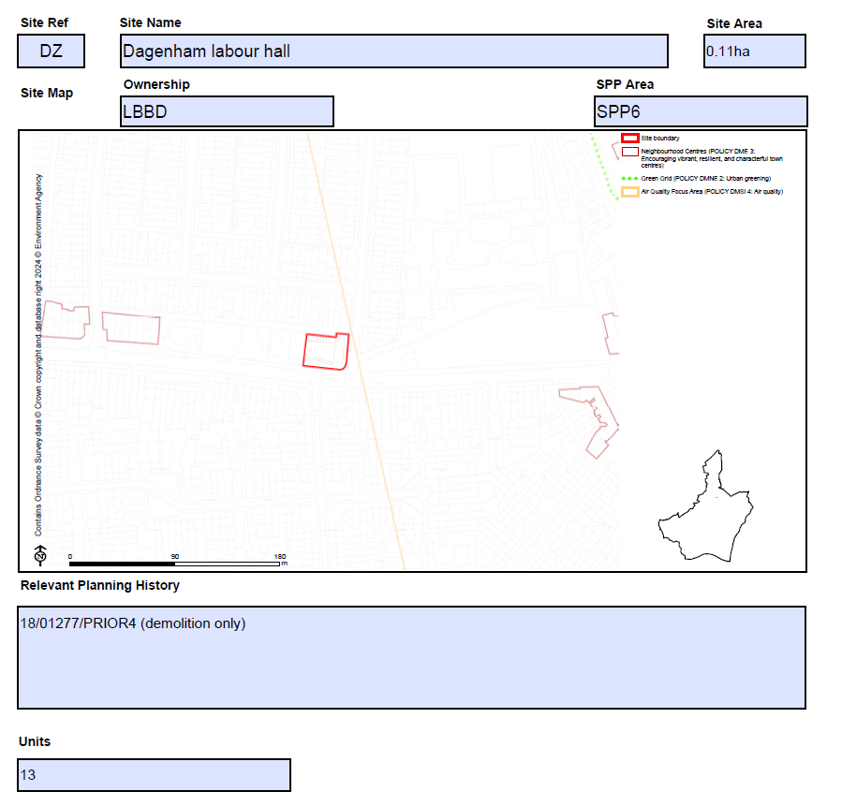
MM178 | SPP6  HU-Land to Rear of 127-133 Becontree Avenue | Add new proforma as follows:  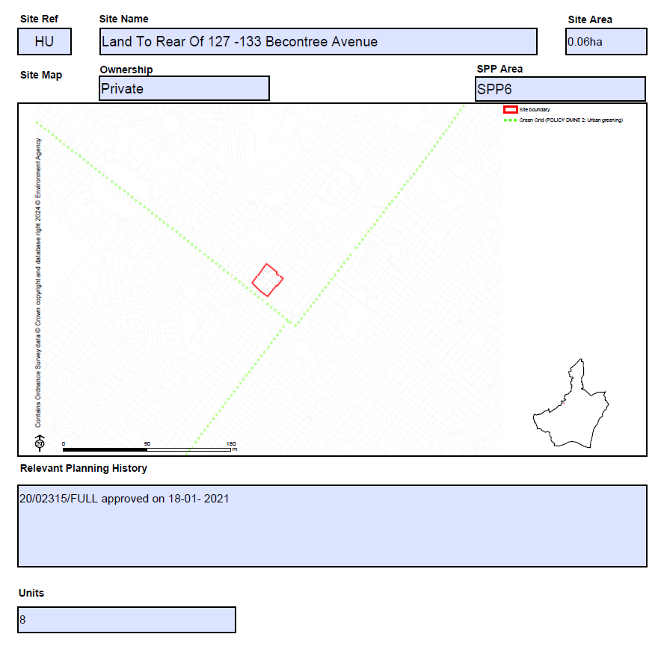
MM179 | SPP6  SR- 2-20 Seabrook Road and 1-27 Shipton Close | Add new proforma as follows:  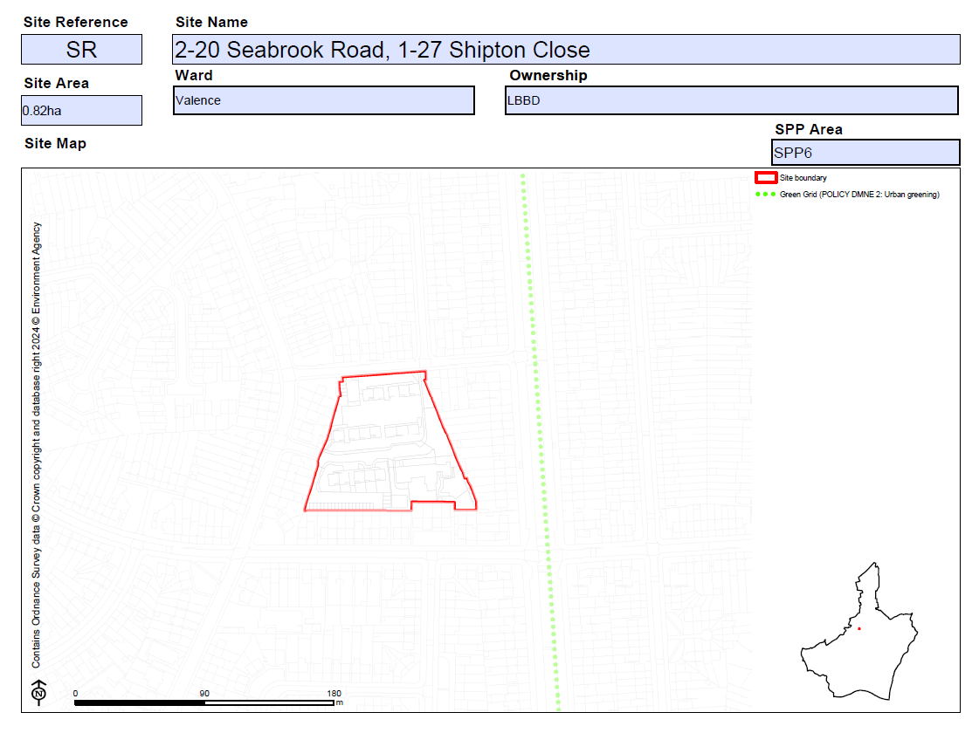  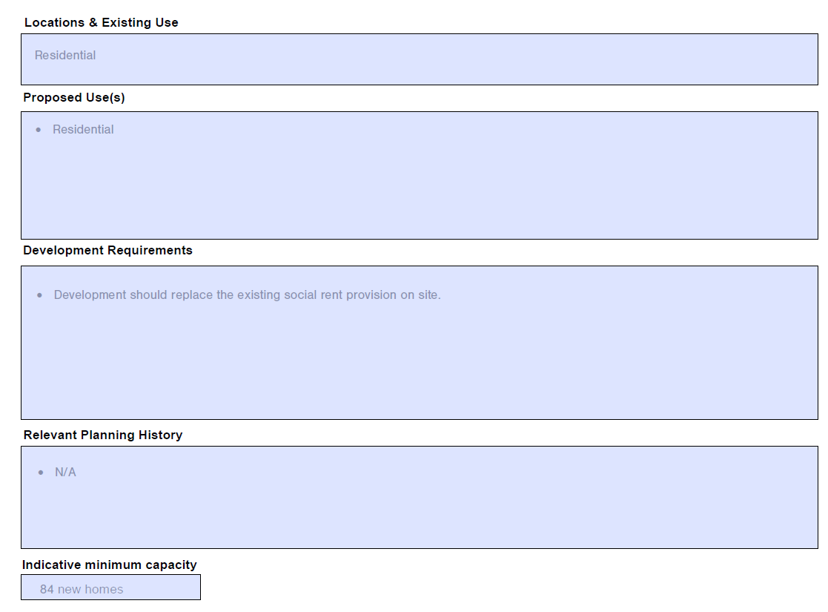
MM180 | SPP6  YS- 2 Stamford Road and Woodward Road | Add new proforma as follows:  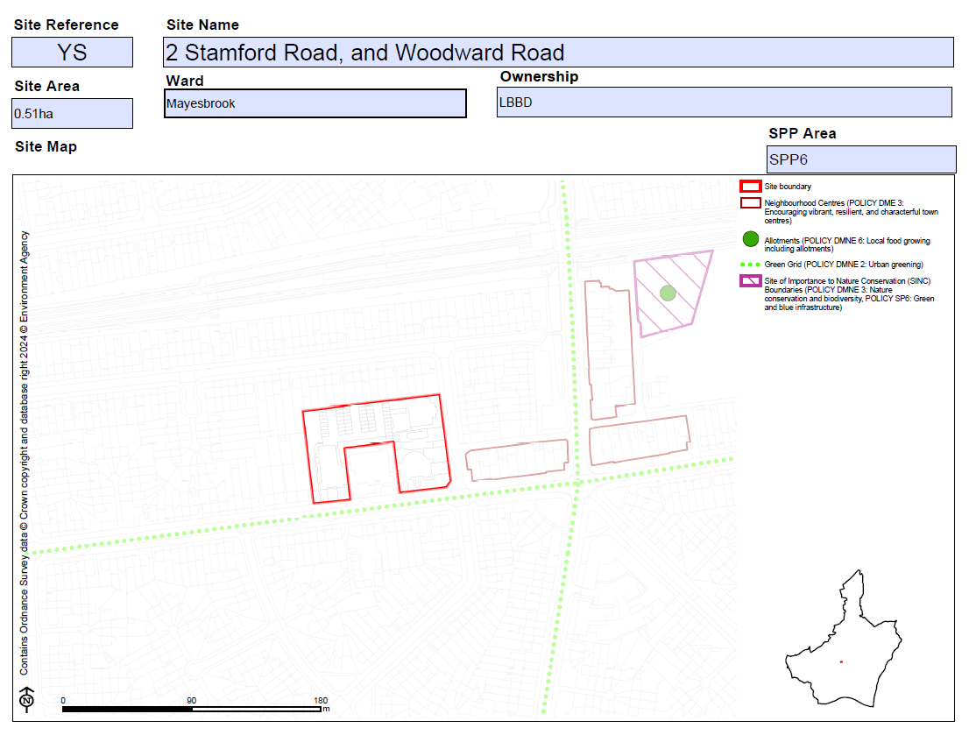  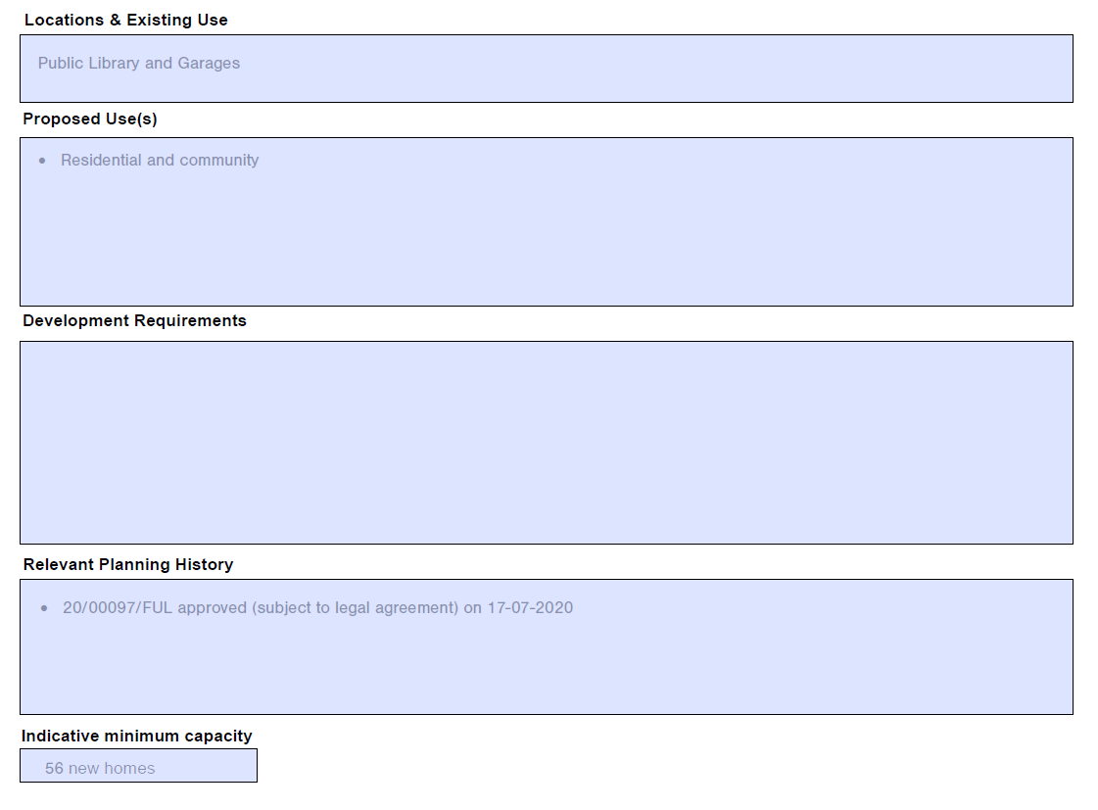
MM181 | SPP6  ZB- 497-515 Gale Street, Dagenham | Add new proforma as follows:  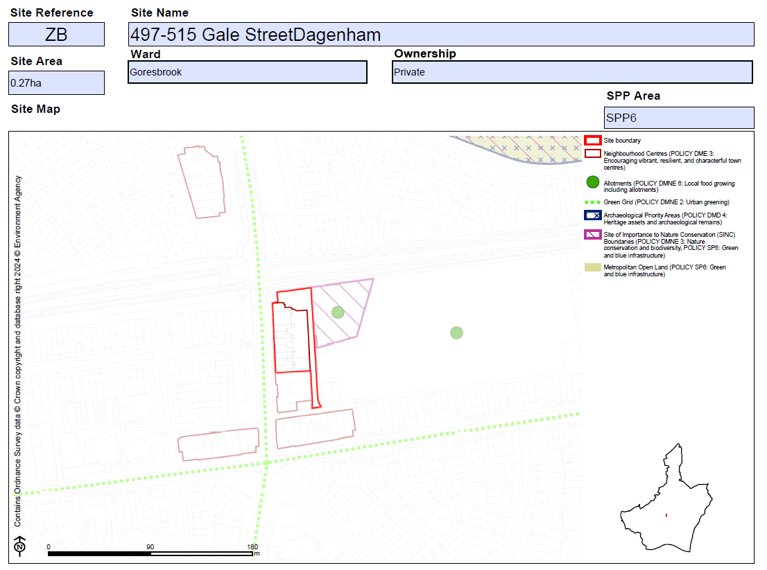  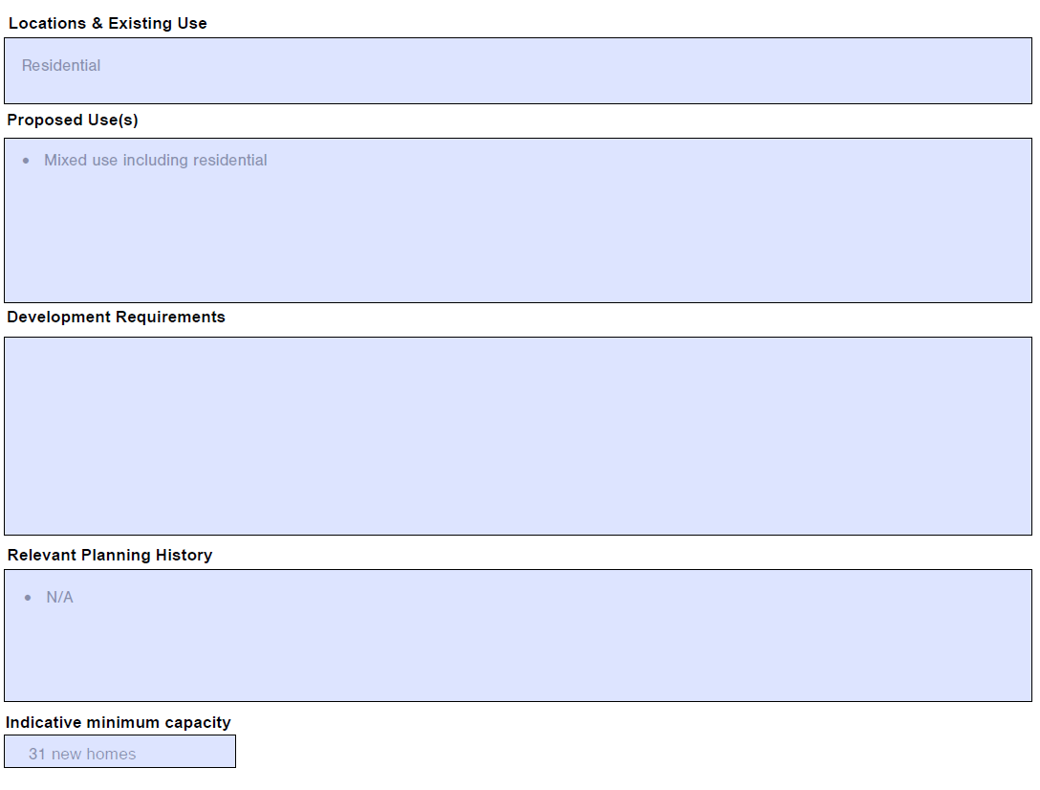
MM182 | SPP6  ZN-Brocklebank Lodge, Becontree Avenue, Dagenham | Add new proforma as follows:  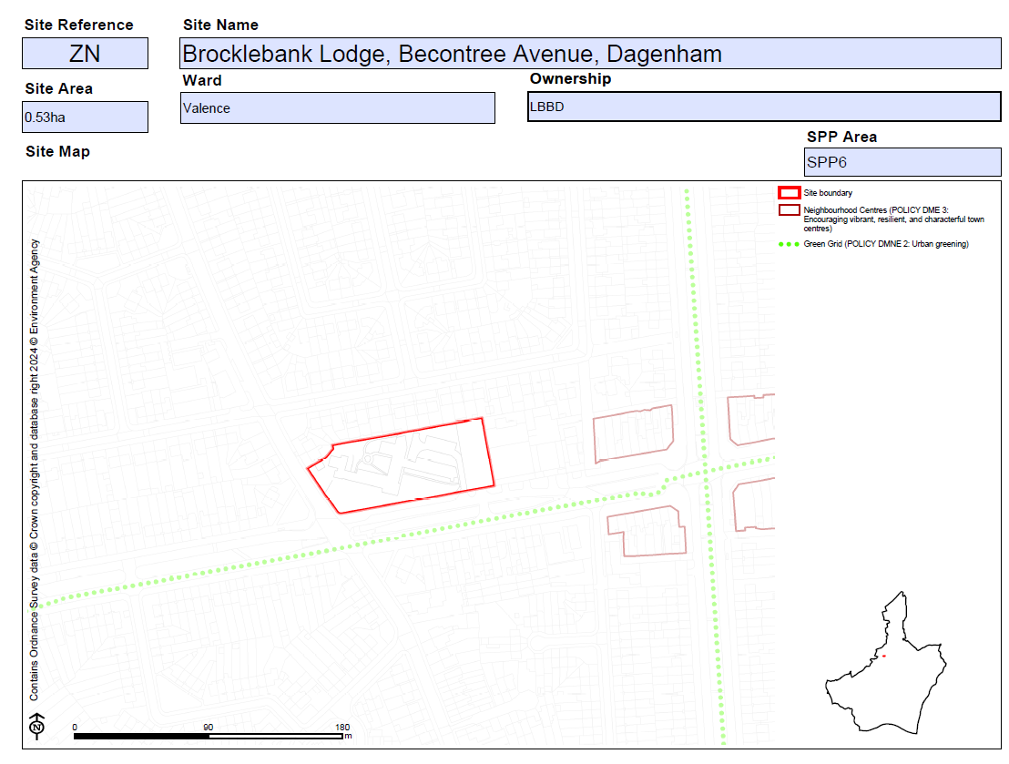  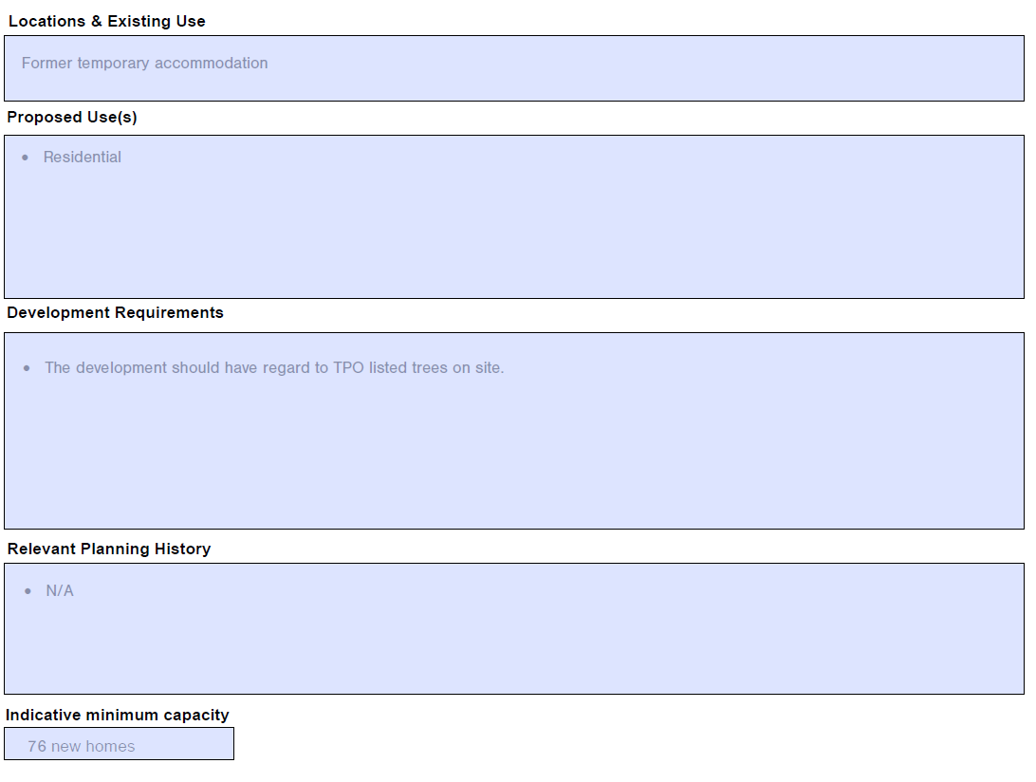
MM183 | SPP6  E_005- 79a Whalebone Lane | Amend site name as follows:  79A Whalebone Lane South  Amend bullet point/s under 'Planning Constraints and Requirements' heading (now proposed to be entitled 'Development Requirements') as follows:  - The parade of shops on the eastern side of Whalebone Lane South fall within the Whalebone Lane South Neighbourhood Centre. Further to the south are two more Neighbourhood Centres - The Merry Fiddlers and Althorne Way. There is an economic opportunity to create a new district centre by linking three Neighbourhood Centres.  - Development proposals for retail and leisure uses exceeding 500sq.m gross will be required to submit an impact assessment in accordance with the NPPF and NPPG.  - The proposed scale and height with a maximum height of around 8m is considered acceptable for a commercial building of proposed use and would be of a similar height to the surrounding buildings.
MM184 | SPP7 | Insert new section heading page as follows:  Sites within Strategic Area SPP7: Becontree Heath and Rush Green  Insert contents page of sites for the SPP7 Area  Add sentence on contents page of sites setting out the following:  Housing Allocation 'Indicative Minimum Capacity' and 'Units' set out the net minimum number of new homes it is expected there is capacity to deliver within the Plan period.
MM185 | SPP7  DH-Oxlow Lane (previously 265-285 Rainham Road North) | Add new proforma as follows:  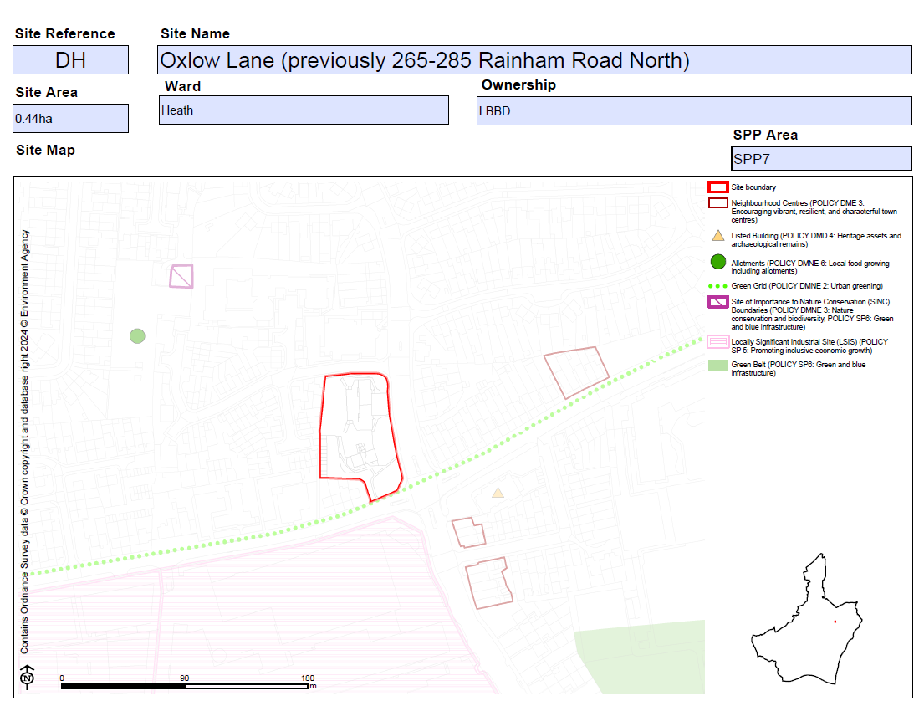  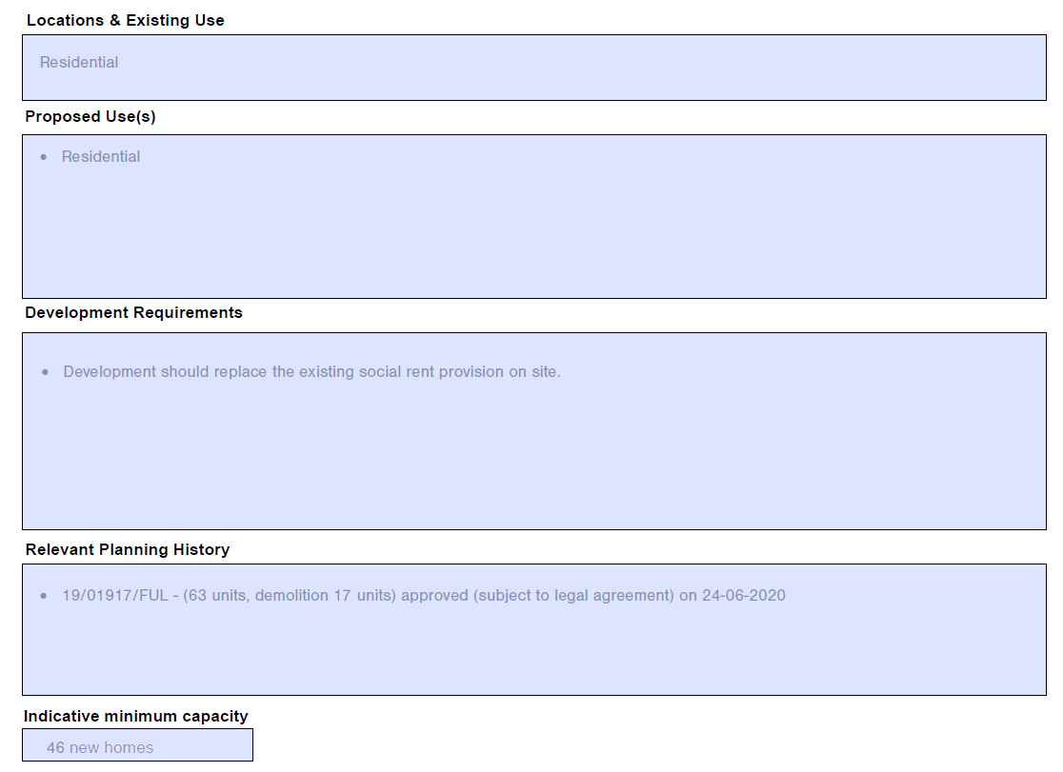
MM186 | SPP7  CW-90 Stour Road | Replace proforma as follows:  Submission Plan  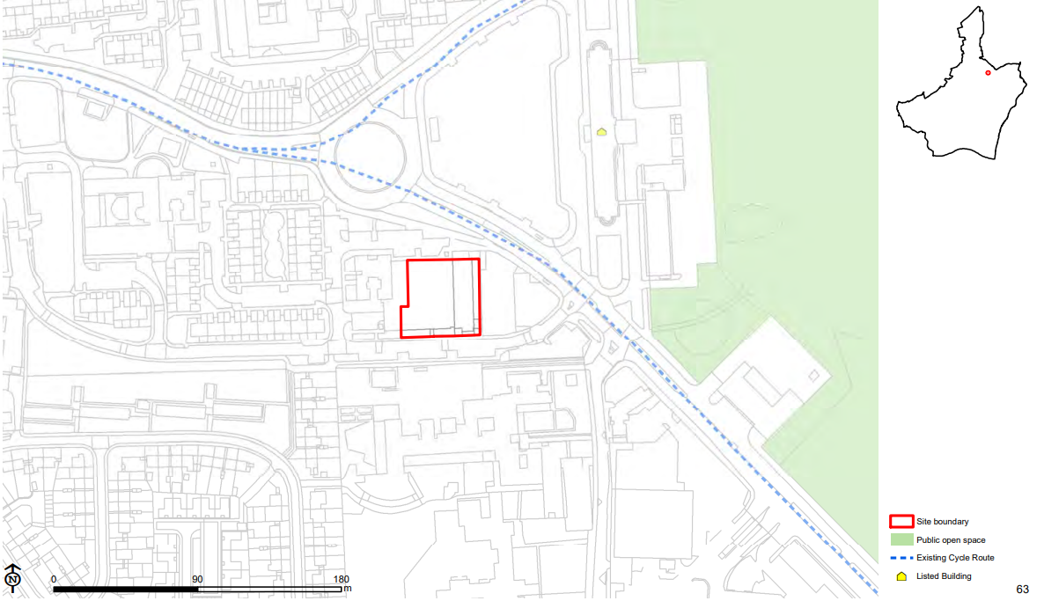  Main Modification Version  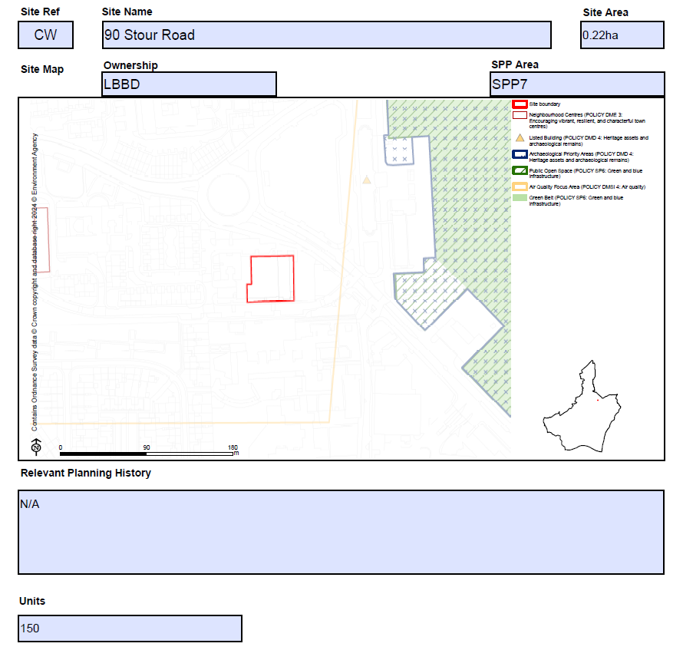
MM187 | SPP7  WE-Fels Farm Dagenham Road Rush Green Romford | Add new proforma as follows:  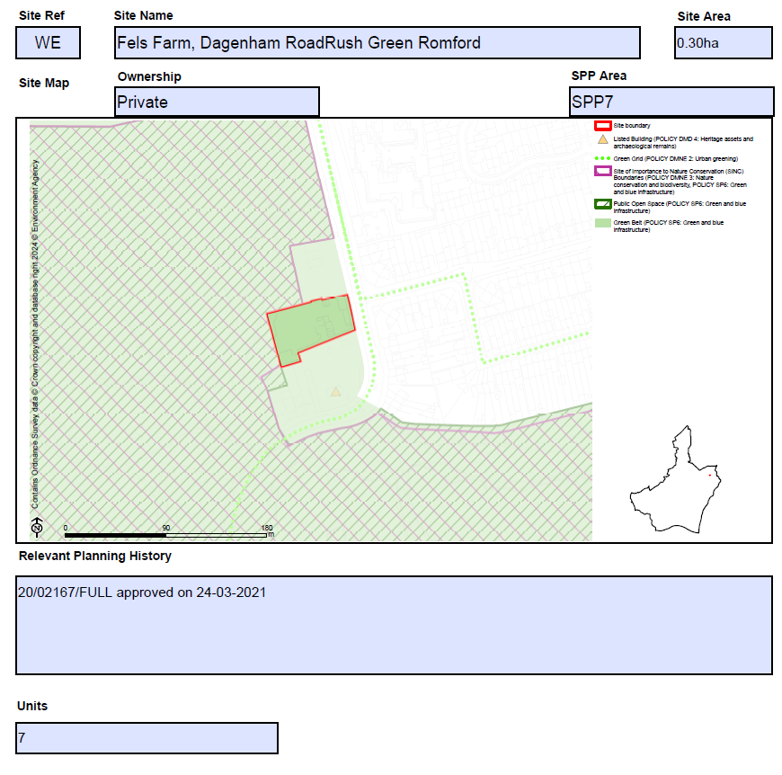
MM188 | SPP7  Eastbrookend Country Park | Add new proforma as follows:  