[EYparentevents@lbbd.gov.uk](mailto:EYparentevents@lbbd.gov.uk)

12th December 2024

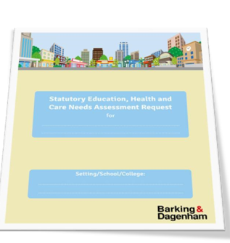

This workshop is designed for parents who have or will be having, an EHC {Educational Health and Care Plan} request submitted. Nichola Bridge and Sarah Randall from the Early Years Inclusion Team for LBBD will be giving you all the information regarding the process, what to expect and myth busting.

This workshop will be taking place at the

Alibon Annexe

177 Sterry Road Dagenham RM10 8PT on the

12th December 2024

10am-12 noon

To book your place please contact [EYparentevents@lbbd.gov.uk](mailto:EYparentevents@lbbd.gov.uk)

Educational Health and Care Plans

{EHCP}

Parent workshops