Public Notice for the review of a premises licence made under the Licensing Act 2003 | 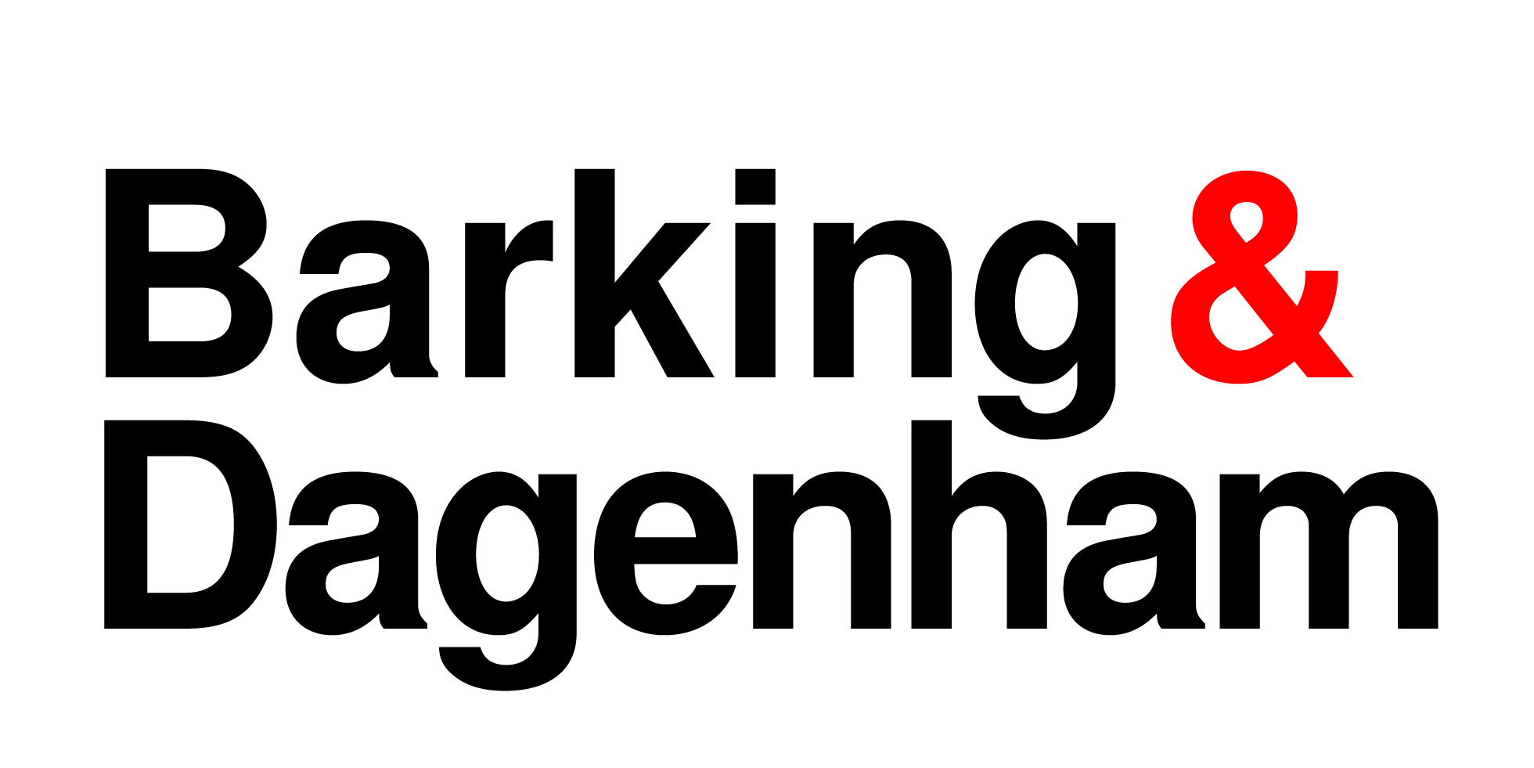

Notice is hereby given that an application was made to the London Borough of Barking & Dagenham for a review of a premises licence under the Licensing Act 2003 on 25 November 2024.

Application made by: Home Office Immigration Enforcement

for the premises at Maramureseanu – 608 Longbridge Road, Dagenham, RM8 2AJ

On the grounds of: Prevention of Crime and disorder,

The full application can be viewed at the Licensing Department, Barking Town Hall, Town Hall Square, Barking IG11 7LU by appointment only. Please email licensing@lbbd.gov.uk to arrange an appointment.

Any person who wishes to make a representation to this application must do so in writing to the Licensing Officer at the above address by;

23 December 2024

Representations must be based on at least one or more of the licensing objectives and must relate to the premises making the application.

It is an offence, under section 158 of the Licensing Act 2003, to knowingly or recklessly make a false statement in or in connection with an application for premises licence. To do so could result in prosecution and a fine of any amount.

