

Get ready for an amazing

Winter

Wonderland

Come to the Children and Young people’s Disability

hub

’s

elf workshop for exciting

seasonal

crafts, music,

games and more.

December 17

th

, 18

th

and 19th De

Hourly

sessions bookable

for Families with Children &

Young People with

Disabilities

l

living in Barking &

Dagenham

Siblings are welcome



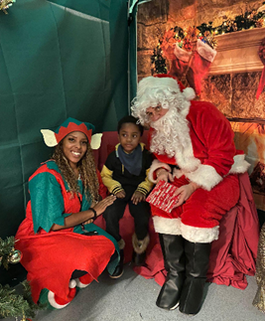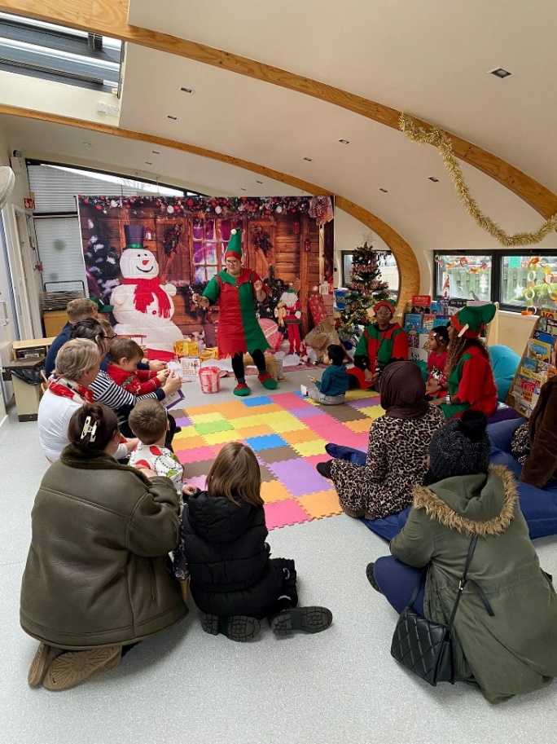



Tuesday 17 December

th

Wednesday 18th and Thursday 19th December

10am-11am

3pm-4pm

4:30pm-5:30pm

6pm-7pm

Our elf can’t wait to meet all its little helpers at

**Becontree Community Hub, Stevens Road, RM8 2QR**

**Can you find our**

**nau**

**ghty elf?**

10am-11am

3pm-4pm

4:30pm-5:30pm

6pm-7pm

**-Please copy and paste the link below for our booking page.**

<https://app.10to8.com/book/cypd-hub/1921927>